sales@prcsoftware.com
Telephone: 1-877-4PM-RISK (1-877-576-7475)
http://www.prcsoftware.com
User Manual
PRC ENTERPRISE RISK REGISTER

ADMINISTRATION 3
User Management 3
Project Management 16
My Profile 25
Currency Settings 33
Access Management 39
Enterprise Project Structure 43
PORTFOLIO MANAGEMENT 52
Scoring System (Portfolio) 52
Manager’s Dashboard (Portfolio) 61
Dashboard (Portfolio) 66
Standard Reports (Portfolio) 69
Portfolio Breakdown Structures 124
Custom Fields (Portfolio) 135
Field Settings (Portfolio) 145
PROJECT SETTINGS 154
Project Breakdown Structure 154
Scoring System (Project) 163
Custom Fields (Project) 173
Field Settings (Project) 180
RISK REGISTER 188
Standard Reports (Project) 188
Risk Details (Threats) 328
Risk Details (Opportunities) 350
Risk Details (Mitigations) 372
Spreadsheet View (Threats) 380
Spreadsheet View (Opportunities) 407
Spreadsheet View (Mitigations) 435
Search Risks (Threats) 451
Search Risks (Opportunities) 458
Manager’s Dashboard (Project) 465
Dashboard (Project) 471
Import Mitigations 475
Import Opportunity Register 481
Import Risk Register 487
Manage Email Update 493
Email Updation 494
Automation Rules 495
FIELD DESCRIPTION 497
Administration 497
Portfolio Management 499
Project Settings 505
Risk Register 509

ADMINISTRATION

User Management
User Management section in the PRC Enterprise Risk Register can be viewed only by those users who have either Read/Write or View access. Users with only Read/Write access can create a new user, edit users, add a project for a selected user, delete a user, unassign a project to a user, and change the access privileges of users.
Users designated with View Access may view specific pages, select a user, view user details and view projects assigned. Access to editing functions is not available to these users.
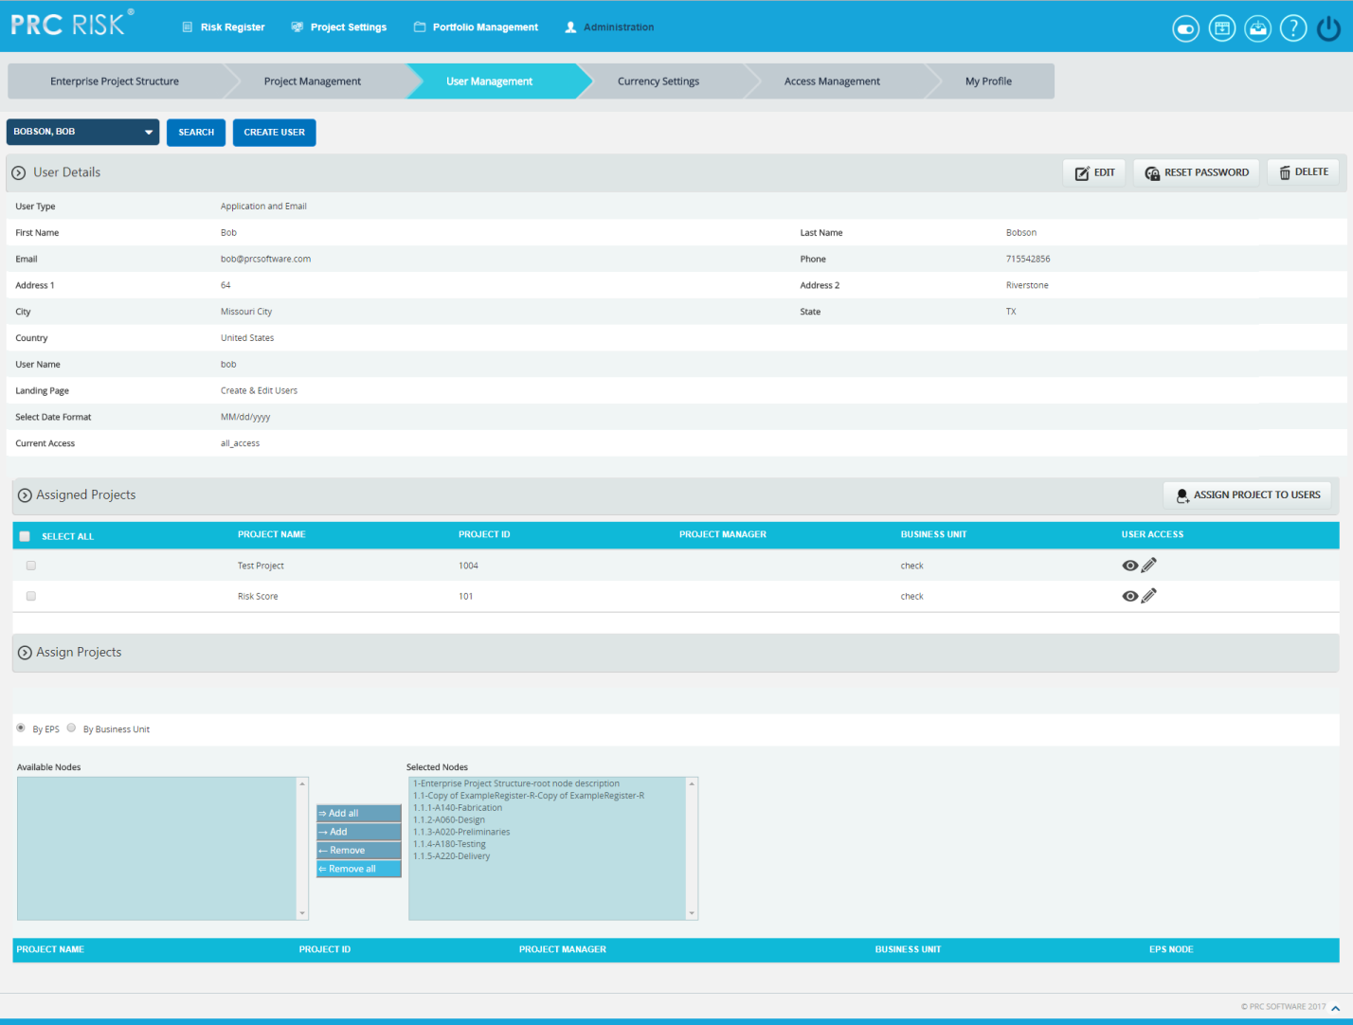
Figure 1

Searching For Users:
Searching for users in the PRC Enterprise Risk Register can be done in two different ways. The Search function allows the user to search based on a keyword. This method is faster when working with large amounts of data. The Select function is commonly used for smaller databases or when the search objective is easy to define.
Using the search function:
Steps:
- Administration ---> User Management
- Click the SEARCH button. (Figure 1)
- Enter the name (which can be either first name or last name or both) or user name. Click the SEARCH button and select the required user. (Figure 2)
- The SHOW ALL button in the search area lists all users available. (Figure 2)
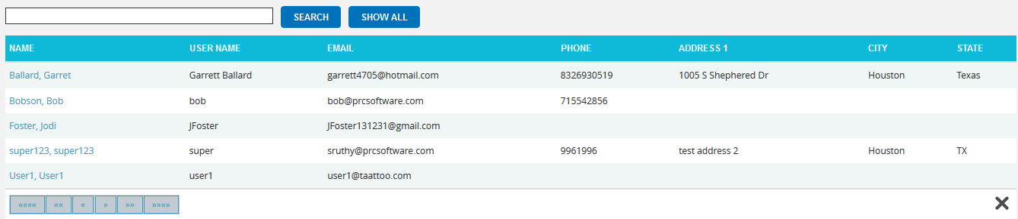
Figure 2
Using the select function (dropdown list):
Steps:
- Administration ---> User Management
- Click the SELECT USER dropdown. (Figure 1)
- Select the required user from the list shown.

Creating a new user:
Creating a new user in the PRC Enterprise Risk Register is quick and easy. It is important to enter as much information as possible about the user when the new user is created. The Landing Page sets the first page the user sees upon login.

Steps:
- Administration ---> User Management
- Click the CREATE USER button. (Figure 1)
- After entering the user data, click the SAVE button. (Figure 1)

Editing user information:
When editing user details in the PRC Enterprise Risk Register, all the fields are unlocked and user can modify all user details.
Steps:
- Administration ---> User Management
- Click the SEARCH button. The available details will be listed.
- Click a record which is to be modified. Then click the EDIT button. (Figure 1)
- After the data is modified, click the SAVE button. (Figure 3)
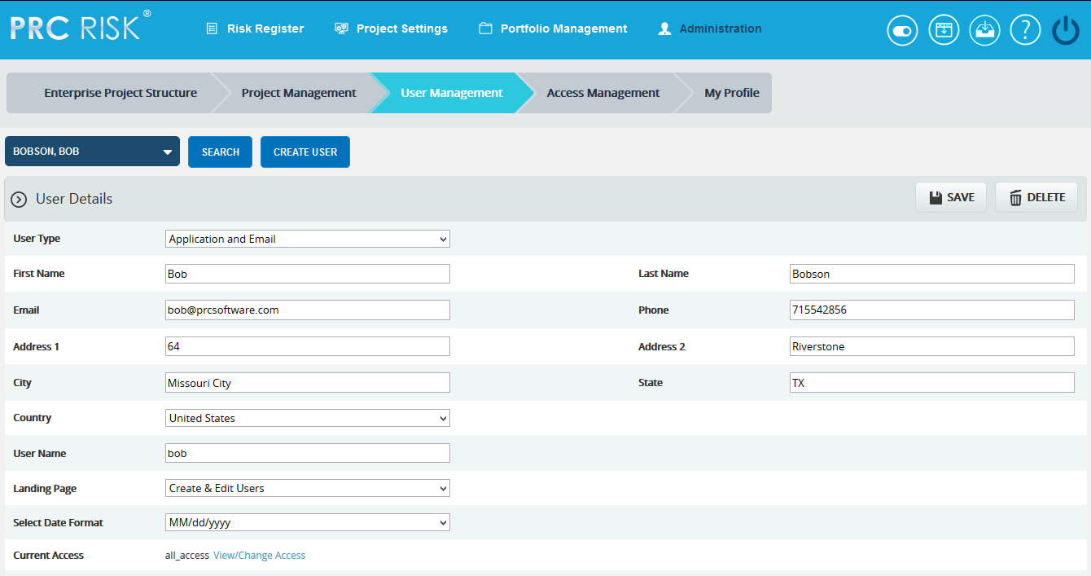
Figure 3

Assign New Project to User:
This functionality helps to assign a project to a selected user. The Project is selected directly and assigned to the user.
Assign Project:
Steps:
- Administration ---> User Management
- Click the ASSIGN PROJECT TO USERS button. (Figure 1)
- Search and select for the project. (Figure 4)
Figure 4
- To continue, click the NEXT STEP button. (Figure 4) A pop up (Figure 5) appears from which user access can be set.
- After modifying access, click the FINISH button (Figure 5) to save changes.
The SHOW ALL button (Figure 4) lists all the projects available from which user can select the required project. If the user knows the project they are searching for, they can enter the name and click the SEARCH button. (Figure 4)
The CANCEL button cancels the projects selected for the user. (Figure 4)

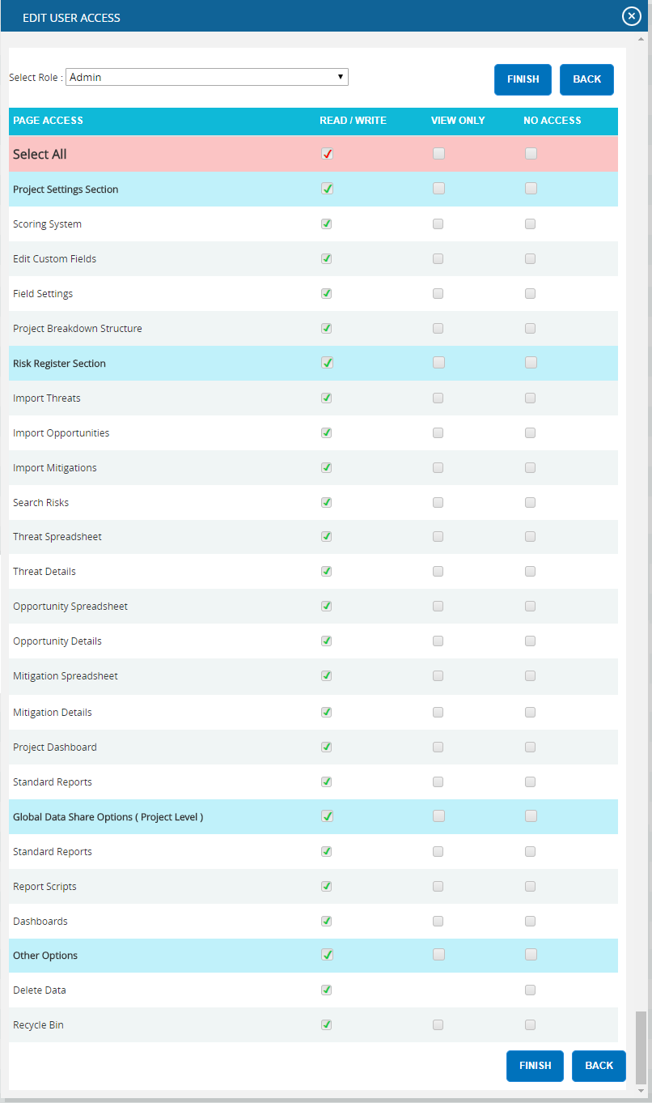
Figure 5
Add User to Projects (For EPS & Business Unit) :
This functionality is used to add a user to the project under EPS node/Business unit. This section is visible only after an EPS node or Business Unit is selected.
If the user is already selected, control goes directly to step 3.
Steps:
- Administration ---> User Management
- Click the ADD USER TO PROJECT button. (Figure 1)
- Select the required user. (Figure 6)
- A pop up (Figure 5) appears from which the user accesses can be set.
- After modifying the accesses, click the FINISH button to save the changes. (Figure 5)
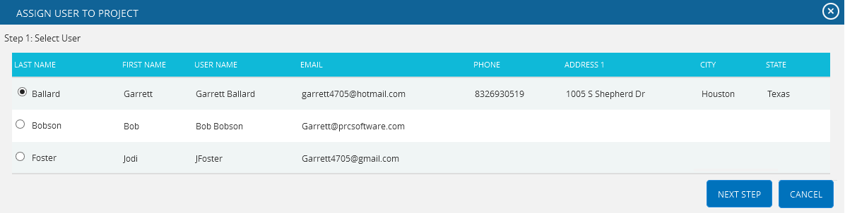
Figure 6
Assign project by selecting EPS node:
This section is used to assign users to projects which have already been added to the Enterprise Project Breakdown Structure node. The functionality consists of two lists, Available Nodes and Selected Nodes. Available Nodes (Figure 7) contains all the nodes added to the Enterprise Project Structure. Selected Nodes (Figure 7) displays the nodes that have previously been selected. A node can be added to the Selected Nodes list using the Add button. All nodes under the Available Nodes list can be moved to the Selected Nodes list using the Add All button.
A single node from the Selected Nodes list can be moved back to the Available Nodes list using the Remove button. If the Selected Nodes list contains more than one node and the user needs to move them back to the Available Nodes list, they can use Remove All button.

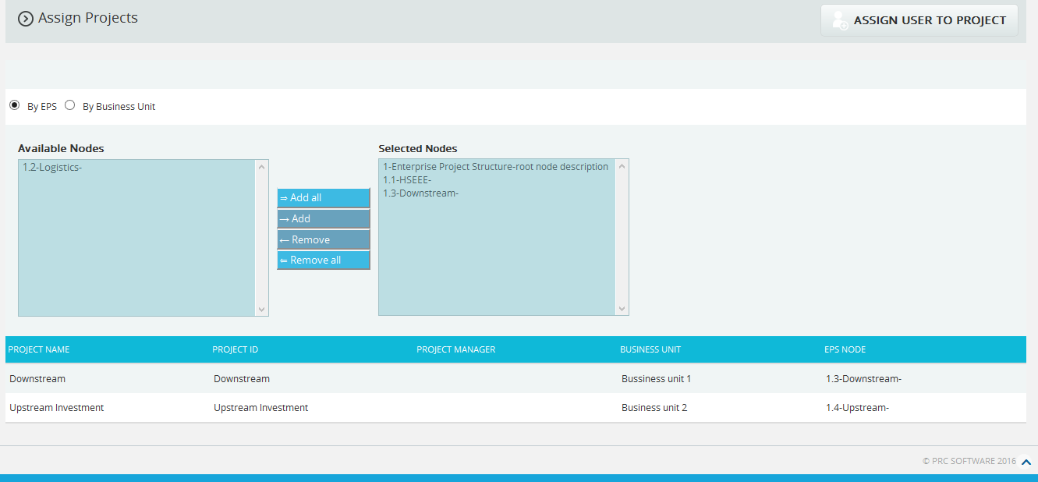
Figure 7
Steps:
- Administration ---> User Management
- Click the By EPS radio button. (Figure 7)
- Add the required nodes to Selected Nodes list by using either the Add button or the Add All button. (Figure 7) The projects under Selected Nodes will be displayed.
- Click the ADD USER TO PROJECT button. (Figure 1) Check the steps described under Assign Projects section.
Assign project by selecting Business Unit:
This functionality helps to assign Projects which have already been added to the Business Unit to the selected user. The functionality consists of two lists, one called Available Nodes (Figure 8) which contains all the business units available and another called Selected Nodes (Figure 8) which displays the business unit selected. A Business Unit can be added to the Selected Nodes list using the Add button. The entire business unit under the Available Nodes list can be moved to the Selected Nodes list using the Add All button. A single business unit from the Selected Nodes list can be moved back to the Available Nodes list using the Remove button. If the Selected Nodes list contains more than a business unit and the user needs to move them back to the Available Nodes list, they can use the Remove All button.

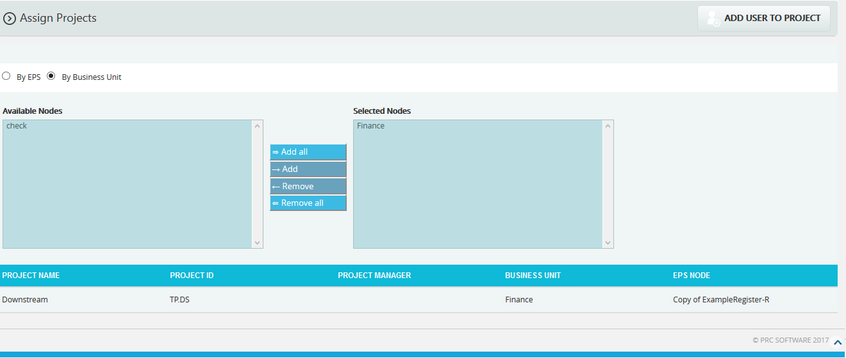
Figure 8
Steps:
- Administration ---> User Management
- Click the By Business Unit radio button. (Figure 8)
- Add the required nodes to the Selected Nodes list by using either Add button or Add All button. (Figure 8) The projects assigned to the business unit under the Selected Nodes list will be displayed.
- Click the ADD USER TO PROJECT button. (Figure 1) Check the steps described under Assign Projects section.

Edit User Accesses:

In order to edit multiple projects user accesses, select the projects by checking the checkboxes under the Select project column and click the EDIT USER ACCESS button to do the changes.
Steps:
  - Administration ---> User Management
  - Click the Select User dropdown. (Figure 1)
  - Select the required user from the list shown.
  - Select the projects, by checking the checkboxes under the Select Project column for which the user accesses are to be changed. (Figure 9)
  - Click the EDIT USER ACCESS button to do the changes. (Figure 9)
  - A pop up appears. (Figure 10) After modifying access, click the save button to save the changes or click CANCEL.
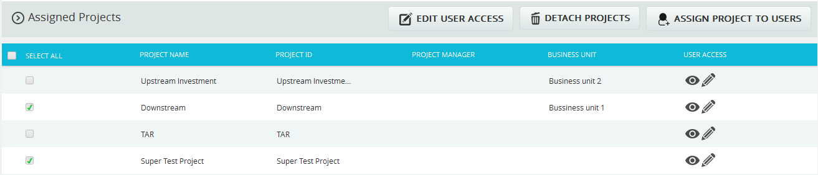
Figure 9

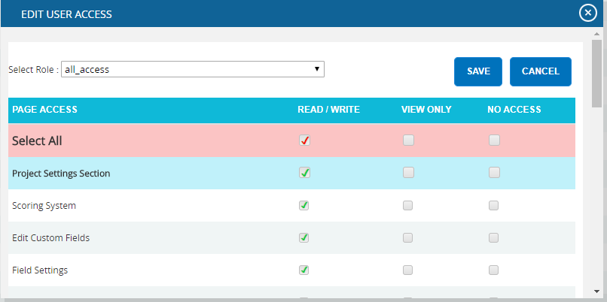
Figure 10
View / Edit:

In order to view or edit individual project’s user access, click View/Edit link (Figure 9) under the Assigned Project section.

Steps:
  - Administration ---> User Management
  - Click the Select User dropdown. (Figure 1)
  - Select the required user from the list shown.
  - Click the View/Edit to view or edit individual project’s user access. (Figure 9)
  - A pop up appears. (Figure 10) After modifying access, click the save button to save the changes or click CANCEL.

Detach Project:
In order to remove a project assigned to a user, select the projects by checking the checkboxes under the Select project column and click DETACH PROJECTS button. (Figure 9)
Steps:
- Administration ---> User Management
- Click the Select User dropdown. (Figure 1)
- Select the required user from the list shown.
- Select the projects, by checking the checkboxes under the Select Project column. (Figure 9)
- Click the DETACH PROJECTS button. (Figure 9)
- A pop up appears. (Figure 11) Click OK to detach or click Cancel.
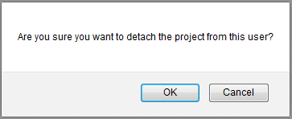
Figure 11

Deleting Users:
The deleted user will be removed from the system. Once the user is deleted, the details are completely removed. The action cannot be undone. In order to delete a user, the user logged in should have Read/Write access for delete function.
Steps:
- Administration ---> User Management
- Select the required user.
- Click the DELETE button. (Figure 1) The user receives a confirmation message. Click OK to remove the user from the system or click Cancel.

Reset Password:
This functionality is used to change the password of the selected user.
Steps:
- Administration ---> User Management
- Click the RESET PASSWORD button. (Figure 1) A pop up appears. (Figure 12)
- Enter New Password and Confirm New Password and click the CHANGE PASSWORD button to finish. (Figure 12)
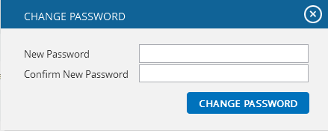
Figure 12
View/Change Access:
This functionality helps to view/change the user access to all the pages by assigning a particular role to the user.
Steps:
- Administration ---> User Management
- Select the required user.
- Click the EDIT button. (Figure 1)
- Click View/Change Access link. (Figure 3) A pop up appears. (Figure 13)
- Select a role from the Select Role dropdown list and click ASSIGN ROLE button. (Figure 13)

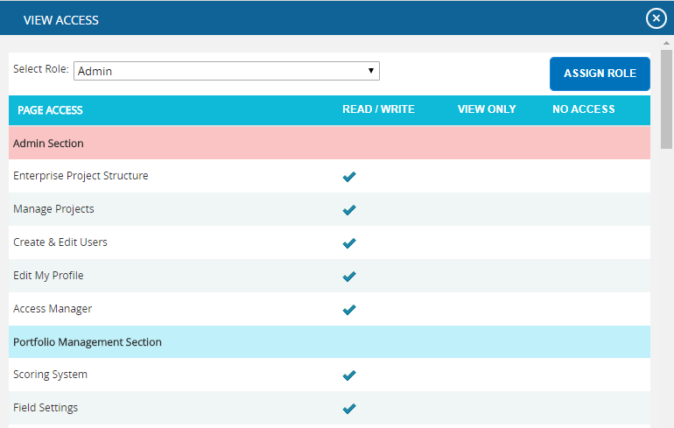
Figure 13
User Type:
This functionality is used to create user based on the User Types such as Application and Email, Application only and Email only.
Application and Email: Allows the user to access the application and also allows sending and receiving emails.
Application only: Allows the user to access only the application.
Email only: Allows the user to only receive email to access the application data.
Steps:
- Administration ---> User Management
- Click the EDIT button. (Figure 1)
- Select the licensing option from the User Type dropdown. (Figure 14)
- Click the SAVE button. (Figure 14)
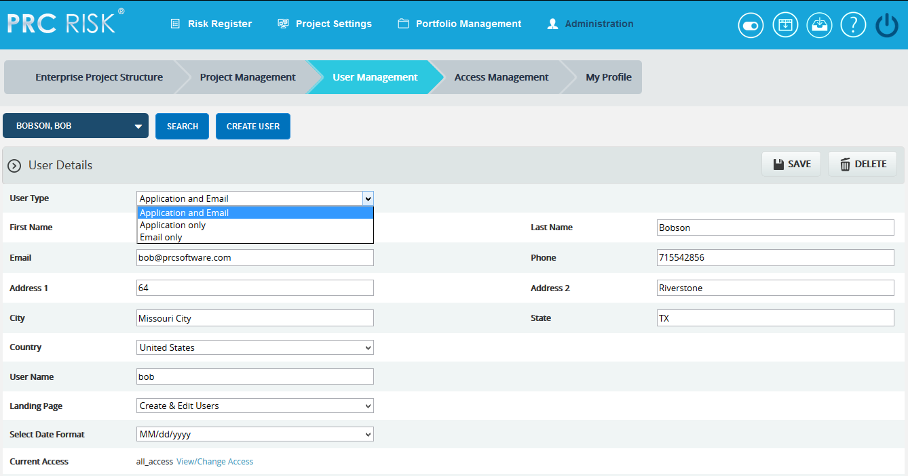
Figure 14

Project Management
The Project Management section can be viewed only by those users who have either Read/Write or View Access. Users with Read/Write access can create new projects, edit projects, add users to a selected project, delete a project, remove a user, and change the access privileges of users added to the selected project. Whereas, View Access enables users to view project data but blocks the ability to alter existing data or add new data. View Access users can select a project, view project details and view users assigned to the project.
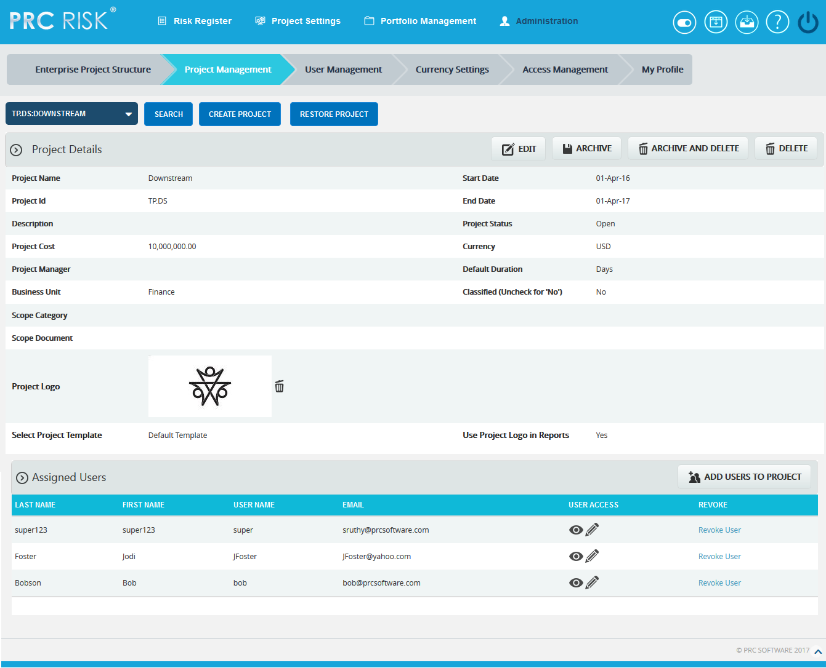
Figure 1
The project manager field has an editable select box which enables the user to either select or enter the details. When the page is loaded for the first time, the currency field displays the application's default currency, which is specified in the My Profile page. The user can edit the currency by changing the selection on the Currency dropdown.

Searching For Projects:
Searching for projects in the PRC Enterprise Risk Register can be done in a couple of ways. The Search function allows the user to search for a project based on a keyword. This method is faster when working with a large amount of data. The Select function is commonly used for smaller databases or when the search criteria can easily be defined.
Using the search function:
Steps:
- Administration ---> Project Management
- Click the SEARCH button. (Figure 1)
- Enter the project name or Id and click the SEARCH button. (Figure 2)

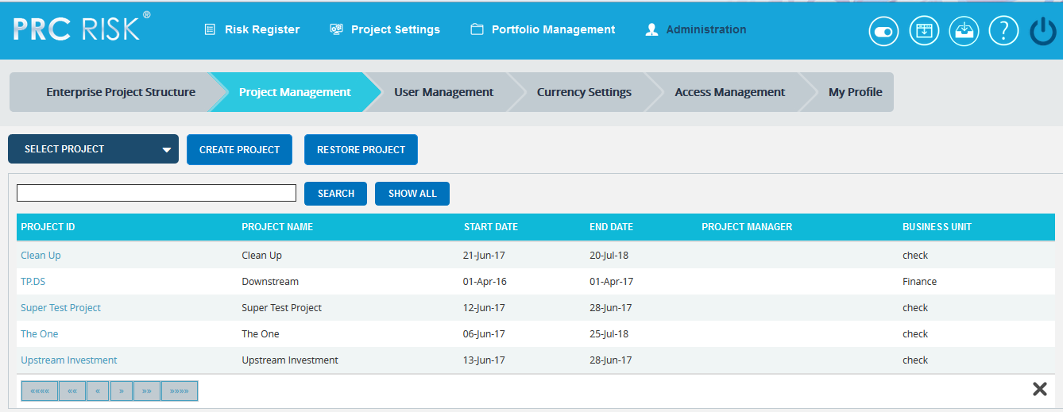
Figure 2
The SHOW ALL button in the search area lists all the projects available. (Figure 2)
Using the select function (dropdown list):
Steps:
- Administration ---> Project Management
- Click the SELECT PROJECT dropdown. (Figure 1)
- Select the required project.

Creating a new project:
It is important to enter as much information as possible about the project when a new project is created. A field, such as the Business Unit field, will be used later for Breakdown Structure creation and mapping. Projects can also be listed as Classified, which means they are hidden to all users except those assigned to it.
Steps:
- Administration ---> Project Management
- Click the CREATE PROJECT button. (Figure 1)
- After entering the project data, click the SAVE button.

Editing project information:
When editing a project, all the fields are unlocked and user can modify all the project details.
Steps:
- Administration ---> Project Management
- Click the EDIT button. (Figure 1)
- After the data is modified, click the SAVE button. (Figure 3)
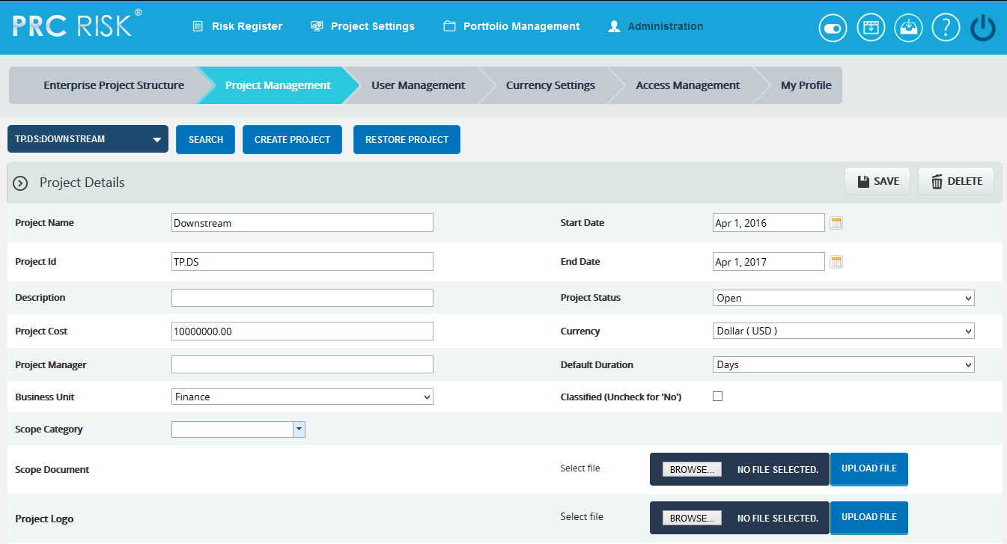
Figure 3

Project Logo:
This functionality is used to upload the project logo for the selected project. This logo is shown in the Risk Register Word and PowerPoint file exports, only if Use Project Logo in Reports checkbox is checked.
Steps:
- Administration ---> Project Management
- Select the required project.
- Click the EDIT button. (Figure 1)
- Click the BROWSE button in the Project Logo and select the required image file. (Figure 3)
- Click the UPLOAD FILE button to finish and click the SAVE button.
- Click DELETE next to the image uploaded to delete the project logo. (Figure 1)

Import Project Schedule:
This functionality is used to import schedule ID(s) in order to map values for the Link to Schedule ID(s) field, in the Risk Details page in Risk Register. A sample sheet used for import is shown in Figure 4.
Steps:
- Administration ---> Project Management
- Select the required project.
- Click the EDIT button. (Figure 1)
- Click the BROWSE button in the Import Project Schedule and select the required file. (Figure 3)
- Click the UPLOAD FILE button to finish.
- After the file is uploaded, map the task name and task code fields and click the SAVE button. (Figure 3)
- Click the Clear File button to remove the imported file. (Figure 5)

To delete the schedule IDs not mapped for any threats/opportunities in the project, use the Click Here to Delete any Unmapped Schedule IDs link shown in Figure 5.
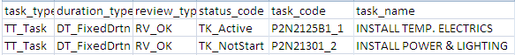
Figure 4

Add users to Project:
This functionality helps to assign a user to the selected project.
Steps:
- Click the ADD USERS TO PROJECT button. (Figure 1)
- A pop up appears from which the user can be searched and selected. (Figure 5)
- SEARCH button is used to search the users who have been assigned to the project. The SHOW ALL button lists all users. If no user is added to the selected project, click the CANCEL button. (Figure 5)
- Click NEXT STEP. A pop up appears from which user accesses can be set. (Figure 6)
- After modifying the accesses, click the FINISH button to save the changes. (Figure 6)
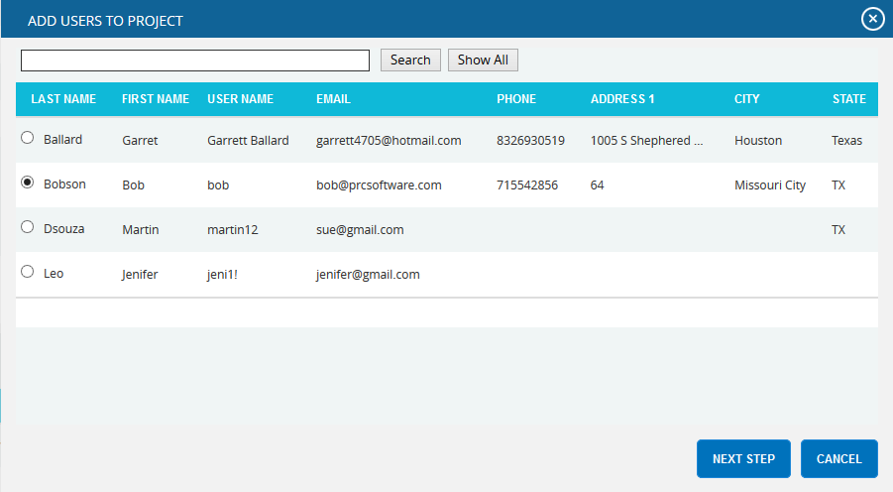
Figure 5
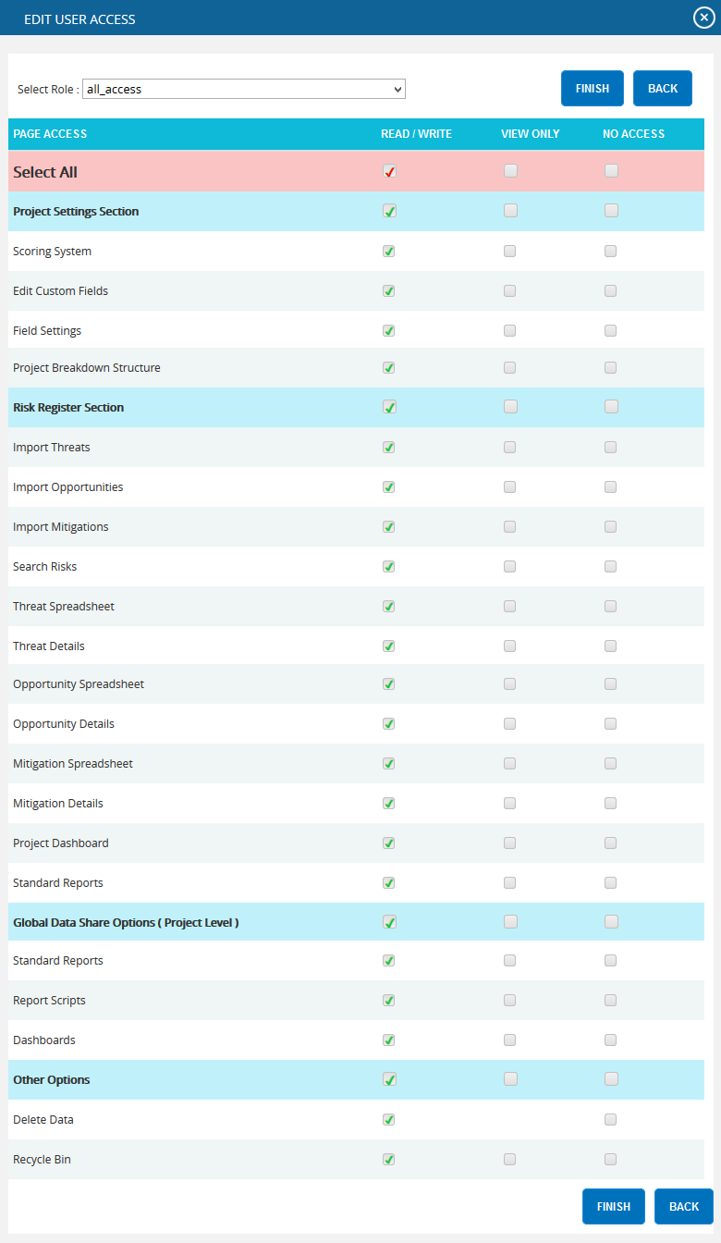
Figure 6

View/Edit Accesses:
To modify the accesses of a user assigned to a project, click View/Edit (Figure 7). A pop up (Figure 8) appears and after modification, click the Finish button to save the changes. (Figure 8)

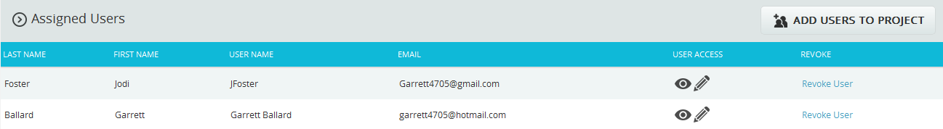
Figure 7
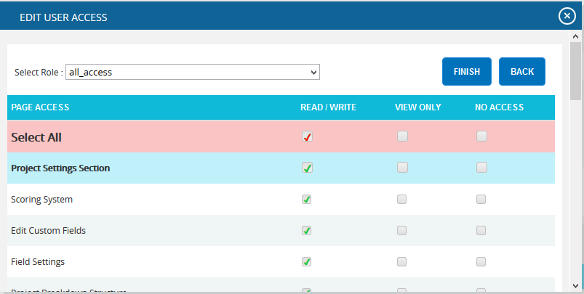
Figure 8

Revoke user:
In order to remove a user assigned to a project, click Revoke User (Figure 7) under Assigned Users section.

Deleting projects:
When deleting projects, The PRC Enterprise Risk Register will remove the project and delete any links it has to the system. Deleted projects will be accessible in the Historical Database.
This button is visible only to the Super User having Read/Write access for delete function.
Steps:
- Administration ---> Project Management
- Select the required Project.
- Click the DELETE button. (Figure 1)
After the user receives the confirmation message, click the OK button. The project is then removed from the system.

Deleting and Archiving Projects:

When deleting and archiving projects, the PRC Enterprise Risk Register exports the project for future use. That is, all the details of the project such as template information, mapped users, risk details and mitigation added to risks are saved with the project and remove the project. The file is saved with .prcriskx extension.
Steps:
- Administration ---> Project Management
- Select the required Project.
- Click the DELETE AND ARCHIVE button. (Figure 1) The user receives the confirmation message (Figure 9), click the OK button. The project is then saved and removed from the system.
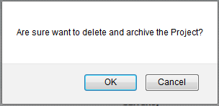
Figure 9

Archiving Project:

When archiving projects, the PRC Enterprise Risk Register exports the project for future use. That is, all the details of the project such as template information, mapped users, risk details and mitigation added to risks are saved with the project.
Steps:
- Administration ---> Project Management
- Select the required Project.
- Click the ARCHIVE button. (Figure 1)

Restoring Project:

The Restore Project functionality allows the user to restore a previously archived project. All the details of the project along with the template information, mapped users, risk and mitigation details, etc are imported. The accepted file type is .prcriskx.
Steps:
- Administration ---> Project Management
- Select the required Project.
- Click the RESTORE PROJECT button. (Figure 1) A pop up appears. (Figure 10)
- Click BROWSE button to browse .prcriskx file and click UPLOAD FILE button. (Figure 10)
- A pop up appears (Figure 11). Map the archived users with the existing users.
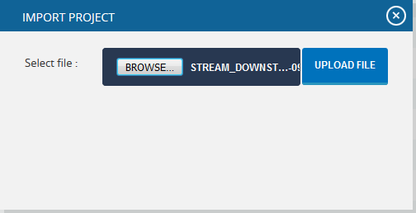

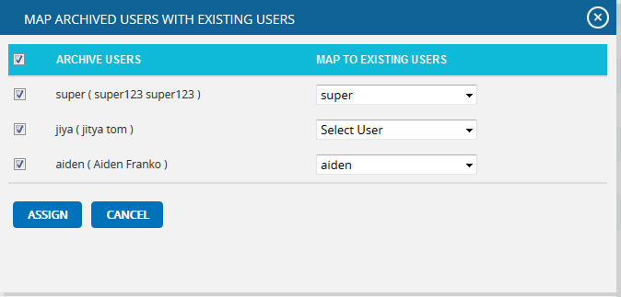
Figure10

Figure11

My Profile
The My Profile page allows the users to manage their own user account. Not all fields can be edited in the My Profile page due to security reasons.
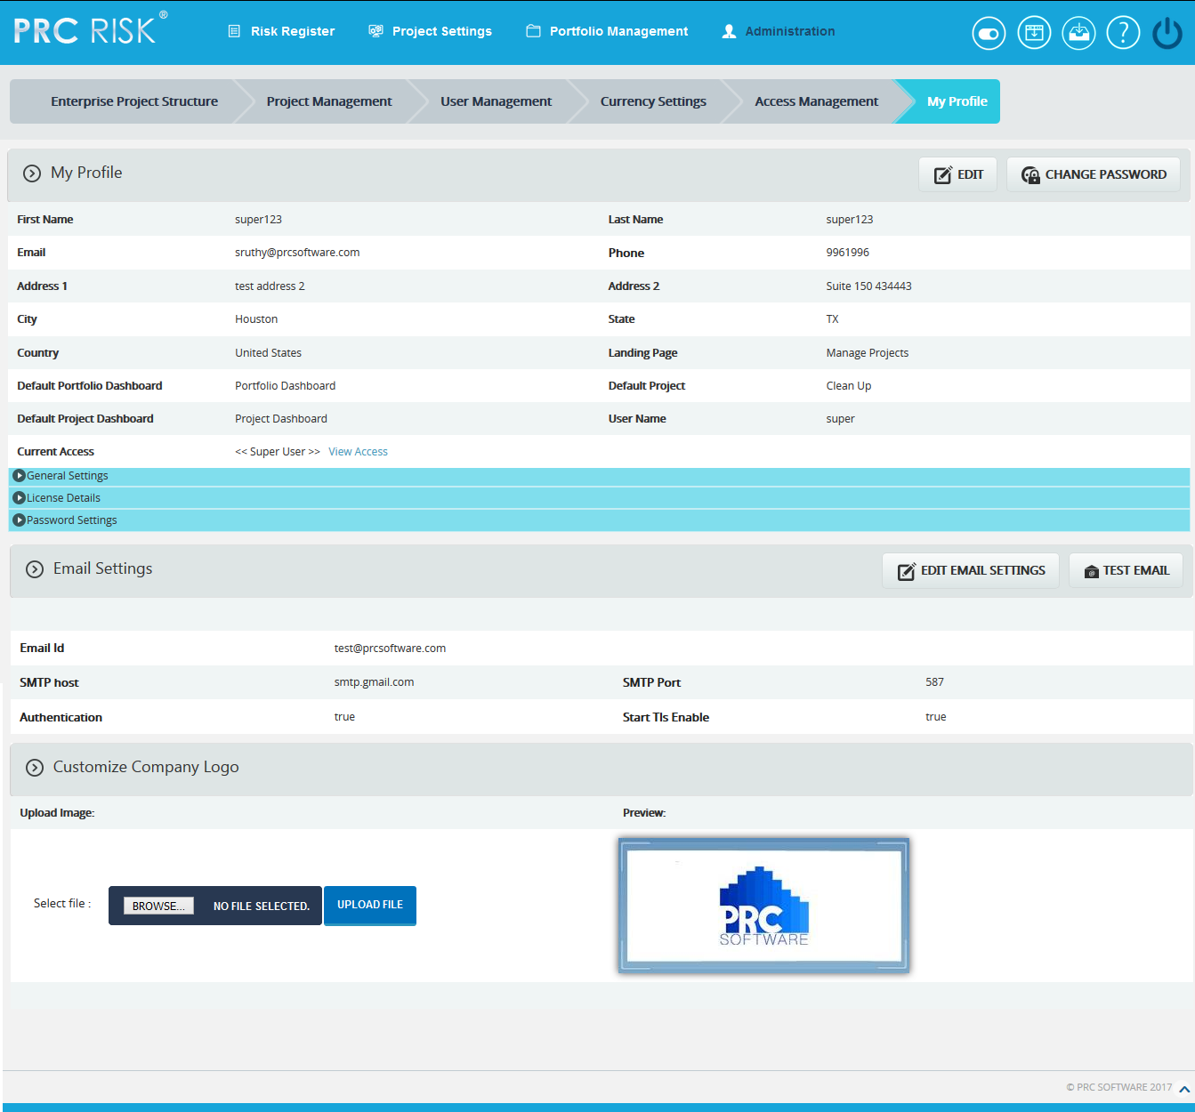
Figure 1

Edit User Account:
This functionality is used to edit the user details. In the user details section only the fields Landing Page and Default Project are unlocked. The Landing Page is used to set the first page the user sees upon login. Default Project is the project which will be selected when the Risk Register menu or Project Settings menu is selected. Under the General Settings section, there is a dropdown where the user can select the date format. The Application Timeout field indicates the session log-out time. This field is visible only to the Super User. (Figure 1)
To Edit User Account, check the following steps described below.
Steps:
- Administration ---> My Profile
- Click the EDIT button. (Figure 1)
- Modify the necessary fields, click the SAVE USER button to finish. (Figure 1)

View Access:
This functionality is used to view the accesses assigned to the user. To view the access, click View Access. (Figure 1) A pop up appears which shows the accesses for each page. (Figure 2)
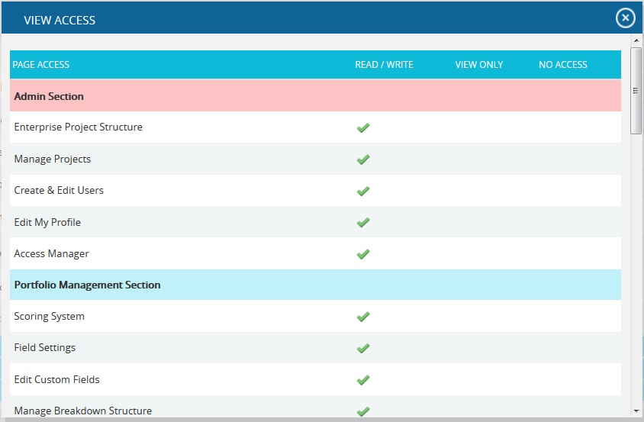
Figure 2

Change Password:
This functionality is used to change the password of the logged-in user.
Steps:
- Administration ---> My Profile
- Click the CHANGE PASSWORD button. (Figure 1) A pop up appears. (Figure 3)
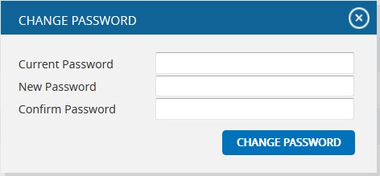
- Enter the Current Password, New Password and Confirm Password and click the Change Password button to finish. (Figure 3)

Figure 3

General Settings:
This functionality is used to set the default parameters for application. With the exception of the date format, all other settings will only be visible to the Super User. (Figure 4)
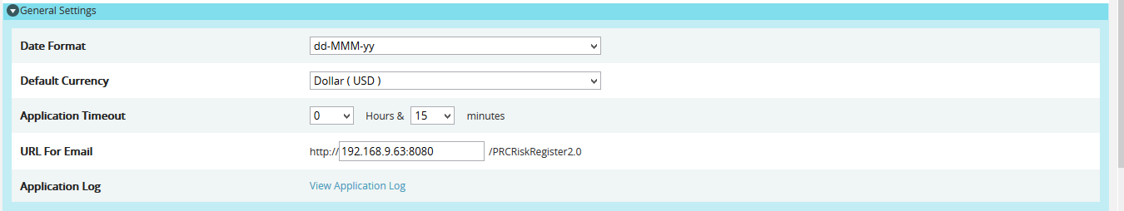
Figure 4

Date Format:
The logged-in user can change the Date format for the application.

Default Currency:
The Super User can set the Default Currency for the application.

Application Timeout:
The Super User can set the Default time-out of the application.

URL for Email:
The Super User can set the application URL which will be enclosed in the email. (Figure 5)
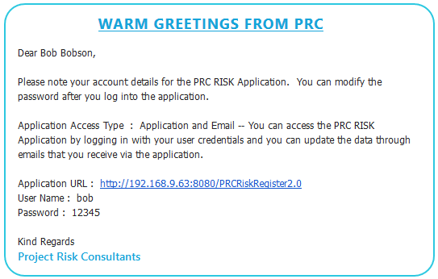
Figure 5
Application Log:
The Super User can trace out the users logged into the application and operations done by the user. Also possible to view the exception log if any exception occurred in users log in. The Super User can download the admin logs & exception logs as single folder in zip file format or as a text file of each log.

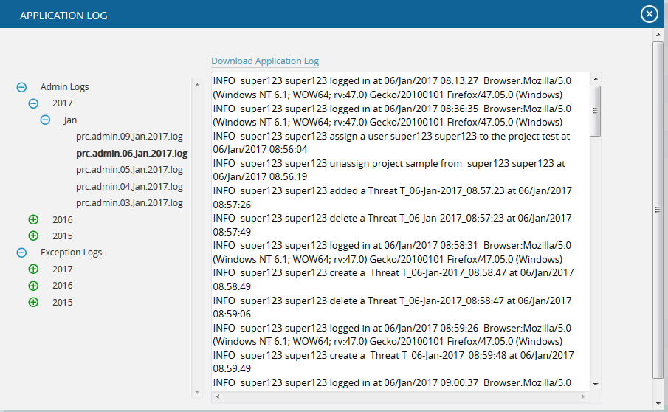
Figure 6

Password Settings:
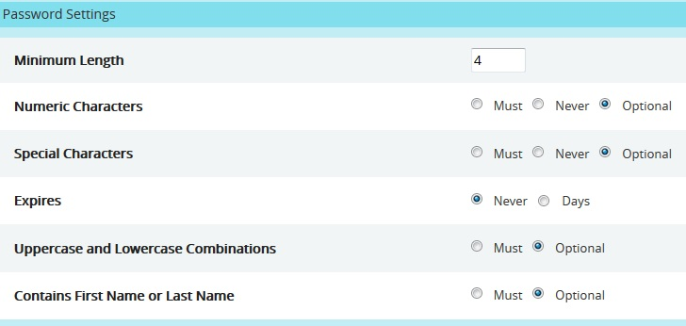
This functionality is used to set the password settings for the application. This section will only be visible for the Super User. Here the Super User can set the minimum password length, the numeric characters and special characters, the expiry period for the password, etc. (Figure 7)
Figure 7
If the Days radio button is selected for the expiry period, then a textbox will appear where can enter the number of days for the password expiry (Figure 8). And according to the entered period an alert mail will be sent to Super User before the password expires.
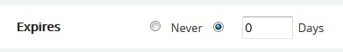
Figure 8

Email Settings:
The Email Settings section is used to set the sender’s email details, phone, the SMTP host used to send the mail, and SMTP port. This section is only visible to the Super User.

Edit Email Settings:
This functionality is used to edit the email settings details.
Steps:
- Administration ---> My Profile
- Click the EDIT EMAIL SETTINGS button. (Figure 1)
- Modify the required fields, and click the SAVE button to finish. (Figure 1)

Test Mail:
This functionality is used to send a test mail to the user whose email ID is specified in the Email Id field.
Steps:
- Administration ---> My Profile
- Click the TEST EMAIL button. A pop up appears. (Figure 9)
- Enter the details and click the SEND EMAIL button to send the email. (Figure 9)

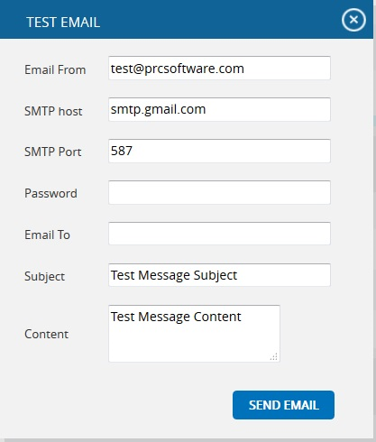

Figure 9

Company Logo:
This functionality is used to upload the Company Logo. Images of type jpg, gif, png, tif, can be uploaded.
Steps:
- Administration ---> My Profile
- Click the Browse button. (Figure 10)
- Select the required image and click the UPLOAD FILE button to finish. (Figure 11)
- Click the SAVE LOGO button to save that image as the company logo. (Figure 12)
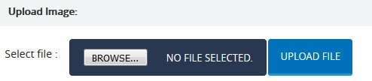
Figure 10
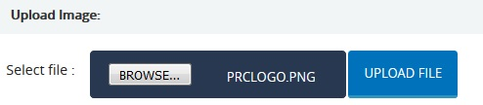
Figure 11
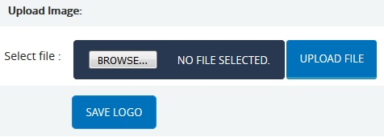
Figure 12

Currency Settings
The Currency Settings page is used to set the desired currency for the PRC application. This page can be viewed or edited only by the Super User.
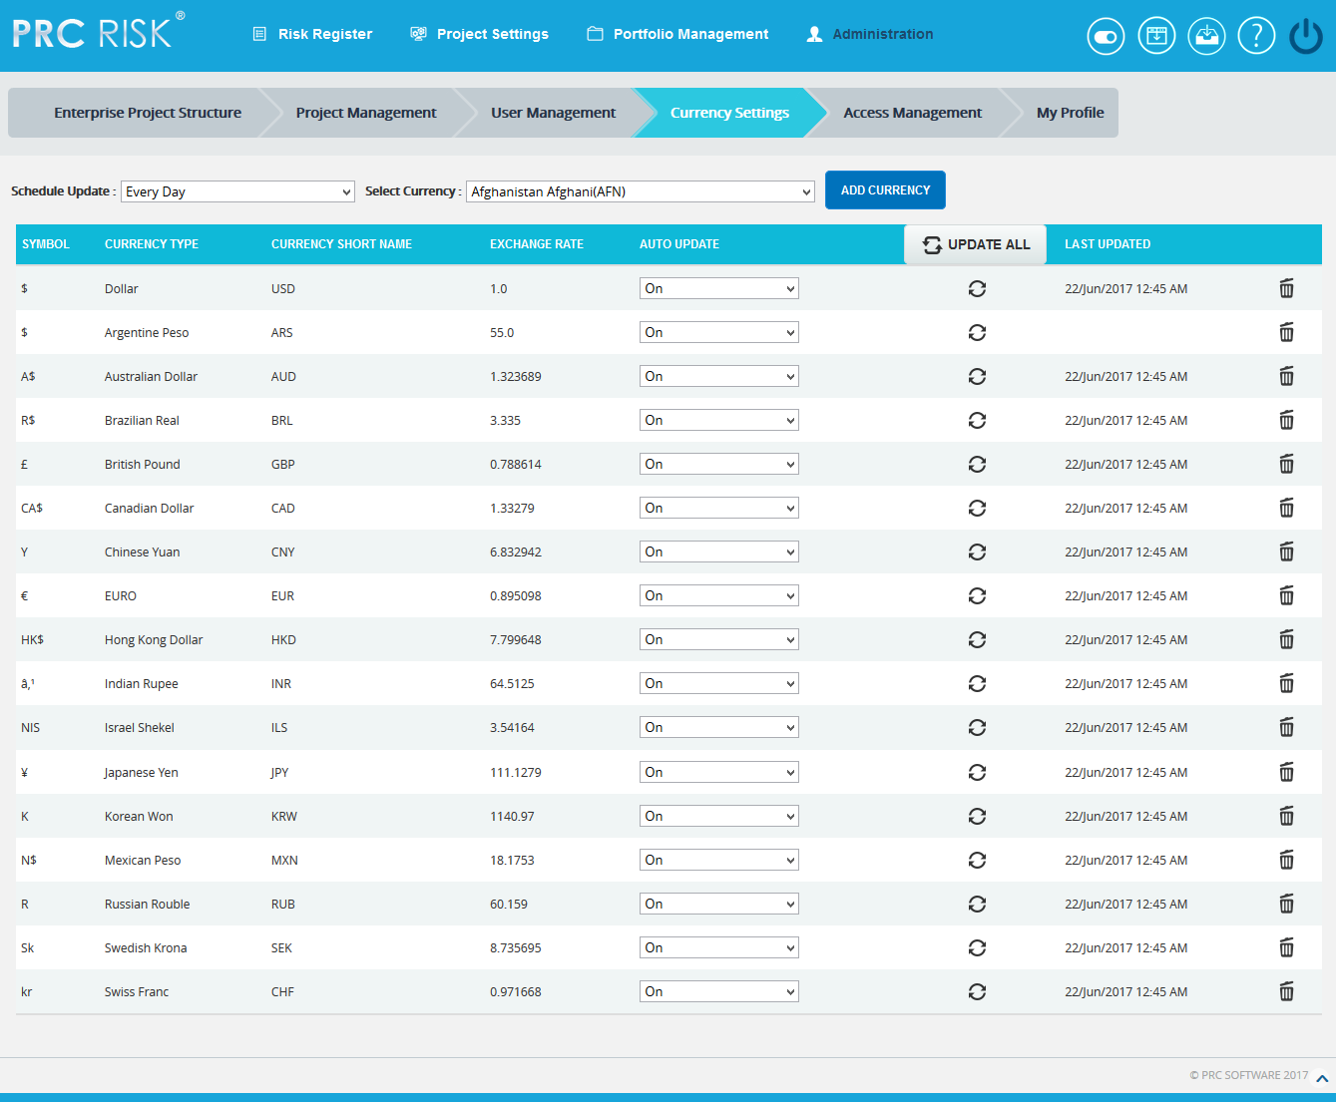
Figure 1

Update All:
The UPDATE ALL button is to update all the currency details added in the application for which the Auto Update is on.
Steps:
- Administration ---> Currency Settings
- Click the UPDATE ALL button to update all the currency details. (Figure 1)

Update:
The Update icon is used to update each currency details separately, for which the Auto Update is on.
Steps:
- Administration ---> Currency Settings
- Click the Update icon to update each currency details separately. (Figure 1)
Save Rates:
The SAVE RATES button is to save the currency exchange rate changes done by the user for which the Auto Update is off. (Figure 2)
Steps:
- Administration ---> Currency Settings
- Edit the currency exchange rate. (Figure 2)
- Click the SAVE RATES button. (Figure 2)
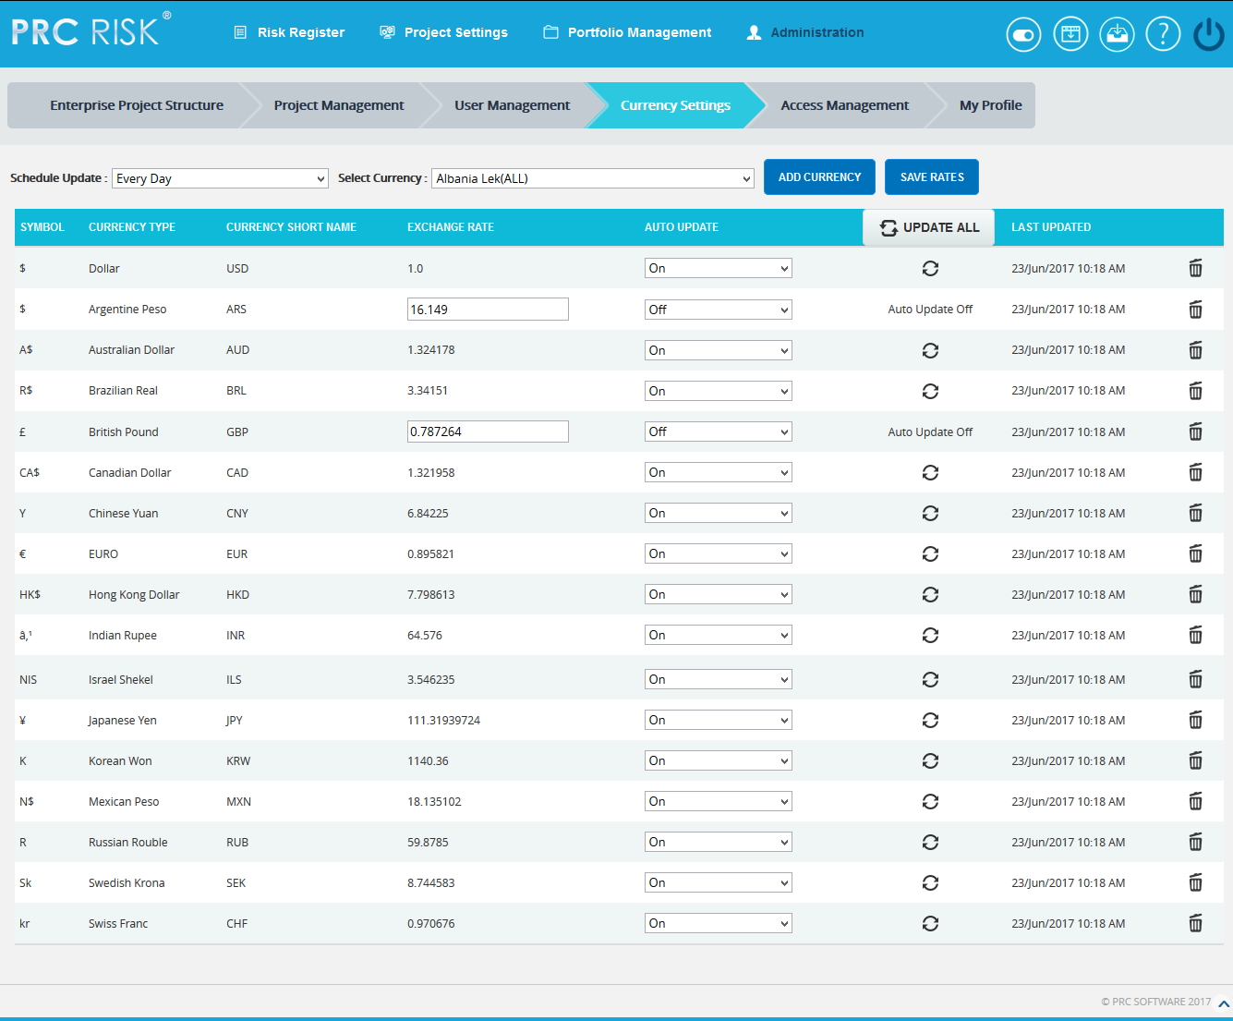
Figure 2
Schedule Update:
The Schedule Update dropdown is to select the time interval when the Currency Settings page should be updated. (Figure 3)
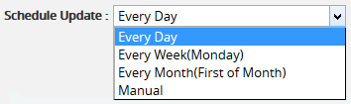
Figure 3

If the Manual option is selected from the dropdown, then the user can change the exchange rates manually for all the currencies as shown in the Figure 4.
Steps:
- Administration ---> Currency Settings
- Edit the currency exchange rate. (Figure 4)
- Click the SAVE RATES button. (Figure 4)
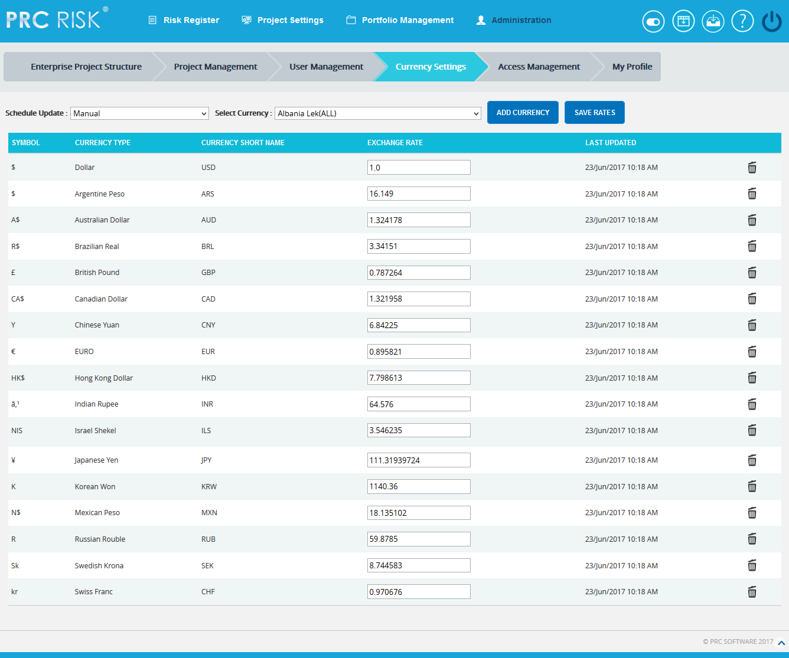
Figure 4

Add Currency:
This functionality is used to add a currency details to the application.
Steps:
- Administration ---> Currency Settings
- Click the Select Currency dropdown that shows the list of currencies in alphabetical order as in http://openexchangerates.org/api/currencies.json link. (Figure 1)
- Select the currency to be added in the application. (Figure 5)
- Click the ADD CURRENCY button. (Figure 5)
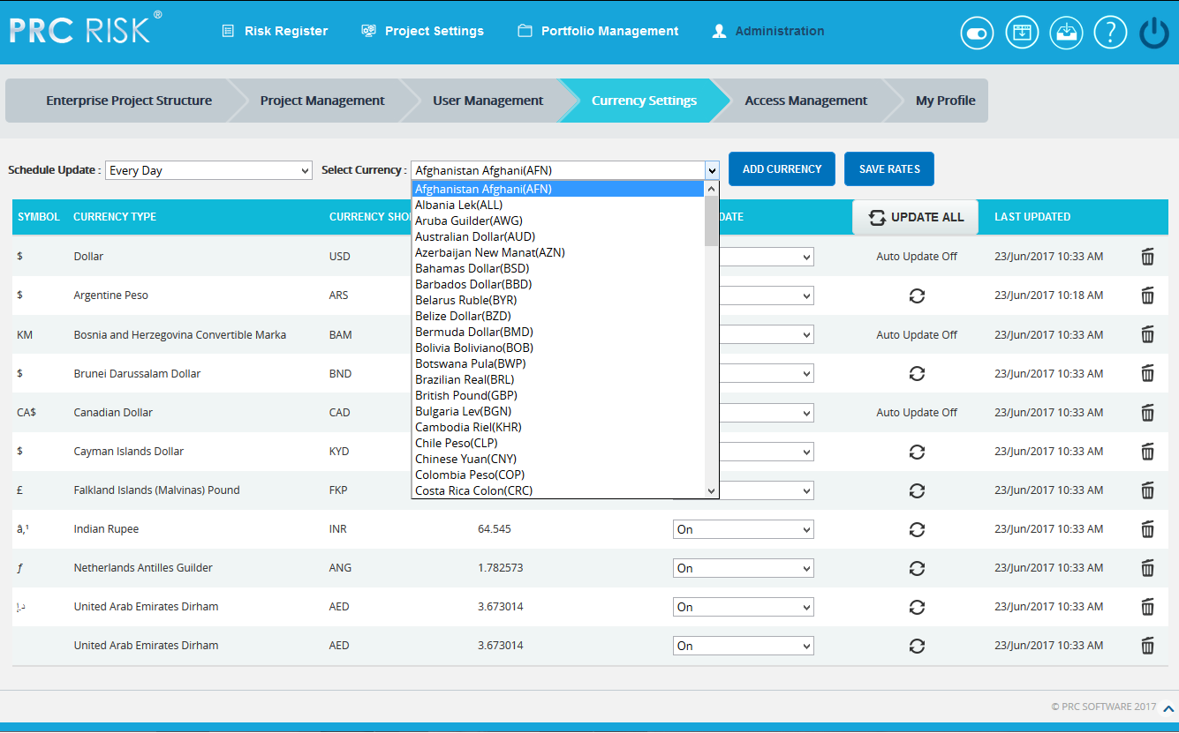
Figure 5

Remove Currency:
This functionality is used to remove currencies from the Currency Settings. While removing each currency, it will automatically add it back to the Select Currency list from where we can add it later if needed. Only the currencies which are not assigned to any of the Projects/ Threats/ Opportunities can be removed.
Steps:
- Administration ---> Currency Settings
- Click Delete icon corresponding to each currency. (Figure 1)

Access Management
The Access Management page is used to set the accesses for the pages in the application. There are three main accesses; Read/Write, View Only and No Access. To modify the data of a particular page the user must be assigned Read/Write access for that page. View Only access to view the page and if the user need not get access to a particular page No Access should be assigned. The Access Management page is visible only to the user who has Read/Write access.
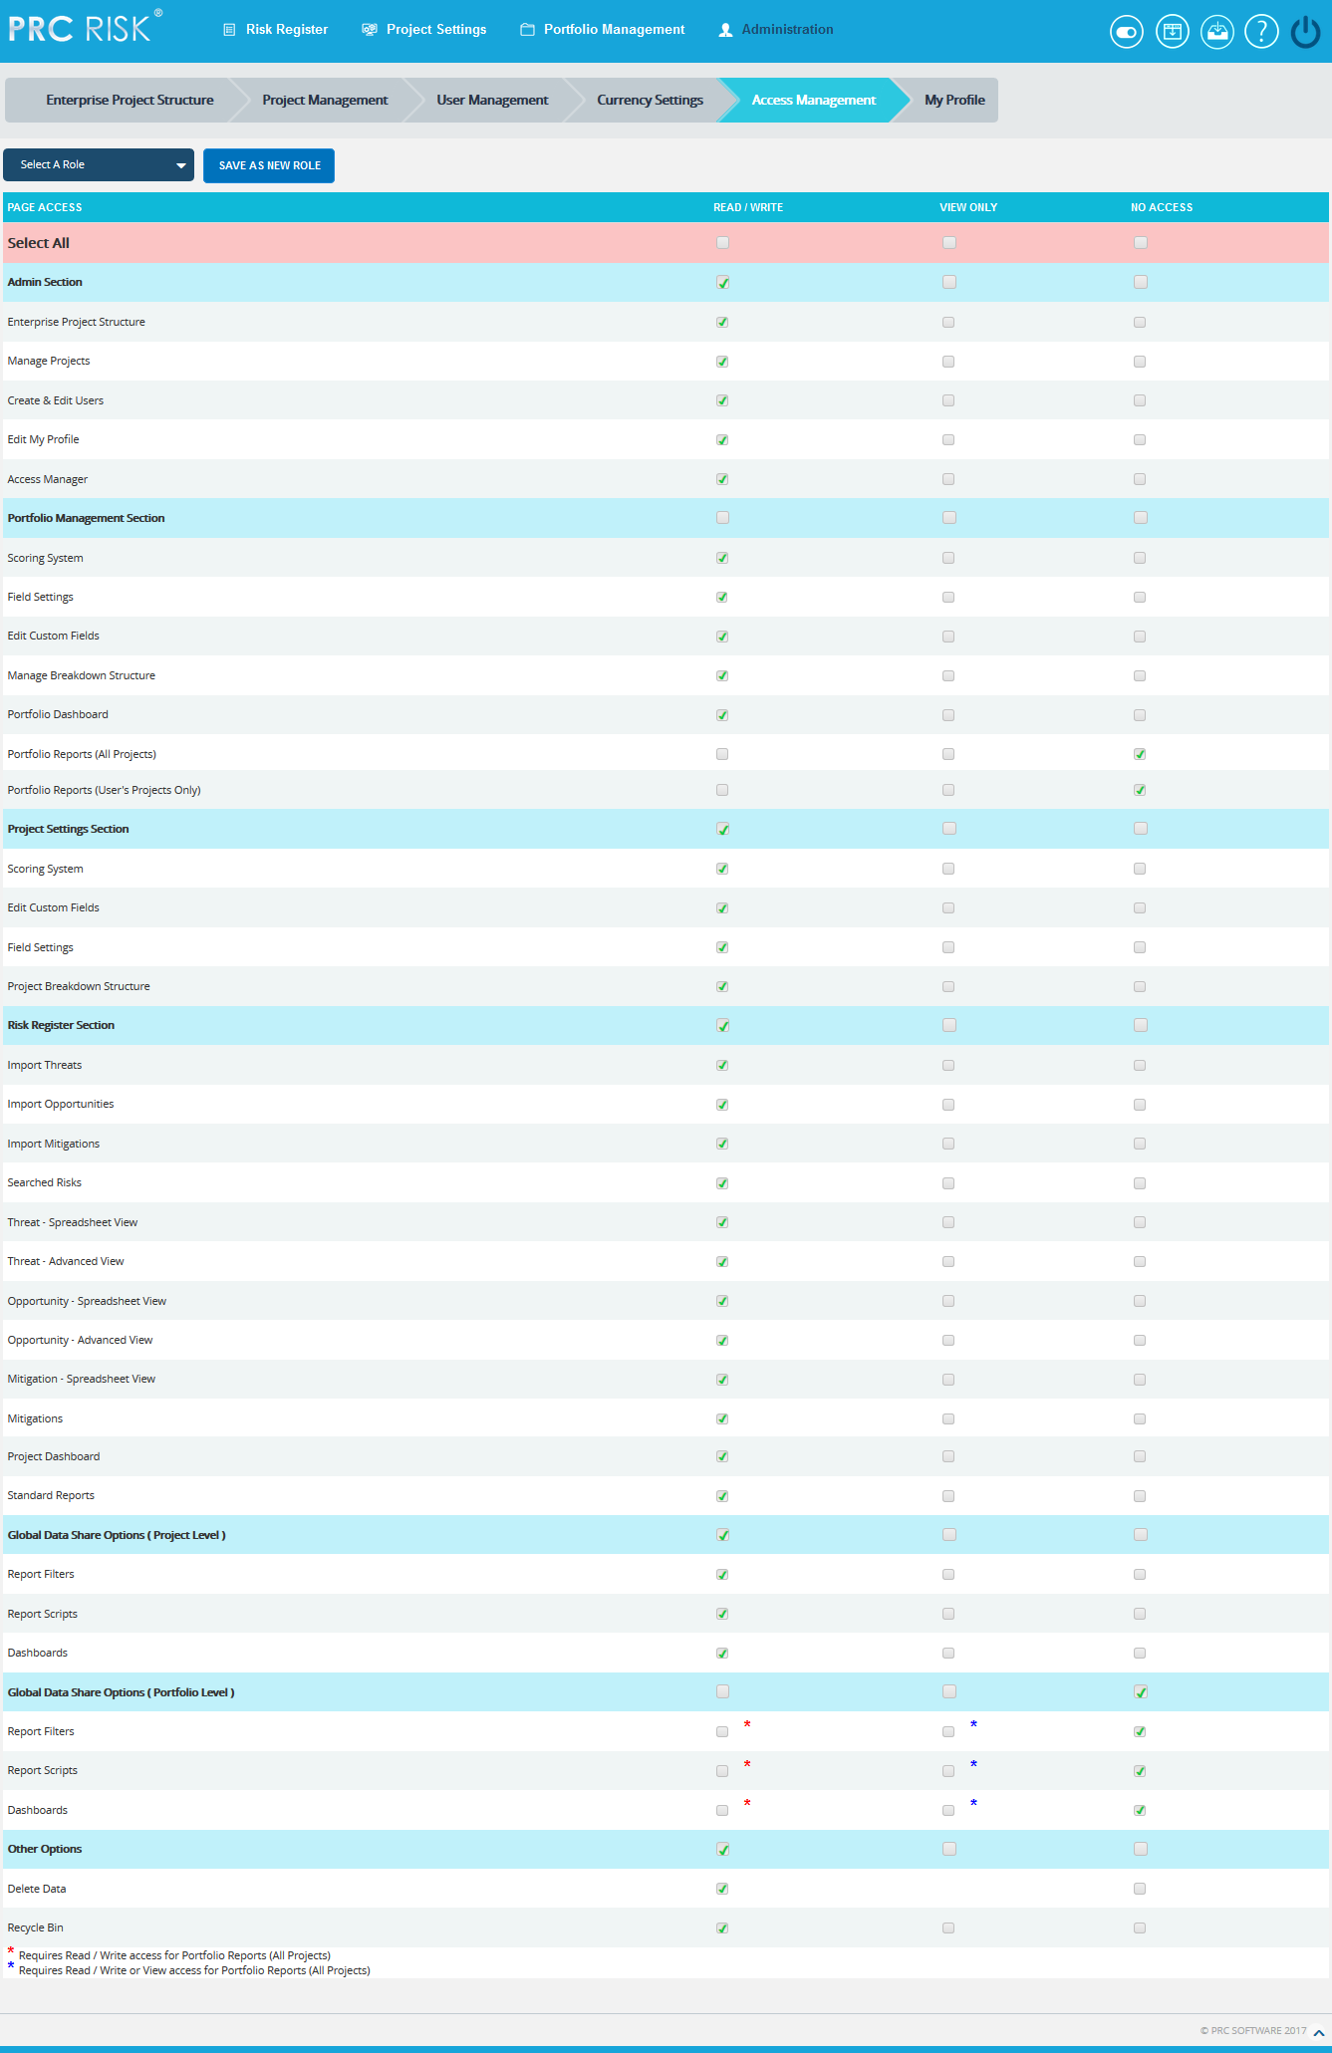
Figure 1
The various roles available can be viewed by selecting them from the Select a Role dropdown. (Figure 1)
The user cannot change the access of the Edit My Profile page. The access for the page will always be Read/Write.

Add A New Role:
This functionality is used to add a new role and assign the various access privileges accordingly.
Steps:
- Administration ---> Access Management
- Check the corresponding checkbox for access. (Figure 1)
- Click the SAVE AS NEW ROLE button. (Figure 1) A pop up appears. (Figure 2)
- Enter the name in the textbox. (Figure 2)
- Click the SAVE button to save. To cancel, click the CANCEL button. (Figure 2)
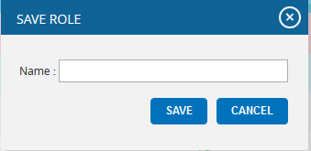
Figure 2

Delete A Role:
This functionality is used to delete a role.
Steps:
- Administration ---> Access Management
- Select a Role to be deleted.
- Click the DELETE ROLE button. (Figure 3) A pop up appears. (Figure 4)
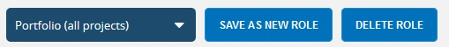
- Click the OK button to delete a role. To cancel, click the Cancel button.

Figure 3
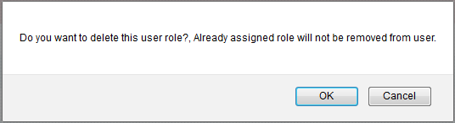

Figure 4

Enterprise Project Structure
The Enterprise Project Structure page allows the user to create a hierarchy which helps to organize projects. The EPS structure is made up of nodes which can represent companies, divisions, or business units. Projects can be assigned to different nodes and may be used for reporting and project assignments to users. Only users with Read/Write access or View access can view this page. Users with Read/Write access can add a new node, rename already existing nodes, remove a node, add a project to a node, promote nodes, demote nodes, and change the order of the nodes. The Super User with Read/Write access can import nodes. Users with View access for the Enterprise Project Structure page can only view the various nodes and projects assigned to it.
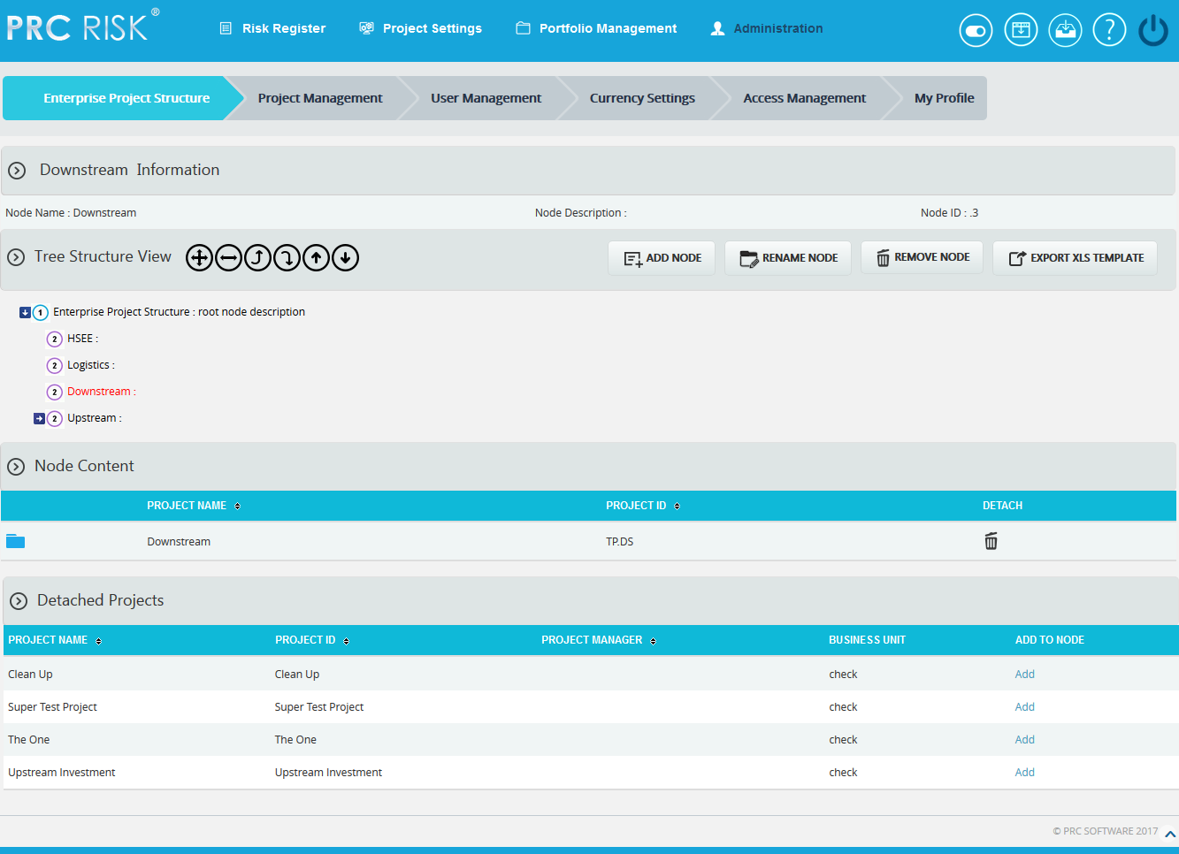
Figure 1

Select Node:
Steps:
- Administration ---> Enterprise Project Structure
- Click on the node shown in the tree structure to select. (Figure 1)

Import EPS:
EPS nodes can be imported only by Super Users and only if the project has not been assigned to any available nodes. The imported file must be of type csv, xls, mpp, xer. Before a file is imported, all nodes except the root node must be deleted in order to accommodate the new nodes.
Steps:
- Administration ---> Enterprise Project Structure
- Click the IMPORT EPS button. A pop up appears. (Figure 2)
- Click the BROWSE button. Select the required file. (Figure 2)
- Click the UPLOAD FILE button to finish. (Figure 2)

Sample sheet used for import:
WBS code | Description | Outline Level
A | ABC123 | 1
B | ABC124 | 2
C | ABC125 | 2
Table 1
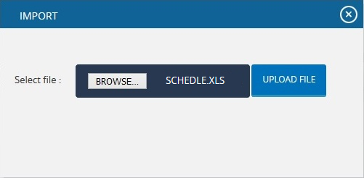
Figure 2

Export XLS template:
This functionality is used to get a sample xls file for importing to the breakdown structures.
Steps:
- Administration ---> Enterprise Project Structure
- Click the EXPORT XLS TEMPLATE button. User will get a sample template on excel. (Figure 3)
Sample excel template:
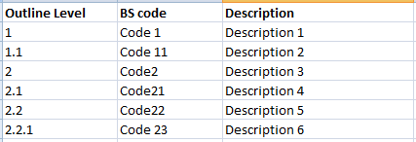
Figure 3

Add EPS Node:
This functionality is used to add a new EPS node.
Steps:
- Administration ---> Enterprise Project Structure
- Select a node.
- Click the ADD NODE button. (Figure 1) A pop up appears. (Figure 4)
- Enter the node name and description.
- Click the SAVE button to save the details. (Figure 4)
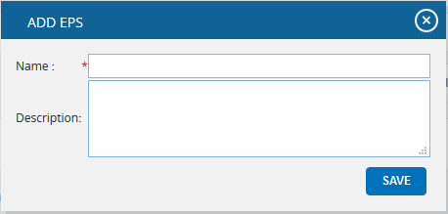
Figure 4

Remove EPS node:
This functionality removes an existing EPS node.
Steps:
- Administration ---> Enterprise Project Structure
- Select a node.
- Click the REMOVE NODE button. (Figure 1) After receiving the confirmation message, click the OK button. The node is removed from the system.

Rename EPS node:
This functionality is used to rename an existing node.
Steps:
- Administration ---> Enterprise Project Structure
- Select a node.
- Click the RENAME NODE button. (Figure 1) A pop up appears. (Figure 4)
- Rename the fields needed.
- Click the SAVE button to save the details. (Figure 4)

Add Projects to node:
This functionality is used to add a project to a selected node.
Steps:
- Administration ---> Enterprise Project Structure
- Select a node.
- Click Add under Detached Projects section to add the project to the node. (Figure 1)

Detach Project:
This functionality is used to detach the project assigned to a node.
Steps:
- Administration ---> Enterprise Project Structure
- Select a node.
- Click the Delete icon under Node Content section to detach the project. (Figure 1) After you receive the confirmation message, click the OK button. The project will be unassigned for the node.

Expand EPS nodes:
This functionality is used to expand all the nodes under enterprise project structure.
Steps:
- Administration ---> Enterprise Project Structure
- Select a node.
- Click the Expand All icon to expand all the nodes. (Figure 5) Upon Expansion, the tree structure becomes like that shown in Figure 6.

Collapse EPS Nodes:
This functionality is used to collapse the expanded nodes shown in Figure 6.
Steps:
- Administration ---> Enterprise Project Structure
- Select a node.
- Click the Collapse all icon shown in Figure 6.
- The Nodes are collapsed and the tree structure becomes like that shown in Figure 5.
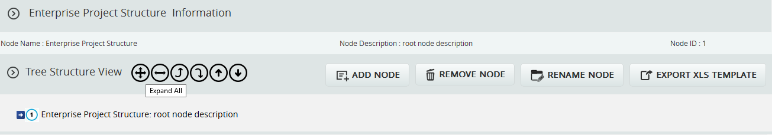
Figure 5
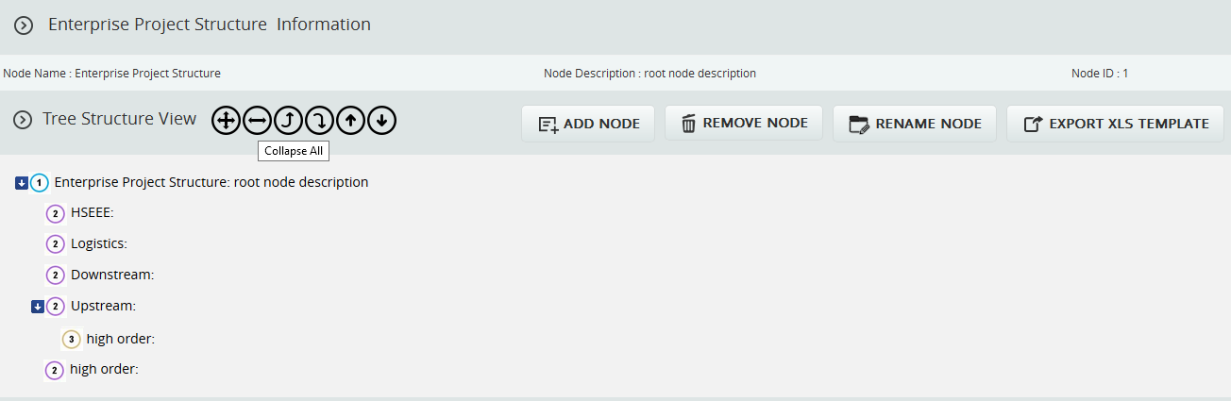
Figure 6

Promote EPS nodes:
This functionality makes the level of the child node the same as that of the immediate parent. For Example, consider the node eps6: desc6 (Figure 7) which is a child of the node Upstream: desc4. When promoted, eps6: desc6 is on the same level as Upstream: desc4 (Figure 8). A node cannot be promoted if it does not have a parent. For example, the Root node cannot be promoted.
Steps:
- Administration ---> Enterprise Project Structure
- Select a node.
- Click the Promote icon to promote the node.
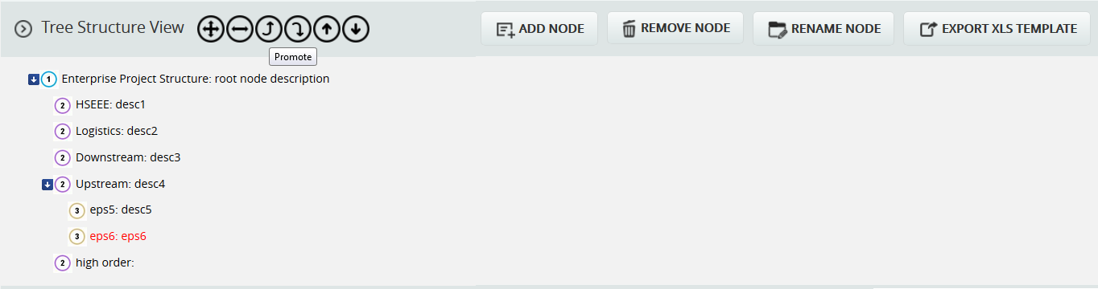
Figure 7
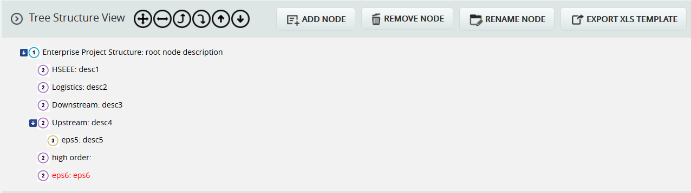
Figure 8

Demote EPS nodes:
When a node is demoted it becomes the child of the node which is of same level and which lies just above it. For Example, Consider node eps6: desc6. (Figure 8) which is of same level as nodes high order: etc. When eps6: desc6 is demoted, it becomes a child node of the node high order: (Figure 9). A node cannot be demoted if there is no other node of same level as the node selected.
Steps:
- Administration ---> Enterprise Project Structure
- Select a node.
- Click the Demote icon to demote node.
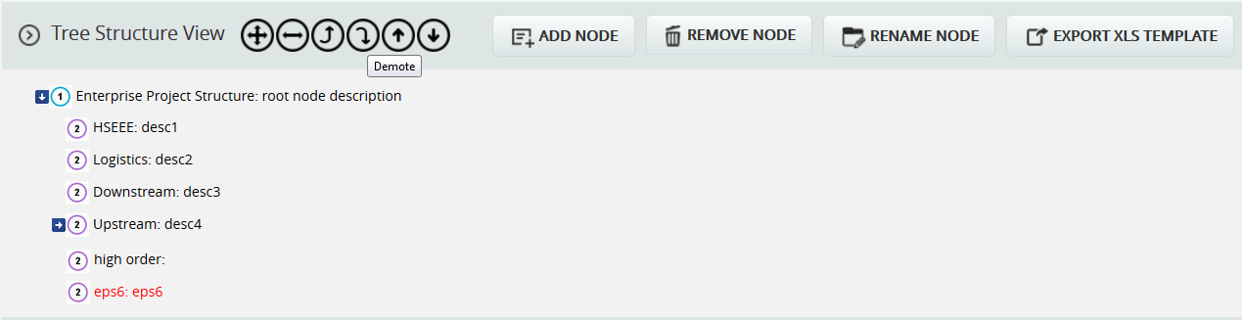
Figure 9

Up Order:
This operation is used to move a node up the tree. This can be applied only to nodes of the same level and this operation is not applicable for the first node. For example, consider the nodes Downstream: desc3 and Logistic: desc2 in Figure 9. The node Downstream: desc3 is located below the node Logistic: desc2. When an up order operation is applied to the node design it moves above the node Logistic: desc2. Figure 10 shows the tree structure after the up order operation is applied.
Steps:
- Administration ---> Enterprise Project Structure
- Select a node.
- Click the Up Order icon to move the node up a level.
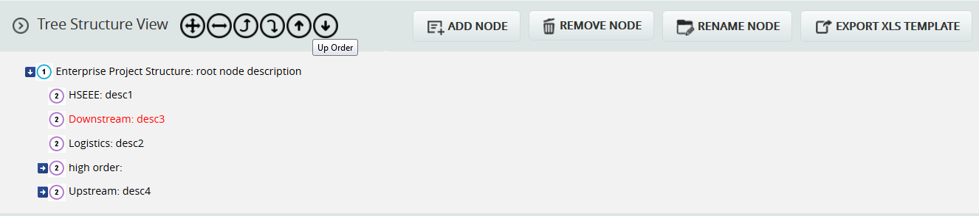
Figure 10

Down Order:
This operation is used to move a node down the tree structure. This can be applied only to nodes of the same level and this operation is not applicable for the last node. For example, consider nodes Downstream: desc3 and Logistic: desc2 in Figure 10. Downstream: desc3 is located above Logistic: desc2 in Figure 10. When down order operation is applied to the node Downstream: desc3, it comes below the node eps 14: desc 14, refer Figure 11 which shows the tree structure after down order operation is applied.
Steps:
- Administration ---> Enterprise Project Structure
- Select a node.
- Click the Down Order icon to move the node down a level.
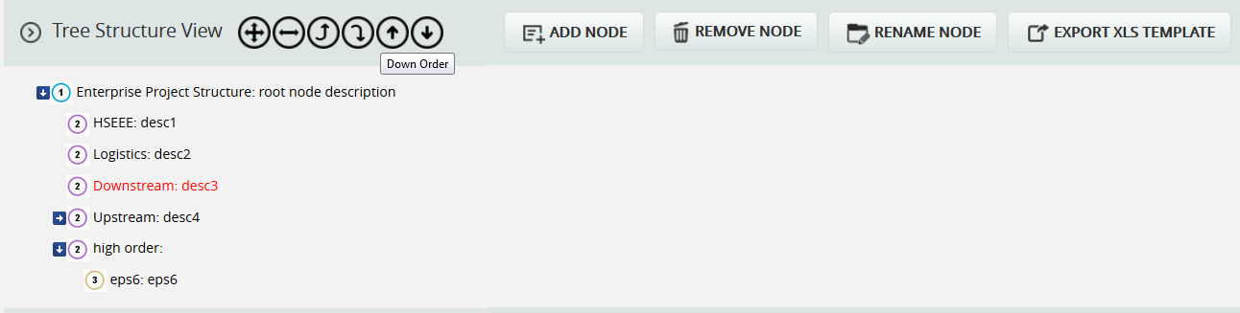
Figure 11

PORTFOLIO MANAGEMENT

Scoring System (Portfolio)
The Scoring System page allows you to create a scoring system template for both Threats and Opportunities separately that can be applied to your project. These templates are saved in the system and can be reused for future projects. The Scoring System Template page in the PRC Enterprise Risk Register can be viewed only by those users who have either Read/Write or View access. Users with only Read/Write access can create a new template, edit template information, edit probability and tolerance levels, edit impacts, edit risk matrix, add new impacts and delete additional impacts.
Users designated with View Access may view templates, view probability and tolerance levels, view impacts and also view the risk matrix.

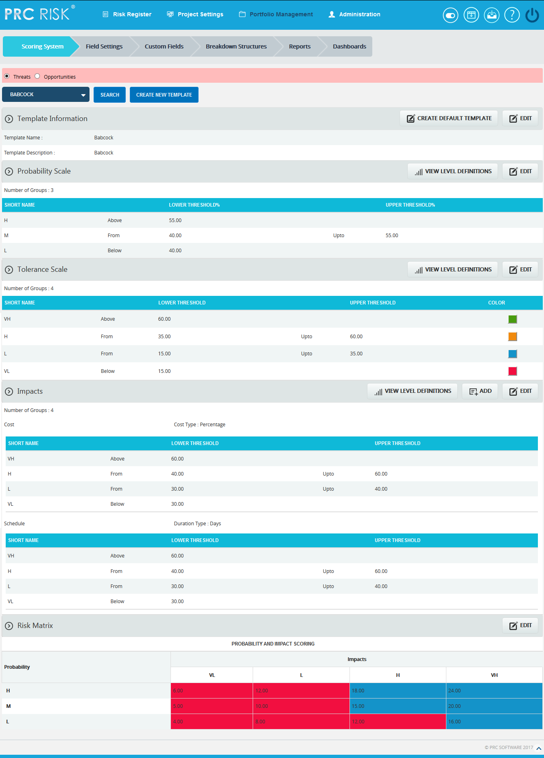
Figure 1
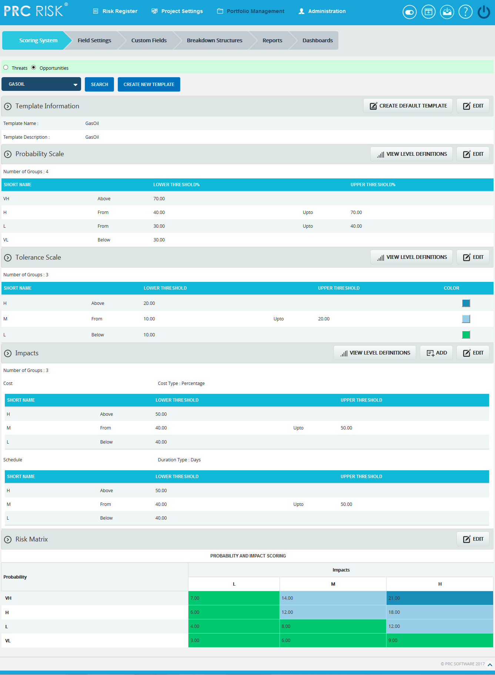
Figure 2

Searching For Templates:
Searching for templates in the Scoring System can be done in two ways. The Search function allows the user to search for a template based on a keyword. This method is faster when you are working with large amounts of data. The Select function is commonly used for databases with less data and when the search objective is known.
Using the search function:
Steps:
- Portfolio Management --->Scoring System (Threats/Opportunities)
- Click the SEARCH button. (Figure 1) or (Figure 2)
- Enter the search keyword (which can be the Template Name or Template Description). Click the SEARCH button and select the required template. (Figure 3)
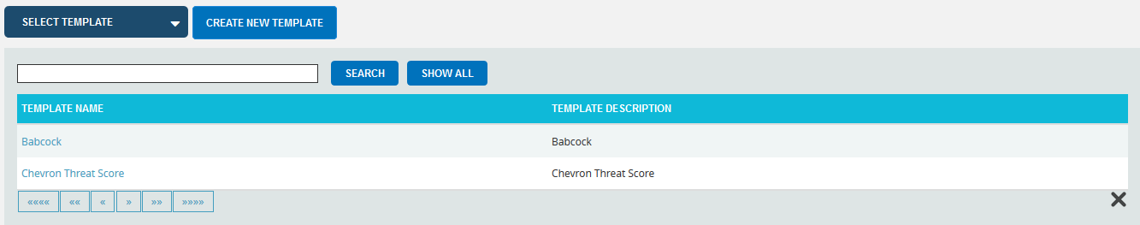
Figure 3
The SHOW ALL button in the search area lists all the templates available (By default).
Using the Select Function (dropdown list):
Steps:
- Portfolio Management --->Scoring System (Threats/Opportunities)
- Click the Select Template dropdown. (Figure 1) or (Figure 2)
- Select the required template from the list shown.

Creating a new template:
Creating a new template is quick and easy. The Template Name is a required field to save the template.
Steps:
- Portfolio Management --->Scoring System (Threats/Opportunities)
- Click the CREATE NEW TEMPLATE button. (Figure 1) or (Figure 2)
- After entering template details, click the SAVE button.

Creating default template:
This functionality is used to create a Master Template. Only once the default template can be created and is done by Super User.
Steps:
- Portfolio Management --->Scoring System (Threats/Opportunities).
- Click the CREATE DEFAULT TEMPLATE button. (Figure 1) or (Figure 2)
- After entering template details, click the SAVE button.

View Default Template:
To view the Master Template, click the View Default Template button. (Figure 1) or (Figure 2)

View Level Definitions:
To view probability and tolerance levels, click the VIEW LEVEL DEFINITIONS button shown in the Probability & Tolerance Scales section. (Figure 1) or (Figure 2) A pop up shown in Figure 4 appears. If the Level Definitions have been modified, click the SAVE button to save the changes.
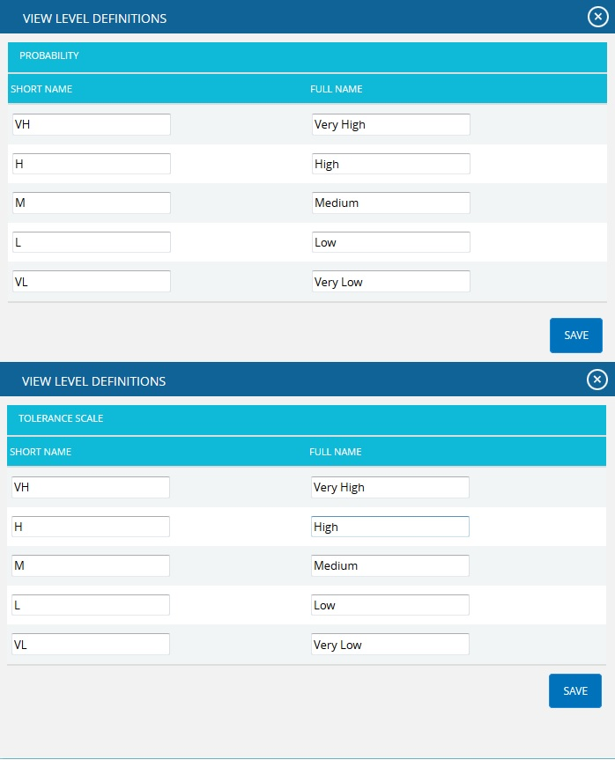
Figure 4
To view impact levels, click the VIEW LEVEL DEFINITIONS button shown in the Impacts section. (Figure 1) or (Figure 2) A pop up appears (Figure 5). If the checkbox for Apply full name to all Impacts is checked, the current full name is applied to cost, schedule and additional impacts. This name can be viewed in the score section’s impact dropdown while adding the risk details. Click the SAVE button to save any modifications to the View Level Definitions.
If the checkbox is not checked, click the NEXT button in Figure 5. A pop up appears. (Figure 6) The modifications to cost, schedule and additional impacts can be done individually and click the SAVE button. (Figure 6)
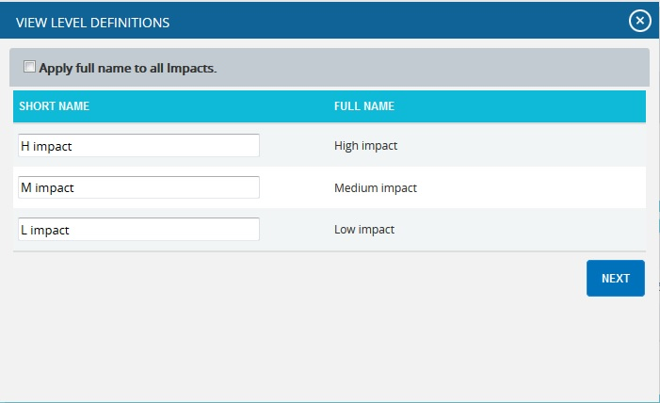
Figure 5
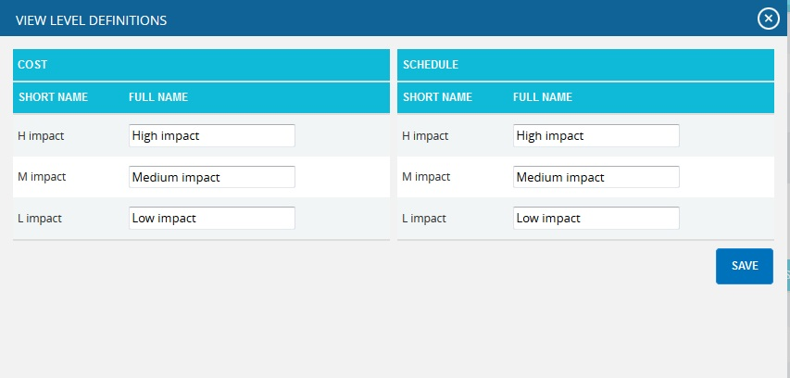
Figure 6

Edit Template Information:
While editing the details of a template, the fields Template Name and Template Description will be unlocked.
Steps:
- Portfolio Management --->Scoring System (Threats/Opportunities)
- Select the required template.
- Click the EDIT button. (Figure 1) or (Figure 2)
- After the data is modified, click the SAVE button.

Edit Probability & Tolerance:
While editing Probability & Tolerance fields such as Number of Groups, Lower Threshold, and Upper Threshold, the color is unlocked.
Steps:
- Portfolio Management --->Scoring System Template (Threats/Opportunities).
- Select the required template.
- Click the EDIT button under Probability & Tolerance. (Figure 1) or (Figure 2)
- After the data is modified, click the SAVE button.
The color is set by clicking on the corresponding color shown beside each field. An example of the color picker is displayed in Figure 7.
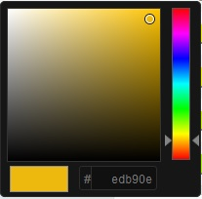
Figure 7

Edit Impacts:
While editing Impacts fields such as Number of Groups, Lower Threshold, Upper Threshold and Duration Type; Name and Description of Additional Impact are unlocked.

Cost Type:
The Cost Type has values Percentage and Currency, where Cost is the default value. If the value percentage is selected for duration type, the cost values will be expressed in the corresponding percentage of total cost of project. For currency, the cost values remain unchanged. These changes are visible only when the corresponding template is assigned to the project.

Duration Type for Schedule:
The Duration Type field for schedule has values: Days, Weeks, Months, Year and Percentage. The default value is Days. If Percentage is selected, the Schedule value will be converted to the percentage of the Number of days between start and end date of a project. These changes are visible only when the corresponding template is assigned to the project.
Steps:
- Portfolio Management --->Scoring System Template (Threats/Opportunities).
- Select the required template.
- Click the EDIT button under Impacts section. (Figure 1) or (Figure 2)
- After the data is modified, click the SAVE button.

Add New Impact:
This functionality is used to add new additional impact.
Steps:
- Portfolio Management --->Scoring System Template (Threats/Opportunities).
- Select the required template.
- Click the ADD button under Impacts section to add new impact. (Figure 1) or (Figure 2)
- After entering the details, click the SAVE button. (Figure 8)

Delete Impacts:
This functionality is used to delete additional impacts. Additional impacts can be deleted only by those users who have Read/Write access for delete.
Steps:
- Portfolio Management --->Scoring System Template (Threats/Opportunities).
- Select the required template.
- Click the Close icon to delete additional Impacts.

Edit Risk Matrix:
This section allows you to define the scores based on the Probability and Impact position.
Steps:
- Portfolio Management --->Scoring System Template (Threats/Opportunities).
- Select the required template.
- Click the EDIT button under Risk Matrix. (Figure 1) or (Figure 2)
- After the data is modified, click the SAVE button.

Manager’s Dashboard (Portfolio)
The Manager’s Dashboard (Portfolio) page shows up to 6 charts chosen by the user. The charts shown on this page must be created on the Standard Reports page. The Manager’s Dashboard gives the user the ability to quickly view the critical project information and export them to MS Word and MS PowerPoint.
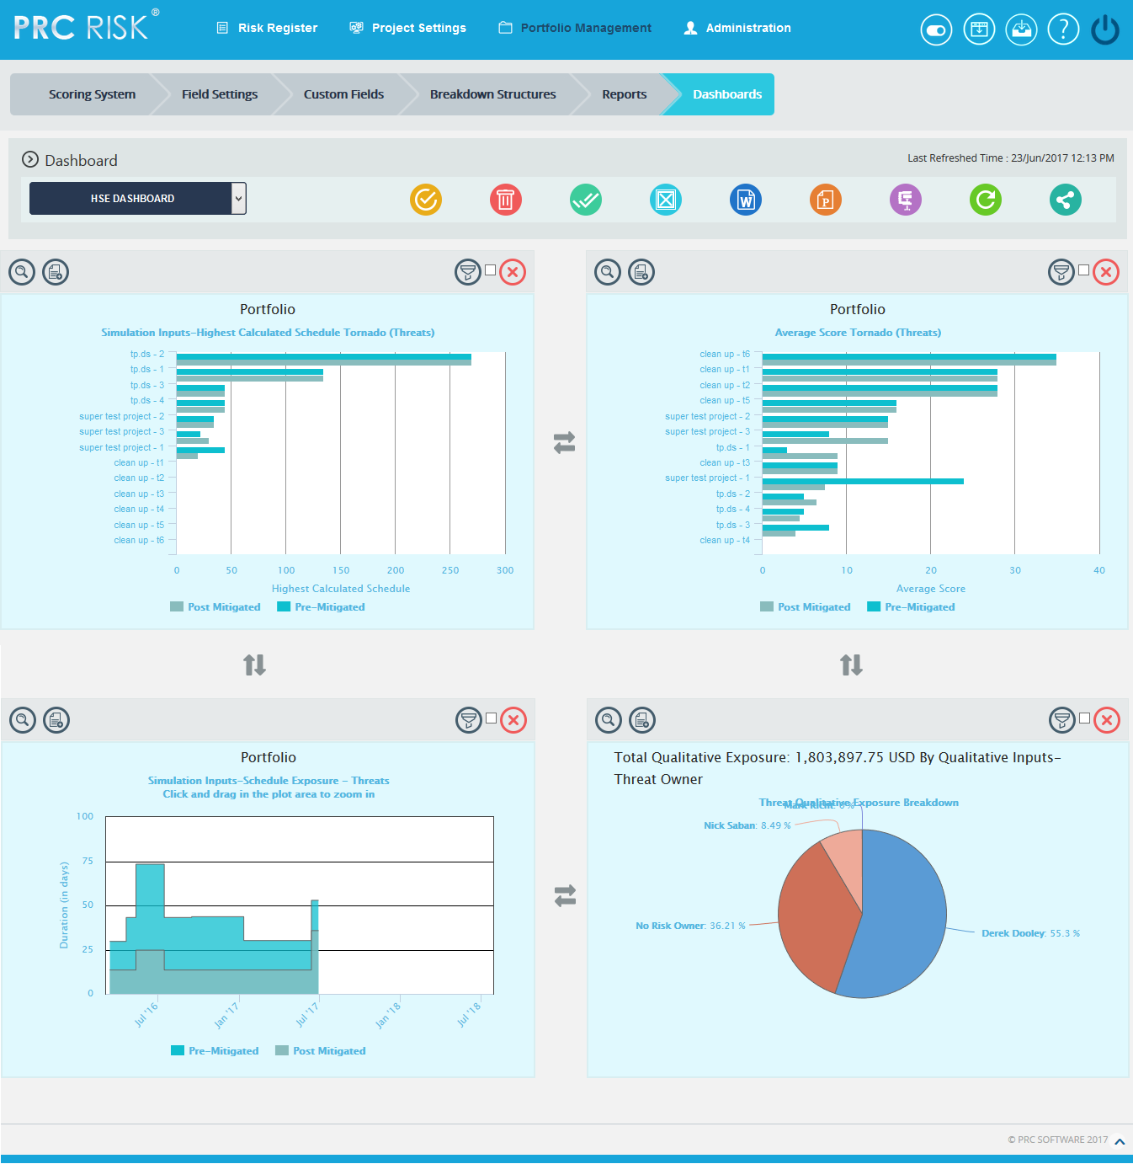
Figure 1

Select Dashboard Dropdown:
This functionality is used to show the corresponding dashboard selected. The dropdown shown in Figure 1 contains dashboard names. Each dashboard name generates the dashboard associated with it.
Steps:
- Portfolio Management —>Dashboards —>Manager’s Dashboard
- Select the dashboard name from the dropdown. (Figure 1)
To navigate to Portfolio Dashboard:
Steps:
- Portfolio Management —>Dashboards —>Manager’s Dashboard
- Select the Portfolio Dashboard from the dropdown. (Figure 1)
Delete Dashboard:
This functionality is used to delete the corresponding dashboard selected from the dropdown.
Steps:
- Portfolio Management —>Dashboards —>Manager’s Dashboard
- Select the Dashboard Name from the Portfolio Dashboard dropdown. (Figure 1)
- Click the Delete button to delete the selected Dashboard. (Figure 1)

Export to Word:
This functionality is used to Export the selected chart to MS Word.
Steps:
- Portfolio Management —>Dashboards —>Manager’s Dashboard
- Select the chart using the provided checkbox in the corner of each chart. (Figure 1)
- Click the Open in Word icon to Export the chart to MS Word. (Figure 1)

Export to PowerPoint:
This functionality is used to Export the selected chart to MS PowerPoint.
Steps:
- Portfolio Management —>Dashboards —>Manager’s Dashboard
- Select the chart using the provided checkbox in the corner of each chart. (Figure 1)
- Click the PowerPoint icon to Export the chart to MS PowerPoint. (Figure 1)

Compress Files:
This functionality is used to compress the selected images to a Zip file.
Steps:
- Portfolio Management —>Dashboards —>Manager’s Dashboard
- Select the chart using the provided checkbox in the corner of each chart. (Figure 1)
- Click the Compress Files icon. (Figure 1)

Check All:
This functionality is used to select all the charts. Click the Check All icon to select all the charts. (Figure 1)
Uncheck All:
This functionality is used to uncheck the selected charts. Click the Uncheck All icon to uncheck the charts selected. (Figure 1)

Set as default:
This functionality is used to make the selected dashboard as the default dashboard. Click the Set as Default icon to set a dashboard as default. (Figure 1)

Refresh:
This functionality is used to refresh the chart with the most recent data from the project database. To refresh the chart, click the Refresh icon. (Figure 1)
Reposition Arrows:
This functionality allows the user to move the selected chart to another position on the page. To reposition a selected chart, click the Reposition arrows nearby. (Figure 1)

Filter:
This functionality allows the user to view the filter applied to the chart. To view filter applied click the Show Filter icon. (Figure 1) An example of the screen which appears after the icon is clicked is shown in Figure 2.
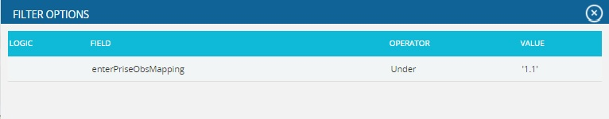
Figure 2
If the user changes the business unit on Manage Projects page for the projects in a particular chart which is already added on the dashboard in which filter is applied, then on clicking the Refresh button, those filters will be removed from the chart.

Delete From Dashboard:
This functionality allows you to delete a chart from the Manager’s Dashboard (Portfolio). To delete a chart, click the Delete icon above each chart. (Figure 1)

Drill Down:
This functionality allows you to redirect to the particular report page in the Standard Reports (Portfolio) from where the chart is added. To redirect a chart, click the Drill Down icon. (Figure 1)

Copy to Dashboard:
This functionality allows you to copy the particular chart to another dashboard. Click the Copy to Dashboard icon.
Steps:
  - Portfolio Management —>Dashboards —>Manager’s Dashboard.
  - Click the Copy to Dashboard icon. (Figure 1)
  - A pop up appears. (Figure 3) Select the name of the dashboard from the Name dropdown, to which the chart has to be copied.
  - Click SAVE button. (Figure 3)

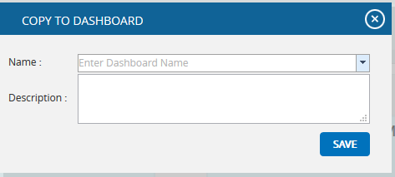
Figure 3

Share Dashboard:
This functionality allows you to share one dashboard chart to a new dashboard. Click the Share Dashboard icon.
Steps:
  - Portfolio Management —>Dashboards —>Manager’s Dashboard.
  - Click the Share Dashboard icon. (Figure 1)
  - A pop up appears. (Figure 4) Give the name and description of the new dashboard to which the chart has to be shared. The Global Access option allows the user to share the dashboard globally.
  - Click SAVE button. (Figure 4)
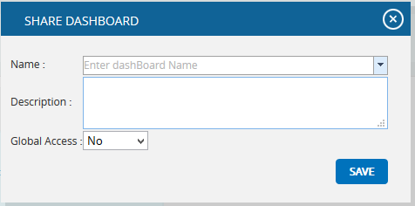
Figure 4

Dashboard (Portfolio)
The Portfolio Dashboard page shows 4 fixed charts: Risk Score Tornado (Threats), Risk Score Tornado (Opportunities), Mitigation Past Due, and Qualitative Inputs-Cost Exposure (Threats). The data shown is from projects across multiple Business Units based on the user’s access level. The Portfolio Dashboard is useful because the user can quickly view the charts most commonly used at the portfolio level. The Portfolio Dashboard page is visible to only those users with Read/Write or View access.
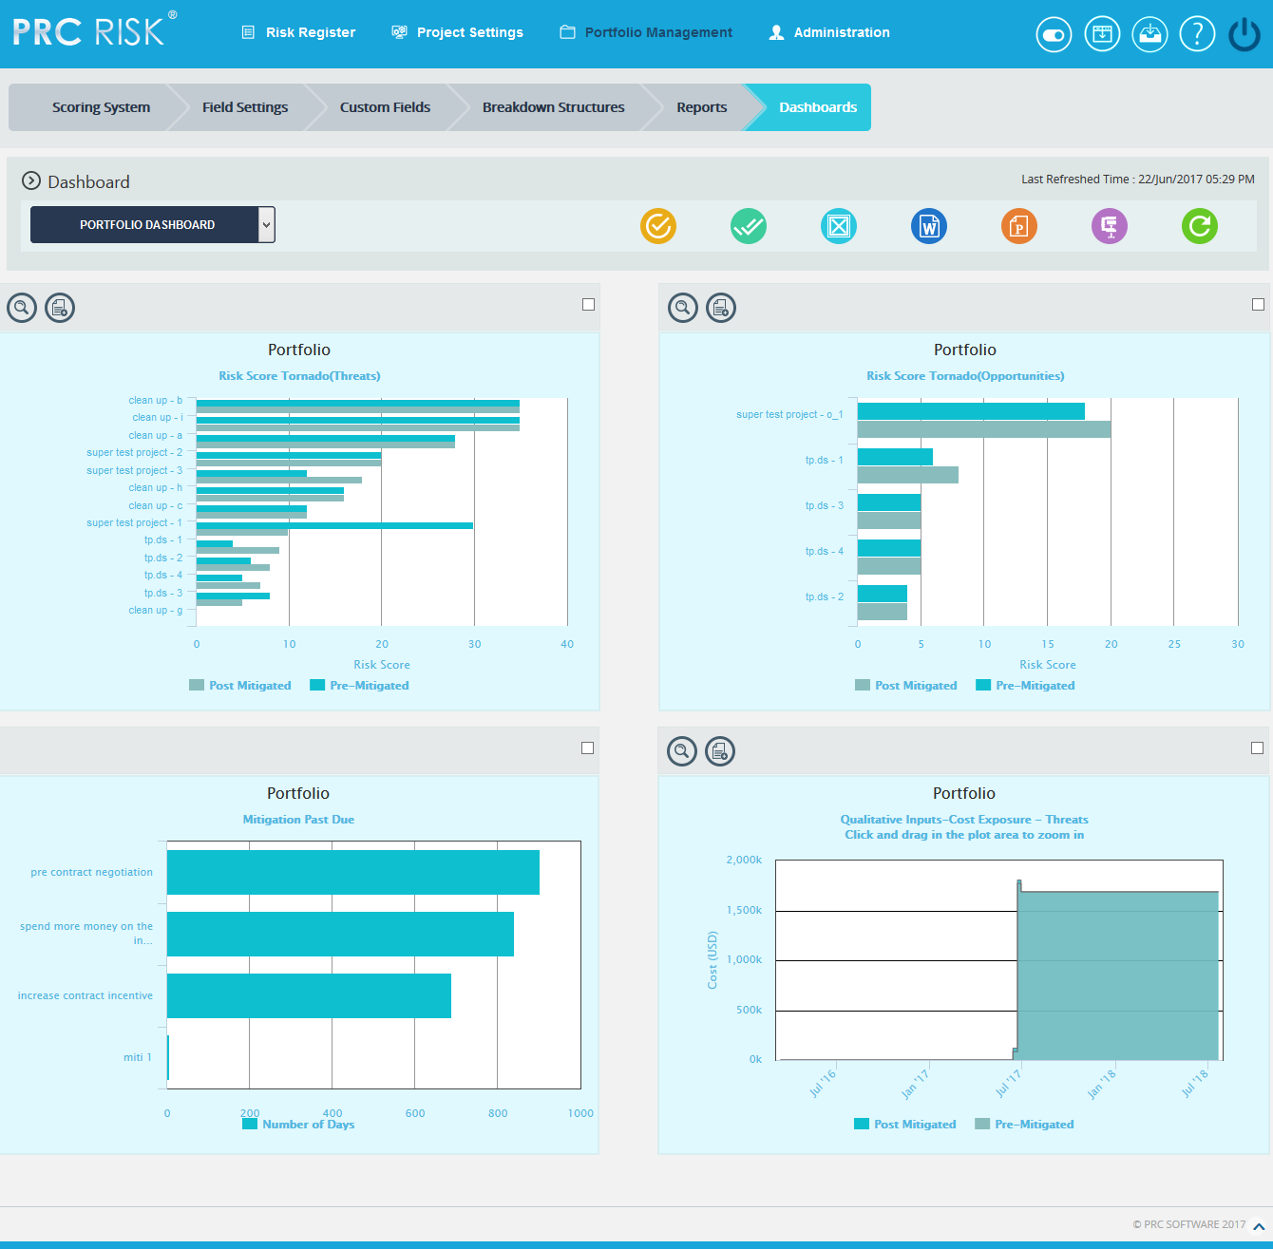
Figure 1

Select Dashboard Dropdown:
This functionality is used to navigate to the Manager's Dashboard (Portfolio) page. The dropdown shown in Figure 1 contains dashboard names. Each dashboard name generates the dashboard associated in the Manager's Dashboard (Portfolio) page.
Steps:
- Portfolio Management ---> Portfolio Dashboards
- Select the dashboard name from the dropdown. (Figure 1)

Export to Word:
This functionality is used to Export the selected chart to MS Word.
Steps:
- Portfolio Management ---> Portfolio Dashboards
- Select the chart using the provided checkbox in the corner of each chart. (Figure 1)
- Click the Open in Word icon to Export the chart to MS Word. (Figure 1)

Export to PowerPoint:
This functionality is used to Export the selected chart to MS Power Point.
Steps:
- Portfolio Management ---> Portfolio Dashboards
- Select the chart using the provided checkbox in the corner of each chart. (Figure 1)
- Click the Power Point icon to Export the chart to MS Power Point. (Figure 1)

Compress Files:
This functionality is used to compress the selected images to a Zip file.
Steps:
- Portfolio Management ---> Portfolio Dashboards
- Select the chart using the provided checkbox in the corner of each chart. (Figure 1)
- Click the Compress Files icon. (Figure 1)

Check All:
This functionality is used to select all the charts in Portfolio Dashboard page. Click the Check All icon to select all the charts. (Figure 1)

Uncheck All:
This functionality is used to uncheck the selected charts. Click the Uncheck All icon to uncheck the charts selected. (Figure 1)

Refresh:
This functionality is used to refresh the chart with the most recent data from the project database. To refresh the chart, click the Refresh icon. (Figure 1)

Set as default:
This functionality is used to make the selected dashboard as the default dashboard. (Figure 1)

Drill Down:
This functionality allows you to redirect to the particular report page in Standard Reports (Portfolio) from where the chart is added. To redirect a chart click Drill Down icon. (Figure 1)

Copy to Dashboard:
This functionality allows you to copy the particular chart to another dashboard. Click the Copy to Dashboard icon.
Steps:
  - Portfolio Management --->Dashboards --->Manager’s Dashboard.
  - Click the Copy to Dashboard icon. (Figure 1)
  - A pop up appears (Figure 2). Select the name of the dashboard from the Name dropdown, to which the chart has to be copied.
  - Click SAVE button. (Figure 2)
Figure 2

Standard Reports (Portfolio)
The Standard Reports (Portfolio) page allows the user to create various reports such as: Threat Reports, Opportunity Reports, Mitigation Reports, Other Risk Reports and Exports. The process to create a report is broken down into steps to make it easier for users to follow. Reports from this page can be added to the Manager's Dashboard for further analysis and reporting. This page can be viewed by only those users who have either Read/Write or View access.
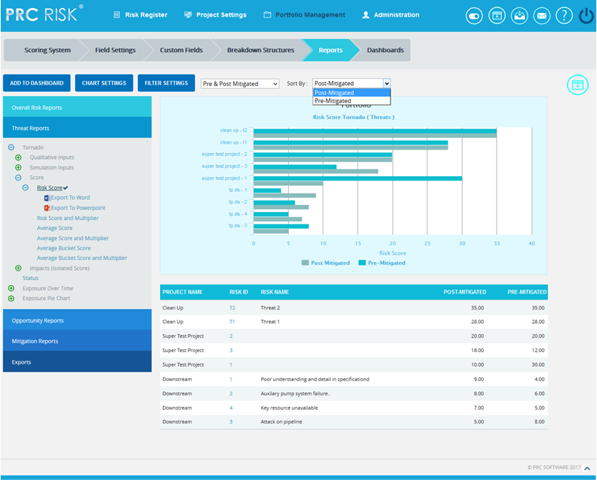
Figure 1
Set as Default Chart Icon:
Set as Default Icon is used to set any chart as the landing page when we select Reports of Portfolio Management. Risk score is the chart to appear first by default. (Figure 1)

Reports:
There are several types of reports in the Standard Report (Portfolio) page. In order to generate a chart, the primary option that should be selected is Report. The Report selected by default (while the page is loaded) is Threat Reports. Figure 2 shows the various types of available reports.
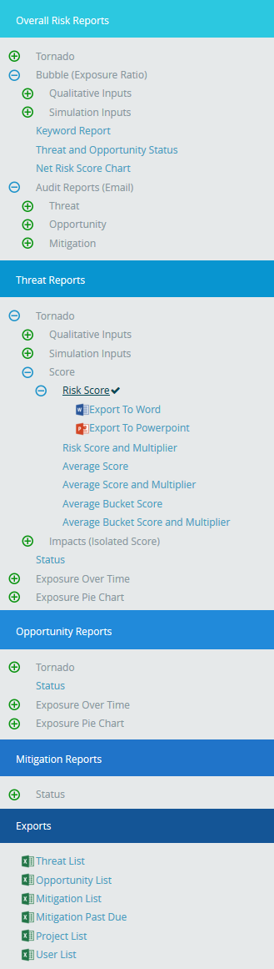
Figure 2

Report Option:
The Report option decides for which risk type the chart should be generated. The risk type listed will vary for the Status Reports. For all other reports it remains the same. The report option for all reports is shown in Figure 3, Figure 4, Figure 5 and 6.
The report option for threat and opportunity are Threat Tornado, Opportunity Tornado, Threat Exposure Over Time, Opportunity Exposure Over Time, Threat Qualitative Exposure Pie Chart, Opportunity Qualitative Exposure Pie Chart, Threat Simulation Exposure Pie Chart and Opportunity Simulation Exposure Pie Chart.

Risk Tornado Charts:
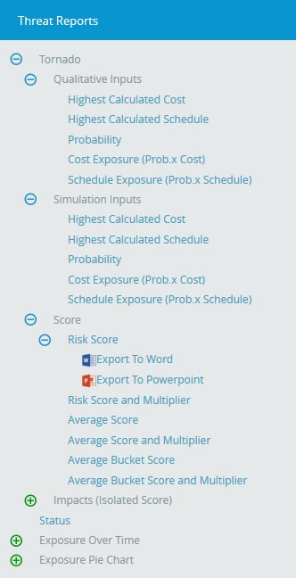

Figure 3

Risk Exposure Charts:
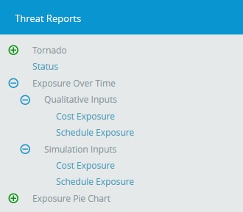

Figure 4

Risk Exposure Pie Charts:
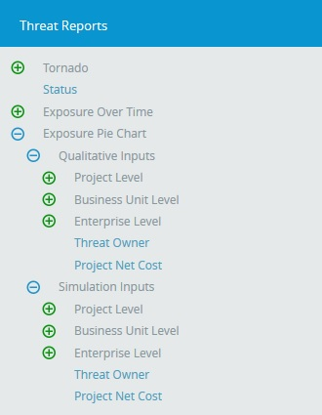

Figure 5

Status Charts:
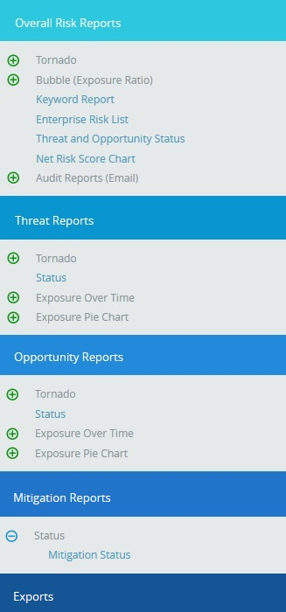
Figure 6

Data Option:
Data Option includes additional impacts if any.
The various data options available are:
- Risk Score
- Qualitative Cost
- Qualitative Schedule
- Other Qualitative impacts
- Qualitative Probability
- Simulation Cost
- Simulation Schedule
- Simulation Probability
- Simulation Cost Exposure
- Qualitative Cost Exposure
- Simulation Schedule Exposure
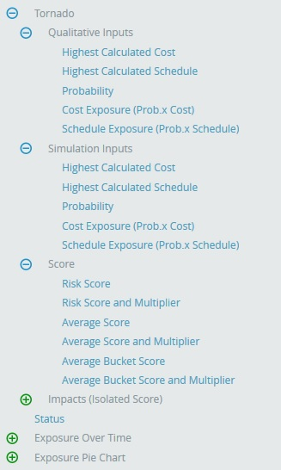

Figure 7

Risk Score:
The Risk Score for Threat/Opportunity is the pre-mitigated score. The Risk Score for mitigation is the post-mitigated score.

Qualitative Cost:
The formulas for Qualitative Cost are:
1. [(Qualitative Cost Upper Limit + Qualitative Cost Lower Limit) / 2] (Pre-Value)
2. [(Qualitative Mitigation Cost Upper Limit + Qualitative Mitigation Cost Lower Limit) / 2] (Post-Value)
If there is no upper limit: Qualitative Cost = lower limit * 1.5
If there is no lower limit: Qualitative Cost = upper limit / 2

Qualitative Schedule:
The formulas for Qualitative schedule are:
1. [(Qualitative Schedule Upper Limit + Qualitative Schedule Lower Limit) / 2] (Pre-Value)
2. [(Qualitative Mitigation Schedule Upper Limit + Qualitative Mitigation Schedule Lower Limit) / 2] (Post-Value)
If there is no upper limit: Qualitative Schedule = lower limit * 1.5
If there is no lower limit: Qualitative Schedule = upper limit / 2

Other Qualitative Impacts:
The formulas for Additional Impacts are:
1. [(Qualitative Additional Impact Upper Limit + Qualitative Additional Impact Lower Limit) / 2] (Pre-Value)
2. [(Qualitative Mitigation Additional Impact Upper Limit + Qualitative Mitigation Additional Impact Lower Limit) / 2] (Post Value)
If there is no upper limit Average value = lower limit * 1.5
If there is no lower limit Average value = upper limit / 2
Qualitative Probability:
The formulas for Qualitative Probability are:
1. [[(Qualitative Probability Upper Limit + Qualitative Probability Lower Limit) / 2]] (Pre-Value)
2. [[(Qualitative Mitigation Probability Upper Limit + Qualitative Probability Lower Limit) / 2]] (Post-Value)
If there is no upper limit: Qualitative Probability = [(lower-limit + 100) / 2]
If there is no lower limit: Qualitative Probability = [(0 + upper-limit) / 2]

Simulation Cost:
The formulas for Simulation Cost are:
1. [(Cost min + Cost max + 4 * (Cost Most likely)) / 6] (Pre Value)
2. [(Mitigation Cost min + Mitigation Cost max + 4 * (Mitigation Cost Most likely)) / 6] (Post Value)
If there is no max then max = min * 2
If there is no min then min = max / 2
If there is no most likely then Avg = [(Min + Max) / 2]

Simulation Schedule:
The formulas for Simulation Schedule are:
1. [(Schedule min + Schedule max + 4 * (Schedule Most likely)) / 6] (Pre-Value)
2. [(Mitigation Schedule min + Mitigation Schedule max + 4 * (Mitigation Schedule Most likely)) / 6] (Post-Value)
If there is no max then max = min * 2
If there is no min then min = max / 2
If there is no most likely then Avg = [(Min + Max) / 2]

Simulation Probability:
The formulas for Simulation Probability are:
1. [[Simulation Probability Percentage]] (Pre-Value)
2. [[Mitigation Simulation Probability]] (Post-Value)

Simulation Cost Exposure:
The formulas for Simulation Cost Exposure are:
1. [(Simulation Cost * Simulation Probability) / 100] (Pre-Value)
2. [(Mitigation Simulation Cost * Mitigation Simulation Probability) / 100] (Post-Value)

Simulation Schedule Exposure:
The formulas for Simulation Schedule Exposure are:
1. [(Simulation Schedule * Simulation Probability) / 100] (Pre-Value)
2. [(Mitigation Simulation Schedule * Mitigation Simulation Probability) / 100] (Post-Value)

The various data options for Threat Qualitative Exposure Pie Chart, Opportunity Qualitative Exposure Pie Chart, Threat Simulation Exposure Pie Chart and Opportunity Simulation Exposure Pie Chart are
- Project-OBS
- Project-WBS
- Project-RBS
- Business Unit-OBS
- Business Unit-WBS
- Business Unit-RBS
- Enterprise-OBS
- Enterprise-WBS
- Enterprise-RBS
- Risk Owner
Project OBS, Project WBS and Project RBS details are added from the page Project Breakdown Structure (Project Settings ---> Project Breakdown Structure)
Business OBS, Business RBS, Business WBS, Enterprise OBS, Enterprise RBS, and Enterprise WBS are added from the page Manage Breakdown Structure (Portfolio Management ---> Manage Breakdown Structure)
From the Select box (Figure 8) there is an option to select either Pre-Mitigated/Post-Mitigated or Pre-Mitigated & Post-Mitigated. This option is hidden for status charts. For Risk Threat Tornado, Opportunity Tornado, Threat Exposure Over Time, Opportunity Exposure Over Time it is shown in Figure 8(a), and for Threat Qualitative Exposure Pie Chart, Opportunity Qualitative Exposure Pie Chart, Threat Simulation Exposure Pie Chart and Opportunity Simulation Exposure Pie Chart it is shown in Figure 8(b).

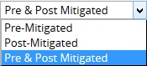

Figure 8(a)

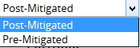
Figure 8(b)

Filter:
This functionality is used to apply a Filter to the chart.
Steps:
- Portfolio Management---> Reports
- Click the FILTER SETTINGS button. (Figure 9) The pop up shown in Figure 10 appears.
- Select the field from the Select Field dropdown. (Figure 10)
- Select the Operator from the Select Operator dropdown. (Figure 10) The various fields and the operators applicable are shown in Table 1.
- The User can select values or enter values from the Select Value dropdown. (Figure 10)
- Click the ADD FILTER OPTION button to add another filter. (Figure 10)
- Click the APPLY FILTER button to view the filtered report or give Name, Description and Global Access option and then click the SAVE AND APPLY FILTER button to view the saved filter report. (Figure 10)
- Select the filter name from the Name dropdown and click the Delete icon that appears, to delete that particular saved filter. (Figure 10)
Figure 9

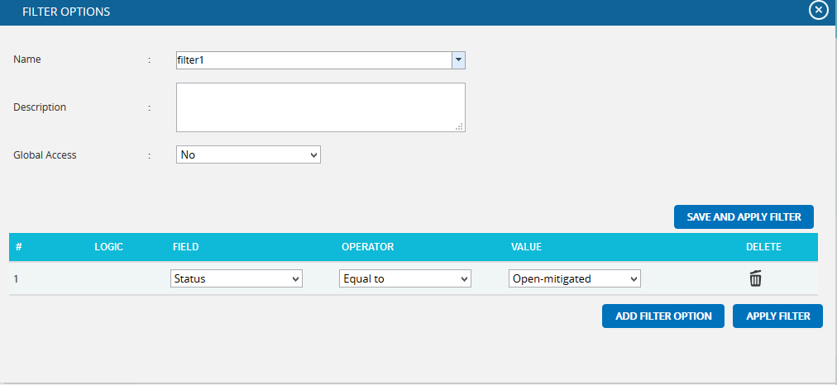
Figure 10

Field Type | Operator | Notes
Text | Equal to | User types text—This chart contains all the values that match the text exactly.
 | Contains | User types text—This chart contains all the values that contain the text anywhere in the string.
 | Not equal to | User types text—This chart contains all the values that do not match exactly.
 | Does not contain | User types text—This chart contains all values where the text is not contained anywhere in the string.
Date | Equal to | Date popup box—This chart contains all values where the date matches exactly.
 | Before | Date popup box—This chart contains all values where the date is before the selected date.
 | After | Date popup box—This chart contains all values where the date is after the selected date.
 | Not equal to | Date popup box—This chart contains all values where the date does not match exactly.
Number | Equal to | User enters number—This chart contains all values which match exactly with the number entered.
 | Greater than | User enters number—This chart contains all values greater than the number entered.
 | Greater than or Equal to | User enters number—This chart contains all values greater than or equal to the number entered.
 | Less than | User entered number—This chart contains all values less than or equal to the number entered.
 | Less than or equal to | User enters number—This chart contains all values less than the number entered
 | Not equal to | User enters number—This chart contains all values which are not the exact match for the number entered.
WBS/OBS/RBS | Under | User selects WBS/OBS/RBS element via a check mark in a popup—All children under the node (and sub-nodes) are shown. If a user check marks Multiple Items, then an OR is applied to all check-marked items.
 | Not Under | User selects WBS/OBS/RBS element via a check mark in a popup—All items are shown except children under the node (and sub-nodes).
List Items (such as status) | Equal to | User selects list element from a dropdown box—This chart will contain all the values which match the selected value exactly.
 | Equal to (select multiple) | User selects list element via a check mark in a popup—If a user check marks multiple items, then an OR is applied to all checked items. This chart will contain all values which match the selected values exactly.
 | Not equal to | User selects list element from a dropdown box—This chart contains all values not equal to the selected value
 | Contains | User selects list element from a dropdown box—This chart contains all values which contain the selected value
 | Not equal to (select multiple) | User selects list element via a check mark in a popup—If the user checks multiple items an OR is applied to all checked items, and the results will not be equal to any checked items. This chart contains all values not equal to the selected values

Table 1

Risk Tornado Chart:
Tornado Diagrams, also called Tornado Plots or Tornado Charts, are special types of Bar Charts where the data categories are listed vertically. These charts are generated by default when the Standard Reports (Portfolio) page is initially loaded. The Post-Mitigated score is the Mitigation score and Pre-Mitigated score is the Risk score.

Threat Tornado:
The Threat Tornado chart corresponds to all threats of the projects to which the logged in user has access.
Steps:
- Portfolio Management ---> Reports
- Click the Threat Reports link to select Threat Tornado Chart. (Figure 1)
- Select Pre-Mitigated to view Pre-Mitigated data (sorted by Pre-Mitigated), Post-Mitigated to view Post-Mitigated data (sorted by Post-Mitigated) or Both, and to view both Pre-Mitigated data and Post-Mitigated data from the dropdown. (Figure 9)
- Click the FILTER SETTINGS button to add a filter. (Steps to be followed to add a filter are explained in Filter section above) (Figure 9)
- Click the Risk Score link or any other data option to generate the report. (Figure 11) The chart generated and the data table are shown below in Figure 12.
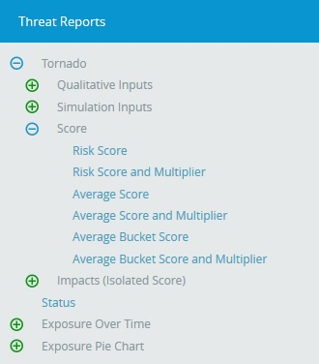
Figure 11

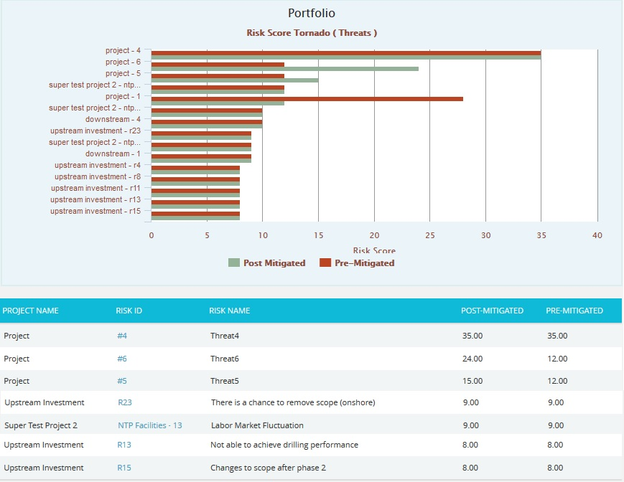
Figure 12

Opportunity Tornado:
The Opportunity Tornado chart corresponds to all the opportunities of the projects to which the logged in user has access.
Steps:
- Portfolio Management ---> Reports
- Click the Opportunity Reports link to select Opportunity Tornado Chart. (Figure 1)
- Select Pre-Mitigated to view Pre-Mitigated data only (sorted by Pre-Mitigated), Post-Mitigated to view Post-Mitigated data (sorted by Post-Mitigated) or Both, and to view both Pre-Mitigated data and Post-Mitigated data from the dropdown. (Figure 9)
- Click the FILTER SETTINGS button to add a filter. (Steps to be followed to add a filter are explained in filter section above) (Figure 9)
- Click the Risk Score link or any other data option to generate the report. (Figure 13) The chart generated and the data table is shown is in Figure 14.

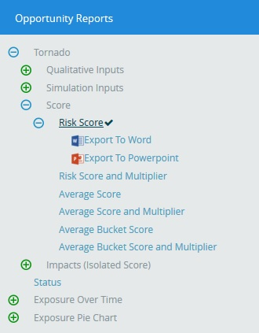
Figure 13

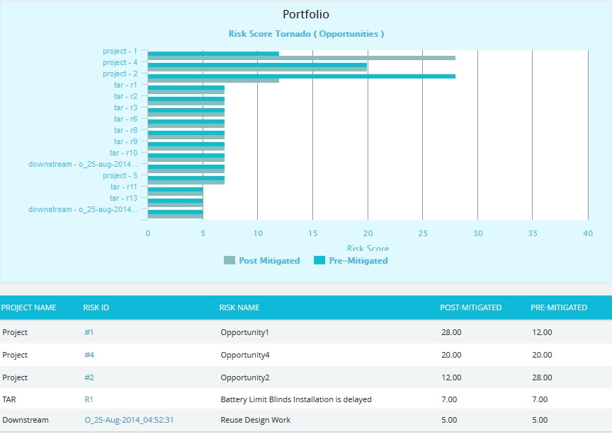
Figure 14
Clicking on the Risk ID shown in the data table in Figure 14 navigates to the page:

Status:
The Status chart is represented by a pie chart and corresponds to the status assigned to the risk.
Steps:
- Portfolio Management ---> Reports
- Click the FILTER SETTINGS button to add a filter. (Steps to be followed to add a filter are explained in the filter section above) (Figure 9)
- Click the Status ---> Threat Status link under Threat Reports to know the status of threats in the selected project. Click the Status ---> Opportunity Status link under Opportunity reports to know the status of opportunity in the selected project. To know the status of mitigations in the selected project, click Status ---> Mitigation Status link. Click the Threat and Opportunity Status link under Other Risk Reports to know the status of threats and opportunities in the selected project. (Figure 15) The chart generated and the data table is shown is in Figure 16.
Figure 15

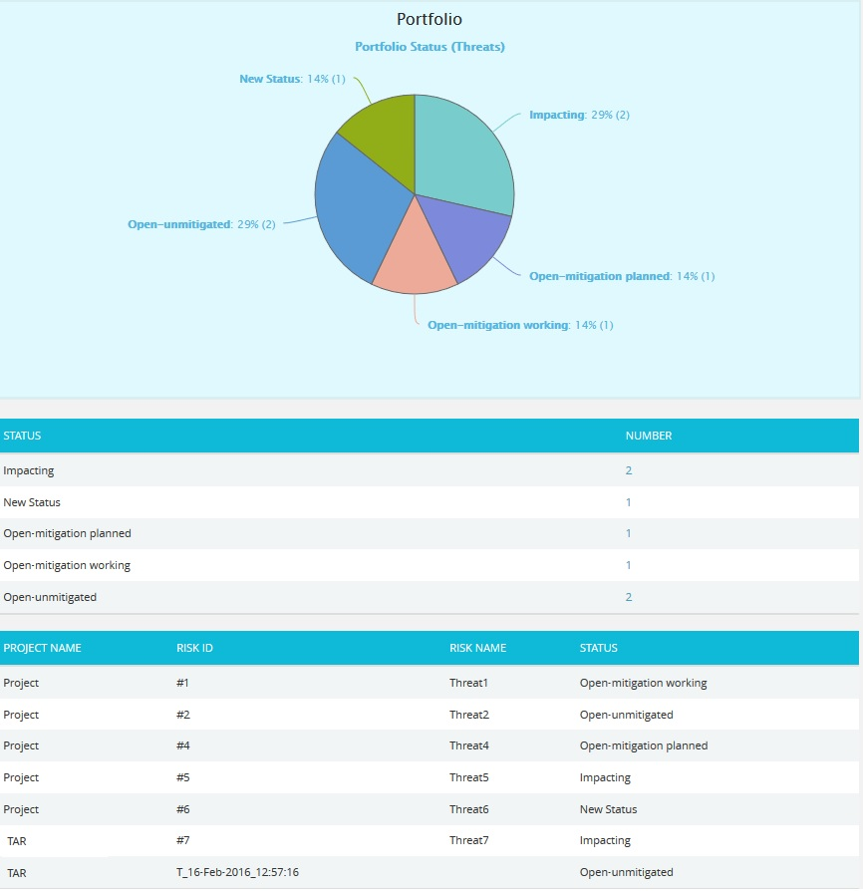
Figure 16
The count under the Number column shown in Figure 16 has a link to the Threat Tornado chart. (Figure 12)

Threat Exposure over Time:
The Threat Exposure Over Time chart is generated based on the qualitative cost exposure, simulation cost exposure, qualitative schedule exposure and simulation schedule exposure for all the threats of the projects to which the logged in user has access.
Steps:
- Portfolio Management ---> Reports
- Click the Exposure Over Time link under Threat Reports. (Figure 1)
- Select Pre-Mitigated to view Pre-Mitigated data only (sorted by Pre-Mitigated), Post-Mitigated to view Post-Mitigated data (sorted by Post-Mitigated) or Both, and to view both Pre-Mitigated data and Post-Mitigated data from the dropdown. (Figure 9)
- Click the FILTER SETTINGS button to add a filter. (Steps to be followed to add a filter are explained in filter section above). (Figure 9)
- Click the Cost Exposure Under Simulation to or any other data option to generate the report. (Figure 17) The chart generated and the data table is shown is in Figure 18.

Figure 17

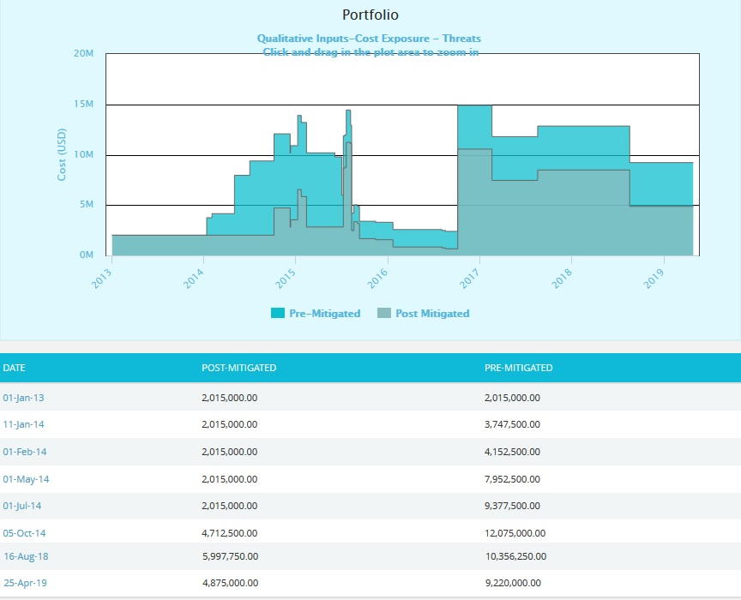
Figure 18
The Column Date of the data table (Figure 18) contains a link that navigates the user to the following charts:
- Simulation Cost Exposure Tornado (Threat) if the option “Cost Under Simulation For Threat Reports” link is selected.
- Qualitative Cost Exposure Tornado (Threat) if the option “Cost Under Qualitative For Threat Reports” link is selected.
- Simulation Schedule Exposure Tornado (Threat) if the option “Schedule Under Simulation For Threat Reports” link is selected.
- Qualitative Schedule Exposure Tornado (Threat) if the option “Schedule Under Qualitative For Threat Reports” link is selected.

Opportunity Exposure over Time:
The Opportunity Exposure Over Time chart is generated based on the qualitative cost exposure, simulation cost exposure, qualitative schedule exposure and simulation schedule exposure for all opportunities on all projects to which the user has access.
Steps:
- Portfolio Management ---> Reports
- Click the Exposure Over Time link under Opportunity Reports. (Figure 1)
- Select Pre-Mitigated to view Pre-Mitigated data only (sorted by Pre-Mitigated), Post-Mitigated to view Post-Mitigated data (sorted by Post-Mitigated) or Both, and to view Pre-Mitigated data and Post-Mitigated data from the dropdown. (Figure 9)
- Click the FILTER SETTINGS button to add a filter. (Steps to be followed to add a filter are explained in filter section above). (Figure 9)
- Click the Cost Exposure Under Simulation or any other data option to generate the report. (Figure 19) The chart generated and the data table is shown in Figure 20.

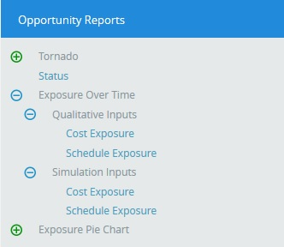
Figure 19

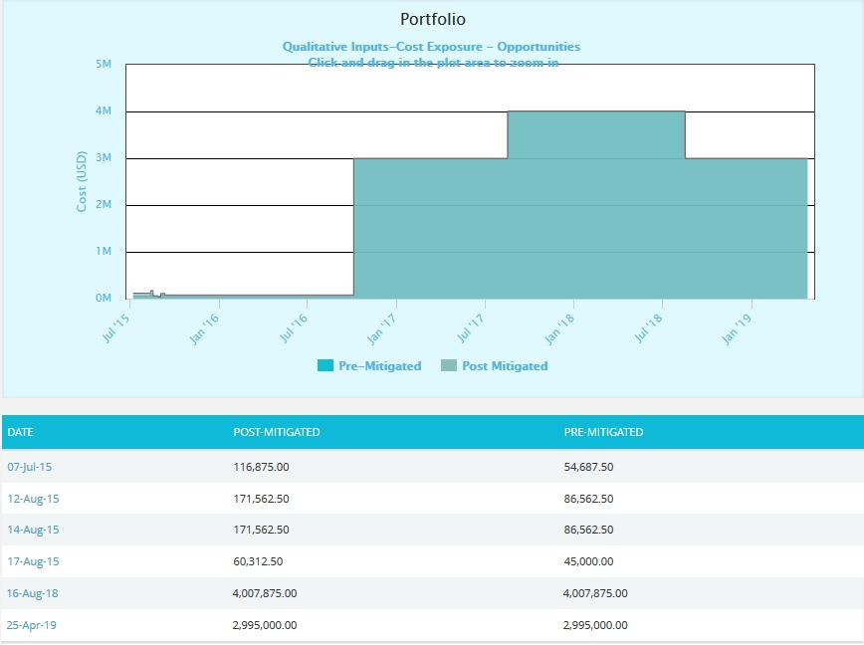
Figure 20
The Column Date of the data table (Figure 20) contains a link that navigates the user to the following charts:
- Simulation Cost Exposure Tornado (Opportunities) if the option “Cost Under Simulation For Opportunity Reports” is selected.
- Qualitative Cost Exposure Tornado (Opportunities) if the option “Cost Under Qualitative For Opportunity Reports” is selected.
- Simulation Schedule Exposure Tornado (Opportunities) if the option “Schedule Under Simulation For Opportunity Reports” is selected.
- Qualitative Schedule Exposure Tornado (Opportunities) if the option “Schedule Under Qualitative For Opportunity Reports” is selected.

Threat Simulation Exposure Pie Chart:
Threat Simulation Exposure Pie Chart depends on the simulation cost exposure of the threats mapped to the breakdown structure of all the projects the logged in user has access.

Steps:
- Portfolio Management ---> Reports
- Click the Exposure Pie Chart link under Threat Reports. (Figure 1)
- Select Pre-Mitigated to view Pre-Mitigated data only (sorted by Pre-Mitigated), Post-Mitigated to view Post-Mitigated data (sorted by Post-Mitigated) from the dropdown. (Figure 9)
- Click the FILTER SETTINGS button to add a filter. (Steps to be followed to add a filter are explained in the filter section above) (Figure 9)
- Click the Project-WBS link or any other data option to generate the report. (Figure 21) The chart generated and the data table is shown in Figure 22.

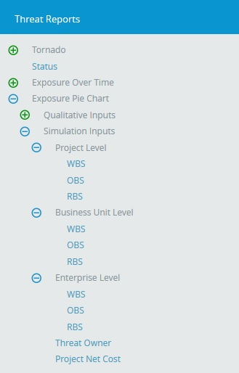
Figure 21

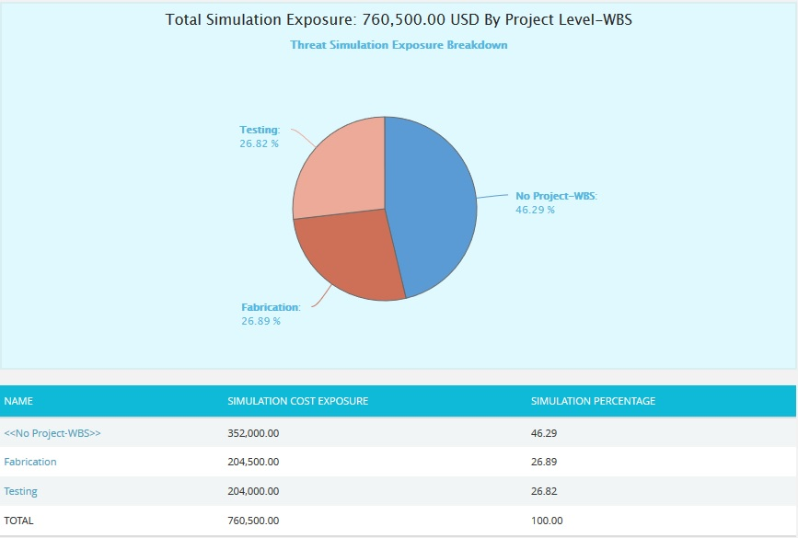
Figure 22
The Name column contains a link to WBS Tornado (Threats). (Figure 22)

Opportunity Simulation Exposure Pie Chart:
The Opportunity Simulation Exposure Pie Chart depends on the simulation cost exposure of the opportunities mapped to the break down structure for all the projects to which the user has access.
Steps:
- Portfolio Management ---> Reports
- Click the Exposure Pie Chart link under Opportunity Reports. (Figure 1)
- Select Pre-Mitigated to view Pre-Mitigated data only (sorted by Pre-Mitigated), Post-Mitigated to view Post-Mitigated data (sorted by Post-Mitigated) from the dropdown. (Figure 9)
- Click the FILTER SETTINGS button to add a filter. (Steps to be followed to add a filter are explained in filter section above) (Figure 9)
- Click the Project-WBS link or any other data option to generate the report. (Figure 23) The chart generated and the data table is shown in Figure 24.

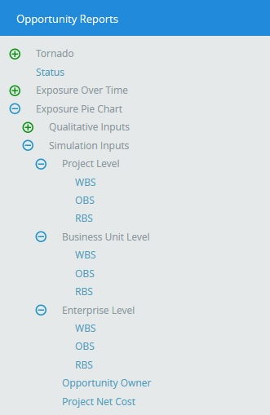
Figure 23

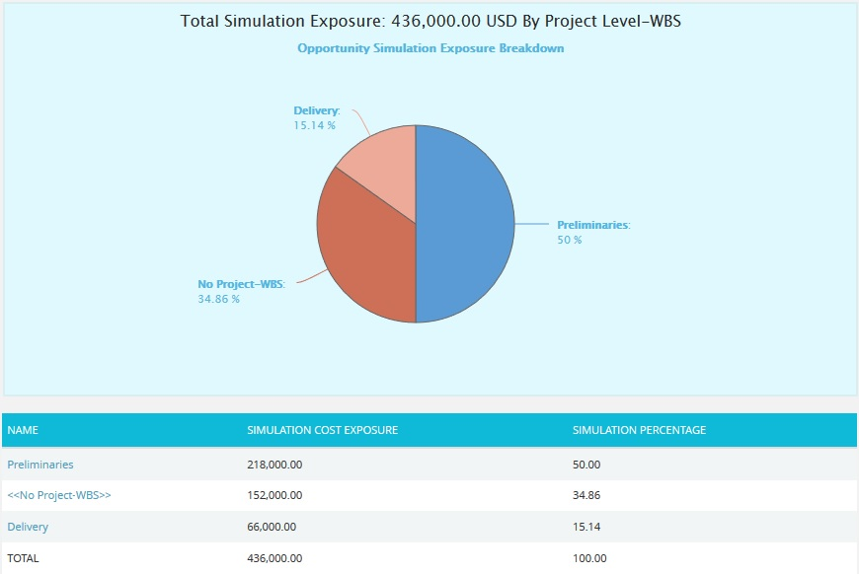
Figure 24
The Name column contains a link to the WBS Tornado (Opportunities). (Figure 24)

Threat Qualitative Exposure Pie Chart:
Threat Qualitative Exposure Pie Chart depends on the qualitative cost exposure of the threats mapped to the break down structure for all the projects the logged in user has access.
Steps:
- Portfolio Management ---> Reports
- Click the Exposure Pie Chart link under Threat Reports. (Figure 1)
- Select Pre-Mitigated to view Pre-Mitigated data only (sorted by Pre-Mitigated), and Post-Mitigated to view Post-Mitigated data (sorted by Post-Mitigated) from the dropdown. (Figure 9)
- Click the FILTER SETTINGS button to add a filter. (Steps to be followed to add a filter are explained in filter section above) (Figure 9)
- Click the Project-WBS link or any other data option to generate the report. (Figure 25) The chart generated and the data table is shown in Figure 26.

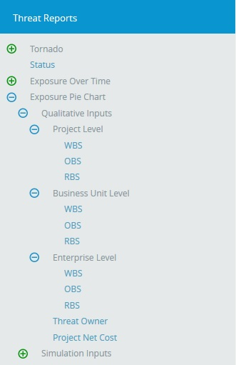
Figure 25
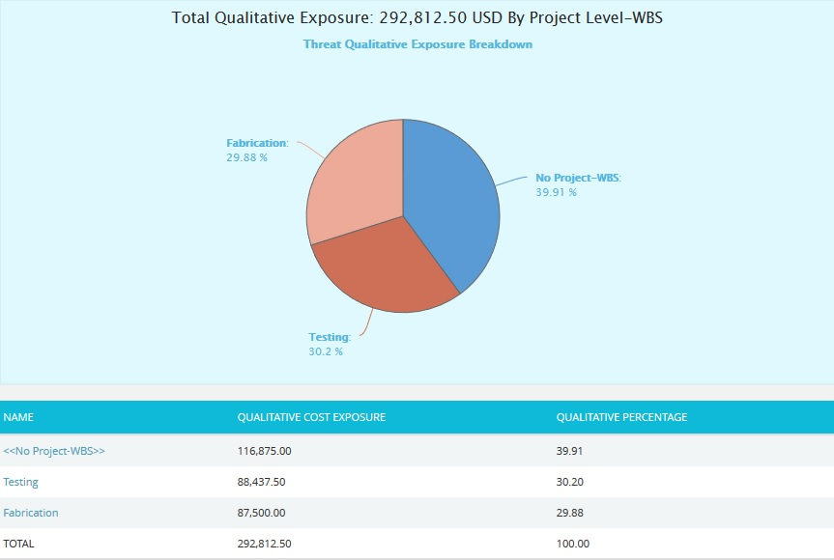
Figure 26
The Name column contains a link to the WBS Tornado (Threats). (Figure 26)

Opportunity Qualitative Exposure Pie Chart:

The Opportunity Qualitative Exposure Pie Chart is generated based on the qualitative cost exposure, simulation cost exposure, qualitative schedule exposure and simulation schedule exposure for all the opportunities for all the projects the user has access.

Steps:
- Portfolio Management ---> Reports
- Click the Exposure Pie Chart link under Opportunity Reports. (Figure 1)
- Select Pre-Mitigated to view Pre-Mitigated data only (sorted by Pre-Mitigated), and Post-Mitigated to view Post-Mitigated data (sorted by Post-Mitigated) from the dropdown. (Figure 9)
- Click the FILTER SETTINGS button to add a filter. (Steps to be followed to add a filter are explained in filter section above) (Figure 9)
- Click the Project-WBS link or any other data option to generate the report. (Figure 27) The chart generated and the data table is shown in Figure 28.

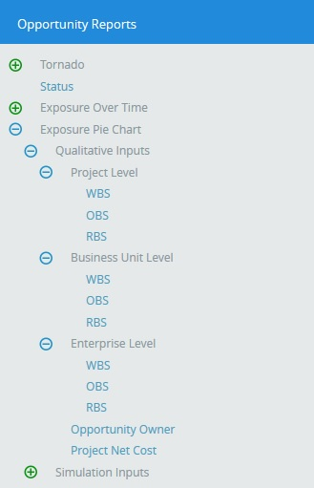
Figure 27
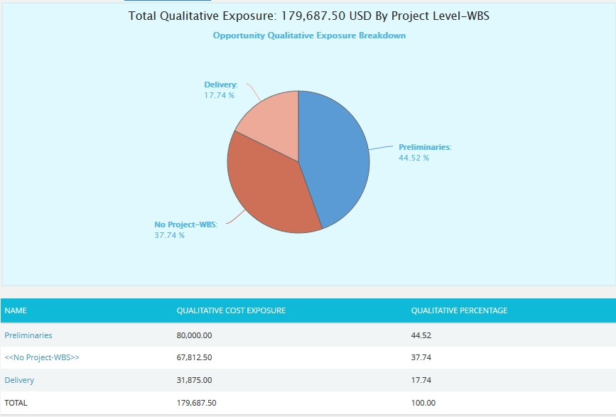
Figure 28
The Name column contains a link to WBS Tornado (Threats). (Figure 28)

Email Settings:
This functionality is used to export the entire page to word and send mail to the person selected. The functionality consists of two lists, Available Users and Selected Users. Available Users (Figure 29) contains all the portfolio level users. Selected Users (Figure 29) displays the users who have been selected. A user can be added to the Selected Users list using the Add button. All users under the Available Users list can be moved to the Selected Users list using the Add All button. (Figure 29) A single user from the Selected Users list can be moved back to the Available Users list using the Remove button. The Remove All button moves all users from the Selected Users list to the Available Users list. The Subject by default has the value Chart Title, which can be changed if needed.

Steps:
- Portfolio Management ---> Reports
- Generate the desired report by clicking on the type of reports provided to the left.
- Click the Email icon to send email.
- Select at least one user to whom mail should be sent.
- Enter the message in the Message text area.
- Click the SEND MESSAGE button to finish. (Figure 29) To cancel, click the CANCEL button. (Figure 29)
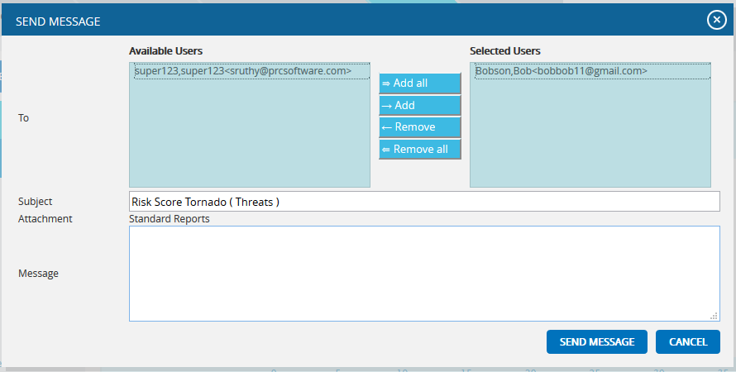
Figure 29

Chart Settings:

This functionality is used to modify the color of the charts generated and also to create and save the editable chart settings and report script. The accessibility of these chart settings is different for different users.
- Users with global access Read/Write option - The editable dropdown has all the global shared chart settings as well as those shared at the personal level. Global access saved name cannot be edited at the global level.
- Users with global access Read only (view only) option - The editable dropdown has all the global shared chart settings as well as those shared at the personal level. The saved name stores only to the personal level, no other users can view that name.

- Users with global access No access option - The editable dropdown has only the chart settings saved at the personal level. The saved name stores only to the personal level, no other users can view that name.
Each chart has its own color setting.
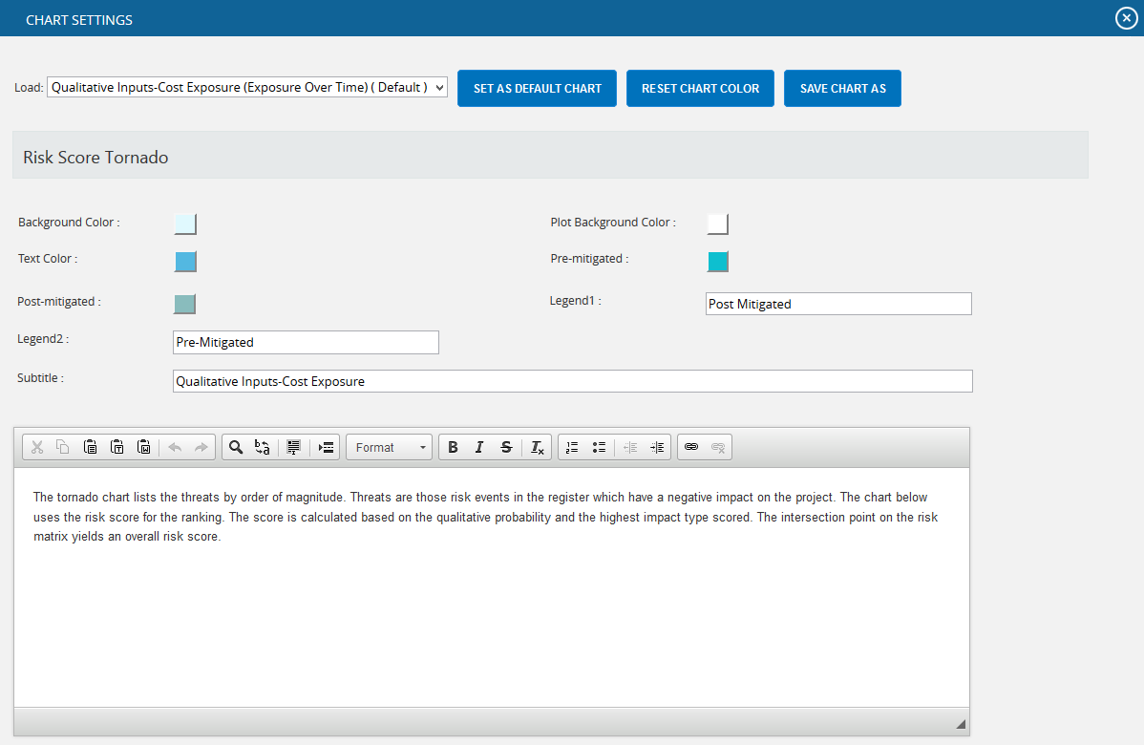
Figure 30
The color is set by clicking on the corresponding color shown beside each field. An example of the color picker for various fields is shown in Figure 31

Figure 31
In Tornado charts, user can set the Y-axis as a combination of project and risk details. By default the Y-axis is Project Id - Risk Id value. User can select either of it as <<None>> but not both as shown in Figure 32.
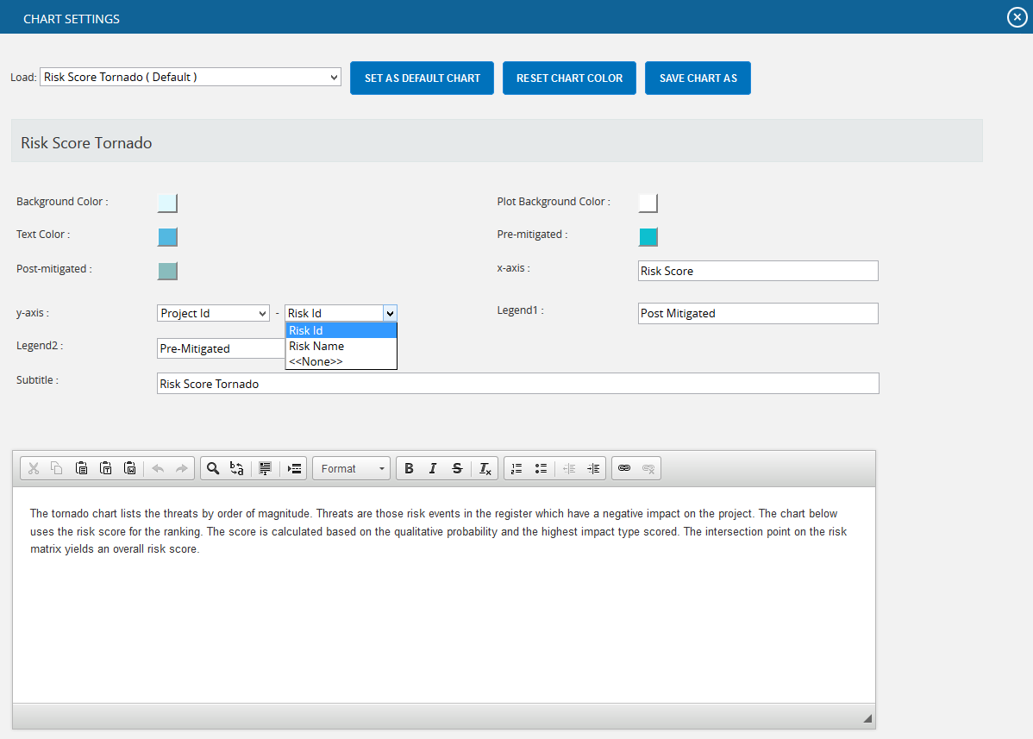
Figure 32

Edit Color:
Steps:
- Portfolio Management ---> Reports
- Click the CHART SETTINGS button to go to chart settings page. (Figure 1)
- Modify the colors needed.
Save As:
This functionality is used to save the user editable chart settings globally or locally with a name and description.
Steps:
- Portfolio Management --> Reports
- Click the CHART SETTINGS icon to go to the chart settings page. (Figure 1)
- Edit the report script and chart settings and click SAVE AS button. (Figure 30)
- Give the name and description to save and also give the global access option in the pop up appears. (Figure 33)
- Click the SAVE button. (Figure 33)
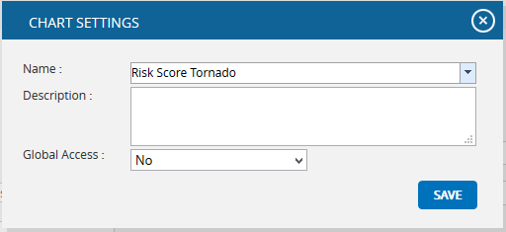
Figure 33

Set As Default Chart:
This functionality is used to set the selected chart settings name, as the default chart.
Steps:
- Portfolio Management --> Reports
- Click the CHART SETTINGS icon to go to the chart settings page. (Figure 1)
- Select a name from the Load dropdown. (Figure 30)
- Click the SET AS DEFAULT button to set the selected chart as default. (Figure 30)
Delete:
This functionality is to delete the selected chart settings name from the Load dropdown. This button appears only for the created users. The default chart settings name cannot be deleted by any user.
Steps:
- Portfolio Management --> Reports
- Click the CHART SETTINGS icon to go to the chart settings page. (Figure 1)
- Select a name from the Load dropdown. (Figure 30)
- Click DELETE button to delete.

Reset:
This functionality is used to reset all the values and report script of the chart to predefined values and script.
Steps:
- Portfolio Management ---> Reports
- Click the CHART SETTINGS button to go to the chart settings page. (Figure 1)
- Click the RESET button to reset the values and report script. (Figure 30)

Add To Managers Dashboard:
This functionality is used to add the chart generated to the portfolio Manager’s Dashboard. A user with View access cannot add a chart to the Manager’s Dashboard.

Steps:
- Portfolio Management ---> Reports
- Generate the desired report by clicking on the type of reports provided to the left.
- Click the SAVE AS NEW CHART button. (Figure 1) A pop up shown in figure 34 appears.
- Enter or select the Name and enter the Description.
- Click the SAVE button to finish. (Figure 34)
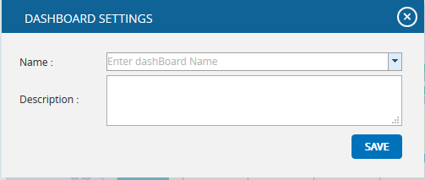
Figure 34

Export to Word:
This functionality is used to export the chart and data table generated to Word.
Steps:
- Portfolio Management ---> Reports
- Generate the desired report by clicking on the type of reports provided to the left.
- Click the Export to Word link. (Figure 2)

Export to PowerPoint:
This functionality is used to export the chart generated to PowerPoint.
Steps:
- Portfolio Management ---> Reports
- Generate the desired report by clicking on the type of reports provided to the left.
- Click the Export to PowerPoint link. (Figure 2)

Overall Risk Reports:
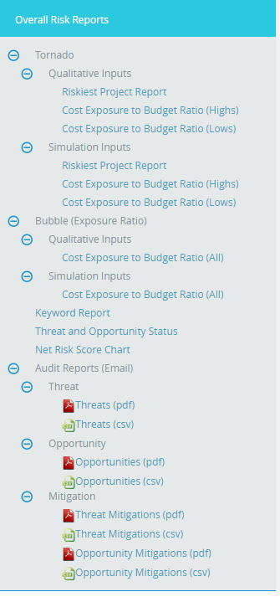
Figure 35

Riskiest Project Report
The Riskiest Project Report page ranks all the projects in the database based on cost. Users can then view the projects by qualitative/simulation in separate charts and can be sorted by pre/post mitigated. When a link in the data table is clicked, a cost tornado chart for the selected project will be created.
Steps:
- Portfolio Management ---> Reports
- Click the Overall Risk Reports link to select Overall Risk Tornado Chart (Figure 2).
- Select the Qualitative Inputs or Simulation Inputs data options to view the charts based on qualitative or simulative inputs.
- Click the Riskiest Project Report (Figure 36).
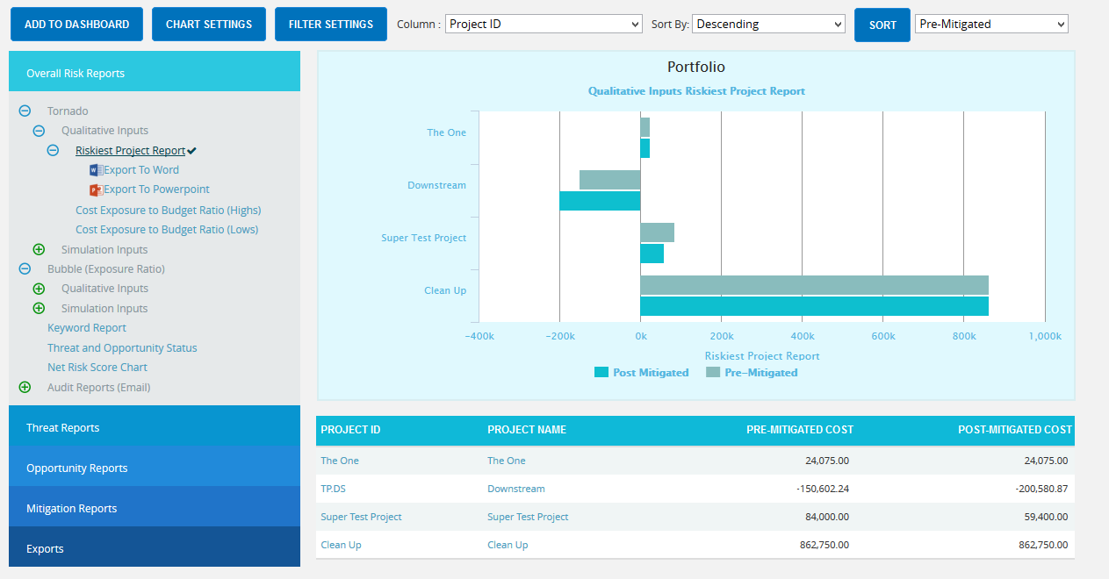
Figure 36

Export to Word:
This functionality is used to export the entire page to word, and to perform this function, click the Export To Word link. (Figure 36)

Sort Data:
To Sort the data according to Project ID, Project Name, Pre-Mitigated Cost, Post-Mitigated Cost, consider the following steps;
Steps:
- Select the required column. (Figure 36)
- Select the order (Ascending/Descending) in which sorting is to be done. (Figure 36)
- Click the Sort button to sort the data. (Figure 36)

Links:
The column Pre-Mitigated Qualitative Cost has a link to the Qualitative Cost Tornado Chart (for Pre-Mitigated data) in the page:
Risk Register ---> Reports ---> Qualitative Cost Exposure Tornado (Pre-Mitigated)

The column Post-Mitigated Qualitative Cost has a link to the Qualitative Cost Tornado Chart (for Post-Mitigated data) in the page:
Risk Register ---> Reports ---> Qualitative Cost Exposure Tornado (Post-Mitigated)

The column Pre-Mitigated Simulation Cost has a link to the Simulation Cost Tornado Chart (for Pre-Mitigated data) in the page:
Risk Register ---> Reports ---> Simulation Cost Exposure Tornado (Pre-Mitigated)

The column Post-Mitigated Simulation Cost has a link to the Simulation Cost Tornado Chart (for Post-Mitigated data) in the page:
Risk Register ---> Reports ---> Simulation Cost Exposure Tornado (Post-Mitigated)

Cost Exposure to Budget Ratio
The Cost Exposure to Budget Ratio Tornado Chart shows the projects in the database based on cost exposure budget ratio that is the ratio which divides the cost exposure by the project budget from the project setup screen. There are Cost Exposure to Budget Ratio (Highs) chart for greatest percentage and Cost Exposure to Budget Ratio (Lows) for the lowest percentage. Users can view the projects by qualitative/simulation in separate charts. The projects listed are based on ascending order of Pre-Mitigated and Post-mitigated Qualitative Cost for Cost Exposure to Budget Ratio (Highs) and descending order of Pre-Mitigated and Post-mitigated Qualitative Cost for Cost Exposure to Budget Ratio (Lows).

Steps:
- Portfolio Management ---> Reports
- Click the Overall Risk Reports link to select Overall Risk Tornado Chart (Figure 2).
- Select the Qualitative Inputs or Simulation Inputs data options to view the charts based on qualitative or simulative inputs.
- Click the Cost Exposure to Budget Ratio (Highs)/Cost Exposure to Budget Ratio (Lows). The chart will be displayed as shown in Figure 37.

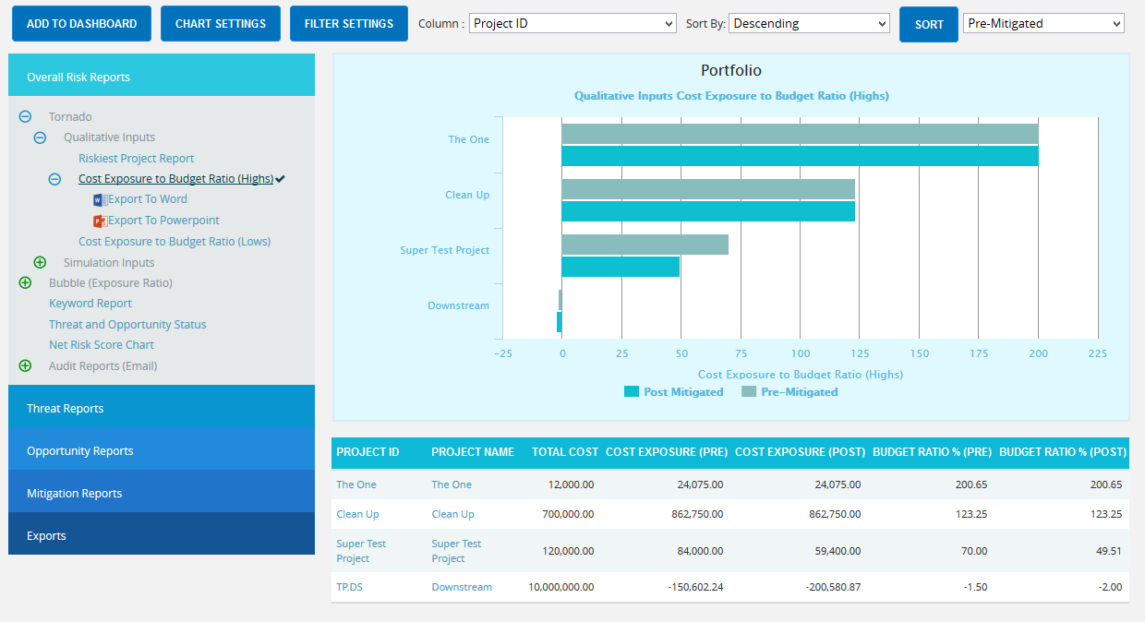
Figure 37

Export to Word:
This functionality is used to export the entire page to word, and to perform this function, click the Export To Word link. (Figure 37)

Sort Data:
To Sort the data according to Project ID, Project Name, Pre-Mitigated Cost, Post-Mitigated Cost, consider the following steps;
Steps:
- Select the required column. (Figure 37)
- Select the order (Ascending/Descending) in which sorting is to be done. (Figure 37)
- Click the Sort button to sort the data. (Figure 37)

Links:
The column Pre-Mitigated Qualitative Cost has a link to the Qualitative Cost Tornado Chart (for Pre-Mitigated data) in the page:
Risk Register ---> Reports ---> Qualitative Cost Exposure Tornado (Pre-Mitigated)

The column Post-Mitigated Qualitative Cost has a link to the Qualitative Cost Tornado Chart (for Post-Mitigated data) in the page:
Risk Register ---> Reports ---> Qualitative Cost Exposure Tornado (Post-Mitigated)

The column Pre-Mitigated Simulation Cost has a link to the Simulation Cost Tornado Chart (for Pre-Mitigated data) in the page:
Risk Register ---> Reports ---> Simulation Cost Exposure Tornado (Pre-Mitigated)

The column Post-Mitigated Simulation Cost has a link to the Simulation Cost Tornado Chart (for Post-Mitigated data) in the page:
Risk Register ---> Reports ---> Simulation Cost Exposure Tornado (Post-Mitigated)

Bubble chart
The Bubble Chart shows the exposure budget ratio of all the projects in the database. The size of the Bubble depends upon the Ratio of the Risk Exposure to the Total cost (Risk Exposure / Total Cost). Users can view the projects by qualitative/simulation in separate charts. The pre-mitigated and post-mitigated costs are seen in the chart. The Projects listed are based on descending order of Project ID.

Steps:
- Portfolio Management ---> Reports
- Click the Overall Risk Reports link to select Bubble Chart. (Figure 2)
- Select the Qualitative Inputs or Simulation Inputs data options to view the charts based on qualitative or simulative inputs.
- Click the Cost Exposure to Budget Ratio (All). The chart will be displayed as shown in Figure 38.

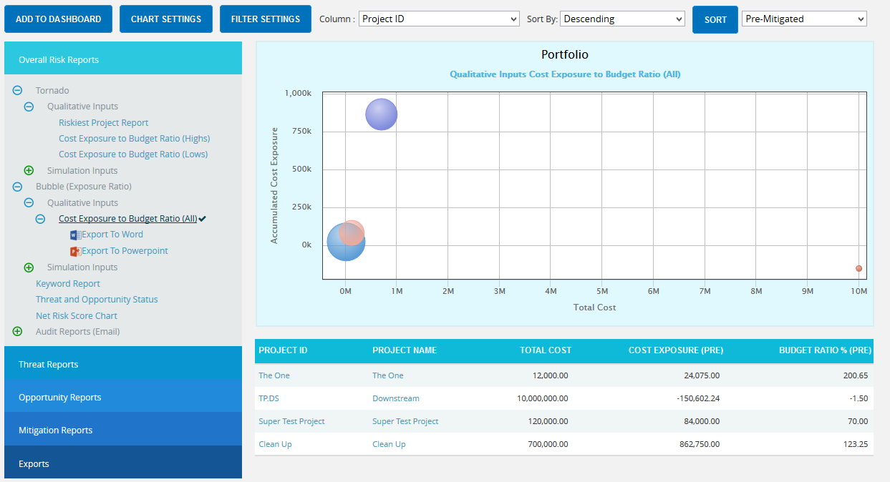
Figure 38

Export to Word:
This functionality is used to export the entire page to word, and to perform this function, click the Export To Word link. (Figure 38)

Sort Data:
To Sort the data according to Project ID, Project Name, Pre-Mitigated Cost, Post-Mitigated Cost, consider the following steps;
Steps:
- Select the required column. (Figure 38)
- Select the order (Ascending/Descending) in which sorting is to be done. (Figure 38)
- Click the Sort button to sort the data. (Figure 38)

Links:
The column Pre-Mitigated Qualitative Cost has a link to the Qualitative Cost Tornado Chart (for Pre-Mitigated data) in the page:
Risk Register ---> Reports ---> Qualitative Cost Exposure Tornado (Pre-Mitigated)

The column Post-Mitigated Qualitative Cost has a link to the Qualitative Cost Tornado Chart (for Post-Mitigated data) in the page:
Risk Register ---> Reports ---> Qualitative Cost Exposure Tornado (Post-Mitigated)

The column Pre-Mitigated Simulation Cost has a link to the Simulation Cost Tornado Chart (for Pre-Mitigated data) in the page:
Risk Register ---> Reports ---> Simulation Cost Exposure Tornado (Pre-Mitigated)

The column Post-Mitigated Simulation Cost has a link to the Simulation Cost Tornado Chart (for Post-Mitigated data) in the page:
Risk Register ---> Reports ---> Simulation Cost Exposure Tornado (Post-Mitigated)

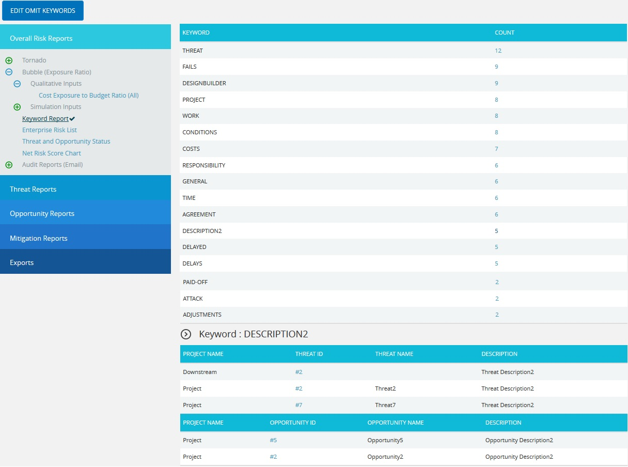
Keyword Report
The Keyword Report searches all the projects in the database and shows the most frequently used word in the Threat/Opportunity Name and Threat/Opportunity Descriptive fields. When the user clicks on the keyword count, the report displays the projects and Threats/Opportunities with which it is associated.
Figure 39

Count link:
The Count link shows the project and Threat/Opportunity information for the selected keyword.

Threat ID link:
The link under Threat ID column navigates the user to the page:
Risk Register ---> Risk Details --->Threats

Opportunity ID link:
The link under the Opportunity ID column navigates the user to the page:
Risk Register ---> Risk Details ---> Opportunity

Edit Omit Keywords:
This functionality is used to omit all keywords which the user does not want to be included in the Keyword Report page. To view the omitted keywords list, click the Edit Omit Keywords button. (Figure 39)

Add new word to Omitted List:
This functionality is used to add a new word to omitted words list.
Steps:
- Portfolio Management ---> Reports
- Click the Keyword Report link under Other Risk Reports.
- Click the EDIT OMIT KEYWORDS button. (Figure 39) A pop up appears. (Figure 40)
- Click the ADD NEW button. (Figure 40)
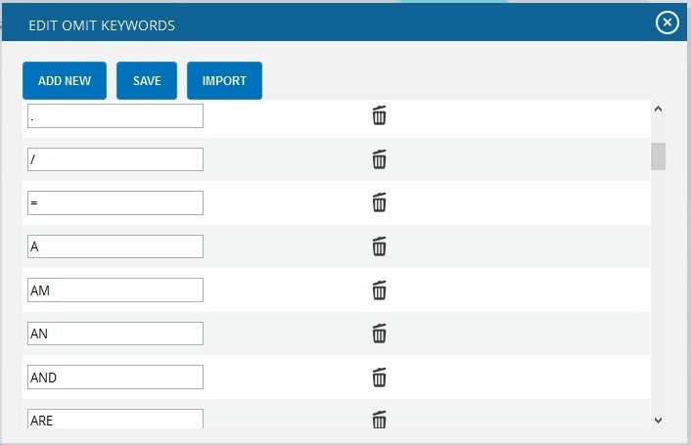
- Enter the required word and click the SAVE button. (Figure 40)

Figure 40

Edit Omitted Words List:
The words shown in the omitted words list can be edited using this functionality.
Steps:
- Portfolio Management ---> Reports
- Click the Keyword Report link under Other Risk Reports.
- Click the EDIT OMIT KEYWORDS button. (Figure 39) A pop up appears. (Figure 40)
- Click the EDIT button. (Figure 40)
- Modify the required words and click the SAVE button to finish. (Figure 40)
- Modify the required words and click the SAVE button to finish. (Figure 40)

Delete Omitted Words:
This functionality is used to delete words from the omitted words list.
Steps:
- Portfolio Management ---> Reports
- Click the Keyword Report link under Other Risk Reports.
- Click the EDIT OMIT KEYWORDS button. (Figure 39) A pop up appears. (Figure 40)
- Click the corresponding Delete icon to delete. (Figure 40)

Threat and Opportunity Status:

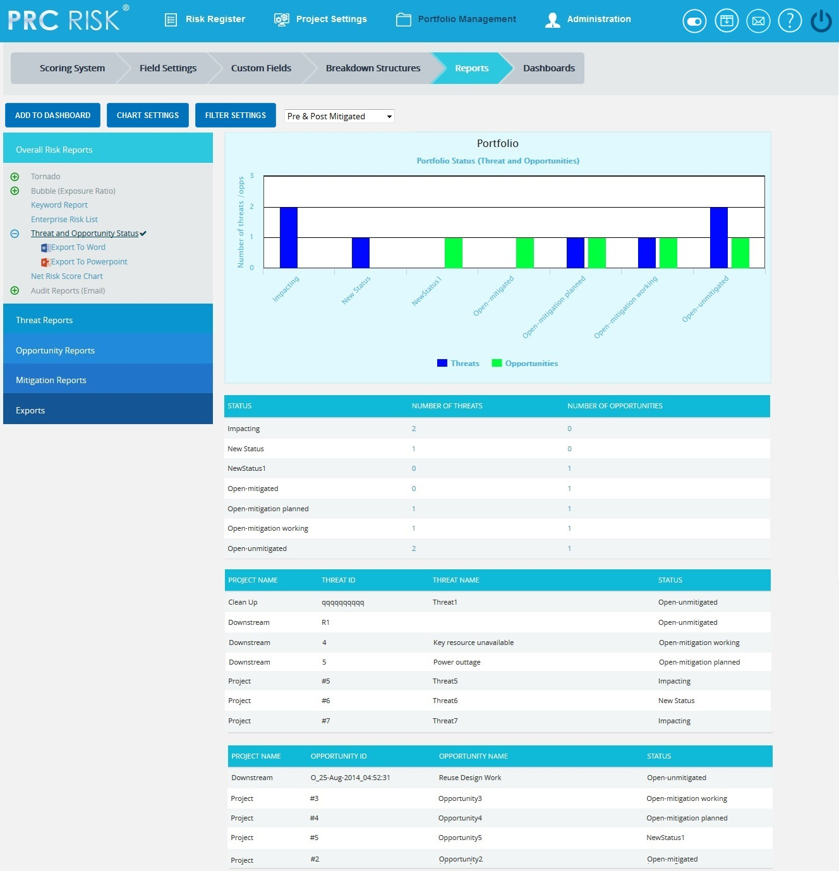
Figure 41

Net risk score Chart:
The Net Risk Score Chart shows the net risk score of all the impacts (cost, schedule, probability, etc) in the projects in the database. The top three impacts of the project are shown separately and all other impact scores are accumulated and shown in the other impacts. For each impact type, the scores will be sum of the values obtained from the corresponding Scoring Matrix of the Project. The chart shows either Post Mitigated or Pre Mitigated values according to the value selected in the dropdown. (Figure 42)
Steps:
- Portfolio Management ---> Reports
- Click the Other Risk Reports link to select Net risk score Chart. (Figure 42)
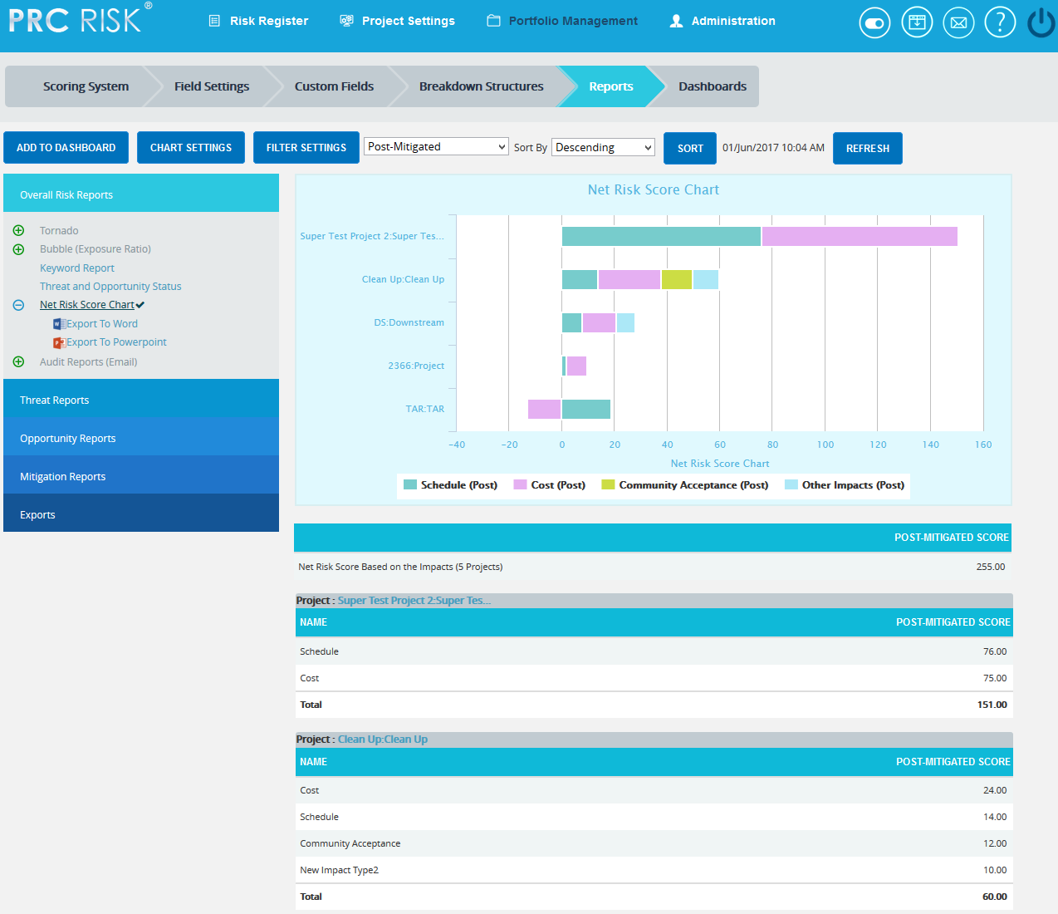

Figure 42

Export to Word:
This functionality is used to export the entire page to word, and to perform this function, click the Export To Word link. (Figure 42)

Sort Data:

To Sort the data according to Pre-Mitigated Qualitative Cost, Post-Mitigated Qualitative Cost, consider the following steps;

Steps:
- Select the required column. (Figure 42)
- Select the order (Ascending/Descending) in which sorting is to be done. (Figure 42)
- Click the Sort button to sort the data. (Figure 42)

Filter:
This functionality is used to apply a Filter to the chart.
Steps:
- Click the FILTER SETTINGS icon. (Figure 42) The pop up appears. (Figure 43)
- Select the impacts to be filtered by checking the checkboxes. (Figure 43)
- Click the LOAD IMPACT SCORES button to load the scores of filtered impacts. (Figure 43)
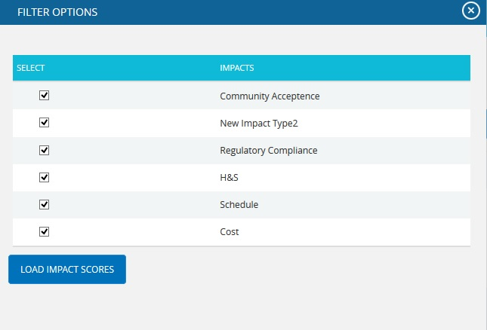

Figure 43
Links:
The impact links under the column Name of each project navigates the user to the page:
Risk Register Risk SpreadsheetRisk score (Pre-Mitigated) and (Post-Mitigated)

Refresh:
This functionality is to refresh the page, click REFRESH button. (Figure 42)

Exports
The Export functionality allows you to easily export project level data to MS Excel.
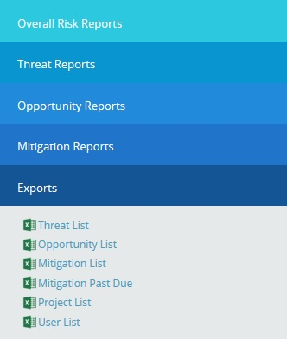
Figure 44

Export threat details:
This functionality is used to export the threat list of all projects assigned to the logged in user into MS Excel. A sample Excel sheet after export (only a few fields are shown) is illustrated in Figure 48.
Steps:
- Portfolio Management ---> Reports ---> Exports
- Click the Threat List link to export. (Figure 44)
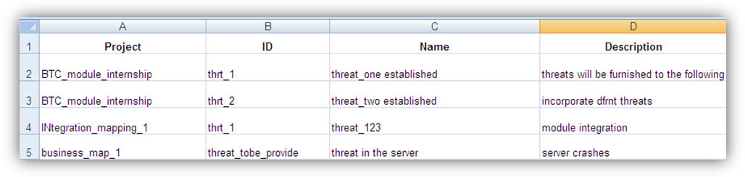
Figure 45

Export opportunity details:
This functionality is used to export the opportunity list of all the projects assigned to the logged in user to MS Excel. A sample Excel sheet after export (only a few fields are shown) is illustrated in Figure 46.
Steps:
- Portfolio Management ---> Reports ---> Exports
- Click the Opportunity List link to export. (Figure 44)
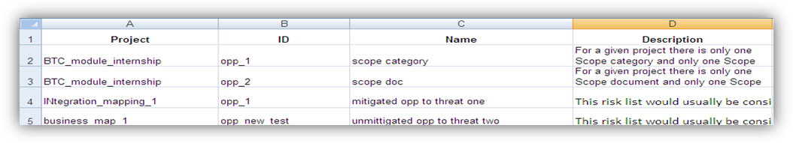
Figure 46

Export mitigation details:
This functionality is used to export the mitigation list of all the projects assigned to the logged in user to MS Excel. A sample Excel sheet after export (only few fields are shown) including the mitigation details (for both threat and opportunity) is illustrated in Figure 47.
Steps:
- Portfolio Management ---> Reports ---> Exports
- Click the Mitigation List link to export. (Figure 44)
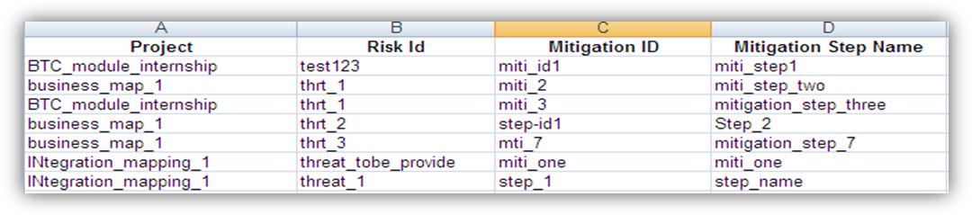
Figure 47

Export Mitigation Past Due details:
This functionality is used to export the mitigation past due list for all projects assigned to the logged in user to MS Excel. A sample sheet is shown (only a few fields are used) in Figure 49. The Number of Days column in the mitigation past due list is calculated as follows:
Number of Days = Current Date - Proposed Mitigation Finish
For example, consider the first row in Figure 49. The Proposed Mitigation Finish is 05/08/2011 and if the current date is 04/18/2012,
Number of days=346
Steps:
- Portfolio Management ---> Reports ---> Exports
- Click the Mitigation Past Due link to export. (Figure 44)

Figure 48

Export User Details:
This functionality is used to export the entire list of users assigned to the logged in user’s projects to MS Excel. The sample sheet shown in Figure 49 lists all the user details.
Steps:
- Portfolio Management ---> Reports ---> Exports
- Click the User List link to export. (Figure 44)
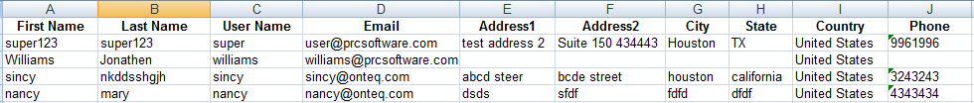

Figure 49

Export Project Details:
This functionality is used to export the entire list of projects assigned to the logged in user to MS Excel. The sample sheet shown in Figure 50 lists all the project details.
Steps:
- Portfolio Management ---> Reports ---> Exports
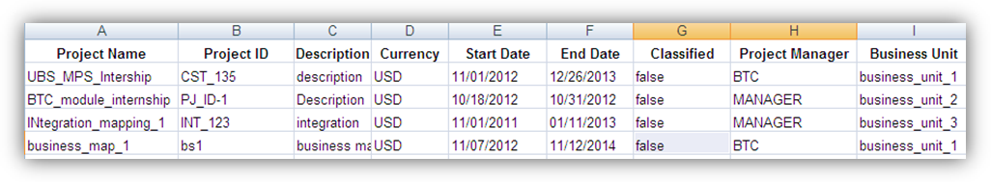
- Click the Project List link to export. (Figure 44)
Figure 50

Portfolio Breakdown Structures
The Portfolio Breakdown Structure page allows the user to setup an Enterprise and Business Unit Level Breakdown Structure. The user can view, import, or manually create a breakdown structure by using the action links in each section. By using the dropdowns in the Portfolio Breakdown Structure page, the user can view the Breakdown Structures for different Business Units/Enterprise level. This page is visible only to those users who have Read/Write access or View access for Portfolio Breakdown Structures. Users with Read/Write access can create, edit, import and delete the Organizational Breakdown Structure, Work Breakdown Structure and Risk Breakdown Structure for enterprise level and business unit level. Users designated with View access can only view the Breakdown Structures for business unit and enterprise levels.
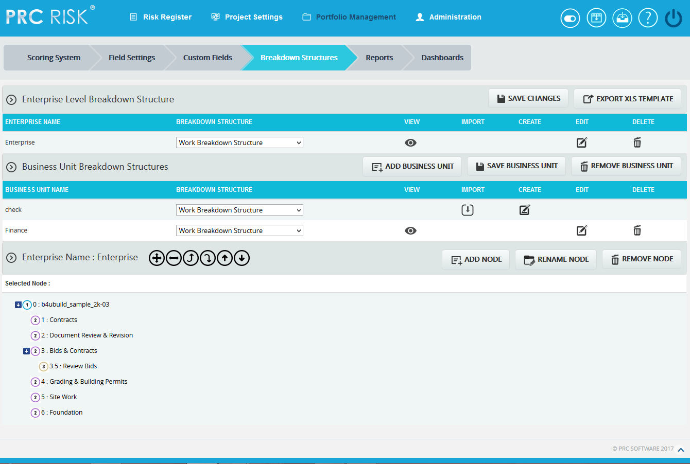
Figure 1

Breakdown Structure:
There are three main breakdown structures: Organizational Breakdown Structure, Work Breakdown Structure and Risk Breakdown Structure. These breakdown structures can be viewed, created, imported, edited and deleted. Each of these functions is explained below in detail.

View:
This functionality is used to view a Breakdown Structure. The steps described below apply to both enterprise and business unit level.
Steps:
- Portfolio Management —> Breakdown Structures
- Select the corresponding breakdown structure from the Breakdown Structure dropdown. (Figure 1)
- Click the corresponding View icon. (Figure 1)
Import:
This functionality is used to Import WBS/OBS/RBS. The steps described below apply to both enterprise and business unit level. This functionality is visible only if no node has been added to the breakdown structure.
Steps:
- Portfolio Management —> Breakdown Structures
- Select the corresponding breakdown structure from the Breakdown Structure dropdown. (Figure 1)
- Click the IMPORT icon. (Figure 1) A pop up appears. (Figure 2)
- Click the Choose File button. Select the required file (csv, xer, mpp, xls). (Figure 2)
- Click the UPLOAD FILE button to finish. (Figure 2)
Sample sheet used for import:
WBS code | Description | Outline Level
A | ABC123 | 1
B | ABC124 | 2
C | ABC125 | 2
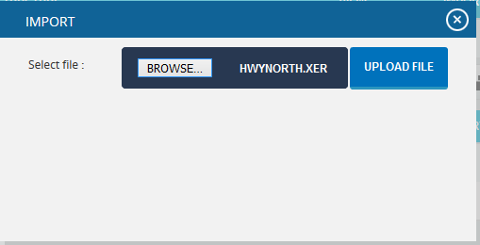

Figure 2

Export XLS template:
This functionality is used to get a sample xls file for importing to the breakdown structures.
Steps:
- Portfolio Management ---> Breakdown Structures
- Click the EXPORT XLS TEMPLATE button. User will get a sample template on excel. (Figure 3)
Sample excel template:
Figure 3

Create:
This functionality helps to create a breakdown structure manually using the tree structure. This is applicable to both enterprise and business unit. This functionality is visible only if no node has been added to the breakdown structure. To create a breakdown structure, click the Create icon. (Figure 1) To add nodes, click the ADD NODE button (Steps are described in detail in Add Node section). (Figure 1)
Edit:
This functionality is used to edit the tree structure. The User can perform operations such as add, remove, rename, expand, collapse, promote, demote, and change the orders of the nodes.
Steps:
- Portfolio Management —> Breakdown Structures
- Click the EDIT icon to edit the tree structure. (Figure 1)

Add Node:
This functionality is used to add a new node.
Steps:
- Portfolio Management —> Breakdown Structures
- Click the EDIT link to edit the tree structure. (Figure 1)
- Click the ADD NODE button. (Figure 1) A pop up appears. (Figure 4)
- Enter the node Name and Code.
- Click the SAVE button to save the details. (Figure 4)
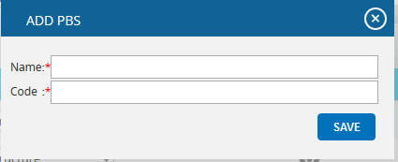
Figure 4

Remove node:
This functionality removes a node from the tree structure.
Steps:
- Portfolio Management —> Breakdown Structures
- Click the EDIT icon to edit the tree structure. (Figure 1)
- Select a node.
- Click the REMOVE NODE button. The node is removed from the system. (Figure 1)

Rename node:
This functionality is used to rename an existing node.
Steps:
- Portfolio Management ---> Breakdown Structures
- Click the EDIT icon to edit the tree structure. (Figure 1)
- Select a node.
- Click the RENAME NODE button. (Figure 1) A pop up appears. (Figure 4)
- Rename the fields needed.
- Click the SAVE button to save the details. (Figure 4)

Expand nodes:
This functionality is used to expand all the nodes under the tree structure.
Steps:
- Portfolio Management ---> Breakdown Structures
- Select a node.
- Click the Expand All icon to expand all the nodes. (Figure 6) Upon Expansion, the tree structure will be displayed as shown in Figure 5.

Collapse Nodes:
This functionality is used to collapse the expanded nodes as shown in Figure 6.
Steps:
- Portfolio Management ---> Breakdown Structures
- Select a node.
- Click the Collapse All icon shown in Figure 5. The nodes are collapsed and the tree structure will be displayed as shown in Figure 6.
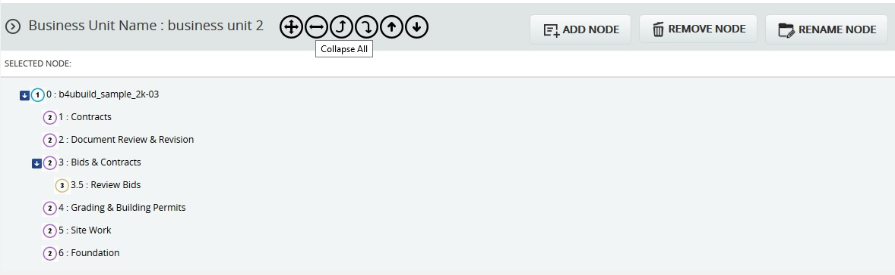
Figure 5
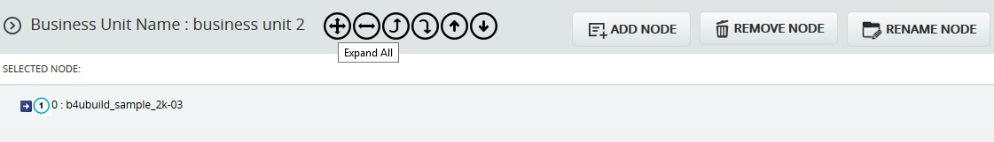
Figure 6

Promote nodes:
This functionality makes the level of the child node the same as that of the immediate parent. For example, consider the node 6: Foundation (Figure 7) which is a child of the node 5: Site Work. When promoted, 6: Foundation is on the same level as 5: Site Work (Figure 8). A node cannot be promoted if it does not have a parent.
Steps:
  - Portfolio Management ---> Breakdown Structures
  - Click the EDIT icon to edit the tree structure. (Figure 1)
  - Select a node.
  - Click the Promote icon to promote the node.
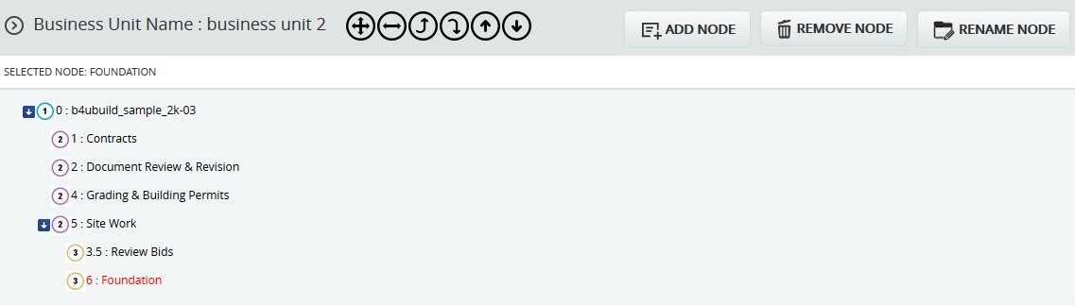
Figure 7
Figure 8

Demote nodes:
When a node is demoted it becomes the child of the node which is of same level and which lies just below it. For Example, consider the node 4: Grading & Building Permits (Figure 8), which is of the same level as the node 2: Document Review & Revision. When 4: Grading & Building Permits is demoted, it becomes a child node of the node 2: Document Review & Revision. (Figure 9) A node cannot be demoted if there is no other node of same level as the node selected.
Steps:
- Portfolio Management ---> Manage Breakdown Structures
- Click the EDIT icon to edit the tree structure. (Figure 1)
- Select node.
- Click the Demote icon to demote a node.
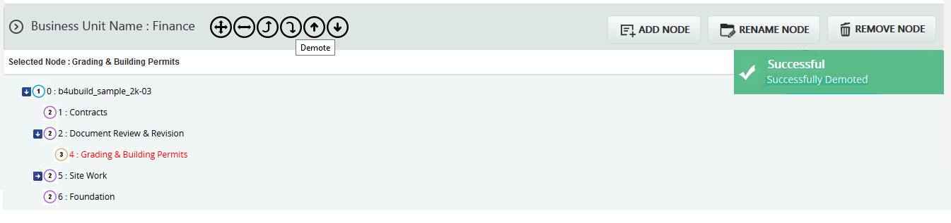
Figure 9

Up Order:
This operation is used to move a node up a level. It can be applied only to the nodes of the same level and this operation is not applicable for the first node. For example, consider the nodes 6: Foundation and 5: Site Work in Figure 9. The node 6: Foundation is located below the node 5: Site Work. When an Up Order operation is applied to the node 6: Foundation, it moves above the node 5: Site Work. Figure 10 shows the tree structure after the Up Order operation is applied.
Steps:
- Portfolio Management ---> Manage Breakdown Structures
- Click the EDIT icon to edit the tree structure. (Figure 1)
- Select node.
- Click the Up Order icon to move up the node up the tree structure.
Figure 10
Down Order:
This operation is used to move a node down the tree structure. This can be applied only to nodes of the same level and this operation is not applicable for the last node. For example, consider nodes 1: Contracts and 2: Document Review & Revision in Figure 10. 1: Contracts is located above 2: Document Review & Revision in Figure 10. When a Down Order operation is applied to the node 1: Contracts, it comes below the node 2: Document Review & Revision. Refer to Figure 11, which shows the tree structure after a Down Order operation is applied.
Steps:
- Portfolio Management ---> Manage Breakdown Structures
- Click the EDIT icon to edit the tree structure. (Figure 1)
- Select the node.
- Click the Down Order icon to move up the node down the tree structure.
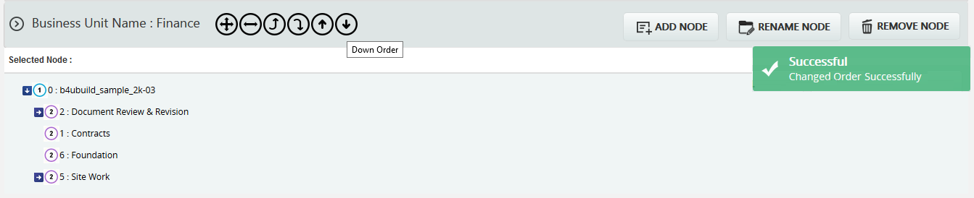
Figure 11

Delete:
This functionality is used to delete the selected breakdown structure from business unit and enterprise level. The steps described below apply to both enterprise breakdown structure and business unit breakdown structure.
Steps:
- Portfolio Management ---> Manage Breakdown Structures
- Click the corresponding DELETE icon. (Figure 1)
- After you receive the confirmation message, click the OK button to delete the breakdown structure. To cancel, click the Cancel button.

Save Changes:
This functionality is used to save the Enterprise Name when its first added. To save the Enterprise Name, click the SAVE CHANGES button. (Figure 1)

Add business Unit:
This functionality is used to add a business unit.
Steps:
- Portfolio Management ---> Manage Breakdown Structures
- Enter the business unit name.
- Click the SAVE BUSINESS UNIT button to save the Business Unit Name. (Figure 1)

Remove Business Unit:
This functionality is used to remove the business unit. Only those business units which are not assigned to any project can be removed.
There are two ways to remove a business unit. The first method is to delete multiple business units and the second is to delete them individually.
Delete Multiple Business Units:
Steps:
- Portfolio Management ---> Manage Breakdown Structures
- Click the REMOVE BUSINESS UNIT button. (Figure 1) A pop up appears. (Figure 12)
- Click the DELETE MULTIPLE button. (Figure 12)
- Select the required business units by using the checkboxes provided. (Figure 13)
- Click the DELETE button to delete the selected business units. (Figure 13)

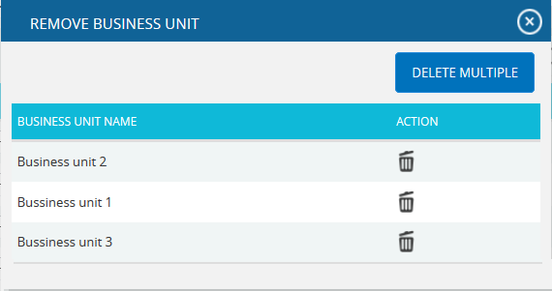

Figure 12

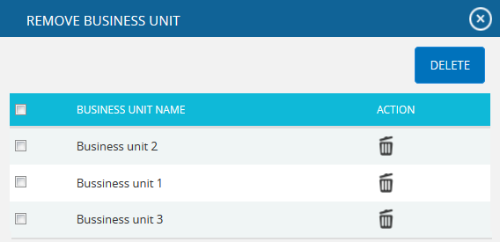

Figure 13
Delete Individually:
To delete the business units individually consider the following steps.
Steps:
- Portfolio Management ---> Manage Breakdown Structures
- C
- Click the corresponding Delete icon. (Figure 12)
- After you receive the confirmation message, click the OK button. The business unit is now removed from the system. To cancel, click the Cancel button. (Figure 14)
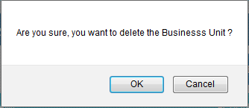
Figure 14

Custom Fields (Portfolio)
The Custom Fields (Portfolio) page allows you to create a template with custom fields or formulas that can be applied to your project. These templates are saved in the system and can be reused for future projects. When creating a custom field, the user will be given the options to choose the data type (text, date, number, currency, list) and location displayed (threat, opportunity, or mitigation sections). When creating a formula field, the user will be given the options to choose the location displayed (threat, opportunity, or mitigation sections).
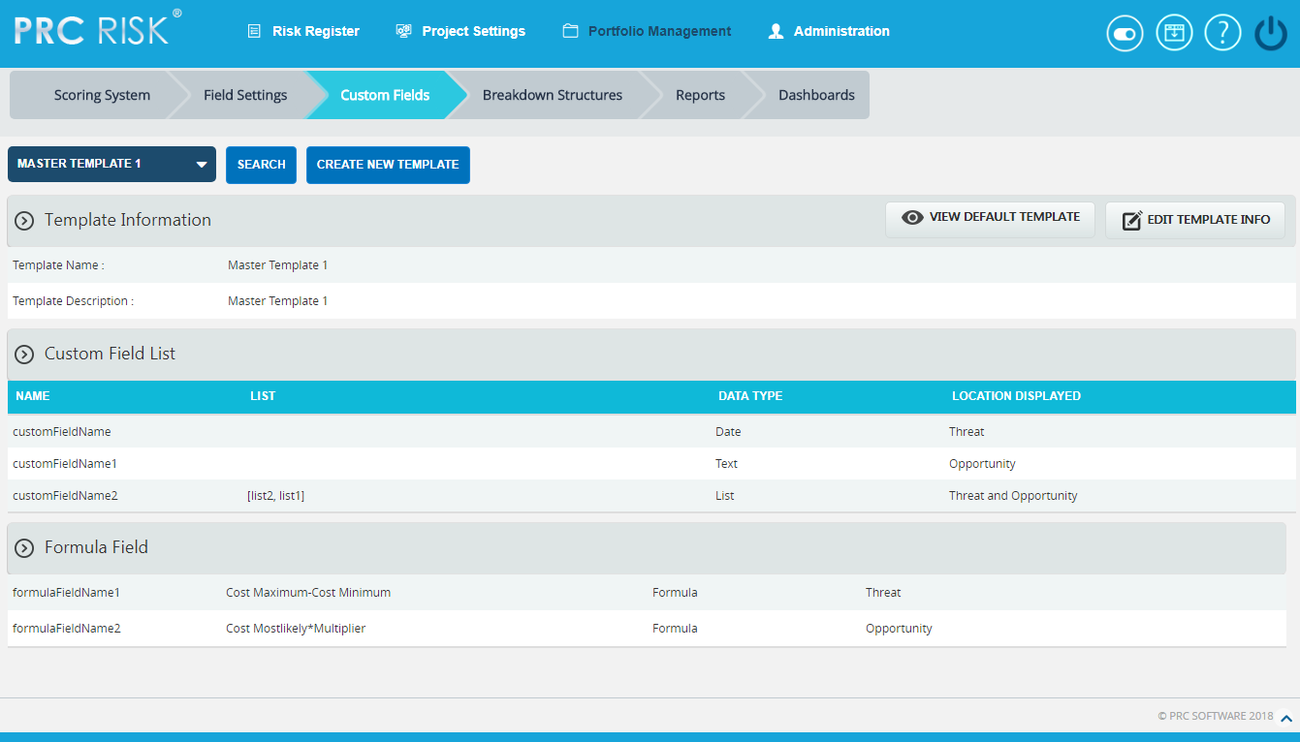
Figure 1

Searching For Templates:
Searching for templates in the Custom Fields (Portfolio) can be done in two ways. The Search function allows the user to search for a template based on a keyword. This method is faster when you are working with a large amount of data. The Select function is commonly used for databases with less data and when the search objective is known.

Using the search function:
Steps:
- Portfolio Management —> Custom Fields
- Click the SEARCH button. (Figure 1)
- Enter the search keyword (which can be the Template Name or Template Description). Click the SEARCH button and select the required template. (Figure 2)
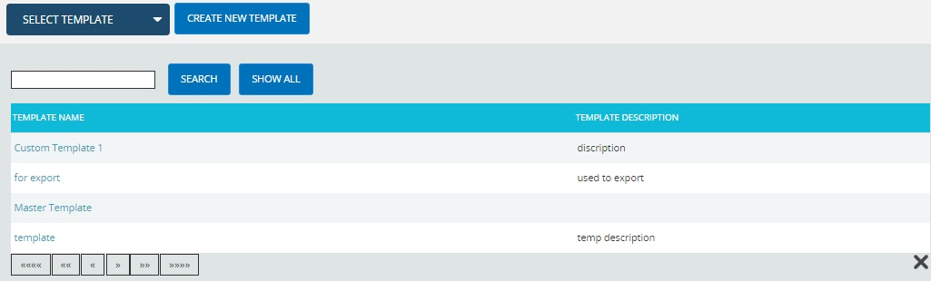
Figure 2
The SHOW ALL button in the search area lists all the templates available (By default).
Using the select function (dropdown list):
Steps:
- Portfolio Management —> Custom Fields
- Click the Select Template dropdown. (Figure 1)
- Select the required template from the list shown.

Creating a new template:
Creating a new template is quick and easy. The Template Name is a required field to save the template.
Steps:
- Portfolio Management —> Custom Fields
- Click the CREATE NEW TEMPLATE button. (Figure 1)
- After entering template details, click the SAVE TEMPLATE button. (Figure 3)

Edit Template Information:
While editing the details of a template, the fields Template Name and Template Description will be unlocked.
Steps:
- Portfolio Management —> Custom Fields
- Select the required template.
- Click the EDIT TEMPLATE INFO button. (Figure 1)
- After the data is modified, click the SAVE TEMPLATE button to finish. (Figure 3)

Creating default template:
This functionality is to create a Master Template. Only once the default template can be created and is done by Super User.
Steps:
- Portfolio Management —> Custom Fields
- Click the CREATE DEFAULT TEMPLATE button. (Figure 1)
- After entering the template details, click the SAVE button.

View Default Template:
To view the Master Template, click the VIEW DEFAULT TEMPLATE button. (Figure 3)

Add Custom Field:
This functionality is used to add a new custom field to the selected template.
Steps:
- Portfolio Management ---> Custom Fields
- Select the required template.
- Click the EDIT TEMPLATE INFO button. (Figure 1)
- Click the ADD CUSTOM FIELD button. (Figure 3)
- Enter the custom field name in the textbox provided. (Figure 3)
- Select the data type from the DATA TYPE dropdown. (Figure 3)
- For the data type List, Enter the value in the Editable Combo box provided and click the Add link. (Figure 3)
- Select location displayed from the LOCATION DISPLAYED dropdown. (Figure 3)
- Click the SAVE TEMPLATE button to finish. (Figure 3)

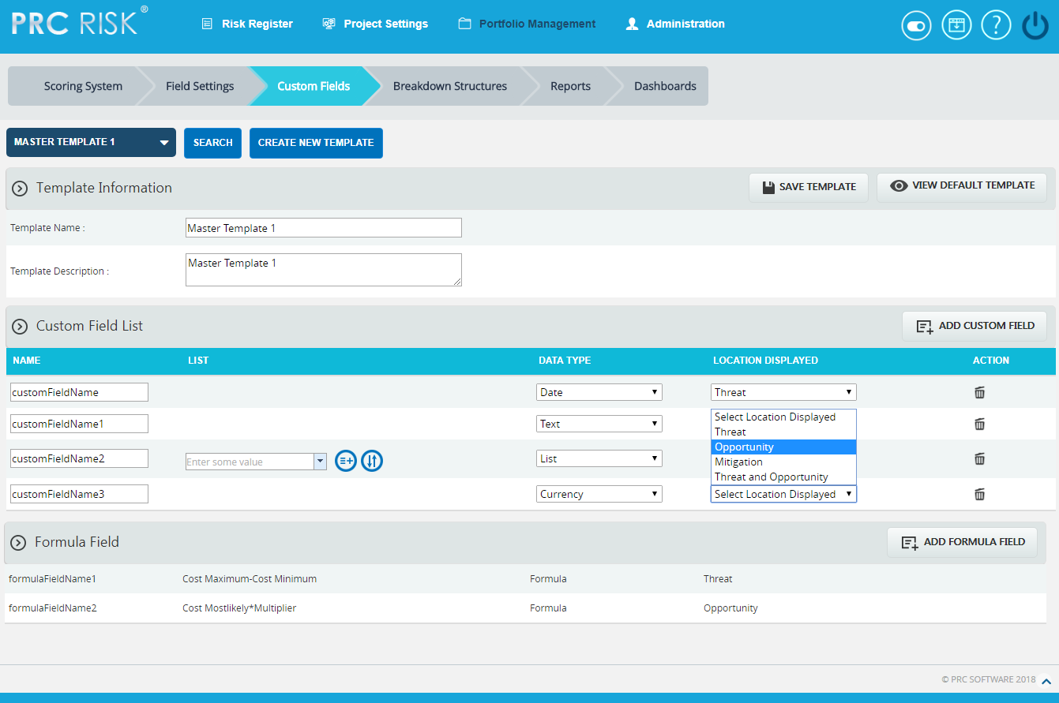
Figure 3

Edit Custom Fields:
This functionality is used to edit custom fields.
Steps:
- Portfolio Management ---> Custom Fields
- Select the required template.
- Click the EDIT TEMPLATE INFO button. (Figure 1)
- Edit the necessary details. For custom fields with data type List, enter the value in the Editable Combo box provided and click the ADD icon to add list values. (Figure 3)
- To rename the existing value, select any value from the dropdown list and click the RENAME icon after renaming it. (Figure 4) Similarly select the list value from the dropdown and click the DELETE icon to delete the value from the list. (Figure 5) Also to re-order the list, select the RE-ORDER icon (Figure 6) and the Re-order List Options box appears. (Figure 7)
- Click the SAVE TEMPLATE button to finish. (Figure 8)
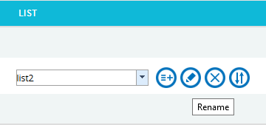
Figure 4
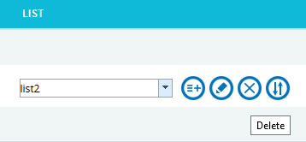
Figure 5
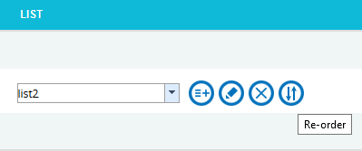
Figure 6
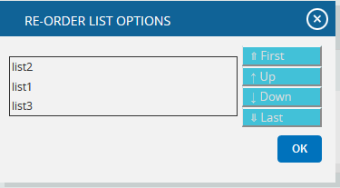
Figure 7

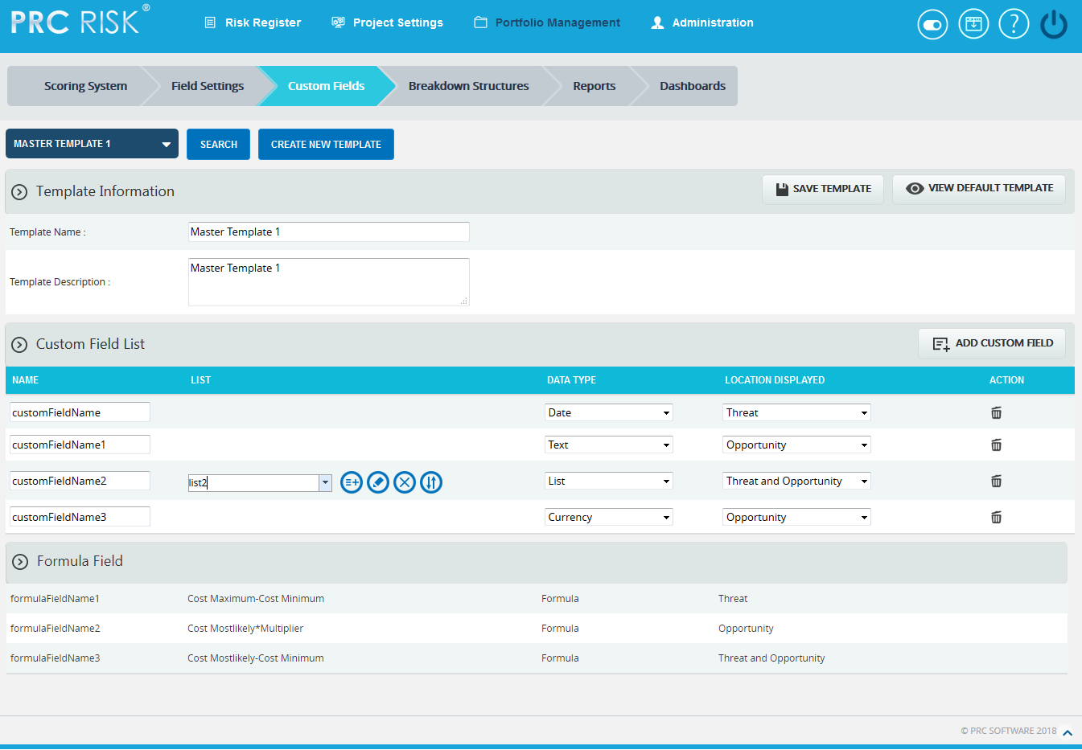
Figure 8

Delete Custom Fields:
This functionality is used to delete the custom fields.
Steps:
- Portfolio Management ---> Custom Fields
- Select the required template.
- Click the EDIT TEMPLATE INFO button. (Figure 1)
- Click the Delete icon to delete the required custom field. (Figure 3)
After you receive the confirmation message (Figure 9) click the OK button to delete the custom field. To cancel, click the Cancel button. (Figure 9)

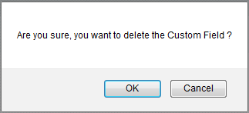
Figure 9

Add Formula Field:
This functionality is used to add a new formula field to the selected template.
Steps:
- Portfolio Management ---> Custom Fields
- Select the required template.
- Click the EDIT TEMPLATE INFO button. (Figure 1)
- Click the ADD FORMULA FIELD button. (Figure 10)
- Enter the formula field name in the textbox provided. (Figure 10)
The only data type is Formula and the same will be mentioned in the DATA TYPE dropdown.
- Select location displayed from the LOCATION DISPLAYED dropdown. (Figure 10)
- Click Create Formula and ADD FORMULA FIELD pop up appears. (Figure 11)
- Select field from the list and insert the operator as required. (Figure 12)
- Click SAVE button to save the formula or click RESET to clear the formula.
- Click the SAVE TEMPLATE button to finish. (Figure 10)

Edit Formula Fields:
This functionality is used to edit formula fields.
Steps:
- Portfolio Management ---> Custom Fields
- Select the required template.
- Click the EDIT TEMPLATE INFO button. (Figure 1)
- Click the ADD FORMULA FIELD button. (Figure 10)
- Edit the formula field name if necessary.
- Formula can be edited by clicking Edit Formula. ADD FORMULA FIELD pop up appears. (Figure 11)
- Edit the necessary changes
- Click SAVE button to save the formula or click RESET to clear the formula.
DATA TYPE and LOCATION DISPLAYED cannot be edited.
- Click the SAVE TEMPLATE button to finish. (Figure 10)
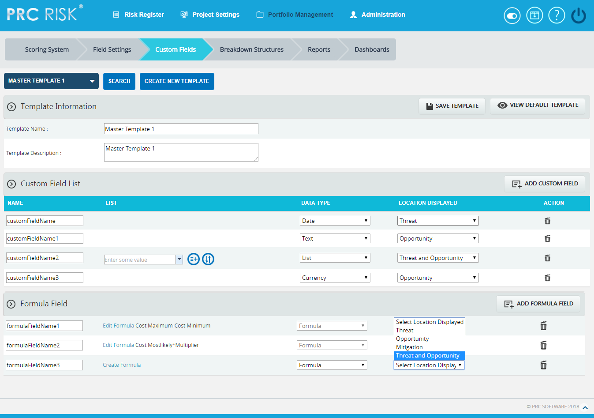
Figure 10
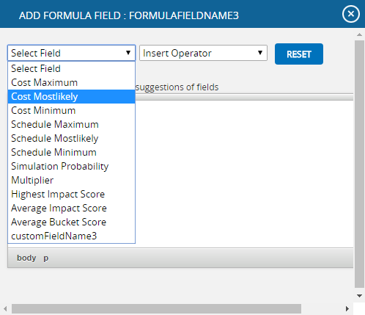
Figure 11
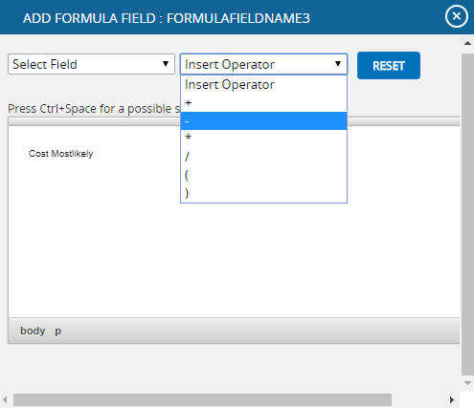
Figure 12

Delete Formula Fields:
This functionality is used to delete the formula fields.
Steps:
- Portfolio Management ---> Custom Fields
- Select the required template.
- Click the EDIT TEMPLATE INFO button. (Figure 1)
- Click the ADD FORMULA FIELD button. (Figure 10)
- Click the Delete icon to delete the required formula field. (Figure 10)
After you receive the confirmation message (Figure 13) click the OK button to delete the formula field. To cancel, click the Cancel button. (Figure 13)
- Click the SAVE TEMPLATE button to finish. (Figure 10)
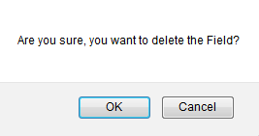
Figure 13

Field Settings (Portfolio)
The Field Settings page contains general template information. In the Field Settings page, the user can customize the Threat Fields, Opportunity Fields, Mitigation Plan Fields, Mitigation Step Fields, Closure Section Fields, Qualitative score fields, Simulation Fields, Data Mapping Fields, Risk Notes Fields and Recovery Plan Fields. The Field Settings page in the PRC Enterprise Risk Register can be viewed only by those users who have either Read/Write or View access. Users with only Read/Write access can create a new template, edit template information and show/hide fields. Users designated with View Access may view the selected template.
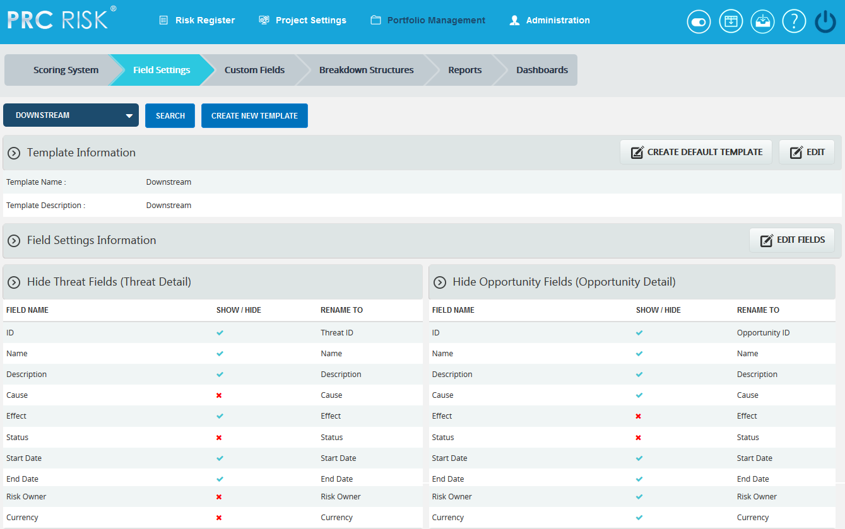
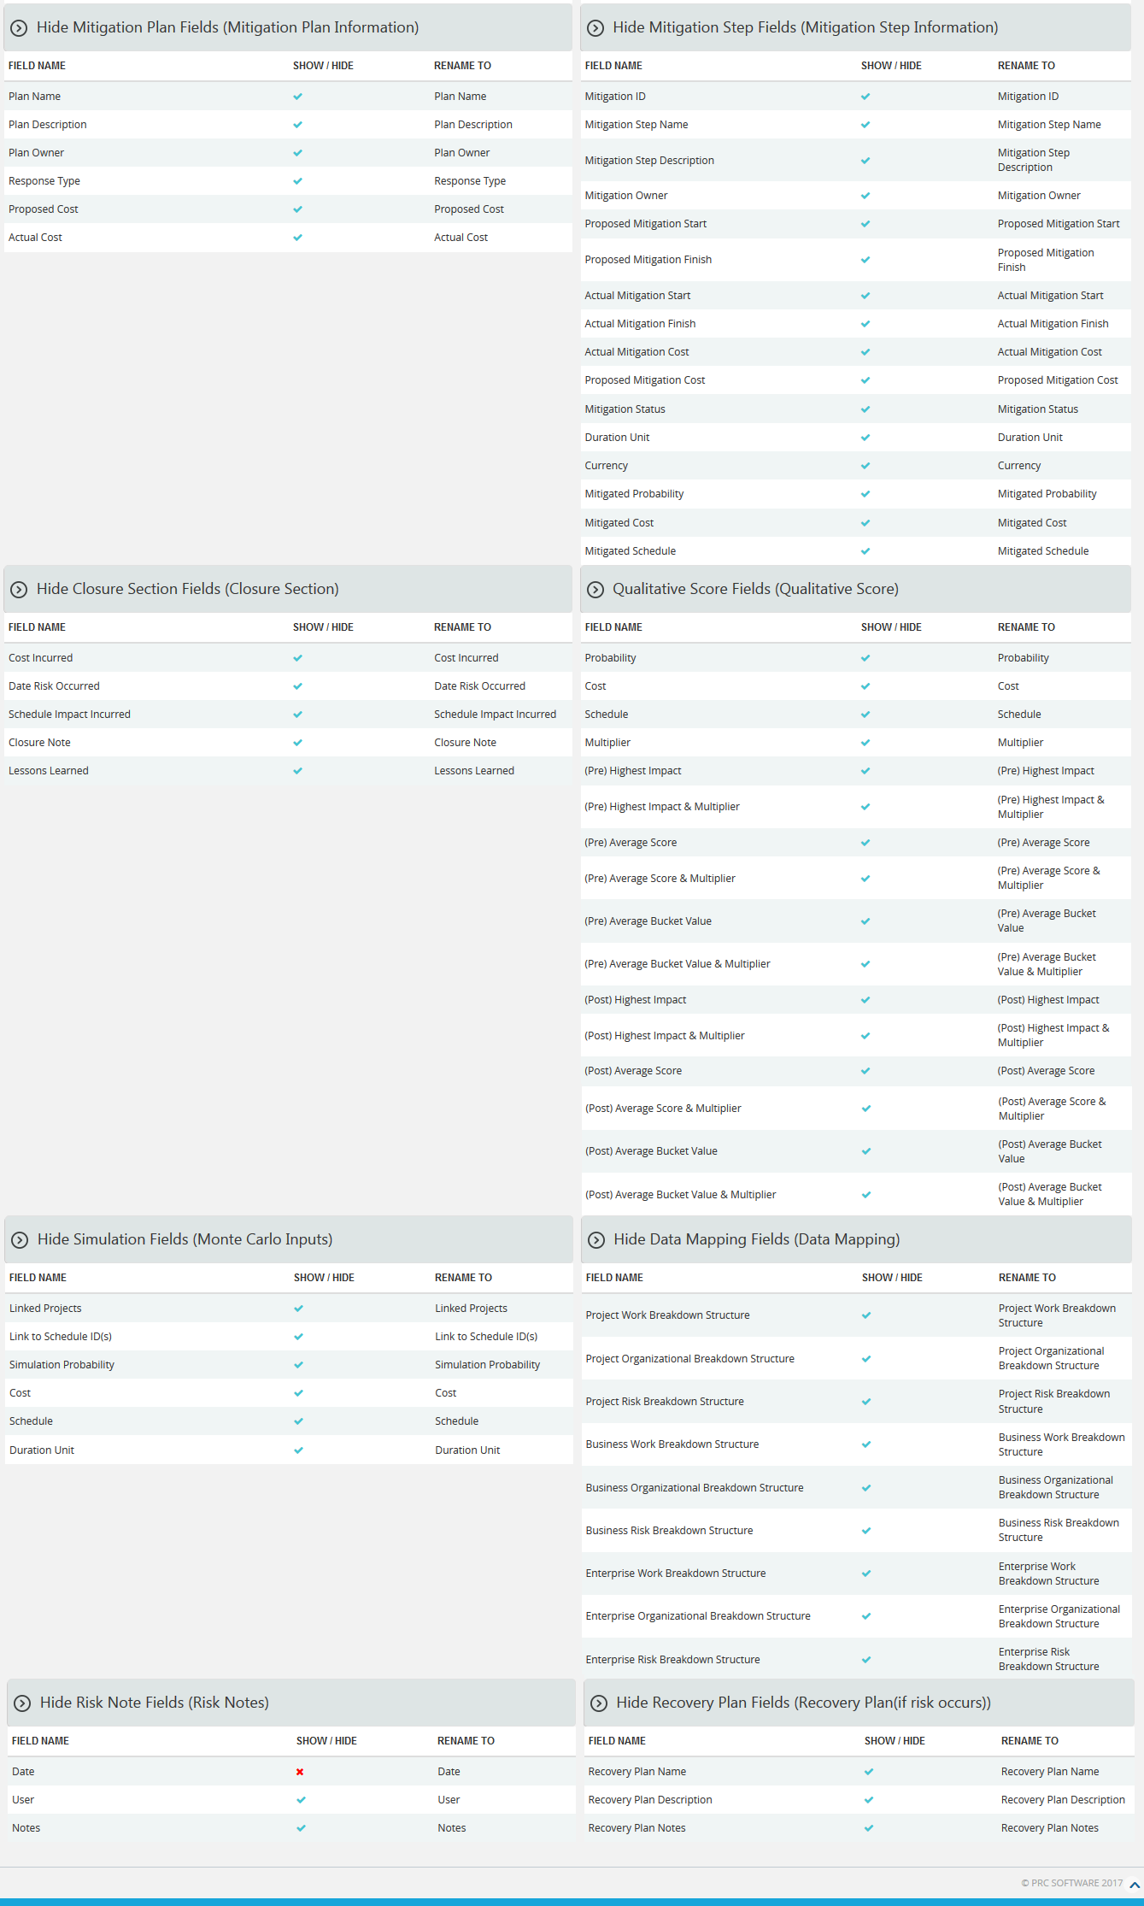
Figure 1

Searching For Templates:
Searching for templates in the Field Settings page can be done in two ways. The Search function allows the user to search for a template based on a keyword. This method is faster when you are working with large amounts of data. The Select function is commonly used for databases with less data and when the search objective is known.
Using the search function:
Steps:
- Portfolio Management —> Field Settings
- Click the SEARCH button. (Figure 1)
- Enter the search keyword (which can be the Template Name or Template Description). Click the SEARCH button and select the required template. (Figure 2)
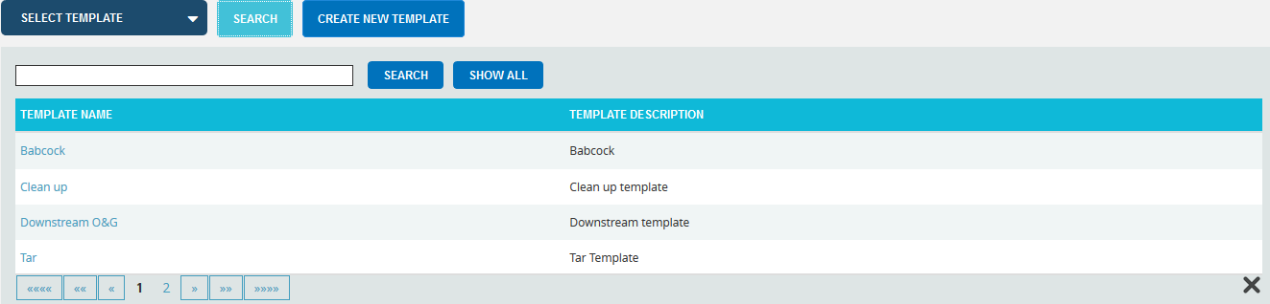
Figure 2
The SHOW ALL button in the search area lists all the templates available (By default).
Using the select function (dropdown list):
Steps:
- Portfolio Management —> Field Settings
- Click the Select Template dropdown. (Figure 1)
- Select the required template from the list shown.

Creating a new template:
Creating a new template is quick and easy. The Template Name is a required field to save the template.
Steps:
- Portfolio Management —> Field Settings
- Click the CREATE NEW TEMPLATE button. (Figure 1)
- After entering template details, click the SAVE button.

Creating default template:
This functionality is used to create a Master Template. Only once the default template can be created and is done by Super User.
Steps:
- Portfolio Management —> Field Settings
- Click the CREATE DEFAULT TEMPLATE button. (Figure 1) or (Figure 2)
- After entering template details, click the SAVE button.

View Default Template:
To view the default template (Master Template), click the VIEW DEFAULT TEMPLATE button. (Figure 1)

Edit Template Information:
While editing the template details, the fields Template Name and Template Description will be unlocked.
Steps:
- Portfolio Management —> Field Settings
- Select the required template.
- Click the EDIT button. (Figure 1)
- After the data is modified, click the SAVE button.

Edit Fields:
This functionality is used to modify the name of each section and fields of the template.
Steps:
- Portfolio Management —> Field Settings
- Click EDIT FIELDS button to modify. (Figure 1)
- Enter the name in the textbox provided, shown at the top of the section (the default name is given) and rename the fields. (Figure 3)
- After editing the changes, click the SAVE ALL button to save the changes. (Figure 3)

Show/ Hide:
Show/Hide applies to each section. As an example, Figure 3 shows the Closure section with the Hide Closure Section Fields in the upper left corner. However, the steps described below apply to all sections.
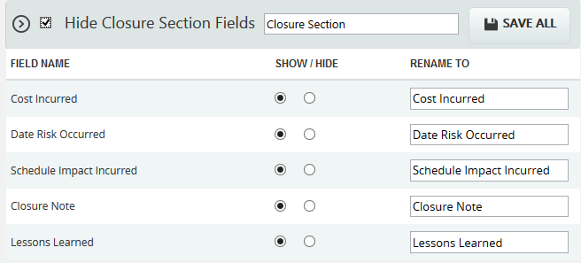
Figure 3
In order to hide the entire section, click the checkbox shown near the section header and click the SAVE ALL button to save the changes. (Figure 3)
To show a field, click the Radio button under the Show column (Figure 3) and click the SAVE ALL button to save the changes.
To hide a field, click the Radio button under the Hide column (Figure 3) and click the SAVE ALL button to save the changes.

Edit Status Options (Threat / Opportunity):
To add, edit or delete the user editable status options. These statuses are categorized into two: open and closed. The statuses checked in SHOW checkbox is only shown in the status list for the mitigations in the Risk Details or Spreadsheet page.
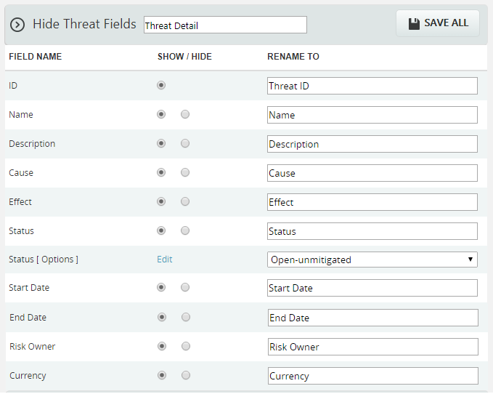
Figure 4
Steps:
- Click the Edit link. (Figure 4)
- A pop up appears where the user can add or edit the status options. (Figure 5)
- Click the ADD button to add a new status option. (Figure 5)
- Click the EDIT button to edit the saved status options. (Figure 5)
- To delete the status, click the DELETE icon. (Figure 6)
- Click the SAVE button to save the changes made. (Figure 6)
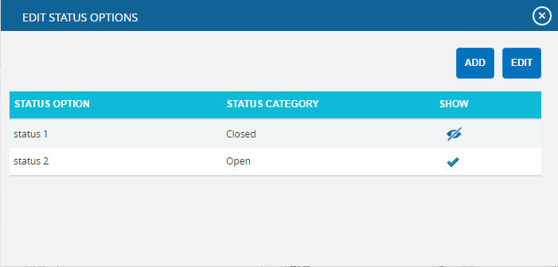
Figure 5

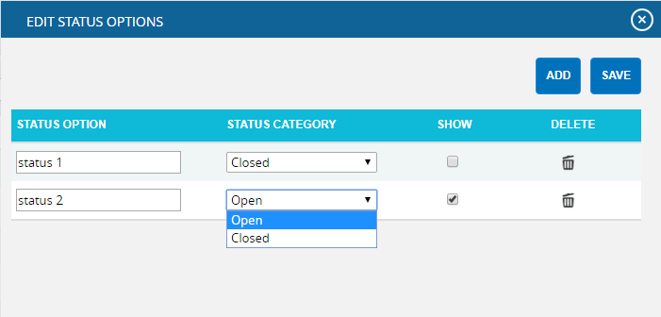
Figure 6
Edit Status Options (Mitigation):
To add, edit or delete the user defined mitigation status options. These statuses are categorized into Proposed, In Progress, Rejected, Complete, Risk Closed and Approved. The statuses checked in SHOW checkbox is only shown in the status list for the mitigations in the Risk Details or Spreadsheet page.
Steps:
- Click the Edit link. (Figure 7)
- A pop up appears where the user can add or edit the mitigation status options. (Figure 8)
- Click the ADD button to add new mitigation status option. (Figure 8)
- Click the EDIT button to edit the saved mitigation status options. (Figure 8)
- To delete the mitigation status, click DELETE icon. (Figure 9)
- Click the SAVE button to save the changes made. (Figure 9)
Figure 7

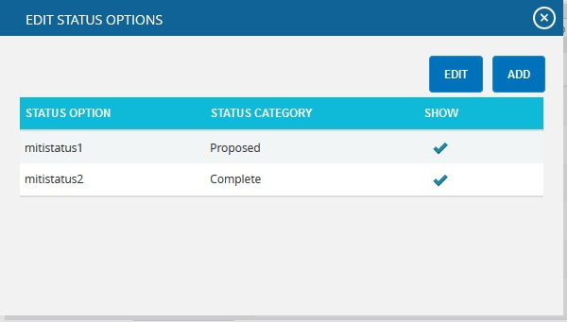

Figure 8

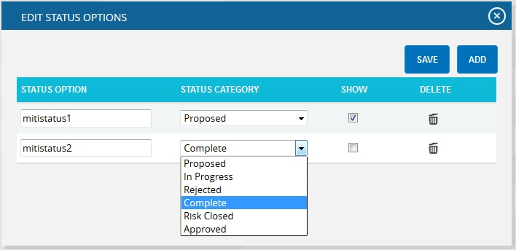
Figure 9

PROJECT SETTINGS

Project Breakdown Structure
The Project Breakdown Structure page allows the user to setup a Project Level Breakdown Structure. The user can view, import, or manually create a Project Breakdown Structure page by using the appropriate action links. By using the drop downs in the Project Breakdown Structure page, the user can view the Work Breakdown Structure, Organizational Breakdown Structure, and Risk Breakdown Structure for the current project.
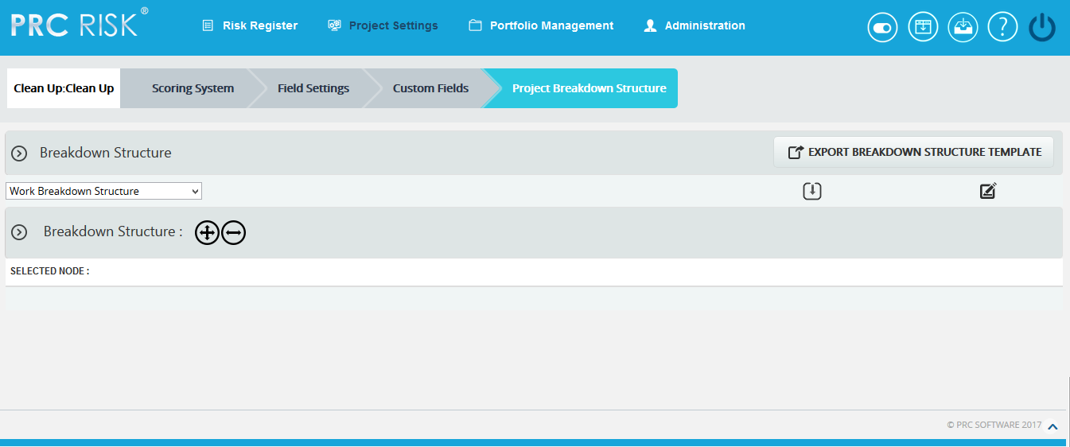
Figure 1
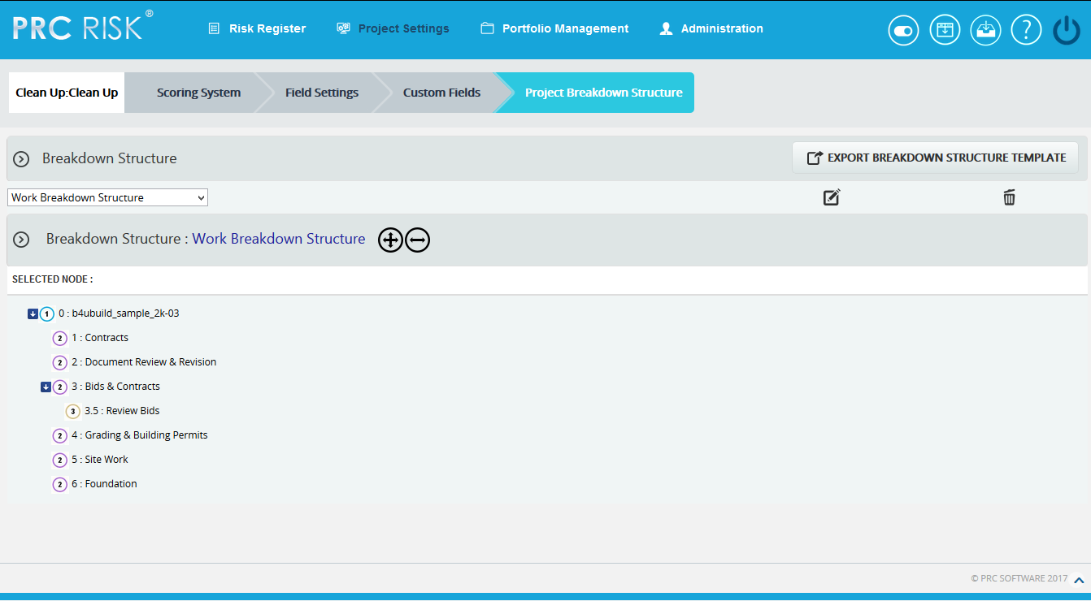
Figure 2

Breakdown Structure:
There are mainly three breakdown structures; such as Organizational Breakdown Structure, Work Breakdown Structure and Risk Breakdown structure. These breakdown structures can be viewed, created, imported, edited and deleted. Each of these methods is explained in detail below:

Import:
This functionality is used to Import Breakdown Structures. This functionality is visible only if no node has been added to the breakdown structure.
Steps:
- Project Settings —>Project Breakdown Structure
- Select the corresponding breakdown structure from the Breakdown Structure dropdown. (Figure 1)
- Click the Import icon. (Figure 1) A pop up appears. (Figure 3)
- Click the BROWSE button. Select the required file (csv, xer, mpp, xls). (Figure 3)
- Click the UPLOAD FILE button to finish. (Figure 3)

Sample sheet used for import:
WBS code | Description | Outline Level
A | ABC123 | 1
B | ABC124 | 2
C | ABC125 | 2
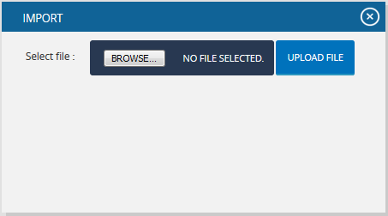
Figure 3

Create:
This functionality helps to create a breakdown structure manually using the tree structure. This functionality is visible only if no node has been added to the breakdown structure. To create a breakdown structure, click the Create link. (Figure 1) To add nodes, click the Add Node button (steps are described in detail in Add Node section). (Figure 2)

Add Node:
This functionality is used to add a new node.
Steps:
- Project Settings —>Project Breakdown Structure
- Click the Edit icon to edit the tree structure. (Figure 6)
- Click the ADD NODE button. (Figure 6) A pop up appears. (Figure 4)
- Enter node name and code.
- Click the SAVE button to save the details. (Figure 4)
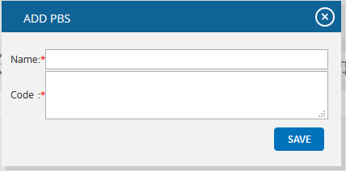
Figure 4

Remove node:
This functionality removes a node.
Steps:
- Project Settings —>Project Breakdown Structure
- Click the Edit icon to edit the tree structure. (Figure 2)
- Select a node.
- Click the REMOVE NODE button. The node is removed from the system. (Figure 6)

Rename node:
This functionality is used to rename an existing node.
Steps:
  - Project Settings —>Project Breakdown Structure
  - Click the Edit icon to edit the tree structure. (Figure 2)
  - Select a node.
  - Click the RENAME NODE button. (Figure 6) A pop up appears. (Figure 5)
  - Rename the fields needed.
  - Click the SAVE button to save the details. (Figure 5)
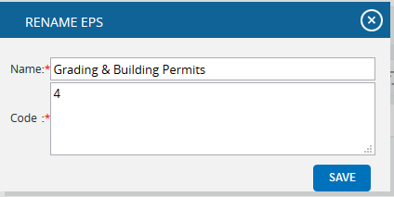
Figure 5

Expand nodes:
This functionality is used to expand all the nodes under tree the structure.
Steps:
- Project Settings --->Project Breakdown Structure
- Select node.
- Click the Expand icon to expand all the nodes. (Figure 7) On expansion, the tree structure becomes as shown in Figure 6.

Collapse Nodes:
This functionality is used to collapse the expanded nodes shown in Figure 7.
Steps:
- Project Settings --->Project Breakdown Structure
- Select node.
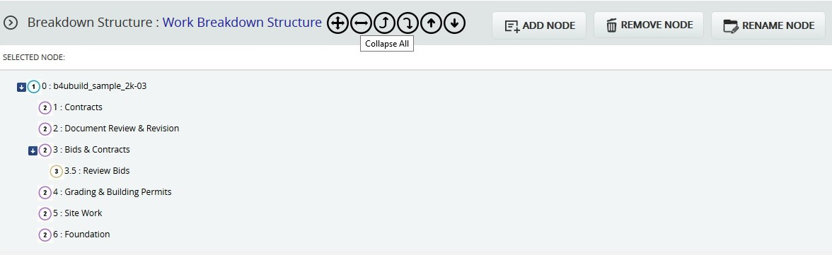
- Click the Collapse icon shown in Figure 6. The Nodes get collapsed and the tree structure becomes as shown in Figure 7.

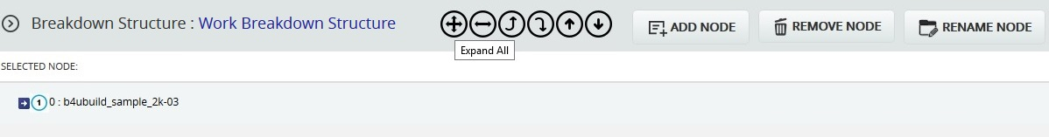
Figure 6
Figure 7

Promote Nodes:
This functionality makes the level of the child node the same as that of the immediate parent. For example, consider the node 6: Foundation (Figure 8) which is a child of the node 5: Site Work. When promoted, 6: Foundation is on the same level as 5: Site Work (Figure 9). A node cannot be promoted if it does not have a parent.
Steps:
- Project Settings --->Project Breakdown Structure
- Click the Edit icon to edit the tree structure. (Figure 2)
- Select node.
- Click the Promote icon to promote the node.
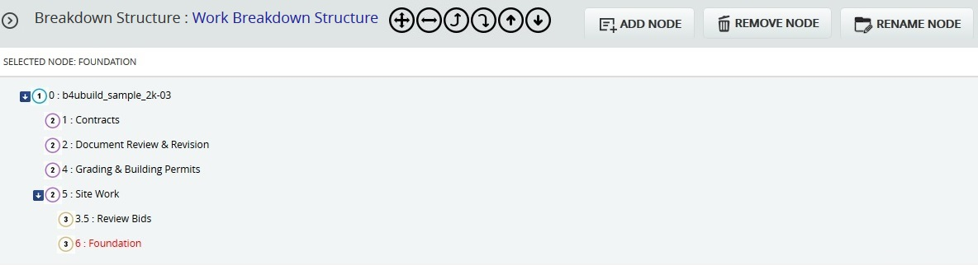
Figure 8
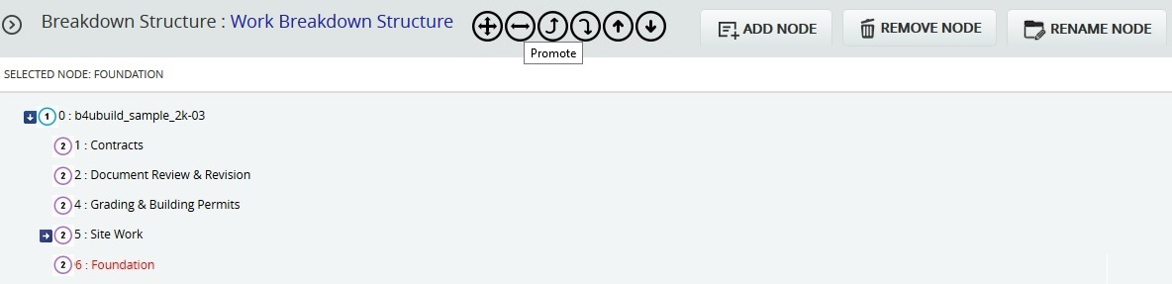
Figure 9

Demote Nodes:
When a node is demoted it becomes the child of the node which is of same level and which lies just below it. For Example, consider the node 4: Grading & Building Permits (Figure 9), which is of the same level as the node 2: Document Review & Revision. When 4: Grading & Building Permits is demoted, it becomes a child node of the node 2: Document Review & Revision. (Figure 10) A node cannot be demoted if there is no other node of same level as the node selected.
Steps:
- Project Settings --->Project Breakdown Structure
- Click the Edit icon to edit the tree structure. (Figure 2)
- Select the node.
- Click the Demote icon to demote the node.

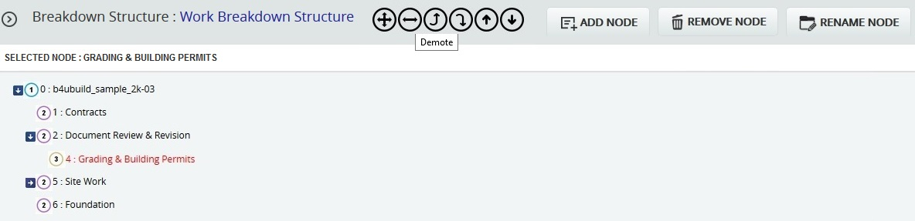
Figure 10

Up Order:
This operation is used to move a node up. The Up Order can be applied only to nodes of the same level and this operation is not applicable for the first node. For example, consider the nodes 6: Foundation and 5: Site Work in Figure 10. The node 6: Foundation is located below the node 5: Site Work. When an Up Order operation is applied to the node 6: Foundation, it moves above the node 5: Site Work. Figure 11 shows the tree structure after the Up Order operation is applied.

Steps:
- Project Settings --->Project Breakdown Structure
- Click the Edit icon to edit the tree structure. (Figure 2)
- Select the node.
- Click the Up Order icon to change the order of a node up.
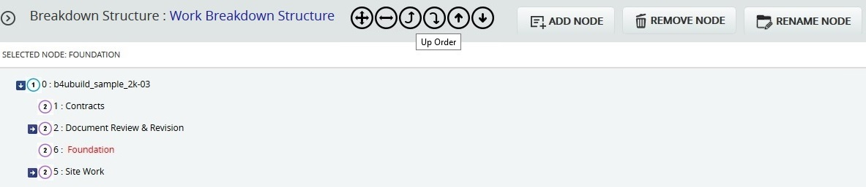

Figure 11

Down Order:
This operation is used to move a node down the tree structure. This can be applied only to nodes of the same level and this operation is not applicable for the last node. For example, consider nodes 1: Contracts and 2: Document Review & Revision in Figure 11. 1: Contracts is located above 2: Document Review & Revision in Figure 11. When a down order operation is applied to the node 1: Contracts, it comes below the node 2: Document Review & Revision. Refer to Figure 12, which shows the tree structure after a Down Order operation is applied.
Steps:
- Project Settings --->Project Breakdown Structure
- Click the Edit icon to edit the tree structure. (Figure 2)
- Select the node.
- Click the Down Order icon to change the order of a node down.
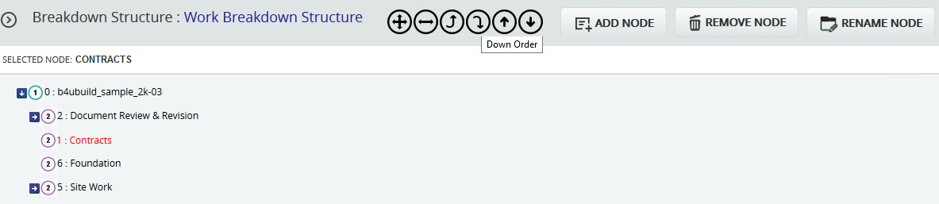

Figure 12

Delete:
This functionality is used to delete the selected breakdown structure.
Steps:
- Project Settings --->Project Breakdown Structure
- Click the corresponding Delete icon. (Figure 2)
- After you receive the confirmation message, click the OK button to delete the breakdown structure. To cancel, click the Cancel button.

Save:
This functionality is used to save the changes made to the Project Level Breakdown Structure.

Edit:
This functionality is used to edit the tree structure. The User can perform operations such as add, remove, rename, expand, collapse, promote, demote nodes as well as change the orders of the nodes.
Steps:
- Project Settings --->Project Breakdown Structure
- Click the Edit icon to edit the tree structure. (Figure 2)

Scoring System (Project)
The Scoring System page allows the user to view or update project settings. The data displayed on this page is the most current data being used on the project. When a project is first created the system applies a default setting. The default project settings can be changed by applying a portfolio template or manually adjusting it in the Scoring System page. The Scoring System will be locked once a threat or opportunity has been scored, and no changes can be made to the Scoring System page. The Scoring System page in the PRC Enterprise Risk Register can be viewed only by those users who have either Read/Write or View access. Users with only Read/Write access can edit probability and tolerance levels, edit impacts, edit the risk matrix, add new impacts and delete additional impacts. Users designated with View Access may view probability and tolerance levels, view impacts and also view the risk matrix.
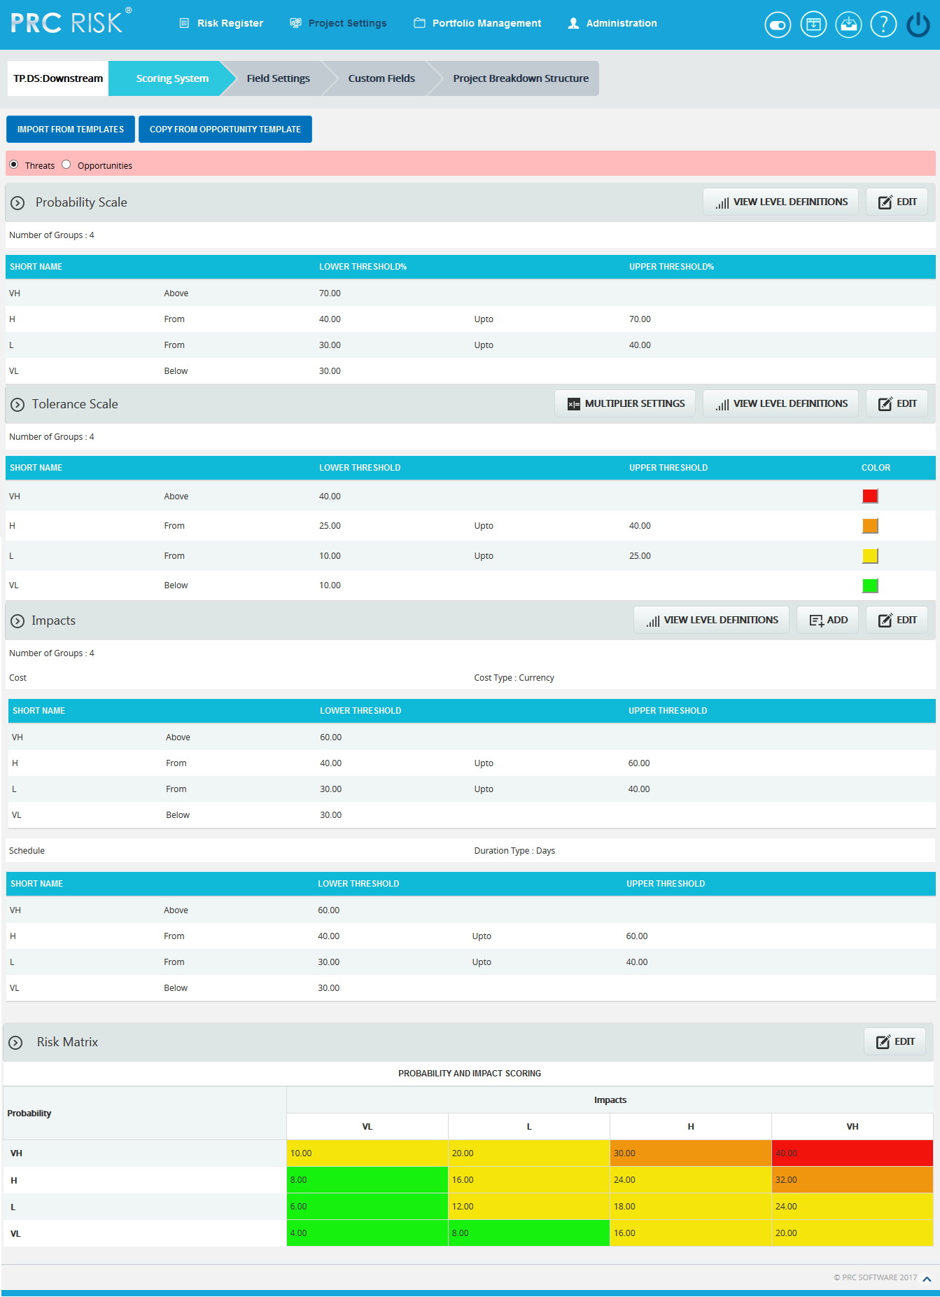
Figure 1.1

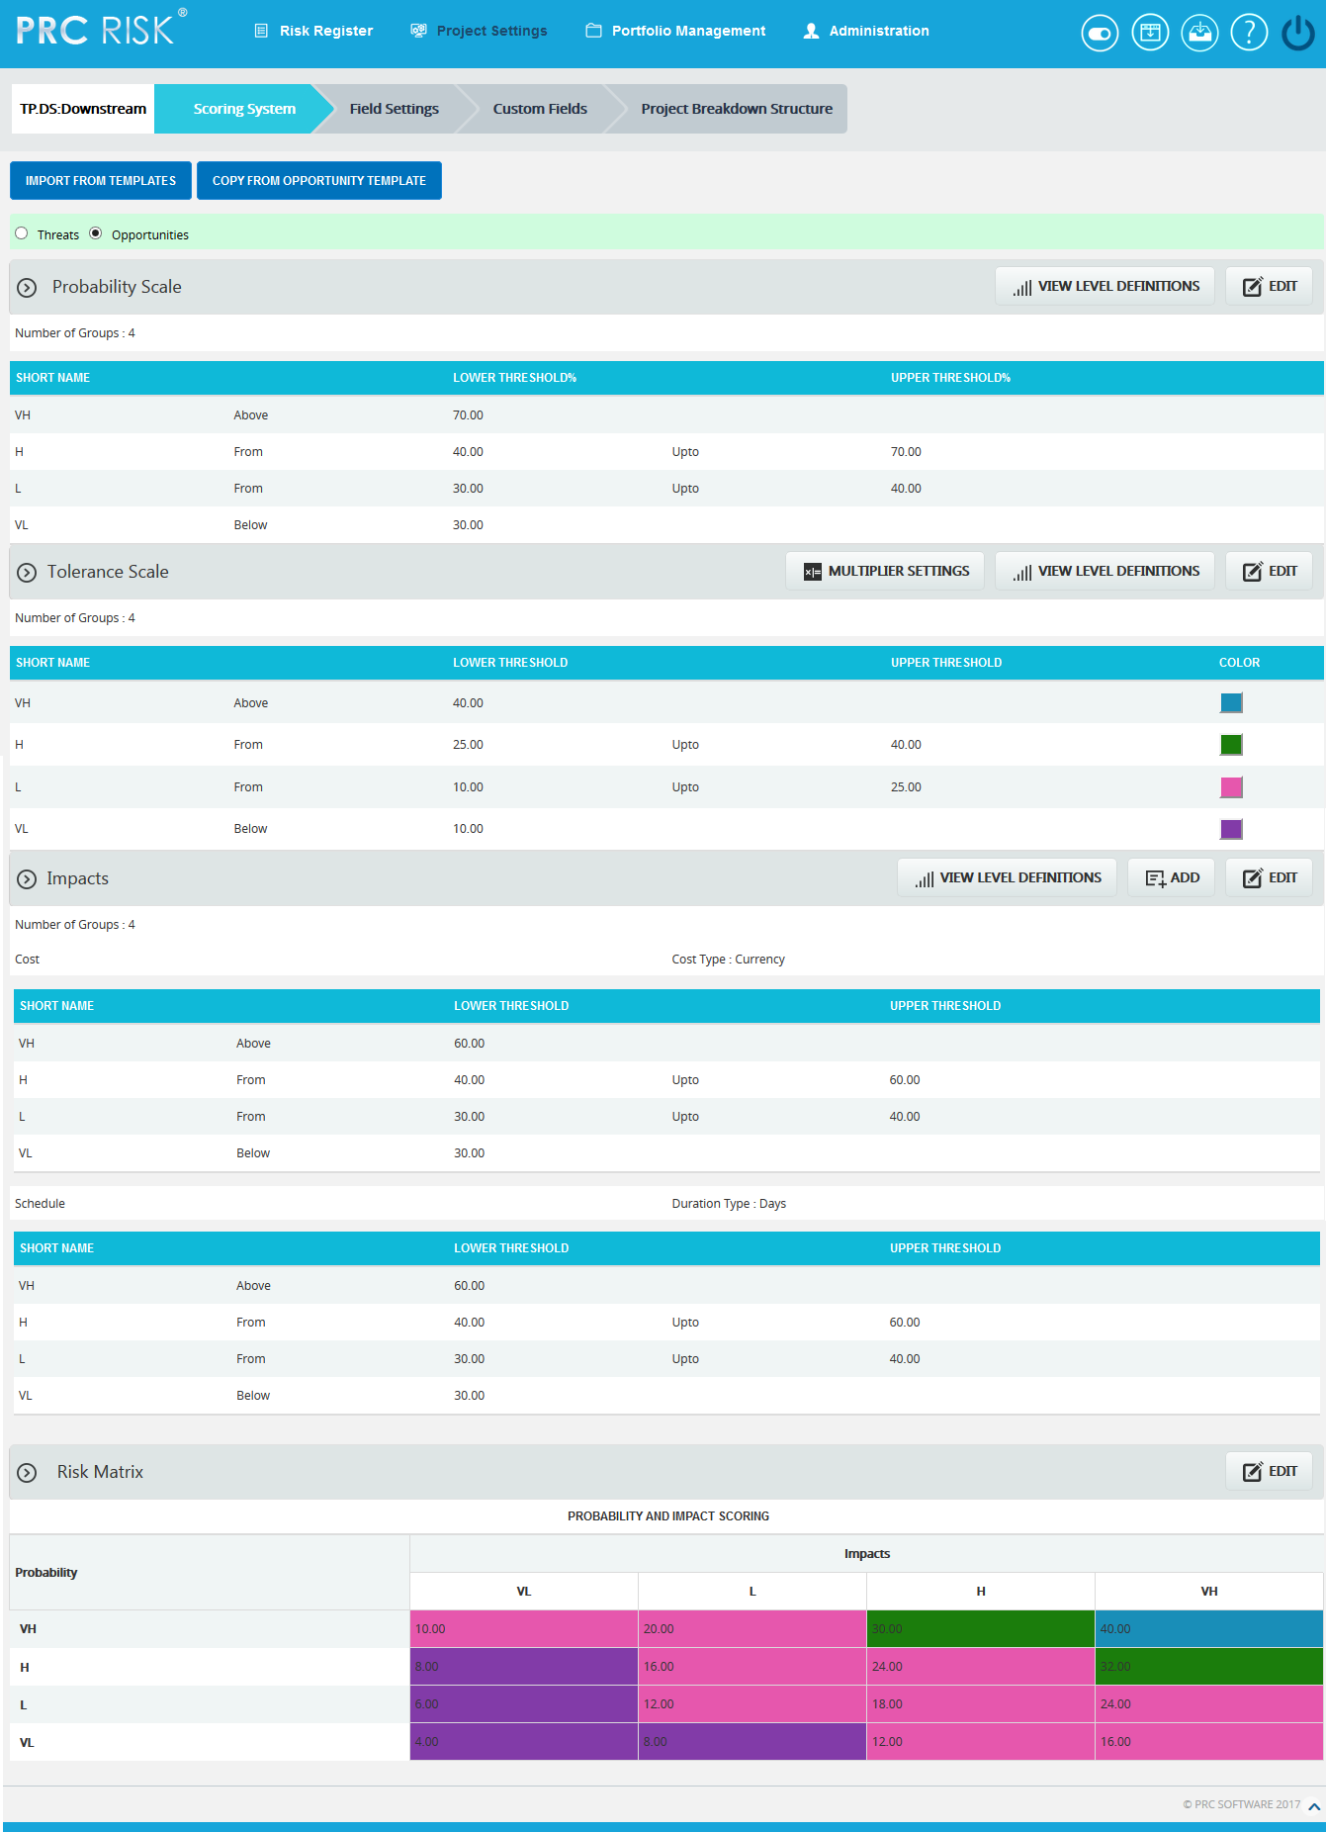

Figure 1.2
Import from Templates:
This functionality is used to assign the Threat/ Opportunity scoring templates created in the portfolio scoring system to the selected project. Once the threats or opportunities are added to the project, then this option will not be there.
Steps:
- Project Settings —> Scoring System
- Click the IMPORT FROM TEMPLATES button. (Figure 1)
- Select a template and click DONE to assign the selected template or click Cancel.

Copy from Threat Template:

This functionality is used to copy threat scoring template of the selected project and assign that template to the selected project’s opportunity scoring template. This button is not available, if any opportunity is added to the project.

Steps:
- Project Settings —> Scoring System
- Click the COPY FROM THREAT TEMPLATE button. (Figure 1.2)

Copy from Opportunity Template:

This functionality is used to copy opportunity scoring template of the selected project and assign that template to the selected project’s threat scoring template. This button is not available, if any threat is added to the project.

Steps:
- Project Settings —> Scoring System
- Click the COPY FROM OPPORTUNITY TEMPLATE button. (Figure 1.1)

View Level Definitions:
To view probability and tolerance levels, click the VIEW LEVEL DEFINITIONS button shown in the Probability & Tolerance Scales section. (Figure 1) A pop up shown in Figure 2 appears. If the Level Definitions have been modified, click the SAVE button to save the changes.
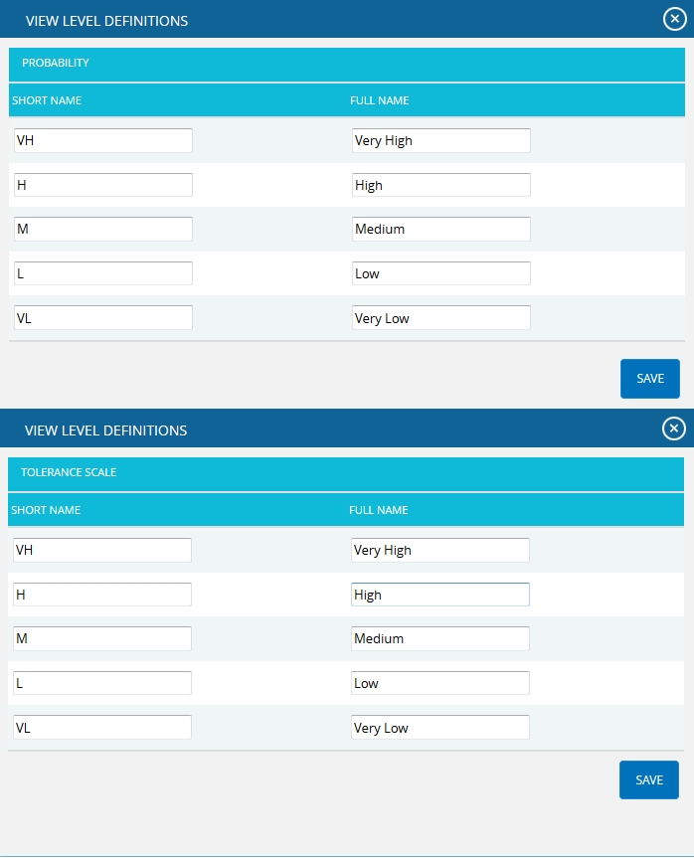

Figure 2

To view impact levels, click the VIEW LEVEL DEFINITIONS button shown in the Impacts section. (Figure 1) A pop up appears. (Figure 3) If the checkbox selected for Apply full name to all Impacts, the current full name applied to cost, schedule and additional impacts. This name can be viewed in the score section’s impact dropdown while adding the risk details. Click the SAVE button to save any modifications to the View Level Definitions.
If the checkbox is not selected, click the NEXT button in Figure 3. A pop up appears. (Figure 4) The modifications of cost, schedule and additional impacts can be done individually and click the SAVE button.

Figure 3

Figure 4

Edit Probability & Tolerance:
While editing Probability & Tolerance fields, such as Number of Groups, Lower Threshold and Upper Threshold, the color is unlocked.
Steps:
- Project Settings —>Scoring System
- Click the EDIT button under Probability and Tolerance scale sections. (Figure 1)
- After the data is modified, click the SAVE button.
- The color is set by clicking on the corresponding color shown beside each field. An example of the color picker is displayed in Figure 5.
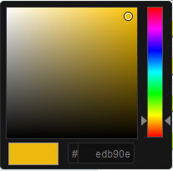
Figure 5
Reload button under Tolerance Scale section is to reload the default threshold values and colors for each number of groups. This button is shown only while clicking EDIT button under Tolerance. (Figure 6)
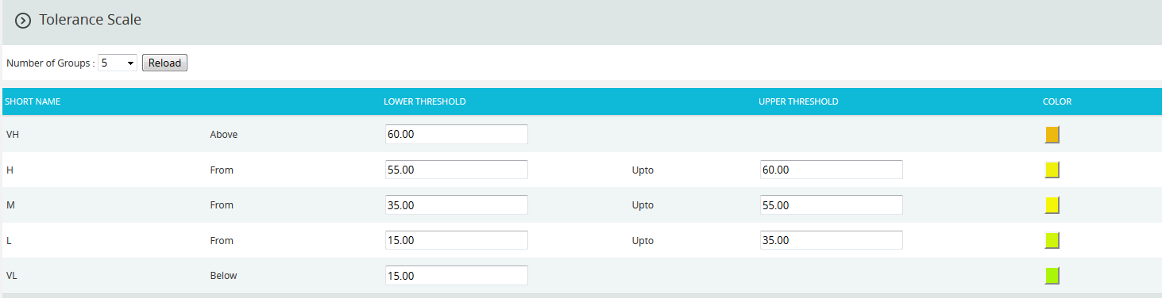
Figure 6

Multiplier Settings:
Multipliers are user input values. To give multiplier values, click MULTIPLIER SETTINGS button. (Figure 1) When the link is clicked, Multiplier values dialog box appears where the user can add, save and delete values. (Figure 7)
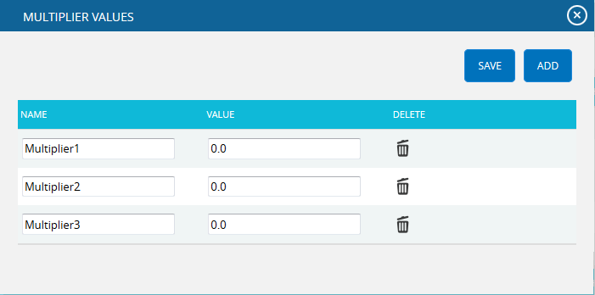

Figure 7

Edit Impacts:
When editing impacts, fields such as Number of Groups, Lower Threshold, Upper Threshold, Duration Type, Name and Description of Additional Impact are unlocked. The field Number of groups will be locked if a Threat/Opportunity has been assigned a score.

Cost Type for Cost:
The Cost Type for cost has values Percentage and Currency, where Currency is the default value.
If the assigned template for the project has value Percentage for the field Cost Type, then the cost values will be expressed in corresponding percentage of total cost of project. The formula for percentage calculation of each threshold value is:
[Percentage value * Project cost]
If the assigned template for the project has value Currency, cost values remain unchanged.

Duration Type for Schedule:
The Duration Type field for schedule has values for Days, Weeks, Months, Year and a Percentage where the default value is Days.
If the assigned template for the project has a value Percentage for Duration Type then the Schedule values will be converted to corresponding percentage of Number of days between start date and end date of a project according to the Default Duration given in the project details.
The formula for percentage calculation of schedule of each threshold value is:
[Total Duration * Percentage value]
Where, Total Duration is:
Total days = project end date – project start date
For Days type, total number of days itself.
For Week type, Total Duration = total days/7
For Hours type, Total Duration = total days * 24.0
For Month type, Total Duration = total days /30
For Year type, Total Duration = total days /365
Steps:
- Project Settings —>Scoring System
- Click the EDIT button under Impacts section. (Figure 1)
- After the data is modified, click the SAVE button.

Add New Impact:
This functionality is used to add a new additional impact.
Steps:
- Project Settings —>Scoring System
- Click the ADD button to add a new impact. (Figure 1)
- After entering the details, click the SAVE button. (Figure 8)

Delete Impacts:
This functionality is used to delete additional impacts. Additional impacts can be deleted only by those users who have Read/Write access for delete.
Steps:
- Project Settings —>Scoring System
- Click the Close icon to delete additional Impacts. (Figure 1)
- After you receive the confirmation message, click the OK button to delete the breakdown structure. To cancel, click the Cancel button.

Edit Risk Matrix:
This section allows you to define the scores based on the Probability and Impact position.
Steps:
- Project Settings ---> Scoring System
- Click the EDIT button under Risk Matrix. (Figure 1)
- After the data is modified, click the SAVE button.

Custom Fields (Project)
The Custom Fields page allows the user to view or update the project settings. The data displayed on this page is what is currently being used on the project. When a project is first created, the system applies a default setting. The default project settings can be changed by applying a portfolio template or manually adjusting it in the Custom Fields page. When creating a custom field the user will be given the options to choose the data type (text, date, number, currency and list) and location displayed (threat, opportunity, threat and opportunity or mitigation sections). When creating a formula field, the user will be given the options to choose the location displayed (threat, opportunity, or mitigation sections). There are no system defaults for the Custom Fields page.
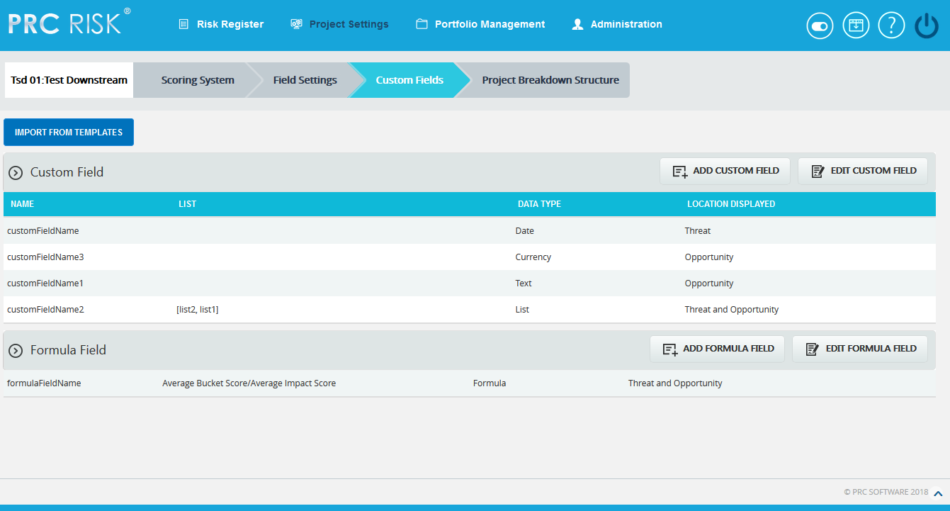
Figure 1
Import from Templates:
This functionality is used to assign the Threat/ Opportunity custom field templates created in the portfolio custom fields to the selected project. Once the threats or opportunities are added to the project, then this option will not be there.
Steps:
- Project Settings —> Custom Fields
- Click the IMPORT FROM TEMPLATES button. (Figure 1)
- Select a template and click DONE to assign the selected template or click Cancel.

Edit Custom Fields:
This functionality is used to edit Custom Fields.
Steps:
  - Project Settings —>Custom Fields
  - Click the EDIT CUSTOM FIELD button.
  - Edit the necessary details. For custom fields with data type List, enter the value in the Editable Combo box provided and click the ADD icon to add list values. (Figure 2) To rename the existing value, select any value from the dropdown list and click the RENAME icon after renaming it. Similarly select a list value from the dropdown and click the DELETE icon to delete the value from the list. Also to re-order the list, select the RE-ORDER icon and the re-order List Options box appears. ( Figure 2)
  - Click the SAVE button to finish. (Figure 3)
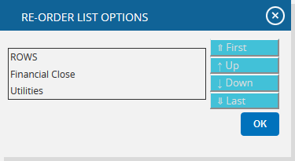
Figure 2

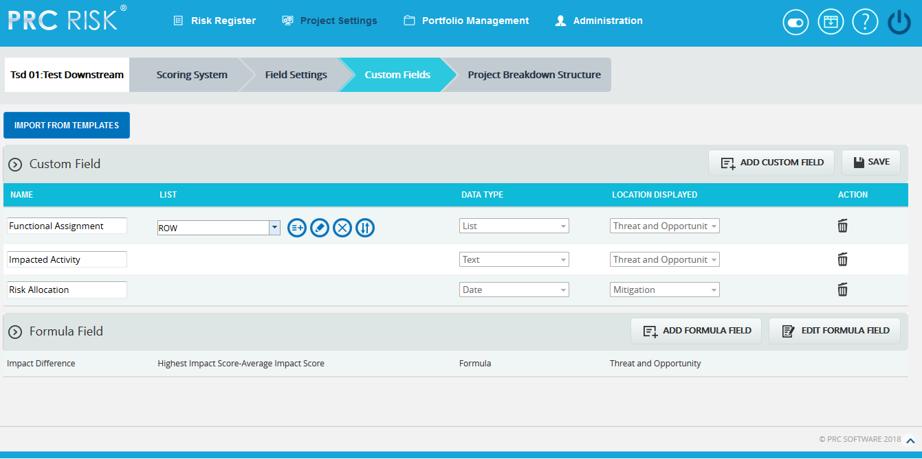

Figure 3

Add Custom Field:
This functionality is used to add new custom field to the selected project.
Steps:
- Project Settings —>Custom Fields
- Click the ADD CUSTOM FIELD button. (Figure 3)
- Enter the Custom Field name in the textbox provided. (Figure 3)
- Select data type from the DATA TYPE dropdown. (Figure 3)
- For the data type List, enter the value in the Editable Combo box provided and click the ADD icon.
- Select location displayed from the LOCATION DISPLAYED dropdown. (Figure 3)
- Click SAVE to finish. (Figure 3)

Delete Custom Fields:
This functionality is used to delete the Custom Fields.
Steps:
- Project Settings —>Custom Fields
- Click the EDIT CUSTOM FIELD button. (Figure 1)
- Click the DELETE icon to delete the required custom field. (Figure 3)

After you receive the confirmation message (Figure 4) click the OK button to delete the custom field. To cancel, click the Cancel button. (Figure 4)
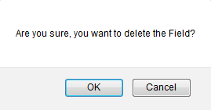
Figure 4

Edit Formula Fields:
This functionality is used to edit Formula Fields.
Steps:
  - Project Settings —>Custom Fields
  - Click the EDIT FORMULA FIELD button. (Figure 1)
  - Edit the formula field name if necessary.
  - Formula can be edited by clicking Edit Formula. ADD FORMULA FIELD pop up appears. (Figure 5)
- Edit the necessary changes
- Click SAVE button to save the formula or click RESET to clear the formula.
- DATA TYPE and LOCATION DISPLAYED cannot be edited.
  - Click the SAVE button to finish. (Figure 6)

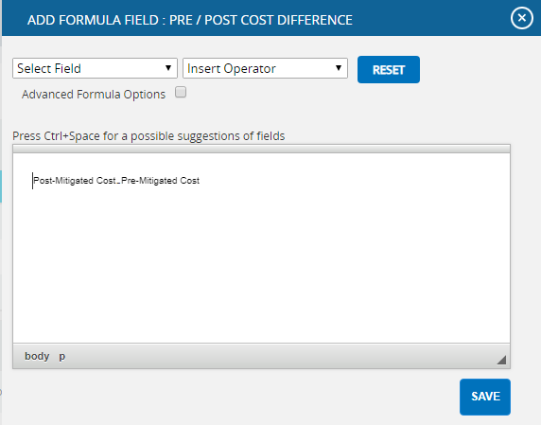

Figure 5
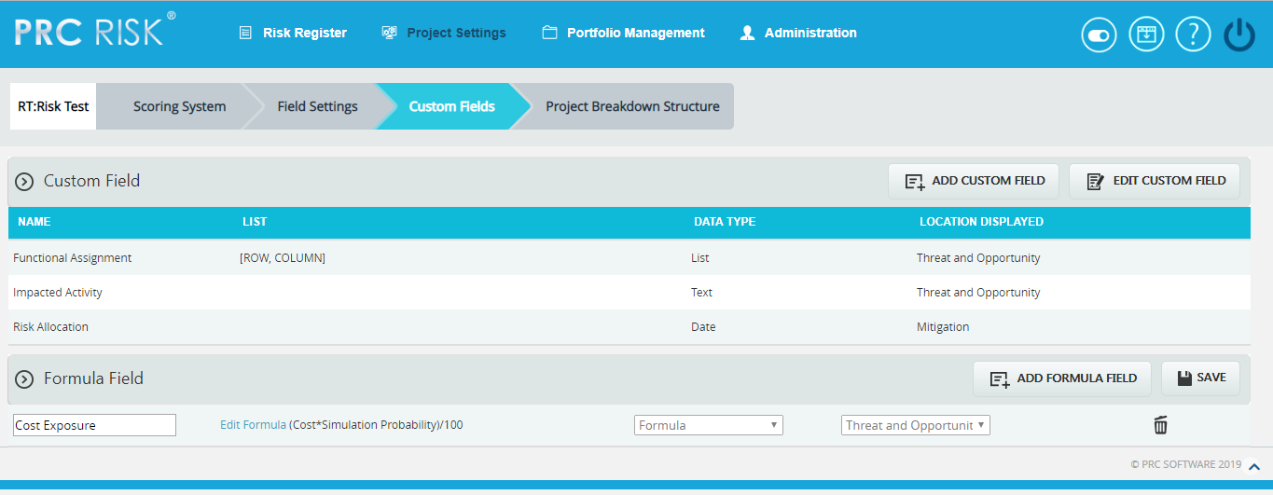
Figure 6

Add Formula Field:
This functionality is used to add new formula field to the selected project.
Steps:
- Project Settings —>Custom Fields
- Click the ADD FORMULA FIELD button. (Figure 8)
- Enter the Formula Field name in the textbox provided. (Figure 8)
The only data type is Formula and the same will be mentioned in the DATA
TYPE dropdown.
- Select location displayed from the LOCATION DISPLAYED dropdown. (Figure 8)
- Click Create Formula and ADD FORMULA FIELD pop up appears. (Figure 5)
- Select field from the list and insert the operator as required. (Figure 5)
- Check the Advanced Formula Options, in case any particular value has to be returned in the field according to conditions set.(Figure 7)
- Click ADD CONDITION button for setting a new condition and the value to be returned whenever the formula satisfies this condition.
- The data type of return value has to be selected from the dropdown.
- The conditions can be deleted using Delete link.

- Click SAVE button to save the formula or click RESET to clear the formula.
- Click SAVE to finish. (Figure 8)

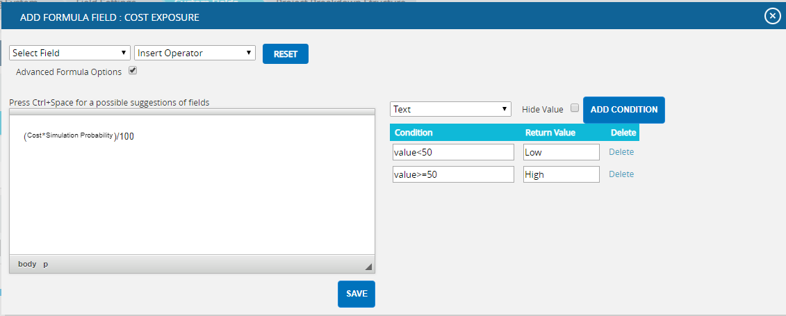
Figure 7
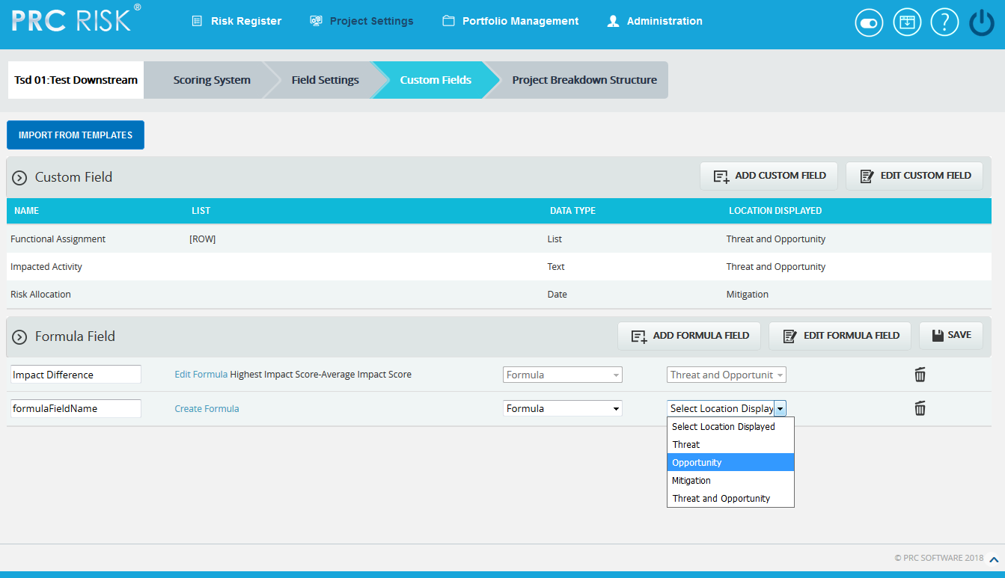
Figure 8

The formula field added here will reflect in Risk Register pages: Risk Spreadsheet, Risk Details & Reports depending on the location selected. If the location selected is mitigation, the formula field will be displayed in Risk Spreadsheet Page ->Mitigations-> Threat / Opportunity and in Risk Details Page->Threat/Opportunity->Mitigation Step Information.

Delete Formula Fields:
This functionality is used to delete the Formula Fields.
Steps:
- Project Settings —>Custom Fields
- Click the EDIT FORMULA FIELD button. (Figure 1)
- Click the DELETE icon to delete the required formula field. (Figure 6)
After you receive the confirmation message (Figure 4) click the OK button to delete the formula field. To cancel, click the Cancel button. (Figure 4)

Field Settings (Project)
The Field Settings page is used to customize the Threat Fields, Opportunity Fields, Mitigation Plan Fields, Mitigation Step Fields, Closure Section Fields, Qualitative score fields, Simulation Fields, Data Mapping Fields, Risk Notes Fields and Recovery Plan Fields. The Field Settings page in the PRC Enterprise Risk Register can be viewed only by those users who have either Read/Write or View access. Users with only Read/Write access can edit session information and show/hide fields.
Users designated with View Access may view the various settings for the selected project.
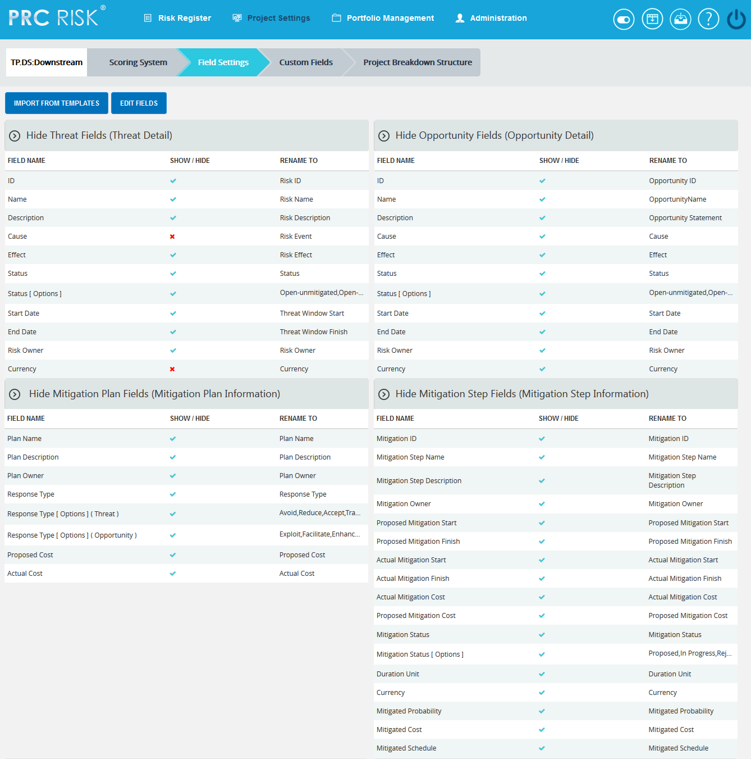
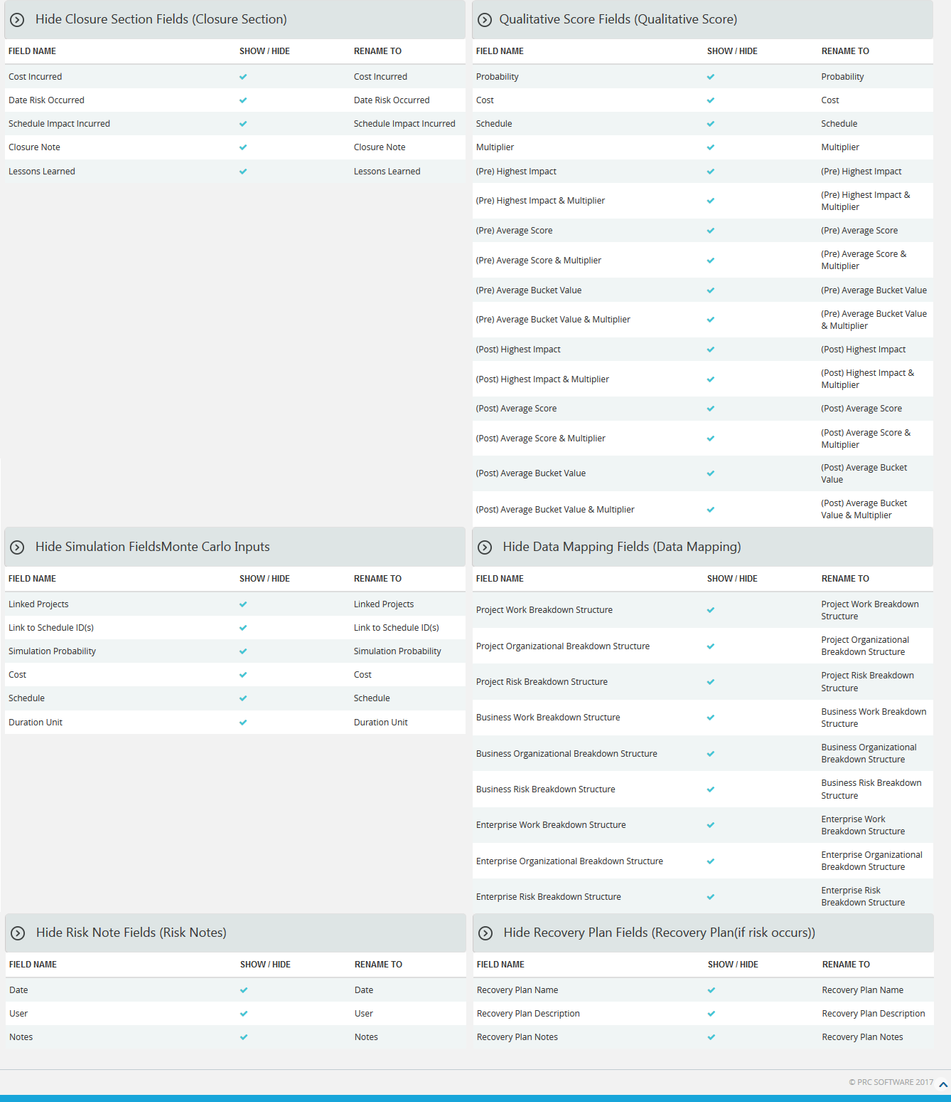
Figure 1

Import from Templates:
This functionality is used to assign the Threat/ Opportunity scoring templates created in the portfolio scoring system to the selected project. Once the threats or opportunities are added to the project, then this option will not be there.
Steps:
- Project Settings —> Field Settings
- Click the IMPORT FROM TEMPLATES button. (Figure 1)
- Select a template and click DONE to assign the selected template or click Cancel.

Edit Fields:
This functionality is used to modify the name of each section and fields of the template.
Steps:
- Project Settings —> Field Settings
- Click EDIT FIELDS button to modify. (Figure 1)
- Enter the name in the textbox provided, shown at the top of the section (the default name is given) and rename the fields. (Figure 2)
- After editing the changes, click the SAVE ALL button to save the changes. (Figure 2)

Show/ Hide:
Show/Hide applies to each section. The example (Figure 2) shows the Closure section. However, the steps are described below apply to all sections.
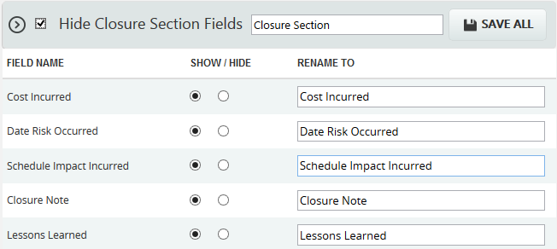
Figure 2
In order to hide the entire section, check the checkbox shown near the section header; click the SAVE ALL button to save the changes. (Figure 2)
To show a field, click the radio button under the Show column (Figure 2) and click the SAVE ALL button to save the changes.
To hide a field, click the radio button under the Hide column (Figure 2) and click the SAVE ALL button to save the changes.
Edit Status Options (Threat / Opportunity):
To add, edit or delete the user editable status options. These statuses are categorized into two: open and closed. The statuses checked in SHOW checkbox is only shown in the status list for the mitigations in the Risk Details or Spreadsheet page.
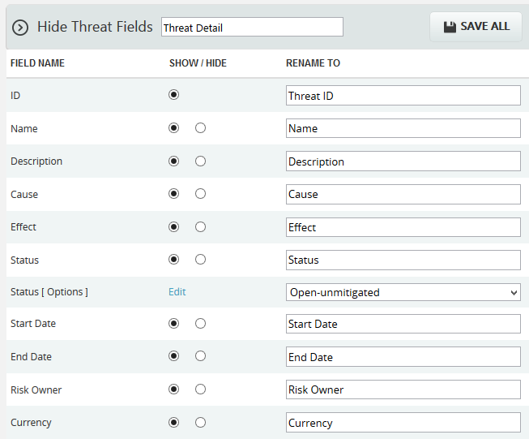
Figure 3
Steps:
- Click the EDIT link. (Figure 3)
- A pop up appears where the user can add or edit the status options. (Figure 4)
- Click the ADD button to add a new status option. (Figure 4)
- Click the EDIT button to edit the saved status options. (Figure 4)
- To delete the status, click the DELETE icon. (Figure 5)
- Click the SAVE button to save the changes made. (Figure 5)
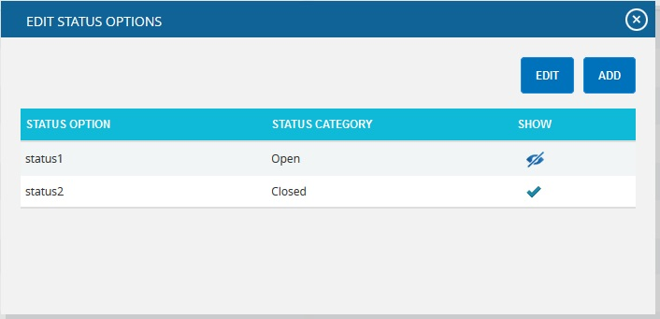
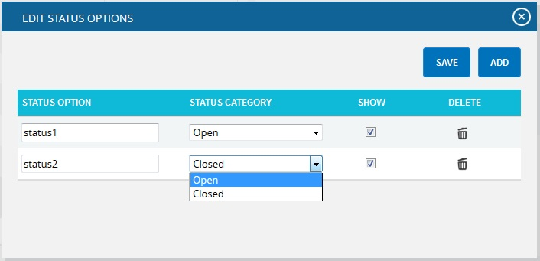
Figure 4
Figure 5
Edit Status Options (Mitigation):
To add, edit or delete the user defined mitigation status options. These statuses are categorized into Proposed, In Progress, Rejected, Complete, Risk Closed and Approved. The statuses checked in SHOW checkbox is only shown in the status list for the mitigations in the Risk Details or Spreadsheet page.
Steps:
- Click the EDIT link. (Figure 6)
- A pop up appears where the user can add or edit the mitigation status options. (Figure 7)
- Click the ADD button to add new mitigation status option. (Figure 7)
- Click the EDIT button to edit the saved mitigation status options. (Figure 7)
- To delete the mitigation status, click DELETE icon. (Figure 8)
- Click the SAVE button to save the changes made. (Figure 8)
Figure 6

Figure 7

Figure 8
Edit Response Type (Threat / Opportunity):
To add user defined response type for Threats and Opportunities.
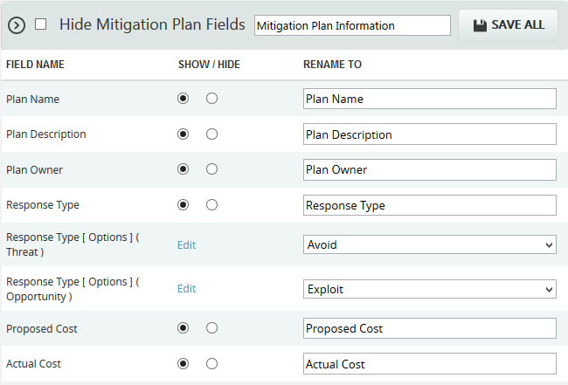
Figure 9
Steps:
- Click the EDIT link for Threat/ Opportunity. (Figure 9)
- A pop up appears where the user can add or edit the response type. (Figure 10)
- Click the ADD button to add a new response type. (Figure 10)
- Click the EDIT button to edit the saved response types. (Figure 10)
- To delete the response types, click DELETE icon. (Figure 11)
- Click the SAVE button to save the changes made. (Figure 11)
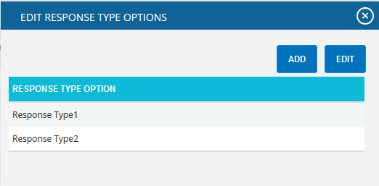
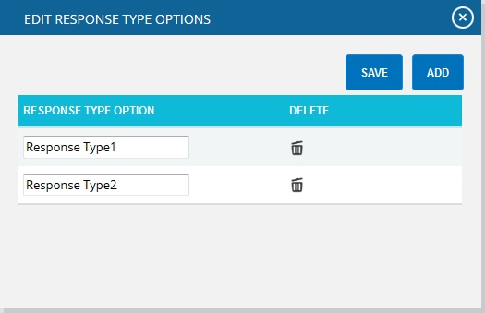
Figure 10

Figure 11

RISK REGISTER

Standard Reports (Project)
The Standard Reports page allows you to create various reports, such as: Overall Risk Reports, Threat Reports, Opportunity Reports, Mitigation Reports, Audit Reports and Exports. The process to create a report is broken down into steps to make it easier for users to follow. Reports from this page can be added to the Manager's Dashboard for further analysis and reporting. This page can be viewed by only those users who have either Read/Write or View access.
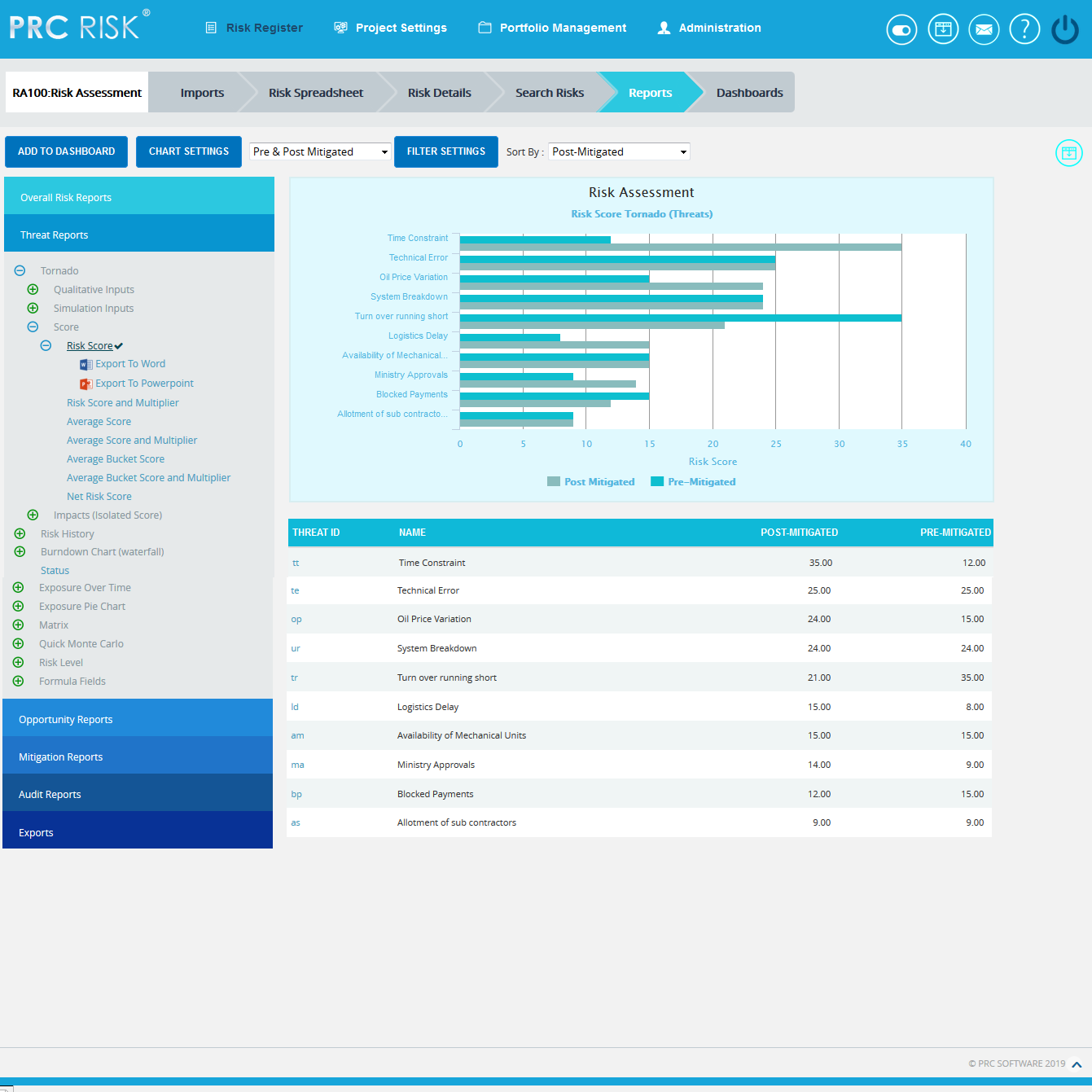
Figure 1
Set as Default Chart Icon:
Set as Default Icon is used to set any chart as the landing page when we select Reports of Risk Register. Risk score is the chart to appear first by default. (Figure 1)
Reports:
There are several types of reports in the Standard Report (Project) page. In order to generate a chart, the primary option that should be selected is Report. The Report selected by default (while the page is loaded) is Risk Tornado. The various available reports are shown in Figure 2.

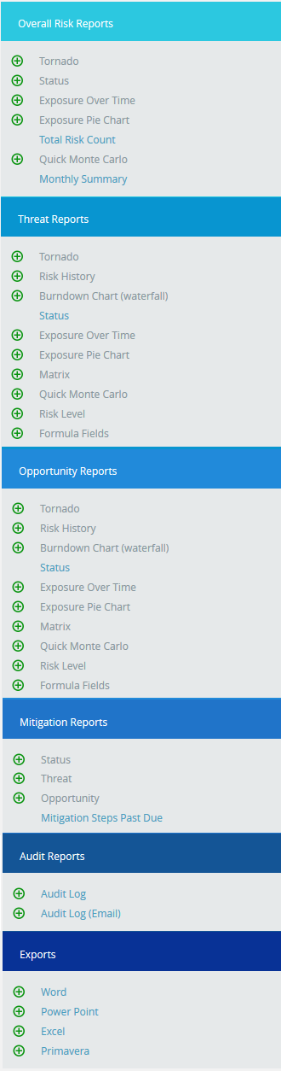
Figure 2
Report Option:
The Report Option decides for which risk type the chart should be generated. The risk type listed will vary for Status Reports. For all other reports it remains the same. The Report Option for all other reports is shown in Figure 3, Figure 4, Figure 5 and 6.
The Report Option for Tornado charts, Risk Exposure charts and Risk exposure-BS charts are Threat Tornado, Opportunity Tornado, Overall Risk Tornado, Threat Exposure Over Time, Opportunity Exposure Over Time, Overall Risk Exposure Over Time, Threat Qualitative Exposure Pie Chart, Opportunity Qualitative Exposure Pie Chart, Overall Risk Qualitative Exposure Pie Chart, Threat Simulation Exposure Pie Chart, Opportunity Simulation Exposure Pie Chart and Overall Risk Simulation Exposure Pie Chart.

Risk Tornado charts:
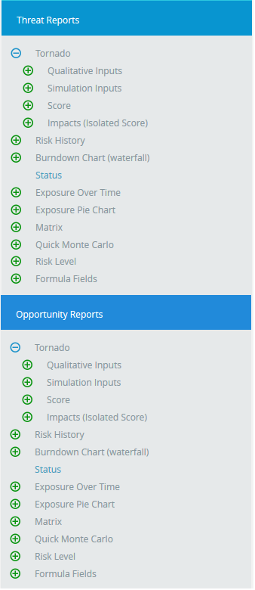
Figure 3

Risk Exposure Charts:

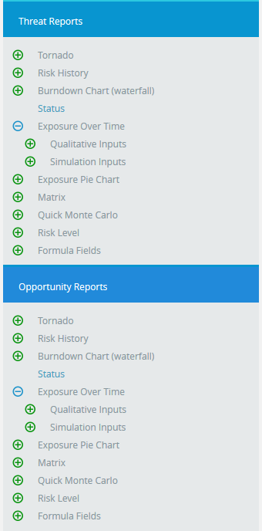
Figure 4

Risk Exposure Pie Charts:
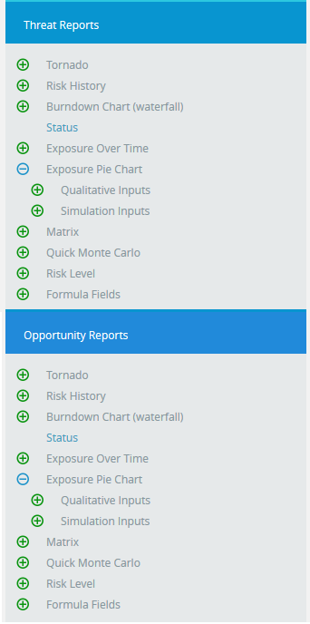
Figure 5

Risk History Charts:

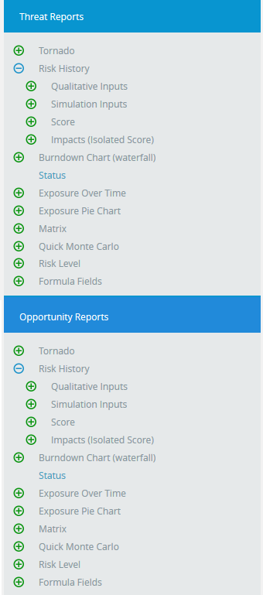

Figure 6

Status Charts:
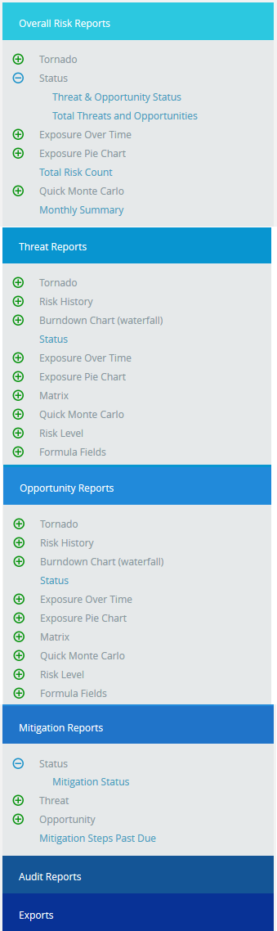
Figure 7

Risk:
Risk should be selected for Risk History and the Burndown Chart (Waterfall) using the Select Risk dropdown. (Figure 8) This dropdown is visible for only Risk History and the Burndown Chart (Waterfall).
Figure 8

Data Option:
The Data options include additional impacts, if any. The various data options available for Risk Tornado, Risk History, and Burndown (Waterfall) are:
- Risk Score
- Risk Score and Multiplier
- Average Score
- Average Score and Multiplier
- Average Bucket Score
- Average Bucket Score and Multiplier
- Other Qualitative impacts
- Qualitative Cost
- Qualitative Schedule
- Qualitative Probability
- Qualitative Cost Exposure
- Qualitative Schedule Exposure
- Simulation Cost
- Simulation Schedule
- Simulation Probability
- Simulation Cost Exposure
- Simulation Schedule Exposure
- Mitigation Started Late (Days)
- Mitigation Finished Late (Days)
- Mitigation Qualitative Cost
- Mitigation Qualitative Schedule
- Mitigation Qualitative Probability
- Mitigation Qualitative Cost Exposure
- Mitigation Qualitative Schedule Exposure
- Mitigation Simulation Cost
- Mitigation Simulation Schedule
- Mitigation Simulation Probability
- Mitigation Simulation Cost Exposure
- Mitigation Simulation Schedule Exposure
- Mitigation Risk Score
- Mitigation Risk Score and Multiplier
- Mitigation Average Score
- Mitigation Average Score and Multiplier
- Mitigation Average Bucket Score
- Mitigation Average Bucket Score and Multiplier
For Example:
Consider the following 3 x 5 matrix

 | VL | L | M | H | VH
H | 3 | 6 | 9 | 12 | 30
M | 2 | 4 | 6 | 8 | 20
L | 1 | 2 | 3 | 4 | 10

Table 1

Multiplier = 2

Probability Range = L (Low), M (Medium), H (High)
Impact Range = VL, L, M, H, VH
Impacts = Cost, Schedule, Safety

Consider, Probability = H
Cost = H
Schedule = M
Safety = L.

1. Risk Score:
By taking the combination of probability and all the impacts like schedule, cost etc, the highest of combination value in risk matrix is taken as Risk Score. The Risk Score for Threat/Opportunity is the pre-mitigated score. The Risk Score for Mitigation is the post-mitigated score.
In the Example, (Table 1)
Risk score = High Probability x High Cost = 12

2. Risk Score and Multiplier:
The multiplier value setting can be done in the Project settings Scoring System. Then the formula for Risk Score and Multiplier is,
Risk Score and Multiplier = Risk score * Multiplier
In the Example, (Table 1)
Risk Score and Multiplier = 12 * 2 = 24
3. Average Score:
The Average Score is the sum of all the impact combinations (cost, schedule etc) with the probability in the risk matrix, divided by number of combinations.
In the Example, (Table 1)
Average Score = (6 + 9 + 12)/3 = 9
4. Average Score and Multiplier:
The multiplier value setting can be done in the Project settings Scoring System. Then the formula for Average Score and Multiplier is,
Average Score and Multiplier = Average score * Multiplier
In the Example, (Table 1)
Average score = (6 + 9 + 12)/3 = 9 *multiplier = 9 * 2 = 18
5. Average Bucket Score:
Bucket value is the index values given to each impact. The Average Impact is the sum of the bucket values or index values of all the impact combinations with probability, by number of combinations. This Average Impact is considered as the index value for the Risk Matrix table. The value on this table corresponding to this index value is considered as the Average bucket score.

Note: If the calculated value of the bucket falls to say 3.66 round it to the nearest bucket which is 4.
In the Example, (Table 2)
 | VL | L | M | H | VH
H | 3 | 6 | 9 | 12 | 30
M | 2 | 4 | 6 | 8 | 20
L | 1 | 2 | 3 | 4 | 10
 | 1 | 2 | 3 | 4 | 5
Table 2

Average Impact = High Probability x ((Low (bucket value) + Medium (bucket value) + High (bucket value)) / 3

That is, High probability x bucket value of (2 + 3 + 4) / 3 = 3
So here, the value corresponding to the index value 3 is 9 which are the average Bucket Score.
6. Average Bucket Score and Multiplier:
The multiplier value setting can be done in the Project settings Scoring System. Then the formula for Average Bucket Score and Multiplier is,
Average Bucket Score and Multiplier = Average Bucket score * Multiplier
In the Example, (Table 2)
Average Bucket score= 9* 2 = 18

7. Other Qualitative Impacts:
The formulas for Additional Impacts are:
- [(Qualitative Additional Impact Upper Limit + Qualitative Additional Impact Lower Limit) / 2] (Pre-Value)
- [(Qualitative Mitigation Additional Impact Upper Limit + Qualitative Mitigation Additional Impact Lower Limit) / 2] (Post Value)
If there is no upper limit: Average value=lower limit * 1.5.
If there is no lower limit: Average value = upper limit / 2

8. Qualitative Cost:
The formulas for Qualitative Cost are:
- [(Qualitative Cost Upper Limit + Qualitative Cost Lower Limit) / 2]. (Pre-Value)
- [(Qualitative Mitigation Cost Upper Limit + Qualitative Mitigation Cost Lower Limit) / 2]. (Post-Value)
If there is no upper limit: Qualitative Cost = lower limit * 1.5
If there is no lower limit: Qualitative Cost = upper limit / 2

9. Qualitative Schedule:
The formulas for Qualitative Schedule are:
- [(Qualitative Schedule Upper Limit + Qualitative Schedule Lower Limit) / 2] . (Pre-Value)
- [(Qualitative Mitigation Schedule Upper Limit + Qualitative Mitigation Schedule Lower Limit) / 2]. (Post-Value)
If there is no upper limit: Qualitative Schedule = lower limit * 1.5
If there is no lower limit: Qualitative Schedule = upper limit / 2

10. Qualitative Probability:
The formulas for Qualitative Probability are:
- [[(Qualitative Probability Upper Limit + Qualitative Probability Lower Limit) / 2 ]] (Pre-Value)
- [[(Qualitative Mitigation Probability Upper Limit + Qualitative Probability Lower Limit) / 2]] (Post-Value)
If there is no upper limit: Qualitative Probability = [(lower-limit + 100) / 2]
If there is no lower limit: Qualitative Probability = [(0+upper-limit) / 2]

11. Qualitative Cost Exposure:
The formulas for Qualitative Cost Exposure are:
- [(Qualitative Cost * Qualitative Probability) / 100] (Pre-Value)
- [(Mitigation Qualitative Cost * Mitigation Qualitative Probability) / 100](Post-Value)

12. Qualitative Schedule Exposure:
The formulas for Qualitative Schedule Exposure are:
- [(Qualitative Schedule * Qualitative Probability) / 100] (Pre-Value)
- [(Mitigation Qualitative Schedule * Mitigation Qualitative Probability) / 100] (Post-Value)

13. Simulation Cost:
The formulas for Simulation Cost are:
- [(Cost min + Cost max + 4 * (Cost Most likely)) / 6] (Pre Value)
- [(Mitigation Cost min + Mitigation Cost max + 4 * ( Mitigation Cost Most likely)) / 6] (Post Value)
If there is no max then max = min * 2
If there is no min then min = max / 2
If there is no most likely then Avg = [(Min + Max) / 2]

14. Simulation Schedule
The formulas for Simulation Schedule are:
- [(Schedule min + Schedule max + 4 * ( Schedule Most likely)) / 6] (Pre-Value)
- [(Mitigation Schedule min + Mitigation Schedule max + 4 * ( Mitigation Schedule Most likely)) / 6] (Post-Value)
If there is no max then max = min * 2
If there is no min then min = max / 2
If there is no most likely then Avg = [(Min + Max) / 2]

15. Simulation Probability:
The formulas for Simulation Probability are:
- [[Simulation Probability Percentage]] (Pre-Value)
- [[Mitigation Simulation Probability]] (Post-Value)

16. Simulation Cost Exposure:
The formulas for Simulation Cost Exposure are:
- [(Simulation Cost * Simulation Probability) / 100] (Pre-Value)
- [(Mitigation Simulation Cost * Mitigation Simulation Probability) / 100](Post-Value)

17. Simulation Schedule Exposure:
The formulas for Simulation Schedule Exposure are:
- [(Simulation Schedule * Simulation Probability) / 100] (Pre-Value)
- [(Mitigation Simulation Schedule * Mitigation Simulation Probability) / 100] (Post-Value)
18. Mitigation Started Late (Days):
The formula to calculate the Mitigation Started Late (Days) is:
No of days late = Positive value of proposed date – Current date
Condition: Risk status should not be closed and Mitigation should not be in Progress, Rejected, Completed status.
19. Mitigation Finished Late (Days):
The formula to calculate the Mitigation Finished Late (Days) is:
No of days late = Proposed finish date - current date (Positive value)
Condition: Risk status should not be closed, and Mitigation should not be in Completed, Rejected status.

20. Mitigation Cost
The formula for Mitigation Cost if only one risk is mapped is:
[Risk Cost – Mitigation Cost]
The formula for Mitigation Cost if more than one risk is mapped is:
[(Cost of first Risk – Mitigation Cost) + (Cost of second Risk – Mitigation Cost) + .....]
21. Mitigation Schedule
The formula for Mitigation Schedule if only one risk is mapped is:
[Risk Schedule – Mitigation Schedule]
The formula for Mitigation Schedule if more than one risk is mapped is:
[(Schedule of first Risk – Mitigation Schedule) + (Schedule of second Risk – Mitigation Schedule) + .....]
22. Mitigation Probability
The formula for Mitigation Probability if only one risk is mapped is:
[Risk Probability – Mitigation Probability]
The formula for Mitigation Probability if more than one risk is mapped is:
[(Probability of first Risk – Mitigation Probability) + (Probability of second Risk – Mitigation Probability) + .....]
23. Mitigation Cost Exposure
The formula for Mitigation Cost Exposure if only one risk is mapped is:
[Risk Cost Exposure – Mitigation Cost Exposure]
The formula for Mitigation Cost Exposure if more than one risk is mapped is:
[(Cost Exposure of first Risk – Mitigation Cost Exposure) + (Cost Exposure of second Risk – Mitigation Cost Exposure) + .....]

24. Mitigation Schedule Exposure
The formula for Mitigation Schedule Exposure if only one risk is mapped is:
[Risk Schedule Exposure – Mitigation Schedule Exposure]
The formula for Mitigation Schedule Exposure if more than one risk is mapped is:
[(Schedule Exposure of first Risk – Mitigation Schedule Exposure) + (Schedule Exposure of second Risk – Mitigation Schedule Exposure) + .....]
25. Mitigation Simulation Cost
The formula for Mitigation Simulation Cost if only one risk is mapped is:
[Risk Simulation Cost – Mitigation Simulation Cost]
The formula for Mitigation Simulation Cost if more than one risk is mapped is:
[(Simulation Cost of first Risk – Mitigation Simulation Cost) + (Simulation Cost of second Risk – Mitigation Simulation Cost) + .....]
26. Mitigation Simulation Schedule
The formula for Mitigation Simulation Schedule if only one risk is mapped is:
[Risk Simulation Schedule – Mitigation Simulation Schedule]
The formula for Mitigation Simulation Schedule if more than one risk is mapped is:
[(Simulation Schedule of first Risk – Mitigation Simulation Schedule) + (Simulation Schedule of second Risk – Mitigation Simulation Schedule) + .....]
27. Mitigation Simulation Probability
The formula for Mitigation Simulation Probability if only one risk is mapped is:
[Risk Simulation Probability – Mitigation Simulation Probability]
The formula for Mitigation Simulation Probability if more than one risk is mapped is:
[(Simulation Probability of first Risk – Mitigation Simulation Probability) + (Simulation Probability of second Risk – Mitigation Simulation Probability) + .....]

28. Mitigation Simulation Cost Exposure
The formula for Mitigation Simulation Cost Exposure if only one risk is mapped is:
[Risk Simulation Cost Exposure – Mitigation Simulation Cost Exposure]
The formula for Mitigation Simulation Cost Exposure if more than one risk is mapped is:
[(Simulation Cost Exposure of first Risk – Mitigation Simulation Cost Exposure) + (Simulation Cost Exposure of second Risk – Mitigation Simulation Cost Exposure) + .....]
29. Mitigation Simulation Schedule Exposure
The formula for Mitigation Simulation Schedule Exposure if only one risk is mapped is:
[Risk Simulation Schedule Exposure – Mitigation Simulation Schedule Exposure]
The formula for Mitigation Simulation Schedule Exposure if more than one risk is mapped is:
[(Simulation Schedule Exposure of first Risk – Mitigation Simulation Schedule Exposure) + (Simulation Schedule Exposure of second Risk – Mitigation Simulation Schedule Exposure) + .....]
30. Mitigation Risk Score
The formula for Mitigation Risk Score if only one risk is mapped is:
[Pre Mitigated Risk Score – Post Mitigated Score]
The formula for Mitigation Risk Score if more than one risk is mapped is:
[(Pre Mitigated Risk Score of first Risk – Post Mitigated Score) + (Pre Mitigated Risk Score of second Risk – Post Mitigated Score) + .....]
31. Mitigation Risk Score and multiplier
The formula for Mitigation Risk Score and multiplier if only one risk is mapped is:
[Pre Mitigated Risk Score and multiplier – Post Mitigated Score and multiplier]
The formula for Mitigation Risk Score and multiplier if more than one risk is mapped is:
[(Pre Mitigated Risk Score and multiplier of first Risk – Post Mitigated Score and multiplier) + (Pre Mitigated Risk Score and multiplier of second Risk – Post Mitigated Score and multiplier) + .....]

32. Mitigation Average Risk Score
The formula for Mitigation Average Risk Score if only one risk is mapped is:
[Pre Mitigated Average Risk Score– Post Mitigated Average Score]
The formula for Mitigation Average Risk Score if more than one risk is mapped is:
[(Pre Mitigated Average Risk Score of first Risk – Post Mitigated Average Score) + (Pre Mitigated Average Risk Score of second Risk – Post Mitigated Average Score) + .....]
33. Mitigation Average Score and multiplier
The formula for Mitigation Average Score and multiplier if only one risk is mapped is:
[Pre Mitigated Average Score and multiplier – Post Mitigated Average Score and multiplier]
The formula for Mitigation Average Score and multiplier if more than one risk is mapped is:
[(Pre Mitigated Average Score and multiplier of first Risk – Post Mitigated Average Score and multiplier) + (Pre Mitigated Average Score and multiplier of second Risk – Post Mitigated Average Score and multiplier) + .....]
34. Mitigation Average Bucket Score
The formula for Mitigation Average Bucket Score if only one risk is mapped is:
[Pre Mitigated Average Bucket Score– Post Mitigated Average Bucket Score]
The formula for Mitigation Average Bucket Score if more than one risk is mapped is:
[(Pre Mitigated Average Bucket Score of first Risk – Post Mitigated Average Bucket Score) + (Pre Mitigated Average Bucket Score of second Risk – Post Mitigated Average Bucket Score) + .....]
35. Mitigation Average Bucket Score and multiplier
The formula for Mitigation Average Bucket Score and multiplier if only one risk is mapped is:
[Pre Mitigated Average Bucket Score and multiplier – Post Mitigated Average Bucket Score and multiplier]
The formula for Mitigation Average Bucket Score and multiplier if more than one risk is mapped is:
[(Pre Mitigated Average Bucket Score and multiplier of first Risk – Post Mitigated Average Bucket Score and multiplier) + (Pre Mitigated Average Bucket Score and multiplier of second Risk – Post Mitigated Average Bucket Score and multiplier) + .....]
The various data options for Threat Qualitative Exposure Pie Chart, Opportunity Qualitative Exposure Pie Chart, Threat Simulation Exposure Pie Chart and Opportunity Simulation Exposure Pie Chart are:
- Project-OBS
- Project-WBS
- Project-RBS
- Business Unit-OBS
- Business Unit-WBS
- Business Unit-RBS
- Enterprise-OBS
- Enterprise-WBS
- Enterprise-RBS
- Risk Owner
Project OBS, Project WBS and Project RBS details are added from the page Project Breakdown Structure (Project Settings ---> Project Breakdown Structure)
Business OBS, Business RBS, Business WBS, Enterprise OBS, Enterprise RBS, Enterprise WBS are added from the page Manage Breakdown Structure (Portfolio Management ---> Manage Breakdown Structure)
In Figure 9 there is an option to select (Pre-Mitigated/Post-Mitigated or Pre-Mitigated & Post-Mitigated). For The various data options for Threat Qualitative Exposure Pie Chart, Opportunity Qualitative Exposure Pie Chart, Overall Risk Qualitative Exposure Pie Chart, Threat Simulation Exposure Pie Chart, Opportunity Simulation Exposure Pie Chart and Overall Risk Simulation Exposure Pie Chart are shown in Figure 9.
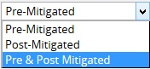
Figure 9
Sort By:
This functionality is used to sort the data for the selected report based on post-mitigated and pre-mitigated
Steps:
  - Risk Register ---> Reports.
  - Select the Sort by dropdown to sort the report based on post-mitigated and pre-mitigated. (Figure 1)

Filter:
This functionality is used to apply the Filter to the chart.
Steps:
- Click the FILTER SETTINGS button. (Figure 10) A pop up shown in Figure 11 appears.
- Select the field from the Select Field dropdown. (Figure 11)
- Select the Operator from the Select Operator dropdown. (Figure 11) The various fields and the operators applicable are shown in Table 3.
- The user can select values or enter values from the SELECT VALUE dropdown. (Figure 11)
- Click the ADD FILTER OPTION button, to add another filter (Figure 11)
- Click the APPLY FILTER button to view the filtered report. Or give the name, description, and global access option and then click the SAVE AND APPLY FILTER button to view the saved filter report. (Figure 11)
- Select the filter name from the Name dropdown and click the DELETE button that appears, to delete that particular saved filter. (Figure 11)
Figure 10
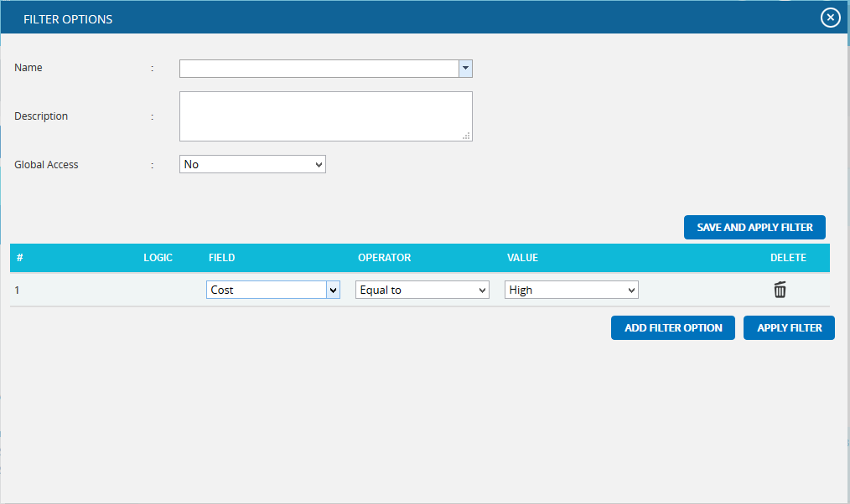
Figure 11

Field Type | Operator | Notes
Text | Equal to | User types text—This chart contains all the values that match the text exactly.
 | Contains | User types text—This chart contains all the values that contain the text anywhere in the string.
 | Not equal to | User types text—This chart contains all the values that do not match exactly.
 | Does not contain | User types text—This chart contains all values where the text is not contained anywhere in the string.
Date | Equal to | Date popup box—This chart contains all values where the date matches exactly.
 | Before | Date popup box—This chart contains all values where the date is before the selected date.
 | After | Date popup box—This chart contains all values where the date is after the selected date.
 | Not equal to | Date popup box—This chart contains all values where the date does not match exactly.
Number | Equal to | User enters number—This chart contains all values which match exactly with the number entered.
 | Greater than | User enters number—This chart contains all values greater than the number entered.
 | Greater than or Equal to | User enters number—This chart contains all values greater than or equal to the number entered.
 | Less than | User entered number—This chart contains all values less than or equal to the number entered.
 | Less than or equal to | User enters number—This chart contains all values less than the number entered
 | Not equal to | User enters number—This chart contains all values which are not the exact match for the number entered.
WBS/OBS/RBS | Under | User selects WBS/OBS/RBS element via a check mark in a popup—All children under the node (and sub-nodes) are shown. If a user check marks Multiple Items, an OR is applied to all check-marked items.
 | Not Under | User selects WBS/OBS/RBS element via a check mark in a popup—All items are shown except children under the node (and sub-nodes).
List Items (such as status) | Equal to | User selects list element from a dropdown box—This chart will contain all the values which match the selected value exactly.
 | Equal to (select multiple) | User selects list element via a check mark in a popup—If a user check marks multiple items, then an OR is applied to all checked items. This chart will contain all values which match the selected values exactly.
 | Not equal to | User selects list element from a dropdown box—This chart contains all values not equal to the selected value
 | Contains | User selects list element from a dropdown box—This chart contains all values which contain the selected value
 | Not equal to (select multiple) | User selects list element via a check mark in a popup—If the user checks multiple items an OR is applied to all checked items, and the results will not be equal to any checked items. This chart contains all values not equal to the selected values
Table 3

Tornado Chart:
Tornado Diagrams, also called Tornado Plots or Tornado Charts, are special types of Bar Charts where the data categories are listed vertically. These charts are generated by default when the Standard Reports (Project) page is initially loaded. The Post-Mitigated score is the Mitigation score and Pre-Mitigated score is the risk score.

Threat Tornado:
The Threat Tornado chart corresponds to all the threats in the selected project.
Steps:
- Risk Register ---> Reports
- Click the Threat Reports link to select Threat Tornado Chart. (Figure 1)
- Select Pre-Mitigated to view Pre-Mitigated data only (sorted by Pre-Mitigated), Post-Mitigated to view Post-Mitigated data (sorted by Post-Mitigated) or both to view both Pre-Mitigated data and Post-Mitigated data from the dropdown. (Figure 10)
- Click the FILTER SETTINGS button to add a filter. (Steps to be followed to add a filter are explained in filter section above). (Figure 10)
- Click the Risk Score data option or any other data option to generate the report. (Figure 12 ) The chart generated and the data table is shown in Figure 13.
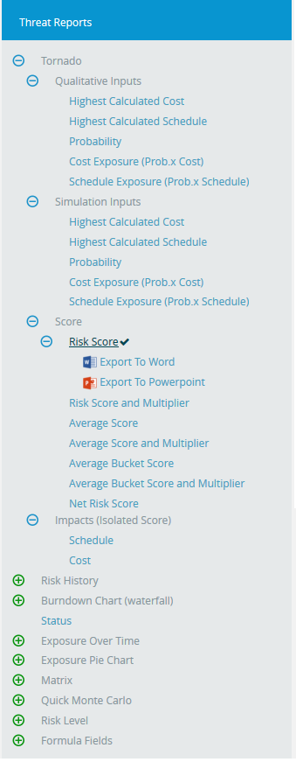
Figure 12
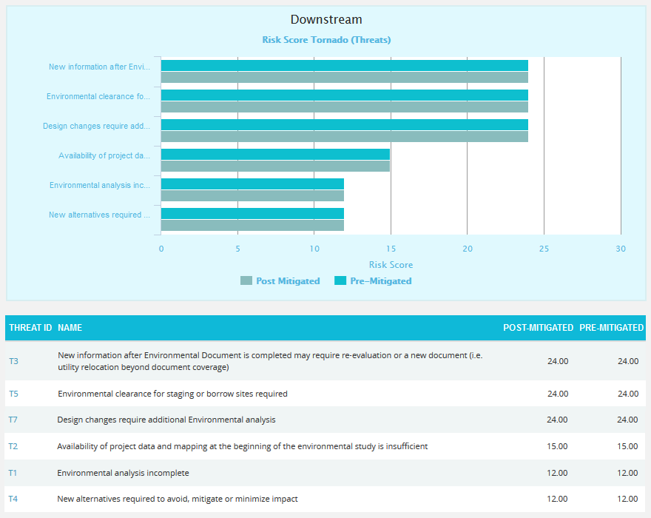
Figure 13
Clicking on the Risk ID shown in the data table in Figure 13 navigates to the page:
Risk Register ---> Risk Details (Threats)

Threat Net Risk Score:
The Threat Net Risk Score Chart shows the net risk score of each threat in a project. The impact types (cost, schedule, safety, etc.) are isolated and evaluated using the probability input. Each threat is ranked individually for all impact types. A threat with a qualitative score of high for cost and high for schedule will have a higher cumulative score than a threat with qualitative scores of high/medium (cost/schedule). Typical risk scoring may only show the highest impact type instead of isolating the impact types. The further breakdown can help to analyze the root cause of a threat receiving a high risk score. It shows only 5 threats in the chart and 20 threats in the table below the chart according to the option Pre Mitigated or Post Mitigated selected from the dropdown. The top 3 impacts are shown separately in the chart and the accumulative score for all other impacts are shown using the score value other impacts.
Steps:
- Risk Register ---> Reports
- Click the Threat Reports link to select Threat Tornado Chart. (Figure 14)
- Click the Net Risk Score link to view the net risk score of each threat in the selected project. (Figure 14)
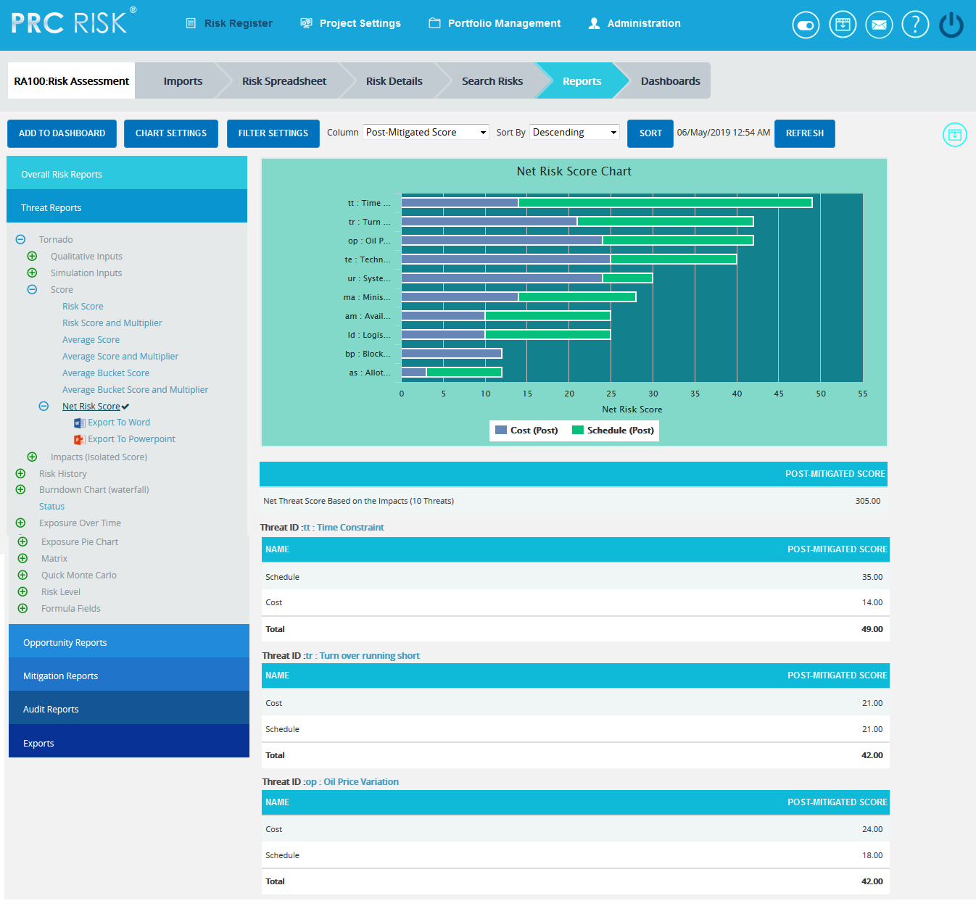
Figure 14
The table below the chart contains each threat’s id and name link (Figure 14) that navigates the user to the Risk Details page of that particular threat.

Filter:
This functionality is used to apply the Filter to the net risk score chart based on the impact types. It shows all the impacts by default.
Steps:
- Risk Register ---> Reports
- Click the Threat Reports link to select Threat Tornado Chart. (Figure 14)
- Click the Net Risk Score link to view the net risk score of each threat in the selected project.
- Click the FILTER SETTINGS button. (Figure 15) A pop up shown in Figure appears.
- Select the impacts to be shown with their scores and click the LOAD IMPACT SCORES button. (Figure 15)
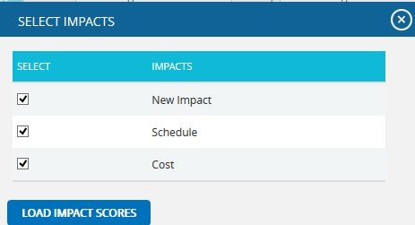
Figure 15

Sort By:
This functionality is used to sort the data for the Net Risk Score chart in ascending or descending order based on the sum of the impact scores.
Steps:
- Risk Register ---> Reports
- Click the Threat Reports link to select Threat Tornado Chart. (Figure 14)
- Click the Net Risk Score link to view the net risk score of each threat in the selected project.
- Select the Sort by dropdown to sort the report in ascending or descending order based on the sum of the impact scores. (Figure 14)
- Click the SORT button. (Figure 14)
Refresh:
This functionality is used to refresh the chart with the most recently added threat in the project. To refresh the chart, click the REFRESH button. (Figure 14)

Tornado:

Opportunity Tornado chart corresponds to all the opportunities in the selected project.
Steps:
- Risk Register ---> Reports
- Click the Opportunity Reports link to select Opportunity Tornado Chart. (Figure 1)
- Select Pre-Mitigated to view Pre-Mitigated data only (sorted by Pre-Mitigated), Post-Mitigated to view Post-Mitigated data (sorted by Post-Mitigated) or both to view both Pre-Mitigated data and Post-Mitigated data from the dropdown. (Figure 10)
- Click the FILTER SETTINGS button to add a filter. (Steps to be followed to add a filter are explained in the filter section above) (Figure 10)
- Click the Risk Score data option or any other data option to generate the report. (Figure 16) The chart generated and the data table is shown in Figure 17.

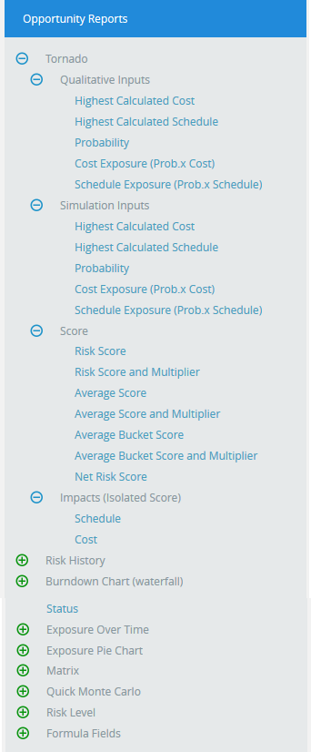
Figure 16

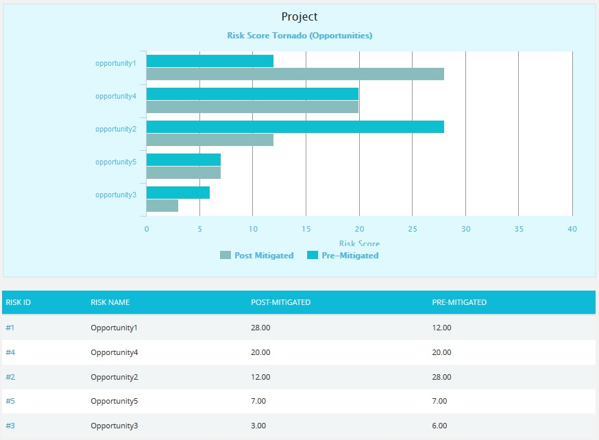
Figure 17
Clicking on the Risk ID shown in the data table in Figure 17 navigates to the page:
Risk Register ---> Risk Details (Opportunities)

Opportunity Net Risk Score:
The Opportunity Net Risk Score Chart shows the net risk score of each opportunity in a project. The impact types (cost, schedule, safety, etc.) are isolated and evaluated using the probability input. Each opportunity is ranked individually for all impact types. An opportunity with a qualitative score of high for cost and high for schedule will have a higher cumulative score than an opportunity with qualitative scores of high/medium (cost/schedule). Typical risk scoring may only show the highest impact type instead of isolating the impact types. The further breakdown can help to analyze the root cause of an opportunity receiving a high risk score. It shows only 5 opportunities in the chart and 20 opportunities in the table below the chart.
Steps:
- Risk Register ---> Reports
- Click the Opportunity Reports link to select Opportunity Tornado Chart. (Figure 18)
- Click the Net Risk Score link to view the net risk score of each opportunity in the selected project.
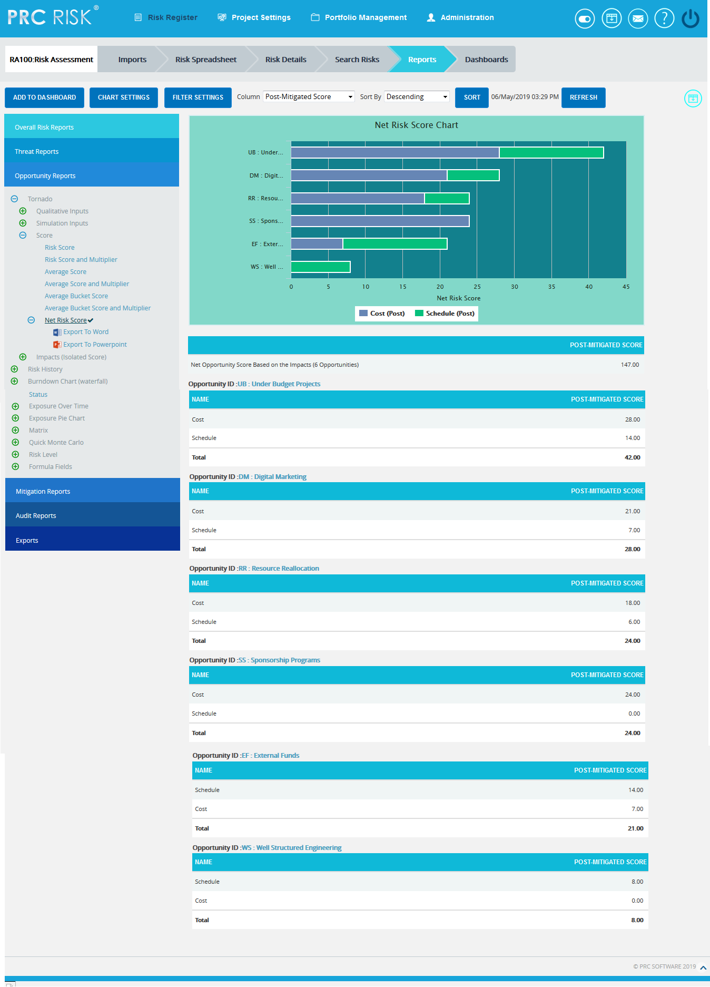
Figure 18
The table below the chart contains each opportunity’s id and name link (Figure 18) that navigates the user to the Risk Details page of that particular opportunity.
Filter:
This functionality is used to apply the Filter to the net risk score chart based on the impact types. It shows all the impacts by default.
Steps:
- Risk Register ---> Reports
- Click the Opportunity Reports link to select Opportunity Tornado Chart. (Figure 18)
- Click the Net Risk Score link to view the net risk score of each opportunity in the selected project.
- Click the FILTER SETTINGS button. (Figure 19) A pop up shown in Figure appears.
- Select the impacts to be shown with their scores and click the LOAD IMPACT SCORES button. (Figure 19)
Figure 19

Sort By:
This functionality is used to sort the data for the Net Risk Score chart in ascending or descending order based on the sum of the impact scores.
Steps:
- Risk Register ---> Reports
- Click the Opportunity Reports link to select Opportunity Tornado Chart. (Figure 18)
- Click the Net Risk Score link to view the net risk score of each opportunity in the selected project.
- Select the Sort by dropdown to sort the report in ascending or descending order based on the sum of the impact scores. (Figure 18)
- Click the SORT button. (Figure 18)
Refresh:
This functionality is used to refresh the chart with the most recently added opportunity in the project. To refresh the chart, click the REFRESH button. (Figure 18)

Threats Risk History:
The Risk History chart plots a point of time when the corresponding data has changed.
Steps:
- Risk Register ---> Reports
- Click the Risk History link to select the report as Risk History. (Figure 1)
- Select Threat Reports link. If the Threat option is selected, the history chart will correspond to the threats in the selected project.(Figure 20)
- Select Pre-Mitigated to view Pre-Mitigated data only (sorted by Pre-Mitigated), Post-Mitigated to view Post-Mitigated data (sorted by Post-Mitigated) or both to view both Pre-Mitigated data and Post-Mitigated data from the dropdown. (Figure 20)
- Click the Risk Score data option or any other data option to generate the report. (Figure 21) The chart generated and the data table is shown in Figure 22.

Opportunity Risk History:
Steps:
- Risk Register ---> Reports
- Click the Risk History link to select the report as Risk History. (Figure 1)
- Select Opportunity Reports link. If the Opportunity option is selected, the history chart will correspond to the Opportunity in the selected project. (Figure 20)
- Select Pre-Mitigated to view Pre-Mitigated data only (sorted by Pre-Mitigated), Post-Mitigated to view Post-Mitigated data (sorted by Post-Mitigated) or both to view both Pre-Mitigated data and Post-Mitigated data from the dropdown. (Figure 20)
- Click the Risk Score data option or any other data option to generate the report. (Figure 21) The chart generated and the data table is shown in Figure 23.
Figure 20

Figure 21

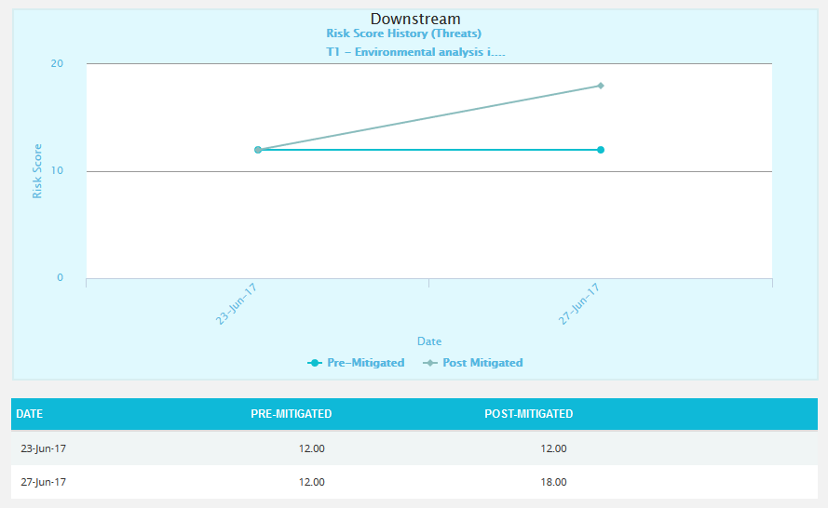
Figure 22
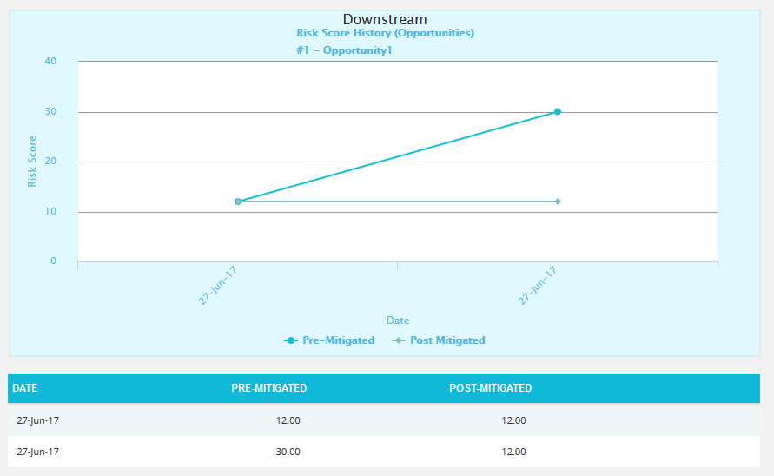
Figure 23

Status:
The Status chart is represented by a pie chart and corresponds to the status assigned to the risk.
Steps:
- Risk Register ---> Reports
- Click the Status link to select the report Status. (Figure 1)
- Click the FILTER SETTINGS button to add a filter. (Steps to be followed to add a filter are explained in filter section above). (Figure 10)
- Click the Status link under Threat reports to know the status of threats in the selected project. Click the Status link under Opportunity reports to know the status of opportunity in the selected project. To know the status of mitigations in the selected project, click Status ---> Mitigation Status link. Click the Threat and Opportunity Status or Total Threats and Opportunities link under Overall Risk Reports to know the status of threats and opportunities in the selected project. (Figure 24) The chart generated and the data tables are shown in Figure 25 and Figure 26.
Figure 24
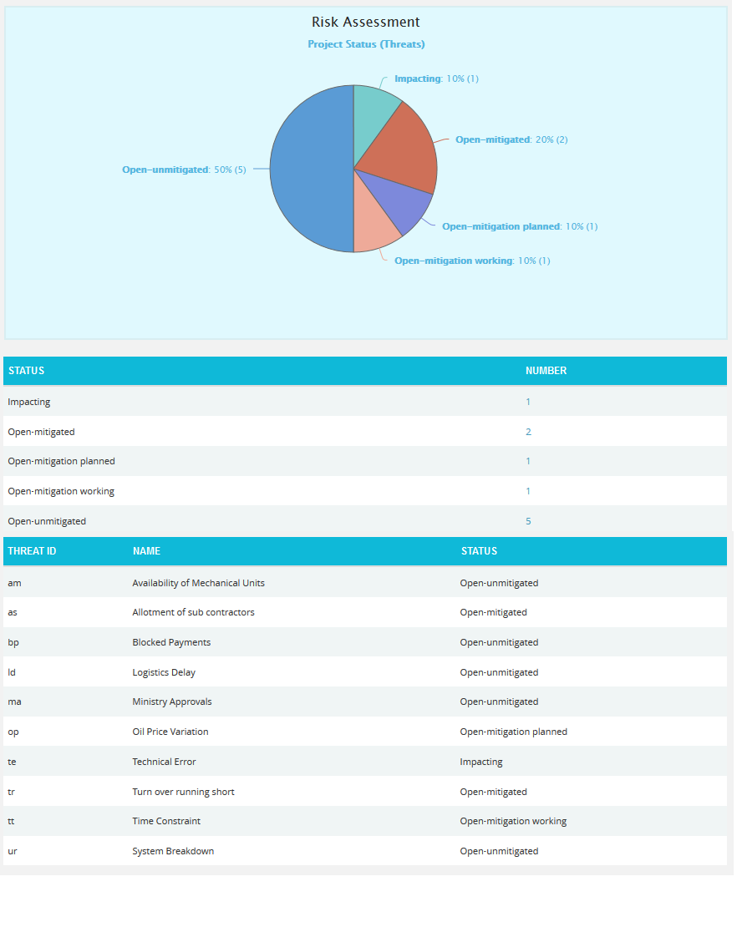
Figure 25
The count under the Number column shown in Figure 25 has a link to the Risk Score Tornado (Threats) Chart. (Figure 13)

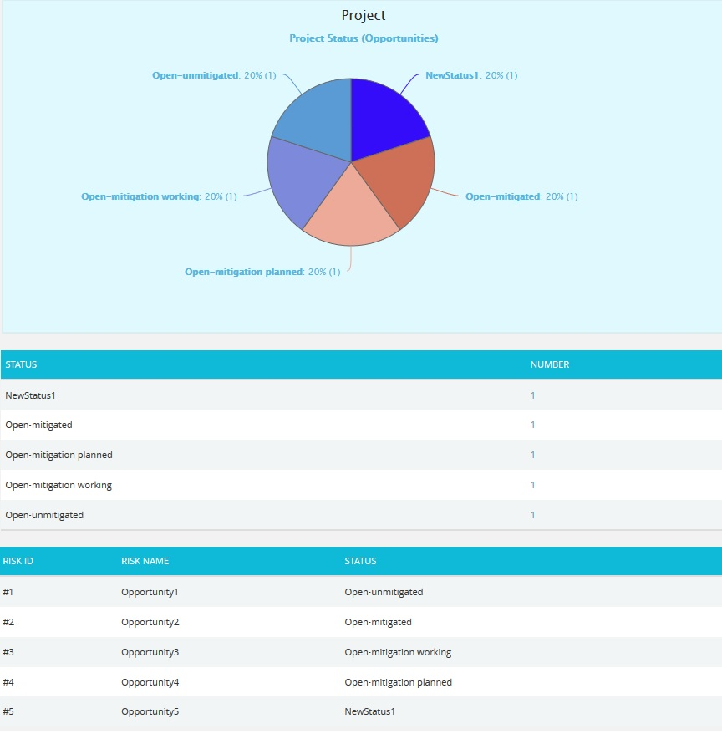

Figure 26
The count under the Number column shown in Figure 26 has a link to the Risk Score Tornado (Opportunities) Chart. (Figure 17)

Burndown Chart (Waterfall):
The Burndown charts are plotted based on Threat Start/Finish dates and Mitigation Actual and Proposed dates. The first value used to plot the chart is the Risk Start Date.
Steps:
- Risk Register ---> Reports
- Click the Burndown Chart (waterfall) link to select the report Burndown Chart. (Figure 1)
- Select Threat or Opportunity Reports link. If the Threat option is selected, the history chart will correspond to the threats in the selected project. If the Opportunity option is selected, the history chart will correspond to the Opportunity in the selected project.
- Click the Risk Score link or any other data option to generate the report for each risk. (Figure 28) The chart generated and the data table is shown in Figure 29.
- Select any Threat/ Opportunity from the Select Risk dropdown. (Figure 27)

Figure 27

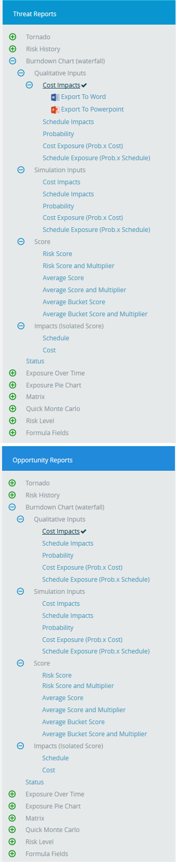
Figure 28
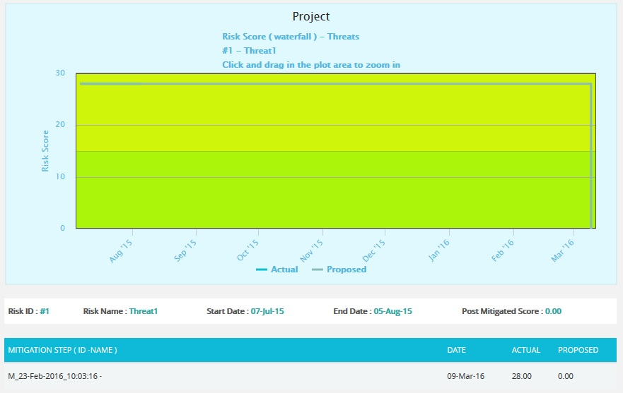
Figure 29

Threat Exposure over Time:
The Threat Exposure over Time chart is generated based on the Qualitative Cost Exposure, Simulation Cost Exposure, Qualitative Schedule Exposure and Simulation Schedule Exposure for all the threats in the selected project.
Steps:
- Risk Register ---> Reports
- Click the Exposure over Time link under Threat Reports. (Figure 1)
- Select Pre-Mitigated to view Pre-Mitigated data only (sorted by Pre-Mitigated), Post-Mitigated to view Post-Mitigated data (sorted by Post-Mitigated) or both to view both Pre-Mitigated data and Post-Mitigated data from the dropdown. (Figure 10)
- Click the FILTER SETTINGS button to add a filter. (Steps to be followed to add a filter are explained in filter section above). (Figure 10)
- Click the Cost under Simulation link or any other data option to generate the report. (Figure 30) The chart generated and the data table is shown in Figure 31.

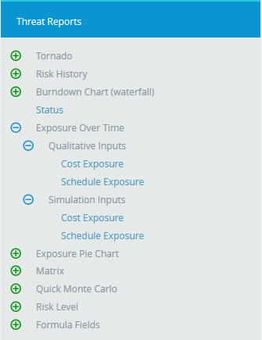
Figure 30
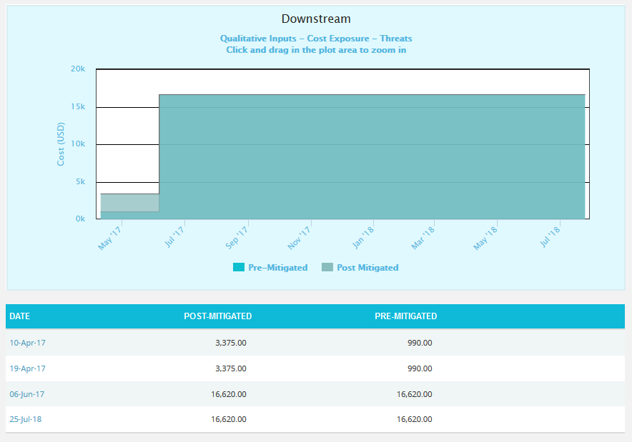
Figure 31

The Column Date of the data table (Figure 31) contains a link that navigates the user to the following charts:
- Simulation Cost Exposure Tornado (Threat), if the option Cost Under Simulation For Threat Reports is selected.
- Qualitative Cost Exposure Tornado (Threat), if the option Cost Under Qualitative For Threat Reports is selected.
- Simulation Schedule Exposure Tornado (Threat), if the option Schedule Under Simulation For Threat Reports is selected.
- Qualitative Schedule Exposure Tornado (Threat), if the option Schedule Under Qualitative For Threat Reports is selected.

Opportunity Exposure over Time:
The Opportunity Exposure over Time chart is generated based on the Qualitative Cost Exposure, Simulation Cost Exposure, Qualitative Schedule Exposure and Simulation Schedule Exposure for all the opportunities in the selected project.
Steps:
- Risk Register ---> Reports
- Click the Exposure over Time link under Opportunity Reports. (Figure 1)
- Select Pre-Mitigated to view Pre-Mitigated data only (sorted by Pre-Mitigated), Post-Mitigated to view Post-Mitigated data (sorted by Post-Mitigated) or both to view both Pre-Mitigated data and Post-Mitigated data from the dropdown. (Figure 10)
- Click the FILTER SETTINGS button to add a filter. (Steps to be followed to add a filter are explained in filter section above). (Figure 10)
- Click the Cost under Simulation link or any other data option to generate the report. (Figure 32) The chart generated and the data table is shown in Figure 33.
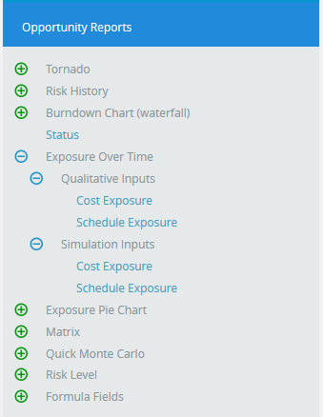
Figure 32
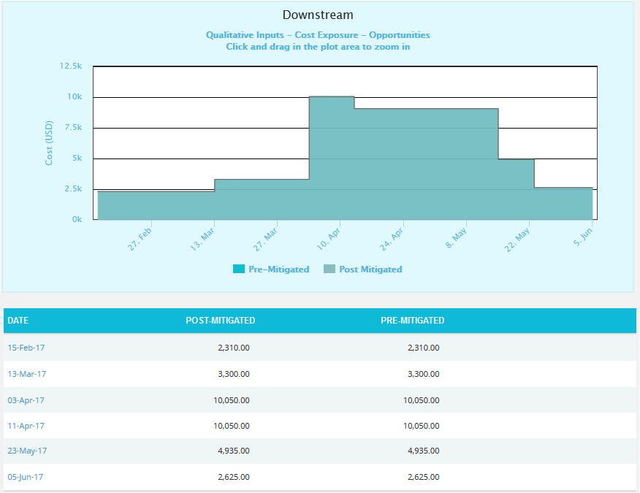
Figure 33
The Column Date of the data table (Figure 33) contains a link that navigates the user to the following charts:
- Simulation Cost Exposure Tornado (Opportunities), if the option Cost Under Simulation For Opportunity Reports is selected.
- Qualitative Cost Exposure Tornado (Opportunities), if the option Cost Under Qualitative For Opportunity Reports is selected.
- Simulation Schedule Exposure Tornado (Opportunities), if the option Schedule Under Simulation For Opportunity Reports is selected.
- Qualitative Schedule Exposure Tornado (Opportunities), if the option Schedule Under Qualitative For Opportunity Reports is selected.

Threat Simulation Exposure Pie Chart:
The Threat Simulation Exposure Pie Chart depends on the simulation cost exposure of the threats mapped to the break down structure in the selected project.
Steps:
- Risk Register ---> Reports
- Click the Exposure Pie Chart link under Threat Reports. (Figure 1)
- Select Pre-Mitigated to view Pre-Mitigated data only (sorted by Pre-Mitigated), Post-Mitigated to view Post-Mitigated data (sorted by Post-Mitigated) from the dropdown. (Figure 10)
- Click the FILTER SETTINGS button to add a filter. (Steps to be followed to add a filter are explained in filter section above). (Figure 10)
- Click the Project-WBS link or any other data option to generate the report. (Figure 34) The chart generated and the data table is shown in Figure 35.
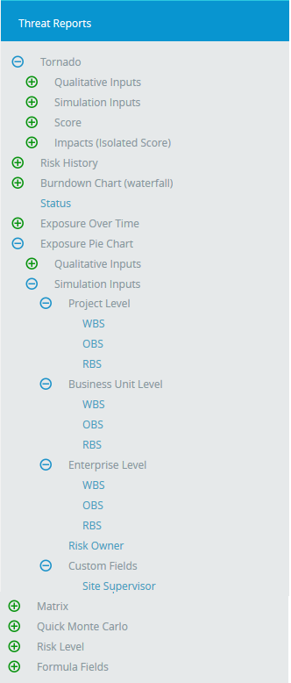
Figure 34
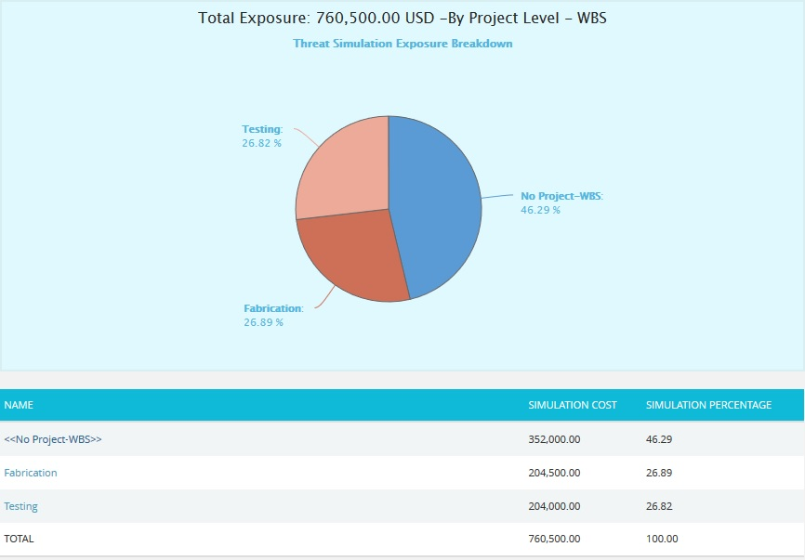
Figure 35
The Name column contains a link to WBS Tornado (Threats). (Figure 35)

Opportunity Simulation Exposure Pie Chart:
The Opportunity Simulation Exposure Pie Chart depends on the simulation cost exposure of the opportunities mapped to the break down structure in the selected project.
Steps:
- Risk Register ---> Reports
- Click the Exposure Pie Chart link under Opportunity Reports. (Figure 1)
- Select Pre-Mitigated to view Pre-Mitigated data only (sorted by Pre-Mitigated), Post-Mitigated to view Post-Mitigated data (sorted by Post-Mitigated) from the dropdown. (Figure 10)
- Click the FILTER SETTINGS button to add a filter. (Steps to be followed to add a filter are explained in filter section above). (Figure 10)
- Click the Project-WBS link or any other data option to generate the report. (Figure 36) The chart generated and the data table is shown in Figure 37.

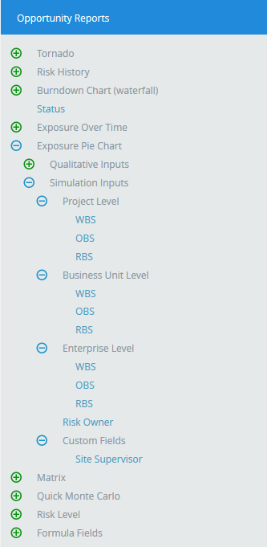
Figure 36
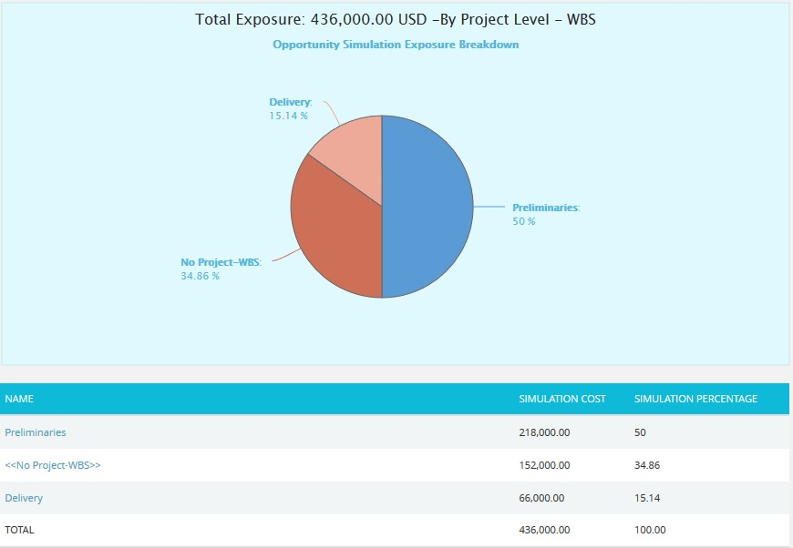
Figure 37
The Name column contains a link to WBS Tornado (Opportunities). (Figure 37)

Threat Qualitative Exposure Pie Chart:
The Threat Qualitative Exposure Pie Chart depends on the qualitative cost exposure of the threats mapped to the break down structure in the selected project.
Steps:
- Risk Register ---> Reports
- Click the Exposure Pie Chart link under Threat Reports. (Figure 1)
- Select Pre-Mitigated to view Pre-Mitigated data only (sorted by Pre-Mitigated), Post-Mitigated to view Post-Mitigated data (sorted by Post-Mitigated) from the dropdown. (Figure 10)
- Click the FILTER SETTINGS button to add a filter. (Steps to be followed to add a filter are explained in the filter section above). (Figure 10)
- Click the Project-WBS link or any other data option to generate the report. (Figure 38) The chart generated and the data table is shown in Figure 39.

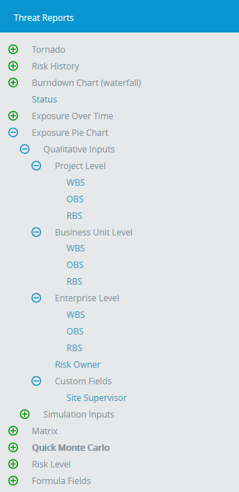
Figure 38

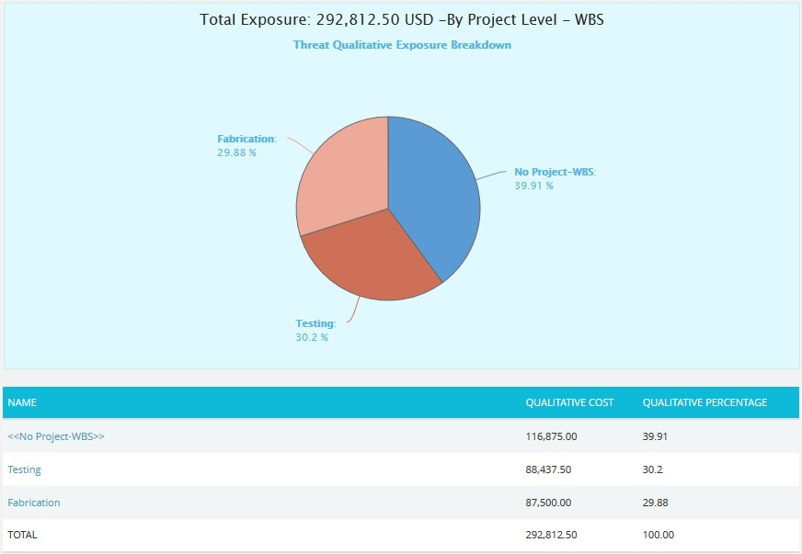Figure 39
The Name column contains a link to WBS Tornado (Threats). (Figure 39)

Opportunity Qualitative Exposure Pie Chart:
The Opportunity Qualitative Exposure Pie Chart depends on the qualitative cost exposure of the opportunities mapped to the break down structure in the selected project.
Steps:
- Risk Register ---> Reports
- Click the Exposure Pie Chart link under Opportunity Reports. (Figure 1)
- Select Pre-Mitigated to view Pre-Mitigated data only (sorted by Pre-Mitigated), Post-Mitigated to view Post-Mitigated data (sorted by Post-Mitigated) from the dropdown. (Figure 10)
- Click the FILTER SETTINGS button to add a filter. (Steps to be followed to add a filter are explained in filter section above). (Figure 10)
- Click the Project-WBS link or any other data option to generate the report. (Figure 40) The chart generated and the data table is shown in Figure 41.

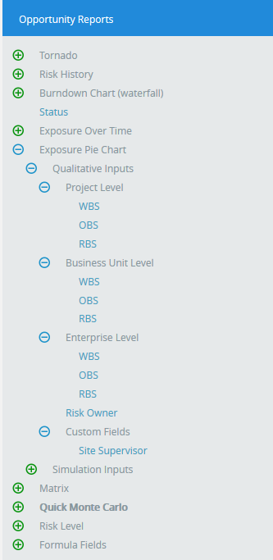
Figure 40

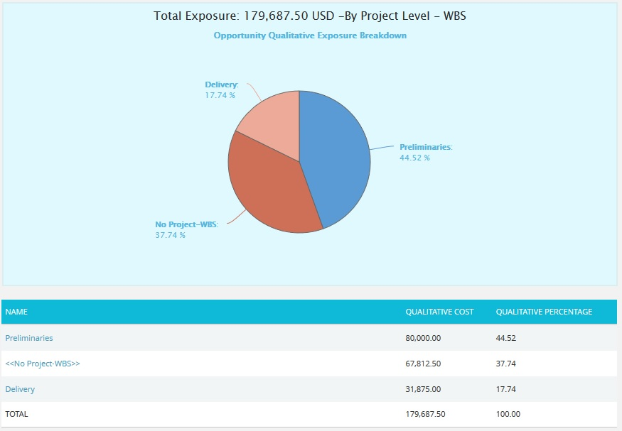
Figure 41
The Name column contains a link to WBS Tornado (Threats). (Figure 41)
Matrix Chart:
Threat Score Matrix:
The Threat score matrix provides a summary of all the Threats in the project on the basis of probability and impacts. The details of those Threats whose Risk Score is 0 will not be displayed in this chart.
- The Pre-Mitigated Risks section shows the Pre-mitigated risk score of all the threats in the project. For example, 12 (3) indicates that 3 threats has a pre-mitigated score of 12.
- The Post-Mitigated Risks section shows the Post-mitigated risk score of all the threats in the project. For example, 24 (3) indicates that 3 threats has a post-mitigated score of 24.
The color is given based on the color that has been set for the probability and impact scale in the Project Settings Threat scoring system.
Steps:
- Risk Register ---> Reports
- Click the Matrix link under Threat Reports. (Figure 1)
- Click the Threat Score Matrix link. (Figure 42) The chart generated and the data table is shown in Figure 42.
- Click the FILTER SETTINGS button to add a filter. (Steps to be followed to add a filter are explained in filter section above). (Figure 10)
- Click REFRESH button to refresh the chart. (Figure 42)
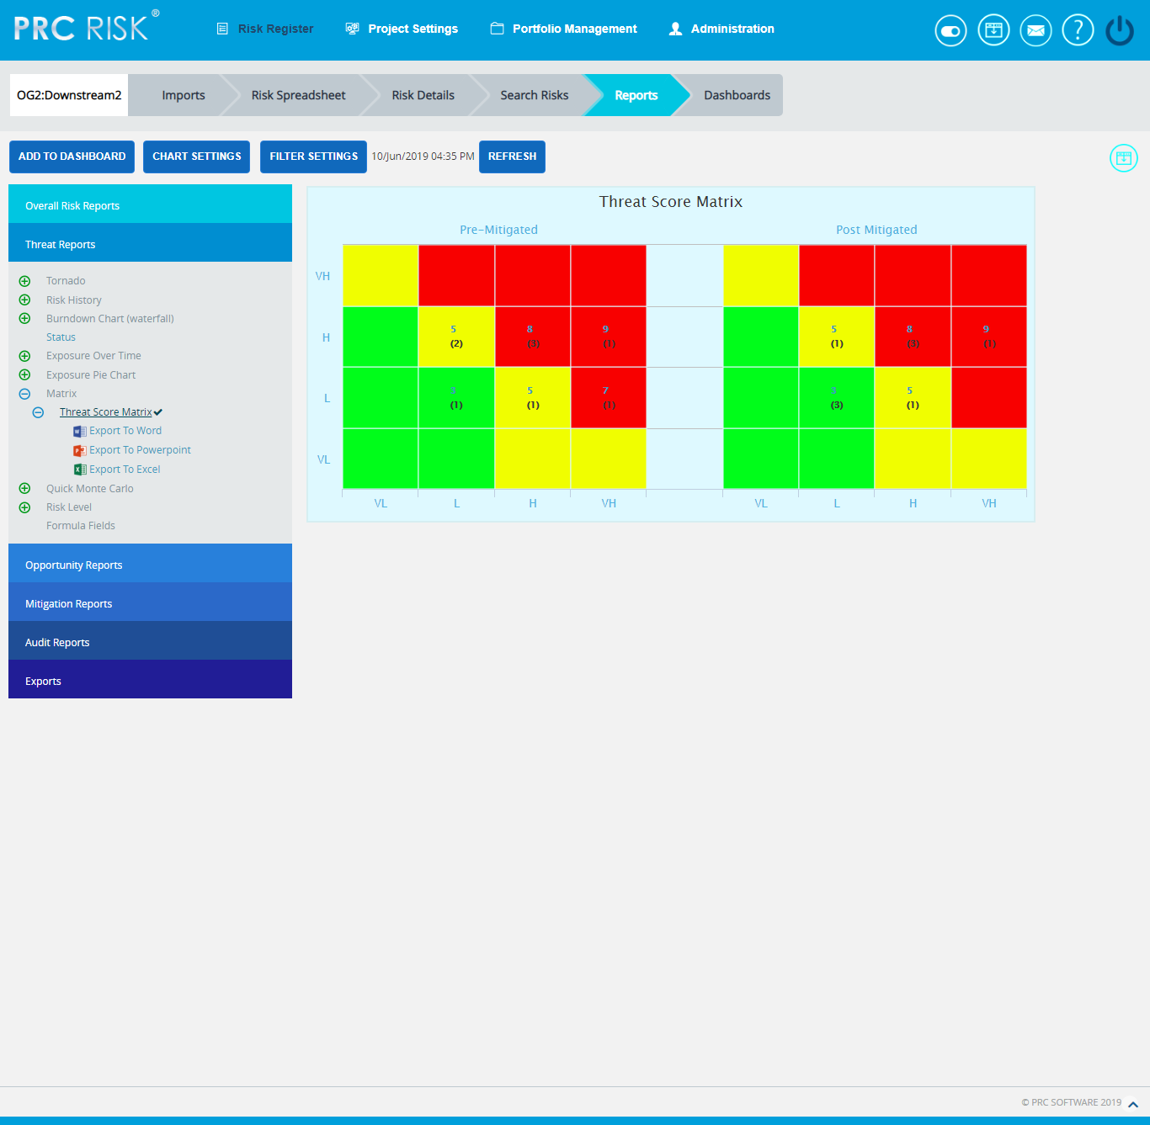
Figure 42

Opportunity Score Matrix:
The Opportunity score matrix provides a summary of all the Opportunities in the project on the basis of probability and impacts. The details of those Opportunities whose Risk Score is 0 will not be displayed in this chart.
- The Pre-Mitigated Risks section shows the Pre-mitigated risk score of all the opportunities in the project. For example, 12 (3) indicates that 3 opportunities have a pre-mitigated score of 12.
- The Post-Mitigated Risks section shows the Post-mitigated risk score of all the opportunities in the project. For example, 24 (3) indicates that 3 opportunities have a post-mitigated score of 24.
The color is given based on the color that has been set for the probability and impact scale in the Project Settings Opportunity scoring system.
Steps:
- Risk Register ---> Reports
- Click the Matrix link under Threat Reports. (Figure 1)
- Click the Opportunity Score Matrix link. (Figure 43) The chart generated and the data table is shown in Figure 43.
- Click the FILTER SETTINGS button to add a filter. (Steps to be followed to add a filter are explained in filter section above). (Figure 10)
- Click REFRESH button to refresh the chart. (Figure 43)
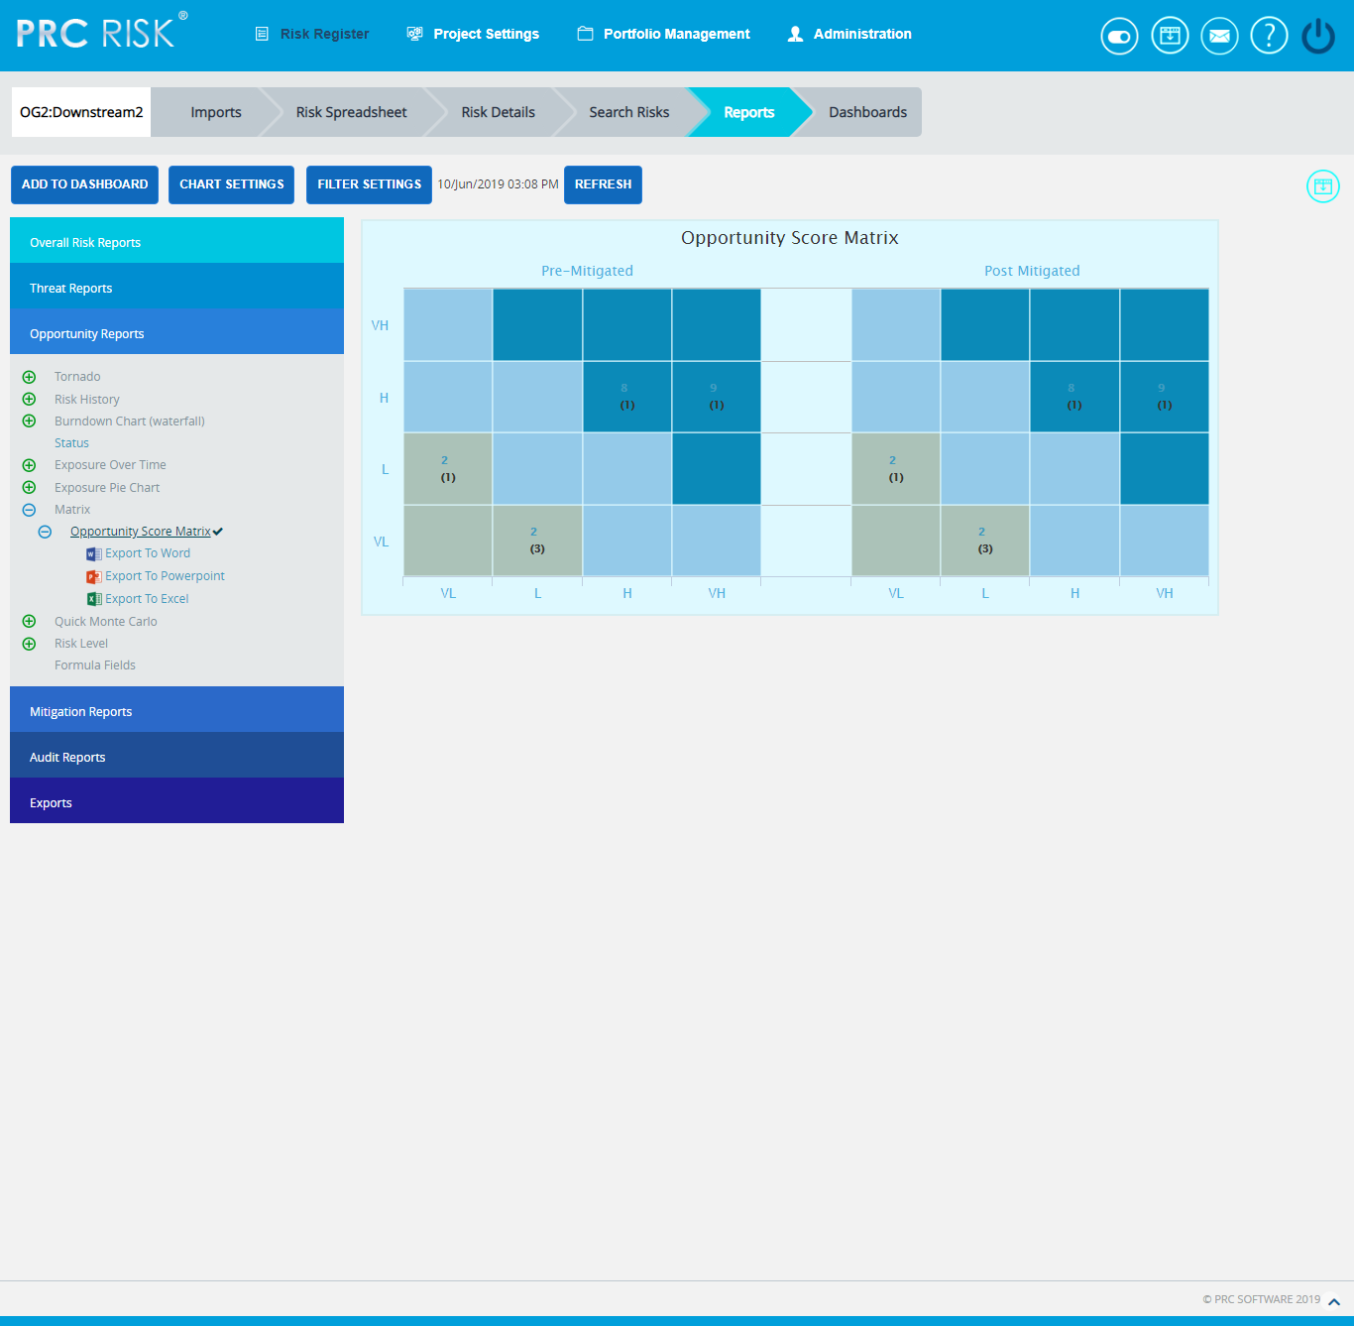
Figure 43
Quick Monte Carlo:
Cost Cumulative S Curve:
The Cost Cumulative S Curve report shows the distribution of the Cost Exposure of a selected project. It simulates cost values using Triangular Distribution. The columns show the hits for each of the total amount of risk cost exposure. The S curve shows the cumulative frequency of the hits in percentage.

Steps:
- Risk Register ---> Reports
- Click the Quick Monte Carlo link under Threat / Opportunity Reports. (Figure 1)
- Click the Cost Cumulative S Curve link. (Figure 44) The chart generated and the data table is shown in Figure 44.
- Click the FILTER SETTINGS button. Cost Analysis Inputs pop up appears where the Iteration number, Highlights, Pre-Mitigated options (Figure 45.1) and Post-mitigated options (Figure 45.2) are given based on which the Cumulative Frequency iterations and the Cumulative percentage values to be highlighted are shown in the chart and table.
- Click the RUN ANALYSIS AND SHOW REPORT button to view the filtered report for Pre-Mitigated and Post-mitigated options. (Figure 45.1 and Figure 45.2)
- Click REFRESH button to refresh the chart. (Figure 44)
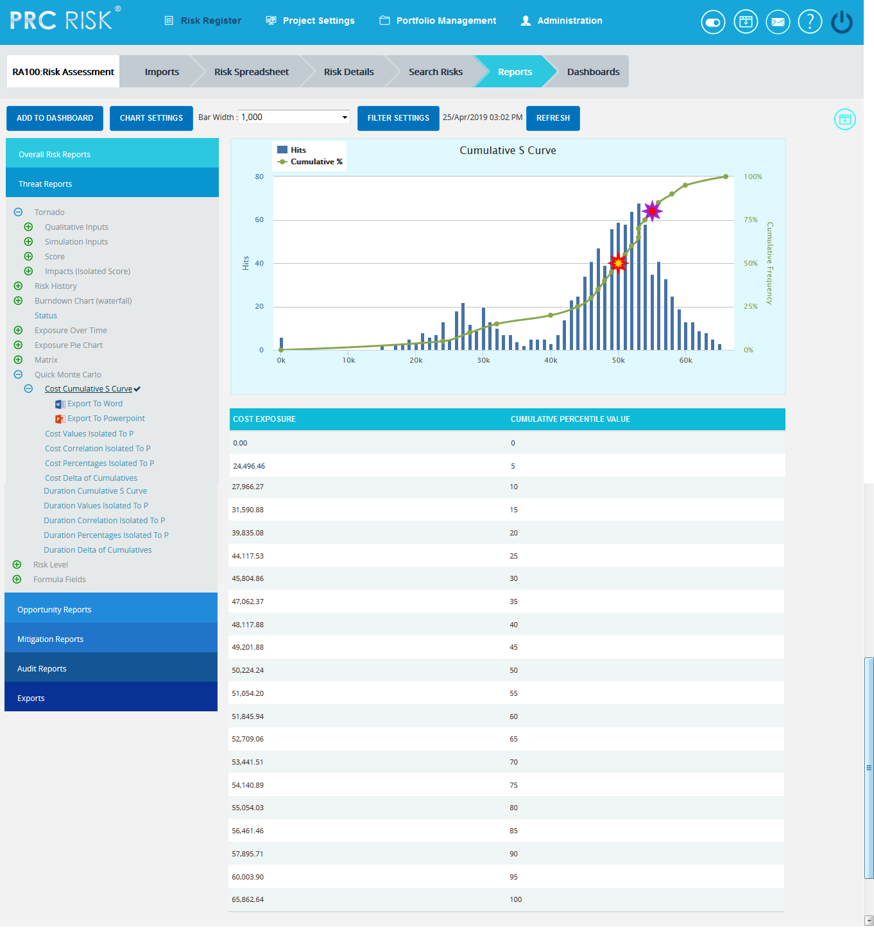
Figure 44

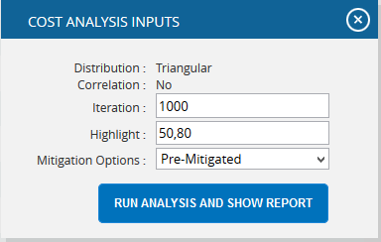
Figure 45.1
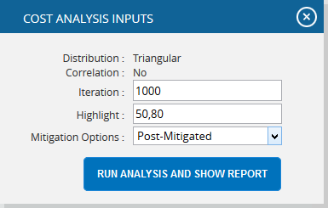
Figure 45.2
Top Risk Reports:

The Top Risk reports are Tornado Charts that depends on the simulated cost exposure values of each risk up to the Pn iteration value, where ‘n’ is the percentile value of total number of iterations given. The Top Risk reports include Cost Values Isolated to P , Cost Correlation Isolated to P and Cost Percentages Isolated to P reports. The x axis represents the cost exposure in Cost Values Isolated to P report and the percentage in Cost Correlation Isolated to P and Cost Percentages Isolated to P reports. The y axis represents the top risk names in all the three charts. Cost Exposure is the qualitative cost multiplied by probability percentage.

Steps:
- Risk Register ---> Reports
- Click the Quick Monte Carlo link under Threat / Opportunity Reports. (Figure 1)
- Click the Cost Values Isolated to P / Cost Correlation Isolated to P / Cost Percentages Isolated to P link. (Figure 46) The chart generated and the data table is shown in Figure 46.
- Click the FILTER SETTINGS button. Cost Analysis Inputs pop up appears where the Cumulative Frequency iteration number is given based on which the iterations are shown in the chart and in the table for Pre-Mitigated and Post-mitigated options. (Figure 47.1 and Figure 47.2)
- Click the RUN ANALYSIS AND SHOW REPORT button to view the filtered report for Pre-Mitigated and Post-mitigated options. (Figure 47.1 and Figure 47.2)
- Click REFRESH button to refresh the chart. (Figure 46)

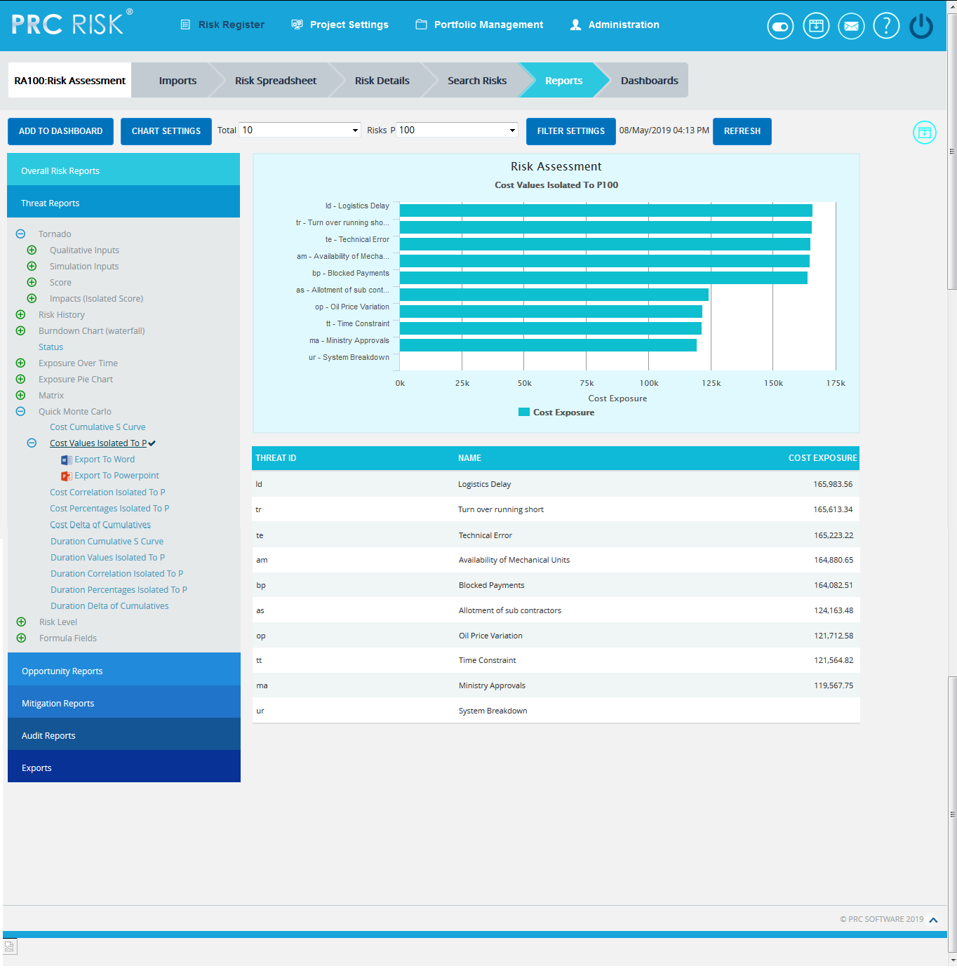
Figure 46
Figure 47.1
Figure 47.2
Cost Delta of Cumulatives:
The Cost Delta of Cumulatives report shows the distribution difference between the pre cost exposure and post cost exposure of a selected project. It simulates cost values using triangular distribution. The S curve shows the cumulative frequency of the hits in percentage.
Steps:
- Risk Register ---> Reports
- Click the Quick Monte Carlo link under Threat / Opportunity Reports. (Figure 1)
- Click the Cost Delta of Cumulatives link. (Figure 48) The chart generated and the data table is shown in Figure 48.
- Click the FILTER SETTINGS button. Cost Analysis Inputs pop up appears where the Iteration number and Highlights (Figure 49) are given based on which the Cumulative Frequency iterations and the Cumulative percentage values to be highlighted are shown in the chart and table.
- Click the RUN ANALYSIS AND SHOW REPORT button to view the filtered report. (Figure 49)

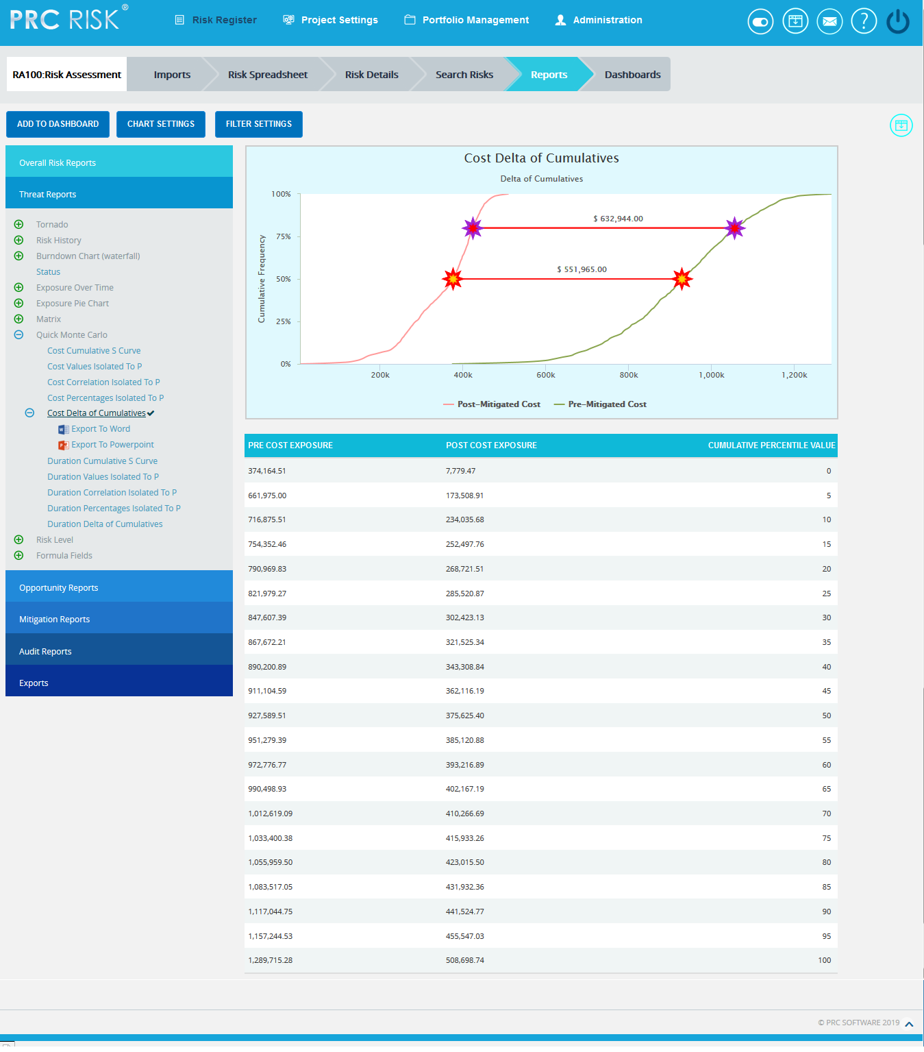
Figure 48

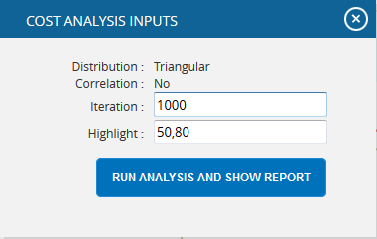
Figure 49
Duration Cumulative S Curve:
The Duration Cumulative S Curve report shows the distribution of the Duration Exposure of a selected project. It simulates duration values using Triangular Distribution. The columns show the hits for each of the total amount of risk duration exposure. The S curve shows the cumulative frequency of the hits in percentage.
Steps:
- Risk Register ---> Reports
- Click the Quick Monte Carlo link under Threat / Opportunity Reports. (Figure 1)
- Click the Duration Cumulative S Curve link. (Figure 50) The chart generated and the data table is shown in Figure 50.
- Click the FILTER SETTINGS button. Cost Analysis Inputs pop up appears where the Iteration number, Highlights, Pre-Mitigated options (Figure51.1) and Post-mitigated options (Figure 51.2) are given based on which the Cumulative Frequency iterations and the Cumulative percentage values to be highlighted are shown in the chart and table.
- Click the RUN ANALYSIS AND SHOW REPORT button to view the filtered report for Pre-Mitigated and Post-mitigated options. (Figure 51.1 and Figure 51.2)
- Click REFRESH button to refresh the chart. (Figure 50)
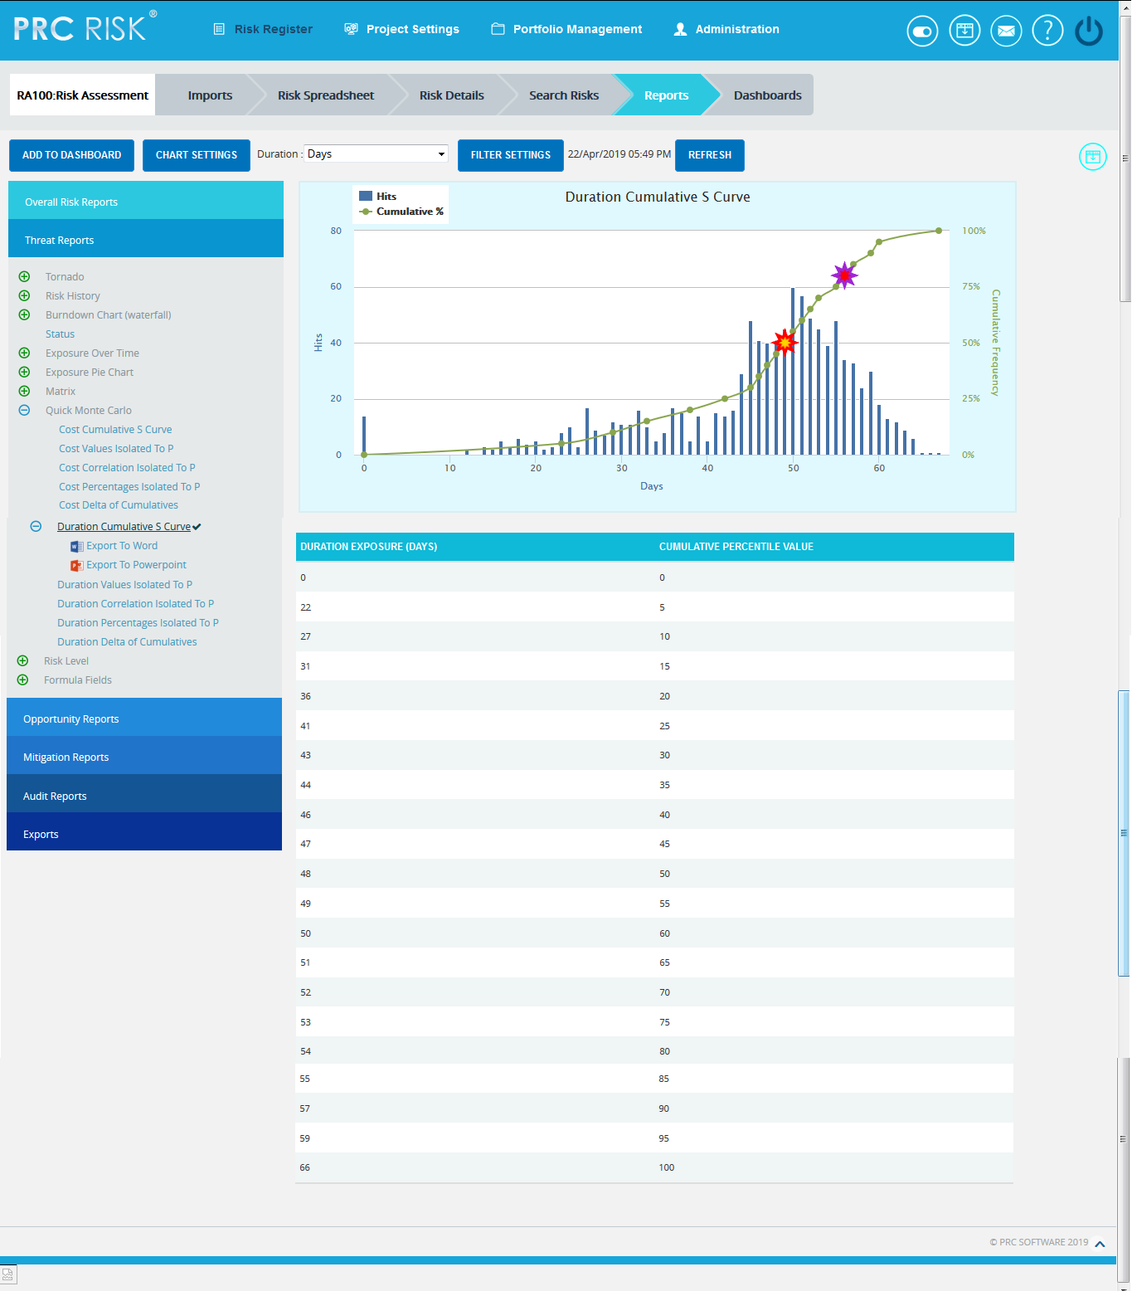
Figure 50
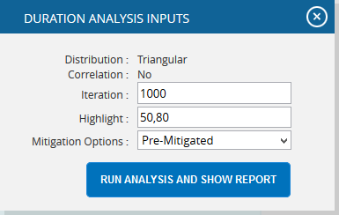
Figure 51.1
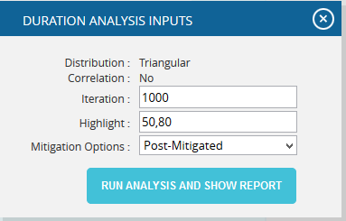
Figure 51.2
Top Risk Reports:

The Top Risk reports are Tornado Charts that depends on the simulated duration exposure values of each risk up to the Pn iteration value, where ‘n’ is the percentile value of total number of iterations given. The Top Risk reports include Duration Values Isolated to P , Duration Correlation Isolated to P and Duration Percentages Isolated to P reports. The x axis represents the duration exposure in Duration Values Isolated to P report and the percentage in Duration Correlation Isolated to P and Duration Percentages Isolated to P reports. The y axis represents the top risk names in all the three charts. Duration Exposure is the qualitative Duration multiplied by probability percentage.

Steps:
- Risk Register ---> Reports
- Click the Quick Monte Carlo link under Threat / Opportunity Reports. (Figure 1)
- Click the Duration Values Isolated to P / Duration Correlation Isolated to P / Duration Percentages Isolated to P link. (Figure 52) The chart generated and the data table is shown in Figure 52.
- Click the FILTER SETTINGS button. Duration Analysis Inputs pop up appears where the Cumulative Frequency iteration number is given based on which the iterations are shown in the chart and in the table for Pre-Mitigated and Post-mitigated options. (Figure 53.1 and Figure 53.2)
- Click the RUN ANALYSIS AND SHOW REPORT button to view the filtered report for Pre-Mitigated and Post-mitigated options. (Figure 53.1 and Figure 53.2)
- Click REFRESH button to refresh the chart. (Figure 52)
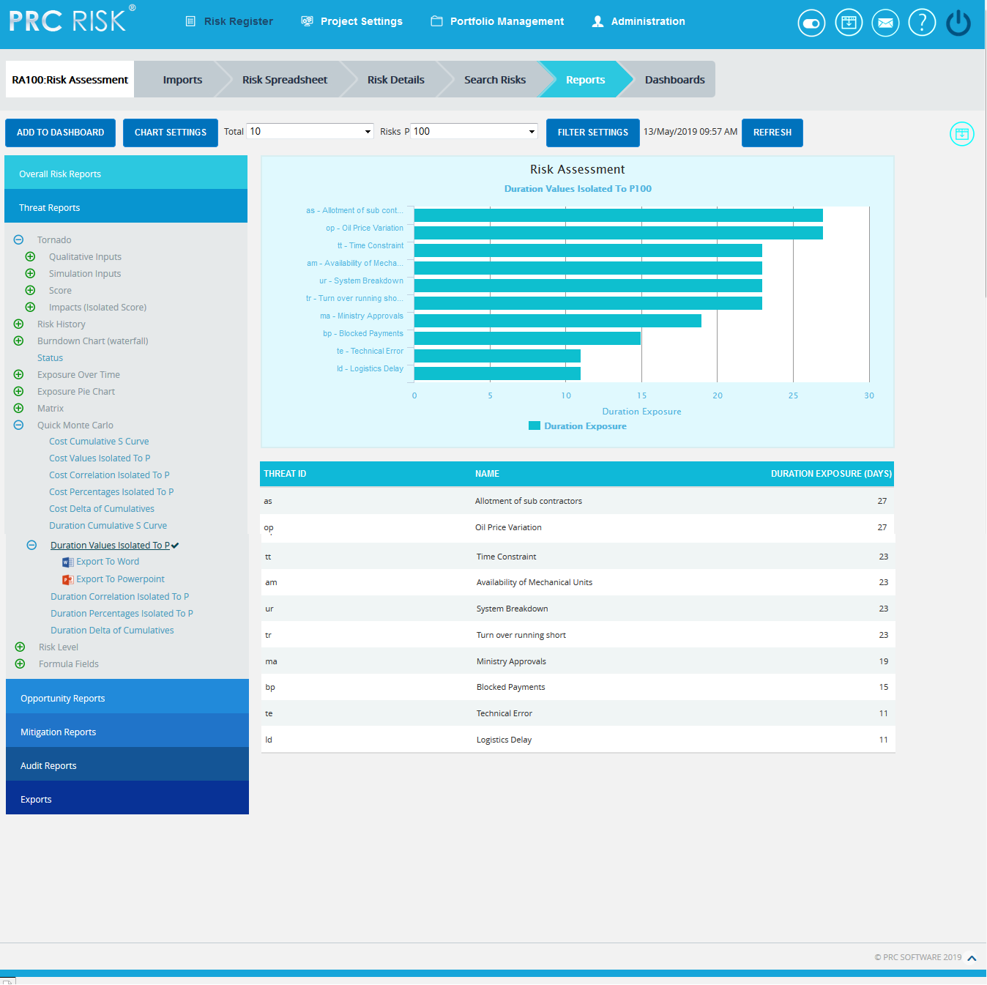
Figure 52
Figure 53.1
Figure 53.2

Duration Delta of Cumulatives:
The Duration Delta of Cumulatives report shows the distribution difference between the pre Duration exposure and post Duration exposure of a selected project. It simulates Duration values using triangular distribution. The S curve shows the cumulative frequency of the hits in percentage.
Steps:
- Risk Register ---> Reports
- Click the Quick Monte Carlo link under Threat / Opportunity Reports. (Figure 1)
- Click the Duration Delta of Cumulatives link. (Figure 54) The chart generated and the data table is shown in Figure 54.
- Click the FILTER SETTINGS button. Duration Analysis Inputs pop up appears where the Iteration number and Highlights (Figure 55) are given based on which the Cumulative Frequency iterations and the Cumulative percentage values to be highlighted are shown in the chart and table.
- Click the RUN ANALYSIS AND SHOW REPORT button to view the filtered report. (Figure 55)

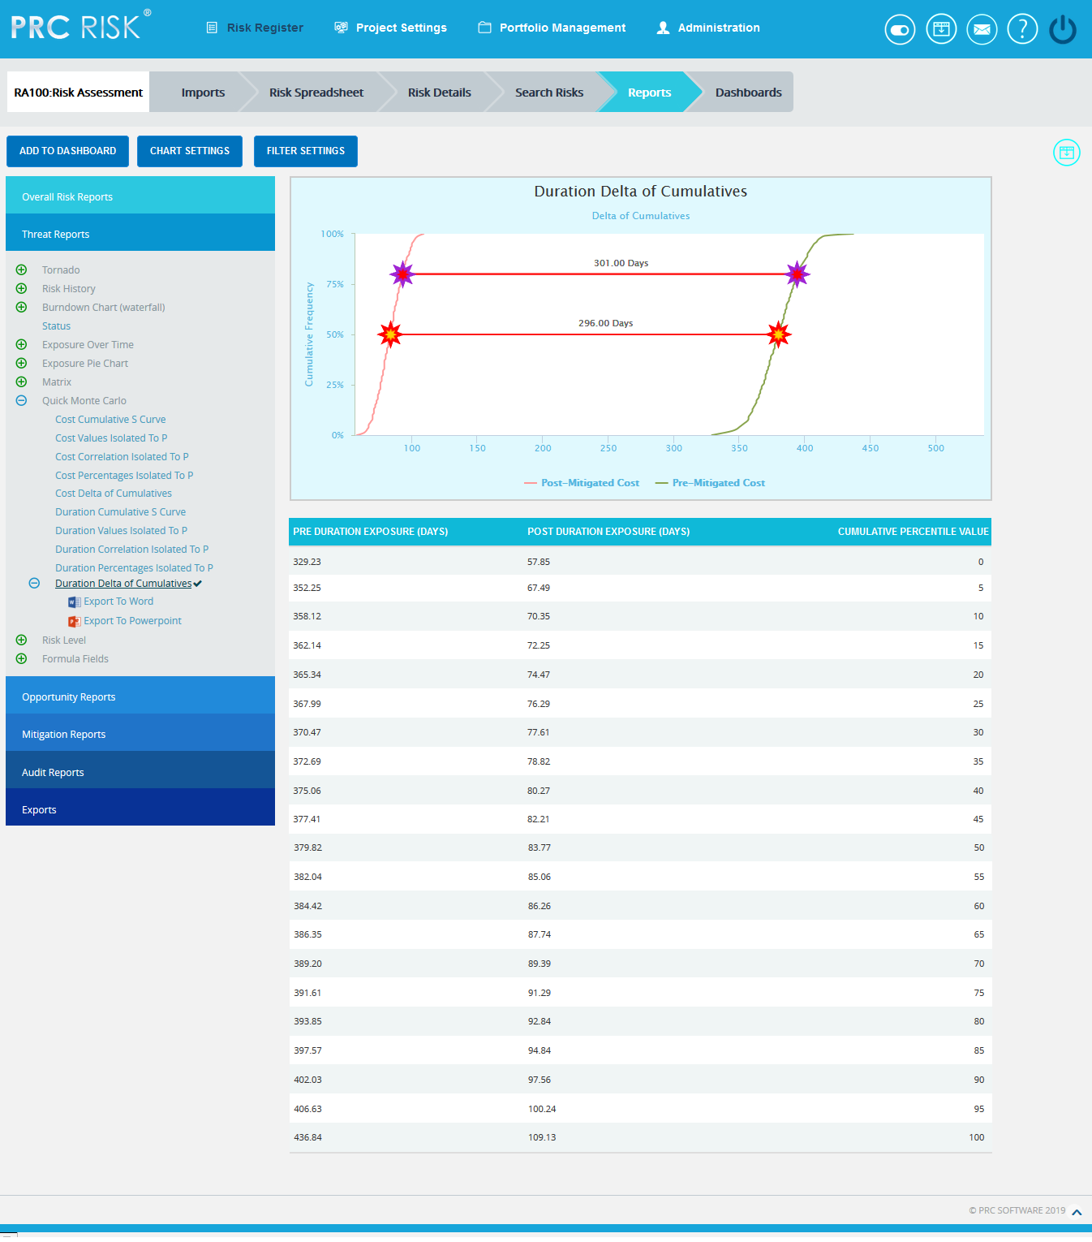
Figure 54

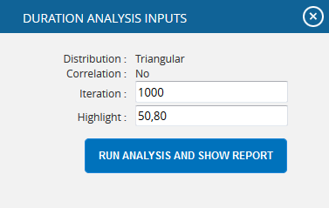
Figure 55

Risk Level Reports:

The Risk Level reports are Pie Charts which show the number of risks mapped to each impact level or probability level.

Steps:

  - Risk Register ---> Reports
  - Select any of the reports under Risk Level option. (Figure 56) The chart generated and the data table is shown in Figure 57.

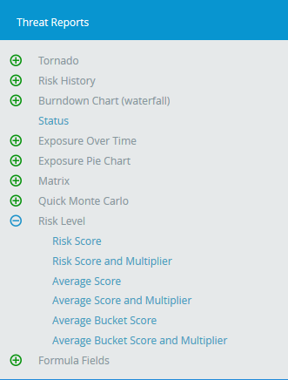
Figure 56

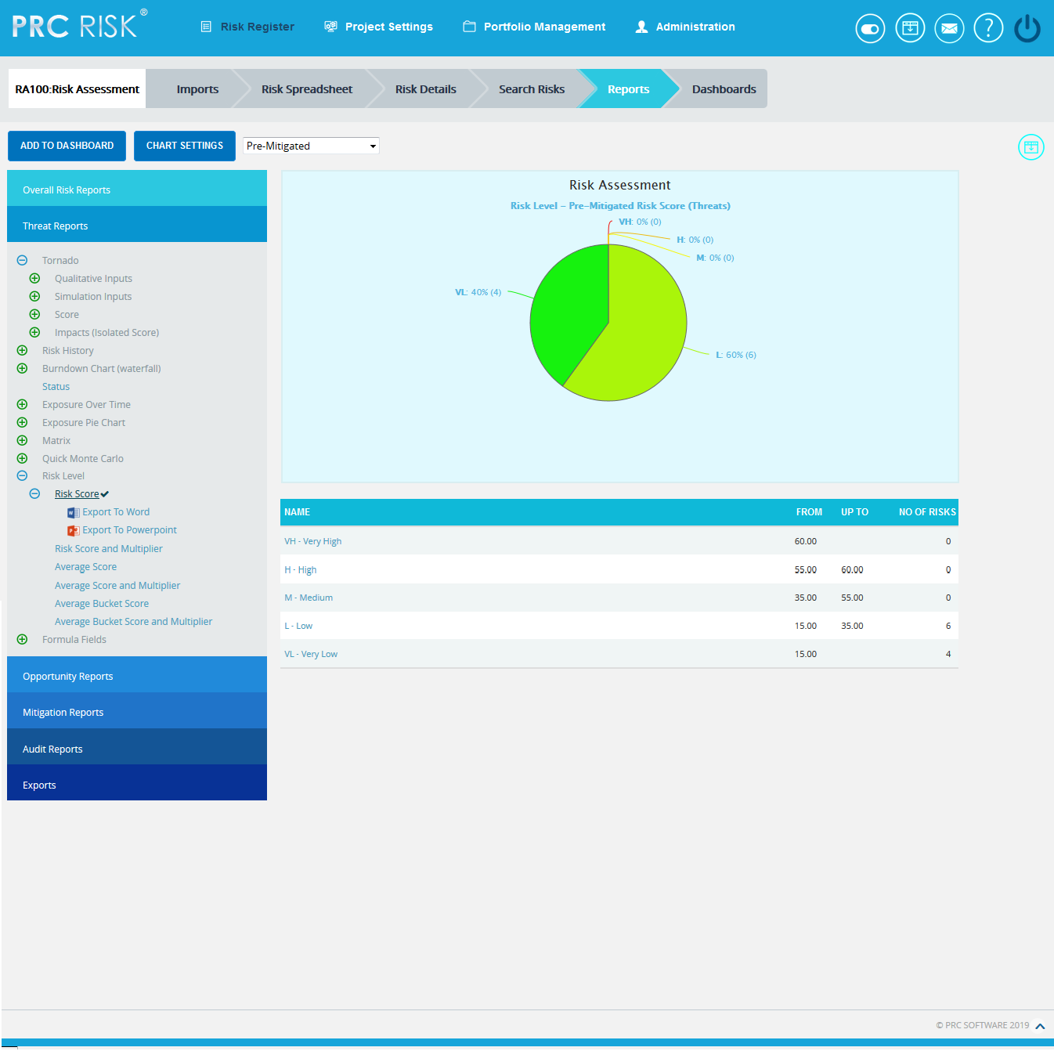

Figure 57

Formula Fields Reports:

These reports are generated corresponding to the user defined formula field values added or imported under Project Settings-> Custom Fields->Formula Field.

Steps:

  - Risk Register ---> Reports
  - Select any of the reports under Formula Fields option. The chart generated and the data table is shown in Figure 58.
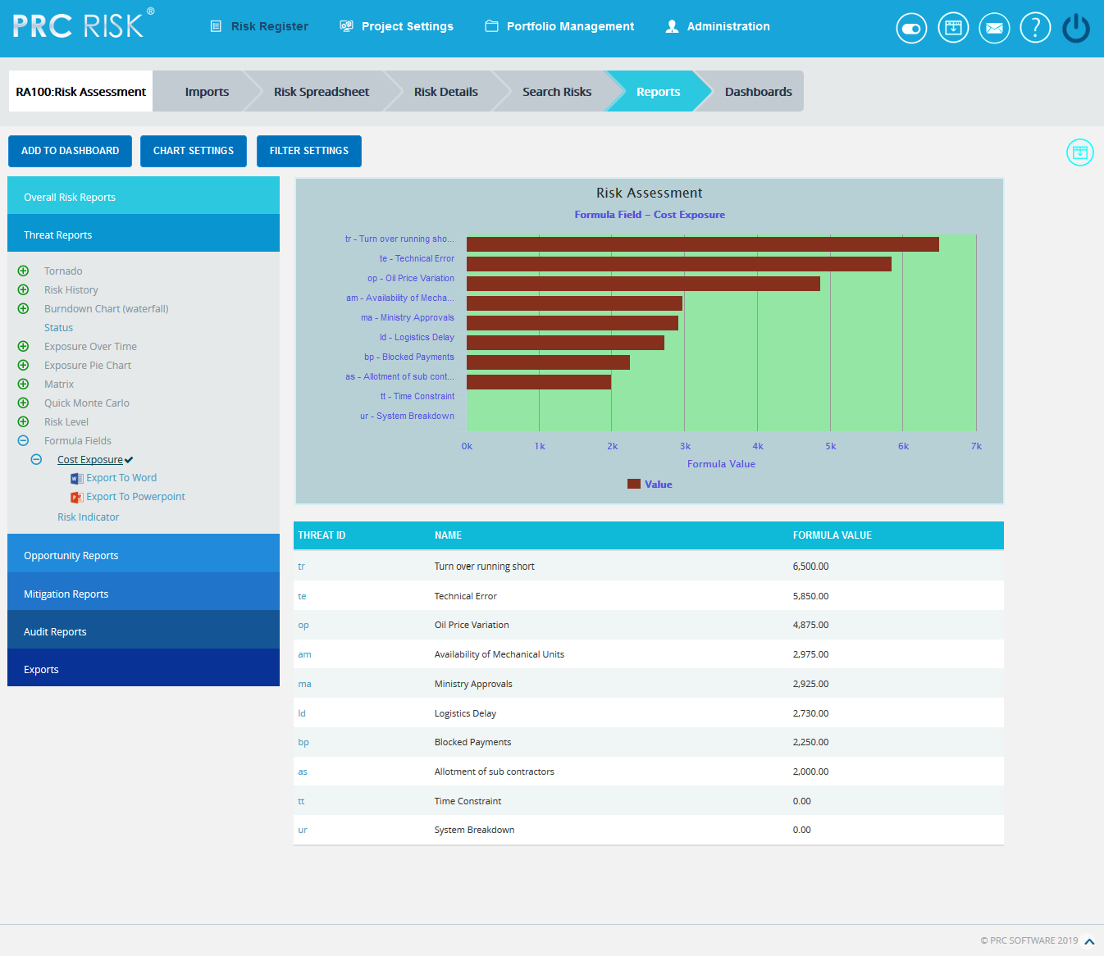
Figure 58

Email Settings:
This functionality is used to export the entire page to Word and send mail to the person selected. The functionality consists of two lists, Available Users and Selected Users. Available Users (Figure 59) contains all the portfolio level users. Selected Users (Figure 59) displays the users who have been selected. A user can be added to the Selected Users list using the Add button. All users under the Available Users list can be moved to Selected Users list using the Add All button. (Figure 59) A single user from the Selected Users list can be moved back to the Available Users list using the Remove button. The Remove All button moves all users from the Selected Users list to the Available Users list. The Subject by default has the value Chart Title, which can be changed if needed.

Steps:
- Risk Register ---> Reports
- Generate the desired report by clicking on the type of reports provided to the left.
- Click the Email icon to send email.
- Select at least one user to whom mail should be sent.
- Enter the message on Message text area.
- Click the SEND MESSAGE button to finish. (Figure 59) To cancel, click the Cancel button. (Figure 59)

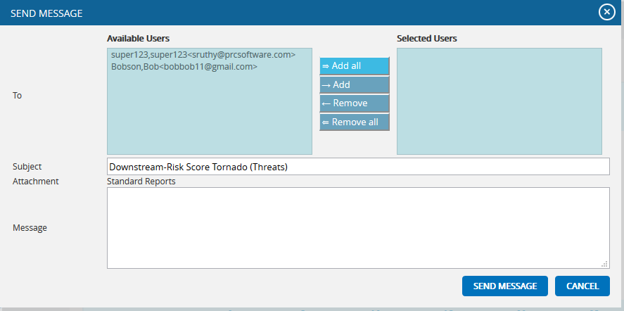

Figure 59

Chart Settings:

This functionality is used to modify the color of the charts generated, to select from the sample chart themes and also to create and save the editable chart settings and report script (Figure 60). The accessibility of these chart settings is different for different users.
  - Users with global access Read/Write option – The editable dropdown has all the global shared chart settings as well as those saved at the personal level. Global access saved name cannot be edited at the global level.
  - Users with global access Read only (view only) option – The editable dropdown has all the global shared chart settings as well as those saved at the personal level. The saved name stores only to the personal level, no other users can view that name.
  - Users with global access No access option – The editable dropdown has only the chart settings saved at personal level. The saved name stores only to the personal level, no other users can view that name.
Each chart has its own chart setting.
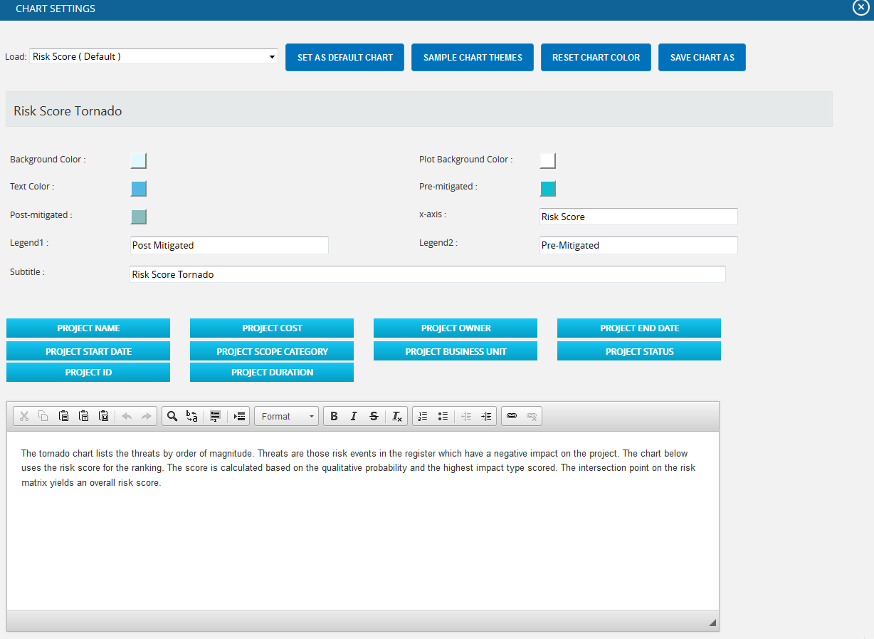
Figure 60
The color is set by clicking on the corresponding color shown beside each field. An example of the color picker for various fields is shown in Figure 61.
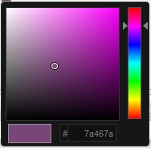

Figure 61

Edit Color:
Steps:
  - Risk Register ---> Reports
  - Click the CHART SETTINGS button. (Figure 1) A Chart Settings pop up appears. (Figure 60)
  - Modify the colors needed.
Insert Variables to Report Script:
This functionality is to insert the variables like Project Name, Project Cost, Project Owner etc., to the report script of each chart.
Steps:
- Risk Register ---> Reports
- Click the CHART SETTINGS button. (Figure 1) A Chart Settings pop up appears. (Figure 60)
- To insert the variables, place the cursor anywhere in the report script and click the required variable buttons. (Figure 60)
Save Chart As:
This functionality is used to save the user editable chart settings globally or locally with a name and description.
Steps:
  - Risk Register ---> Reports
  - Click the CHART SETTINGS button. (Figure 1)
  - Edit the report script and chart settings and click SAVE CHART AS button. (Figure 60)
  - Give the name and description to save and also give the global access option in the pop up appears. (Figure 62)
  - Click the SAVE button. (Figure 62)
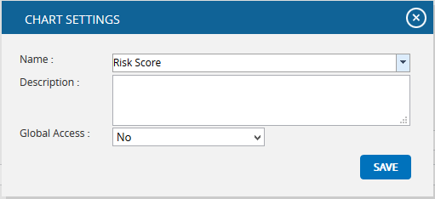
Figure 62
Set As Default Chart:
This functionality is to set the selected chart settings name, as the default chart.
Steps:
  - Risk Register ---> Reports
  - Click the CHART SETTINGS button to go to the chart settings page. (Figure 1)
  - Select a name from the Load dropdown. (Figure 60)
  - Click the SET AS DEFAULT CHART button to set the selected chart as default. (Figure 60)
Delete:
This functionality is to delete the selected chart settings name from the Load dropdown. This button appears only for the created users. The default chart settings name cannot be deleted by any user.
Steps:
  - Risk Register ---> Reports
  - Click the CHART SETTINGS button to go to the chart settings page. (Figure 1)
  - Select a name from the Load dropdown. (Figure 60)
  - Click the DELETE button to delete.

Reset Chart Color :
This functionality is used to reset all the values and report script of the chart to predefined values and script.
Steps:
  - Risk Register ---> Reports
  - Click the CHART SETTINGS button to go to the chart settings page. (Figure 1)
  - Click the RESET CHART COLOR button to reset the values and report script. (Figure 60)
Sample Chart Themes:
This functionality is used to select a chart theme from the list of default samples.
Steps:
  - Risk Register ---> Reports
  - Click the CHART SETTINGS button to go to the chart settings page. (Figure 1)
  - Select a name from the Load dropdown. (Figure 60)
  - Click the SAMPLE CHART THEME button. (Figure 60)
  - Select the required sample from the set of themes that appear in the CHART SAMPLE THEMES pop up. (Figure 63)
  - Click the SELECT THEME button to proceed. (Figure 63)
  - Click SAVE CHART AS button. (Figure 60)
  - Give the name and description to save and also give the global access option in the pop up which appears. (Figure 62)
  - Click the SAVE button. (Figure 62)

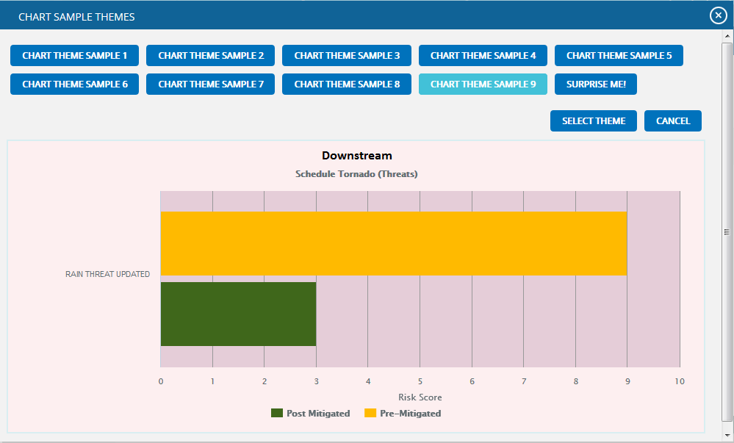

Figure 63

Add To Managers Dashboard:
This functionality is used to add the chart generated to the project’s Managers Dashboard. A user with View access cannot add a chart to Managers Dashboard.
Steps:
- Risk Register ---> Reports
- Generate the desired report by clicking on the type of reports provided to the left.
- Click the ADD TO DASHBOARD button. (Figure 1) A pop up shown in Figure 64 appears.
- Enter or select the name. Enter description.
- Click the SAVE button to finish. (Figure 64)

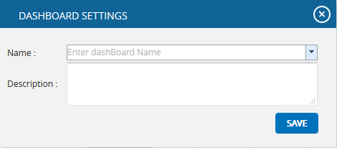
Figure 64

Export to Word:
This functionality is used to export the chart and data table generated to Word.
Steps:
- Risk Register ---> Reports
- Generate the desired report by clicking on the type of reports provided to the left.
- Click the Export to Word link. (Figure 1)

Export to PowerPoint:
This functionality is used to export the chart generated to PowerPoint.
Steps:
- Risk Register ---> Reports
- Generate the desired report by clicking on the type of reports provided to the left.
- Click the Export to PowerPoint link. (Figure 1)

Overall Risk Reports:
Overall Risk Tornado:

The Overall Risk Tornado shows all the threats and opportunities on a single tornado with the opportunities being to the left of the zero and the threats being to the right of the zero. The sort order should be based on a next value.

Steps:
- Risk Register ---> Reports
- Click the Overall Risk Reports link to select Overall Risk Tornado Chart. (Figure 1)
- Select the Qualitative Inputs or Simulation Inputs or Score data options to view the charts based on qualitative or simulative inputs or score. (Figure 65)
- Select Pre-Mitigated to view Pre-Mitigated data only (sorted by Pre-Mitigated), Post-Mitigated to view Post-Mitigated data (sorted by Post-Mitigated) from the dropdown. (Figure 10)
- Click the Highest Cost Impact data option or any other data option to generate the report. (Figure 65) The chart generated and the data table is shown in Figure 66.
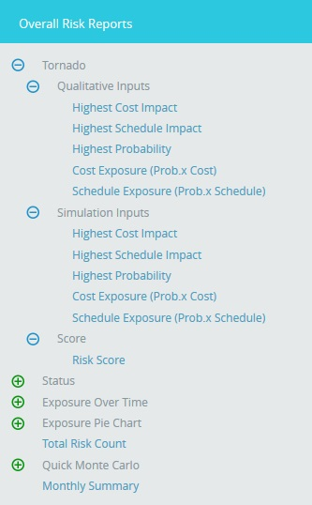

Figure 65
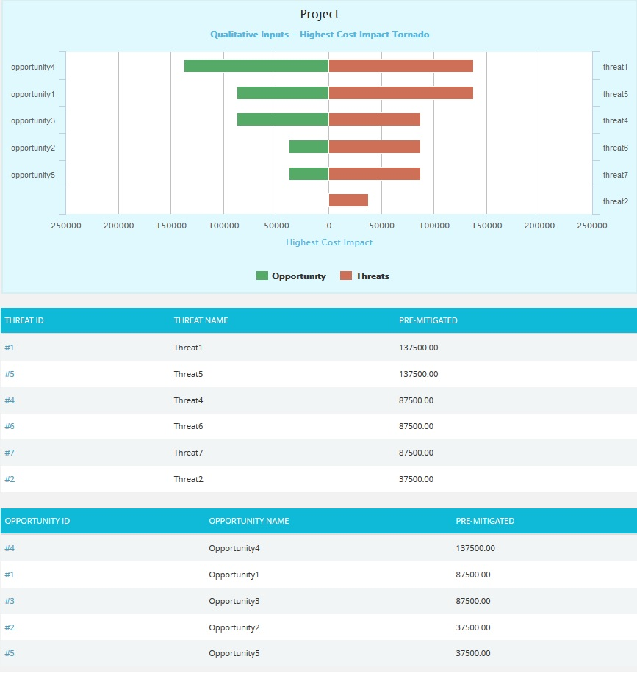
Figure 66

Overall Risk Status:

The Overall Risk status has two statuses, Threat and Opportunity Status which is represented by a bar diagram that shows total number of threats and opportunities in all statuses and Total Threats and Opportunities which is represented by a pie chart that shows total number of threats and opportunities in open status.
- Risk Register ---> Reports
- Click the Status from the Overall Risk Reports (Figure 67).
- Click Threat and Opportunity Status to view the chart showing the total number of threats and opportunities in all statuses. The chart generated and the data table is shown in Figure 67.
- Click Total Threats and Opportunities to view the chart showing the total number of threats and opportunities in open status. The chart generated and the data table is shown in Figure 68.

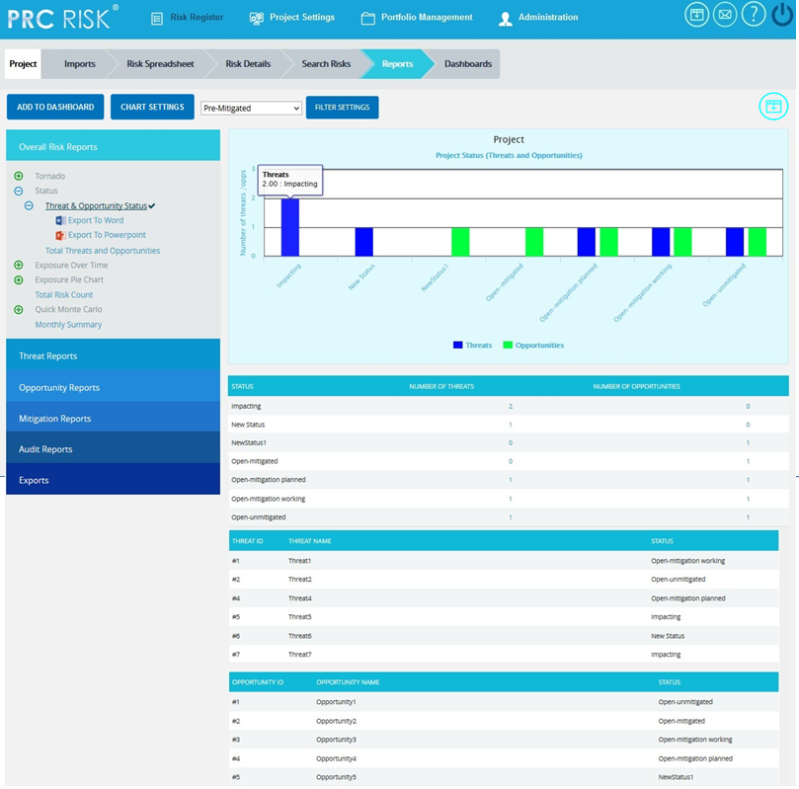
Figure 67

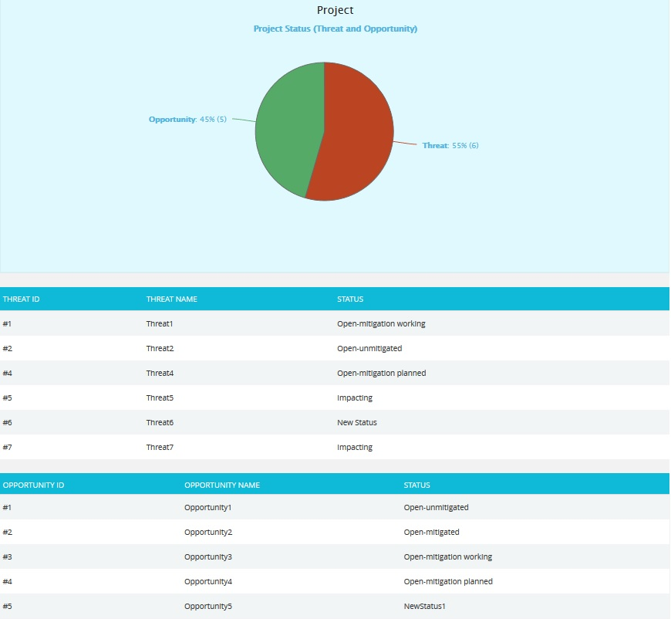
Figure 68

Overall Risk Exposure over Time:
The Overall Risk Exposure over Time chart is generated based on the Qualitative Cost Exposure, Simulation Cost Exposure, Qualitative Schedule Exposure and Simulation Schedule Exposure for all the threats and opportunities in the selected project. The values on the chart would be a combination of threats and opportunities. Threats would be a positive value and Opportunities would count as a negative value in the net value on the chart.

Steps:
- Risk Register ---> Reports
- Click the Exposure over Time link under Overall Risk Reports. (Figure 1)
- Select Pre-Mitigated to view Pre-Mitigated data only (sorted by Pre-Mitigated), Post-Mitigated to view Post-Mitigated data (sorted by Post-Mitigated) from the dropdown. (Figure 10)
- Click the Cost under Simulation/Qualitative link or any other data option to generate the report. (Figure 69) The chart generated and the data table is shown in Figure 70.
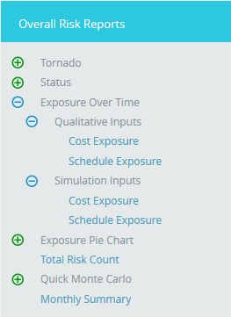

Figure 69
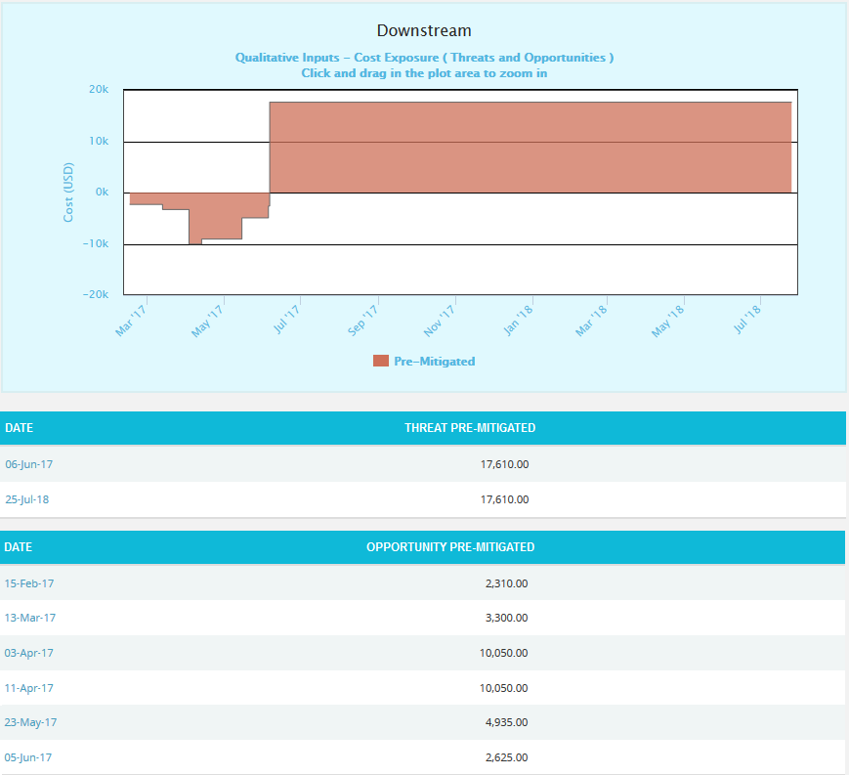
Figure 70
The Column Date of the data table (Figure 70) contains a link that navigates the user to the following charts:
- Simulation Cost Exposure Tornado (Threat), if the option Cost Under Simulation For Threat Reports is selected.
- Qualitative Cost Exposure Tornado (Threat), if the option Cost Under Qualitative For Threat Reports is selected.
- Simulation Schedule Exposure Tornado (Threat), if the option Schedule Under Simulation For Threat Reports is selected.
- Qualitative Schedule Exposure Tornado (Threat), if the option Schedule Under Qualitative For Threat Reports is selected
- Simulation Cost Exposure Tornado (Opportunities), if the option Cost Under Simulation For Opportunity Reports is selected.
- Qualitative Cost Exposure Tornado (Opportunities), if the option Cost Under Qualitative For Opportunity Reports is selected.
- Simulation Schedule Exposure Tornado (Opportunities), if the option Schedule Under Simulation For Opportunity Reports is selected.
- Qualitative Schedule Exposure Tornado (Opportunities), if the option Schedule Under Qualitative For Opportunity Reports is selected.

Overall Risk Simulation Exposure Pie Chart:
The Overall Risk Simulation Exposure Pie Chart depends on the simulation cost exposure of the threats and opportunities mapped to the break down structure in the selected project.
Steps:
- Risk Register ---> Reports
- Click the Exposure Pie Chart link under Overall Risk Reports. (Figure 1)
- Select Pre-Mitigated to view Pre-Mitigated data only (sorted by Pre-Mitigated), Post-Mitigated to view Post-Mitigated data (sorted by Post-Mitigated) from the dropdown. (Figure 10)
- Click the Project-WBS link or any other data option to generate the report. (Figure 71) The chart generated and the data table is shown in Figure 72.

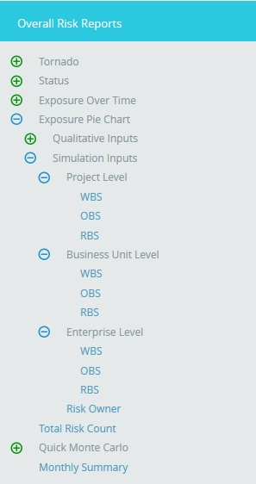

Figure 71
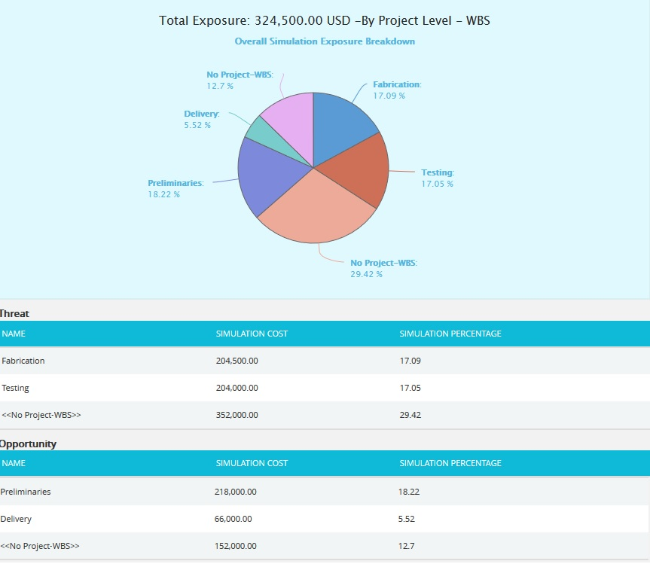
Figure 72

Overall Risk Qualitative Exposure Pie Chart:
The Overall Risk Qualitative Exposure Pie Chart depends on the qualitative cost exposure of the threats and opportunities mapped to the break down structure in the selected project.

Steps:
- Risk Register ---> Reports
- Click the Exposure Pie Chart link under Overall Risk Reports. (Figure 1)
- Select Pre-Mitigated to view Pre-Mitigated data only (sorted by Pre-Mitigated), Post-Mitigated to view Post-Mitigated data (sorted by Post-Mitigated) from the dropdown. (Figure 10)
- Click the Project-WBS link or any other data option to generate the report. (Figure 73) The chart generated and the data table is shown in Figure 74.
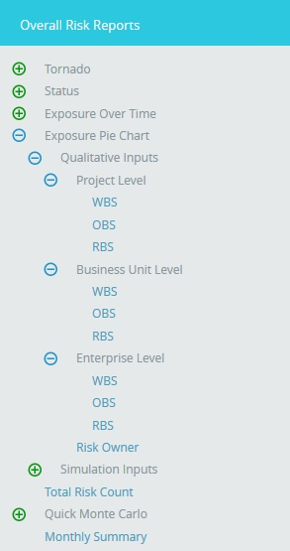

Figure 73

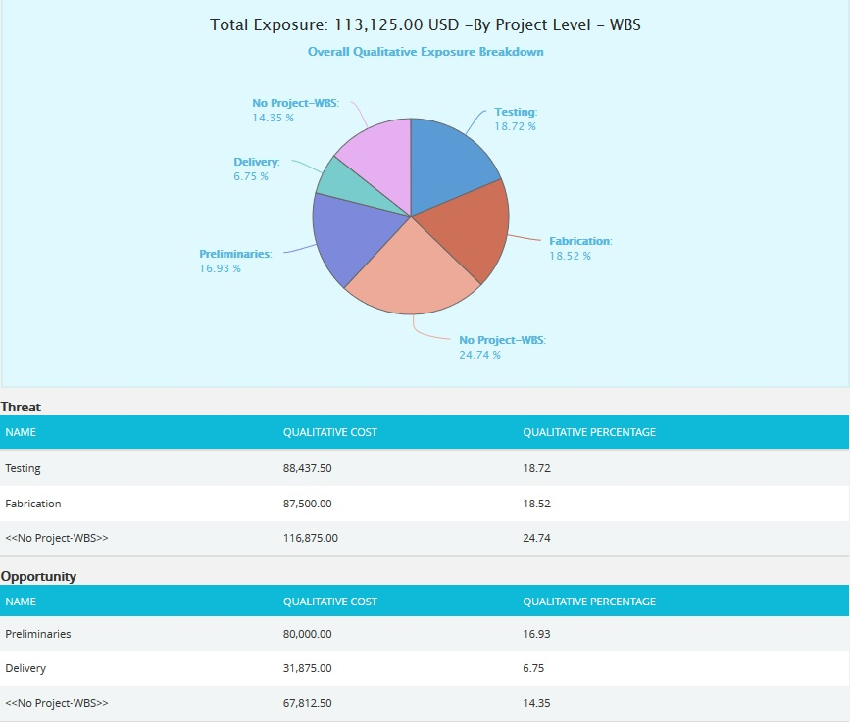
Figure 74

Total Risk Count:
The Total Risk Count chart shows the total count of risks in the selected project, while counting the total number of Threats and Opportunities separately. The Threats and Opportunities count is shown both in percentage and number.

Steps:
- Risk Register ---> Reports
- Click the Total Risk Count link under Overall Risk Reports. (Figure 75)
- The chart generated and the data table is shown in Figure 75.
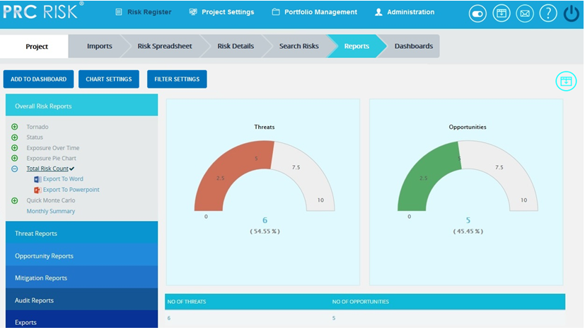
Figure 75
Overall Quick Monte Carlo:
Cost Cumulative S Curve:
The Cost Cumulative S Curve report shows the distribution of Cost Exposure of the threats and opportunities of a selected project. It simulates threats and opportunities cost values using Triangular Distribution. The columns show the hits for each of the total amount of risk cost exposure. The S curve shows the cumulative frequency of the hits in percentage.

Steps:
  - Risk Register ---> Reports
  - Click the Quick Monte Carlo link under Overall Reports. (Figure 1)
  - Click the Cost Cumulative S Curve link. (Figure 76) The chart generated and the data table is shown in Figure 76.
  - Click the FILTER SETTINGS. Cost Analysis Inputs pop up appears where the Iteration number and the Highlights are given based on which the Cumulative Frequency iterations and the Cumulative percentage values to be highlighted are shown in the chart and table for Pre-Mitigated and Post-mitigated options. (Figure 77.1 and Figure 77.2)
  - Click the RUN ANALYSIS AND SHOW REPORT button to view the filtered report for Pre-Mitigated and Post-mitigated options. (Figure 77.1 and Figure 77.2)
  - Click REFRESH button to refresh the chart. (Figure 76)
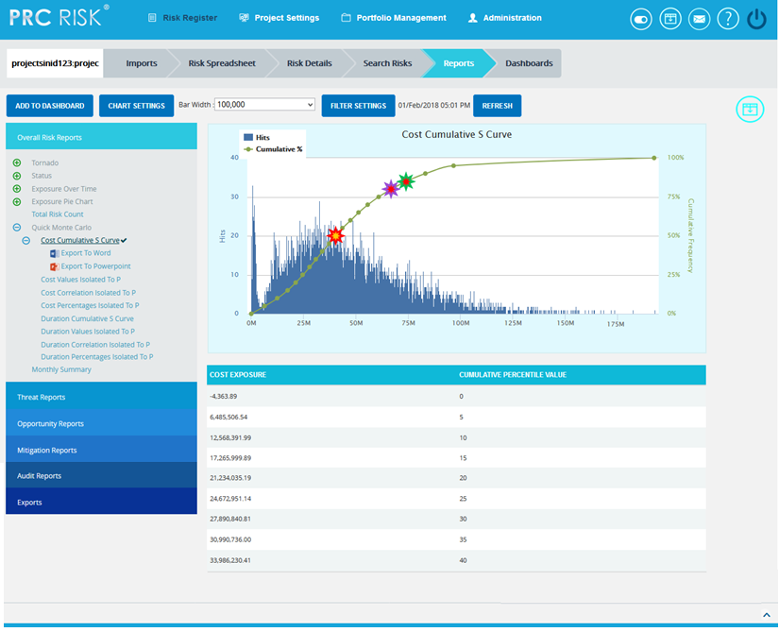
Figure 76
Figure 77.1
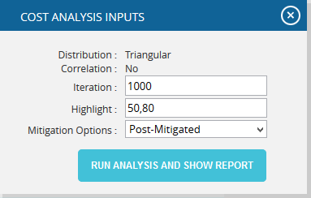
Figure 77.2
Top Risk Reports:

The Top Risk reports are Tornado Charts that shows the top ten threats and opportunities on a single tornado with the opportunities being to the left of the zero and the threats being to the right of the zero. It depends on the simulated cost exposure values of each top Threat and Opportunity up to the Pn iteration value, where ‘n’ is the percentile value of total number of iterations given. Cost Exposure is the qualitative cost multiplied by probability percentage. The Top Risk reports include Cost Values Isolated to P, Cost Correlation Isolated to P and Cost Percentages Isolated to P reports. The x axis represents the cost exposure in Cost Values Isolated to P report and the percentage in Cost Correlation Isolated to P and Cost Percentages Isolated to P reports. The y axis represents the top risk names in all the three charts. Cost Exposure is the qualitative cost multiplied by probability percentage.
Steps:
- Risk Register ---> Reports
- Click the Quick Monte Carlo link under Overall Reports. (Figure 1)
- Click the Cost Values Isolated to P / Cost Correlation Isolated to P / Cost Percentages Isolated to P link. (Figure 78) The chart generated and the data table is shown in Figure 78.
- Click the FILTER SETTINGS. Cost Analysis Inputs pop up appears where the Cumulative Frequency iteration number is given based on which the iterations are shown in the chart and in the table for Pre-Mitigated and Post-mitigated options. (Figure 77.1 and Figure 77.2)
- Click the RUN ANALYSIS AND SHOW REPORT button to view the filtered report for Pre-Mitigated and Post-mitigated options. (Figure 77.1 and Figure 77.2)
- Click REFRESH button to refresh the chart. (Figure 78)
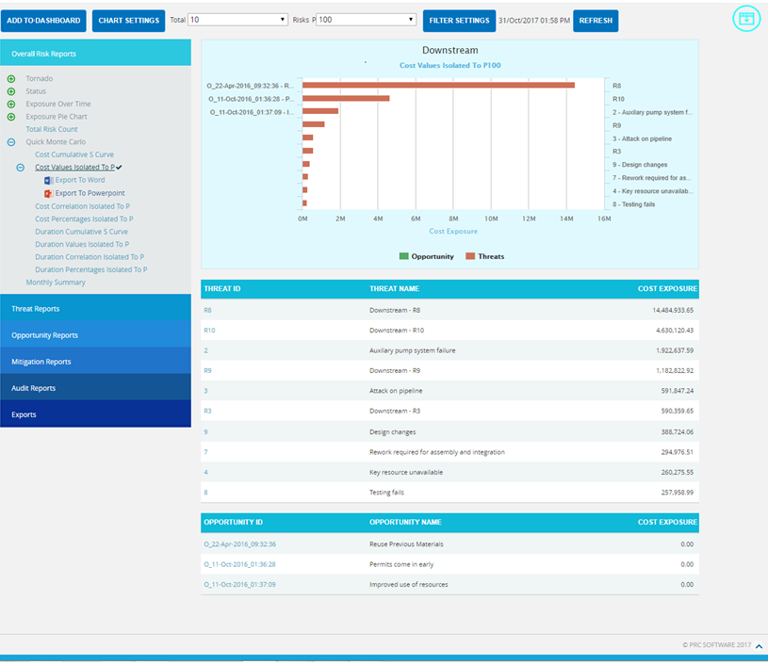
Figure 78
Duration Cumulative S Curve:
The Duration Cumulative S Curve report shows the distribution of Duration Exposure of the threats and opportunities of a selected project. It simulates threats and opportunities duration values using Triangular Distribution. The columns show the hits for each of the total amount of risk duration exposure. The S curve shows the cumulative frequency of the hits in percentage.
Steps:
  - Risk Register ---> Reports
  - Click the Quick Monte Carlo link under Overall Reports. (Figure 1)
  - Click the Duration Cumulative S Curve link. (Figure 79) The chart generated and the data table is shown in Figure 79.
  - Click the FILTER SETTINGS. Duration Analysis Inputs pop up appears where the Iteration number and the Highlights are given based on which the Cumulative Frequency iterations and the Cumulative percentage values to be highlighted are shown in the chart and table for Pre-Mitigated and Post-mitigated options. (Figure 80.1 and Figure 80.2)
  - Click the RUN ANALYSIS AND SHOW REPORT button to view the filtered report for Pre-Mitigated and Post-mitigated options. (Figure 80.1 and Figure 80.2)
  - Click REFRESH button to refresh the chart. (Figure 79)
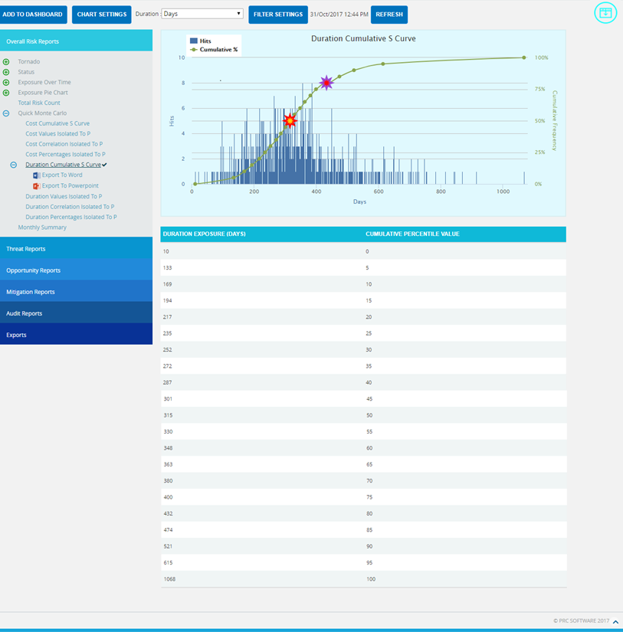
Figure 79
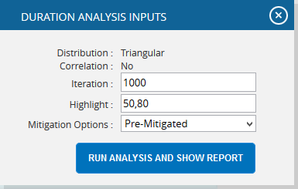
Figure 80.1

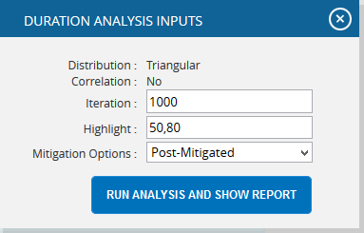
Figure 80.2
Top Risk Reports:

The Top Risk reports are Tornado Charts that shows the top ten threats and opportunities on a single tornado with the opportunities being to the left of the zero and the threats being to the right of the zero. It depends on the simulated duration exposure values of each top Threat and Opportunity up to the Pn iteration value, where ‘n’ is the percentile value of total number of iterations given. Duration Exposure is the qualitative duration multiplied by probability percentage. The Top Risk reports include Duration Values Isolated to P, Duration Correlation Isolated to P and Duration Percentages Isolated to P reports. The x axis represents the duration exposure in Duration Values Isolated to P report and the percentage in Duration Correlation Isolated to P and Duration Percentages Isolated to P reports. The y axis represents the top risk names in all the three charts.
Steps:
- Risk Register ---> Reports
- Click the Quick Monte Carlo link under Overall Reports. (Figure 1)
- Click the Duration Values Isolated to P / Duration Correlation Isolated to P / Duration Percentages Isolated to P link. (Figure 81) The chart generated and the data table is shown in Figure 81.
- Click the FILTER SETTINGS. Duration Analysis Inputs pop up appears where the Cumulative Frequency iteration number is given based on which the iterations are shown in the chart and in the table for Pre-Mitigated and Post-mitigated options. (Figure 80.1 and Figure 80.2)
- Click the RUN ANALYSIS AND SHOW REPORT button to view the filtered report for Pre-Mitigated and Post-mitigated options. (Figure 80.1 and Figure 80.2)
- Click REFRESH button to refresh the chart. (Figure 81)
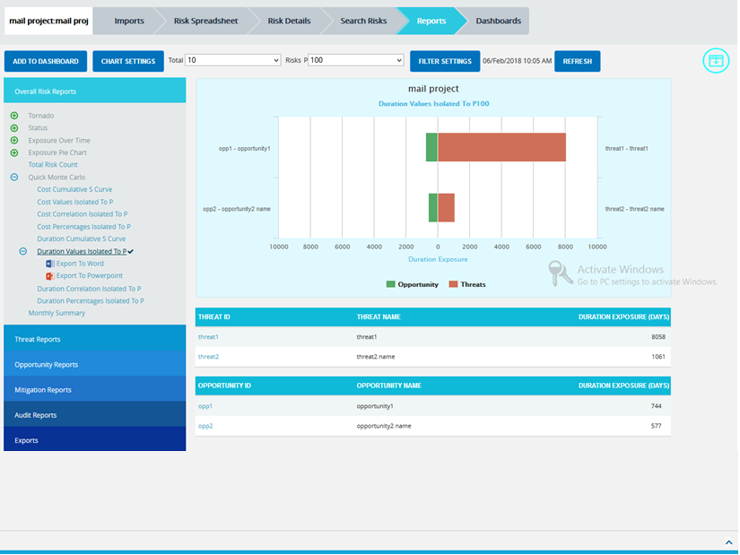
Figure 81
Overall Risk Monthly Summary:
The Monthly Summary report shows summary of the raised threats/opportunities/mitigations of the particular project in that month and also shows the details of threat/opportunities/mitigations which are not scored. The summary generated with Id and Name. (Figure 82)
Steps:
  - Risk Register ---> Reports
  - Click the Monthly Summary link under Overall Reports. (Figure 1)
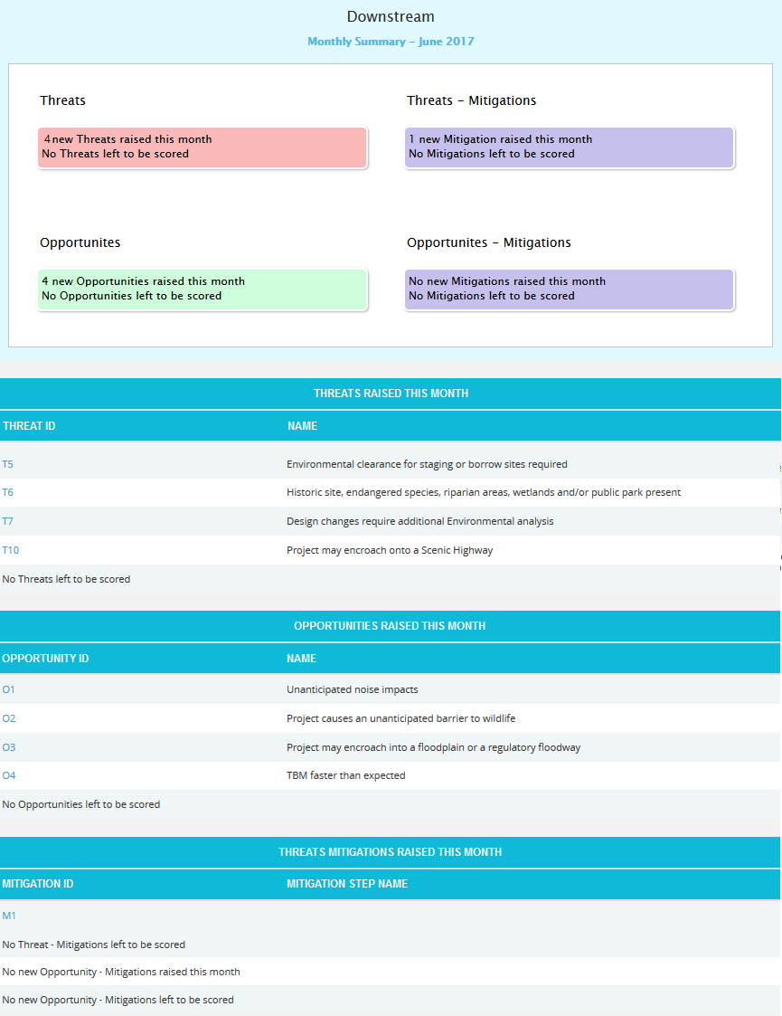
Figure 82
Mitigation Reports:
Mitigation Status:
This functionality is to display the risks and its mitigation details based on the mitigation status in the selected project whose value is open, closed, proposed, in progress, rejected, complete, risk closed or approved. The Status chart is represented by a pie chart and corresponds to the status assigned to the risk.
Steps:
- Risk Register ---> Reports
- Click the Mitigation Reports link to select the Status (Figure 83)
- Click the Mitigation Status to generate the chart and data tables Figure 84. The mitigation status can be drilled down to the Spreadsheet View Page and can be further drilled down to view the advanced view page.
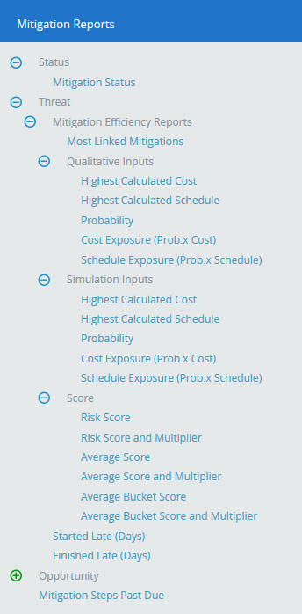
Figure 83

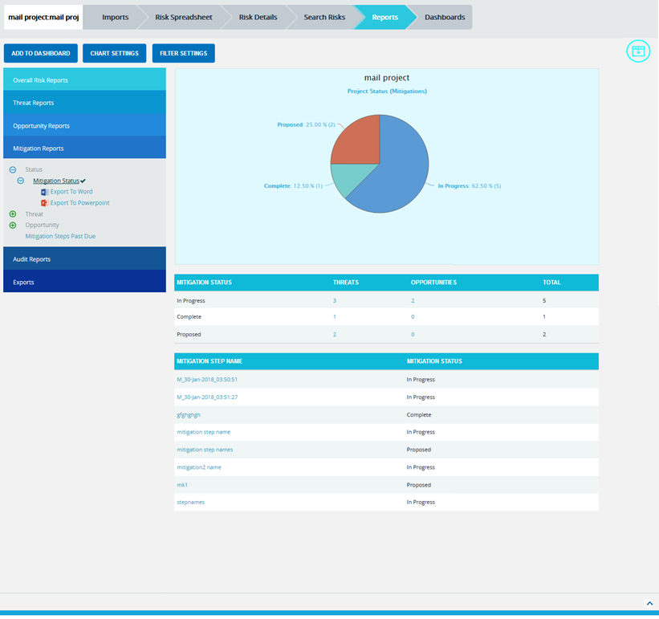
Figure 84

Mitigation Efficiency Reports:
The Mitigation Efficiency reports are Tornado charts that list the top efficient mitigations linked to threats or opportunities by order of magnitude. These reports consider the mitigations that reduce the overall impacts of the mapped threats or opportunities. The Most Linked Mitigations reports show the top efficient mitigations linked to the most number of threats or opportunities. The other reports under the mitigation efficiency show the sum of the differences of corresponding values of each risks mapped to the mitigation.

Steps:
- Risk Register ---> Reports
- Click the Mitigation Reports link to select Threat / Opportunity Mitigation Efficiency Reports. (Figure 83)
- Click the Most Linked Mitigations data option (Figure 85.1) or any other data option (Figure 85.2) to generate the report and the data.
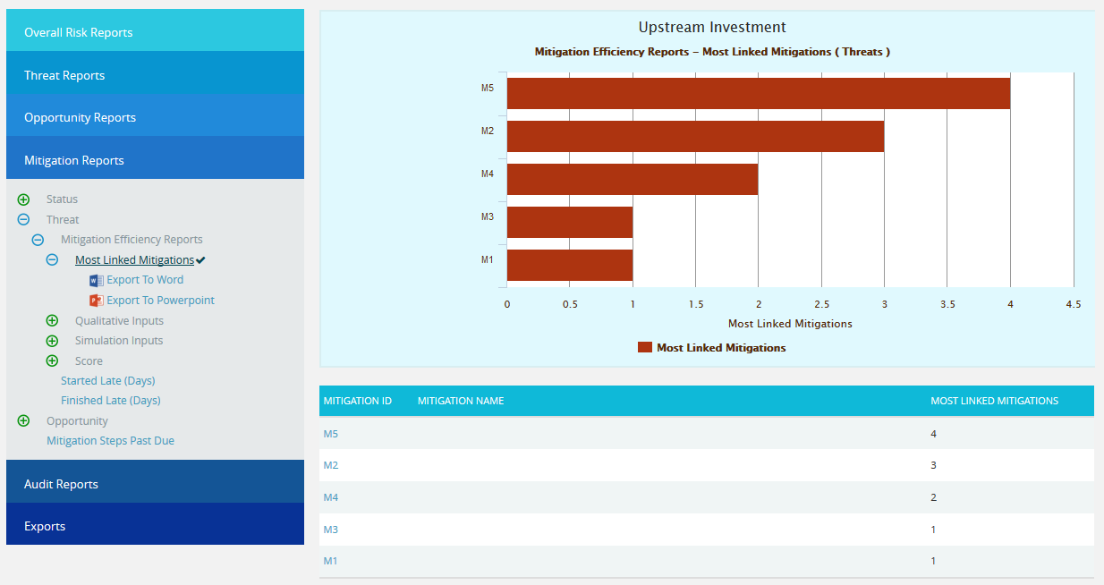
Figure 85.1
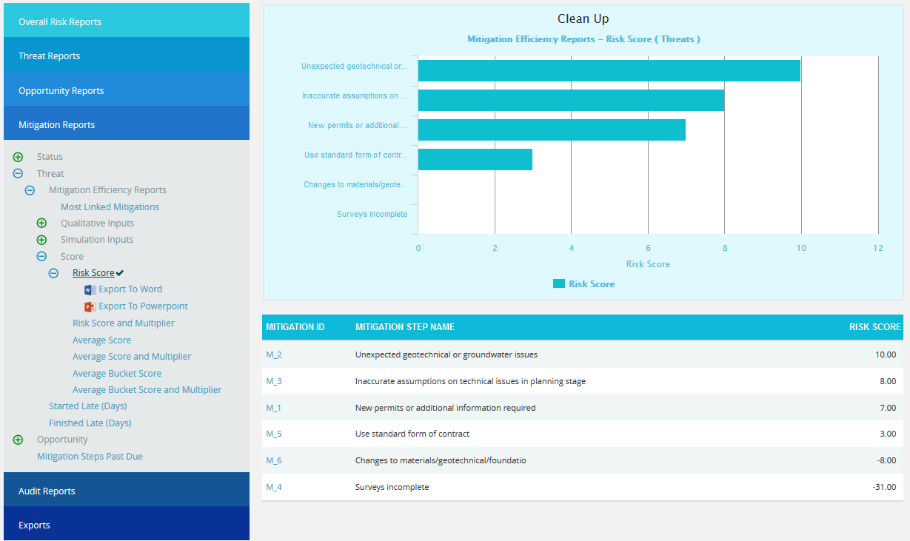
Figure 85.2
Mitigation Steps Past Due:
The Mitigation Steps Past Due shows all mitigation steps that are past due in the selected project. This is calculated on the basis of the number of days that a mitigating action has started or finished late. In this chart the needle is pointed to the total number of overdue mitigations.
Steps:
- Risk Register ---> Reports
- Click the Mitigation Steps Past Due link under Mitigation Reports. (Figure 86)
- The chart generated and the data table is shown in Figure 86.
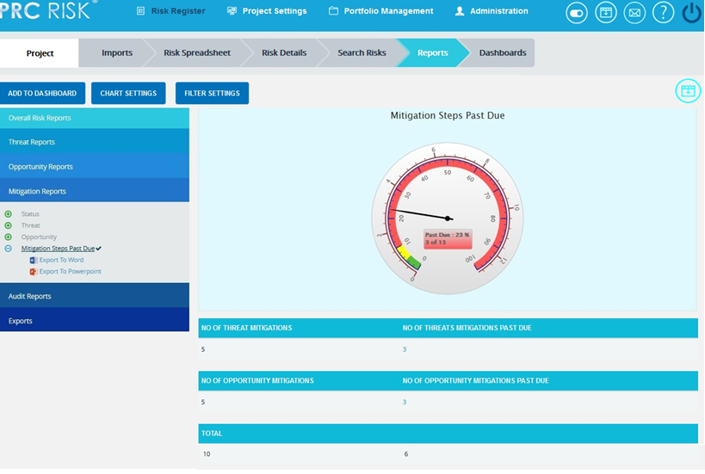
Figure 86

Exports:
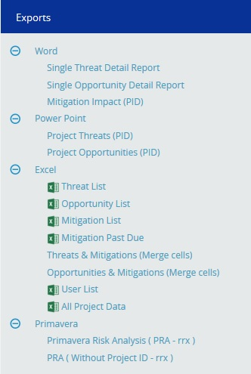
Figure 87

Single Threat Detail Report
The Single Threat Detail Report shows the details of the threat summary of the selected threat (Figure 88). Select Threat Id from the Select Risk dropdown to view the summary report of the threat. To export the threat summary report to Word, click the Export to Word link.
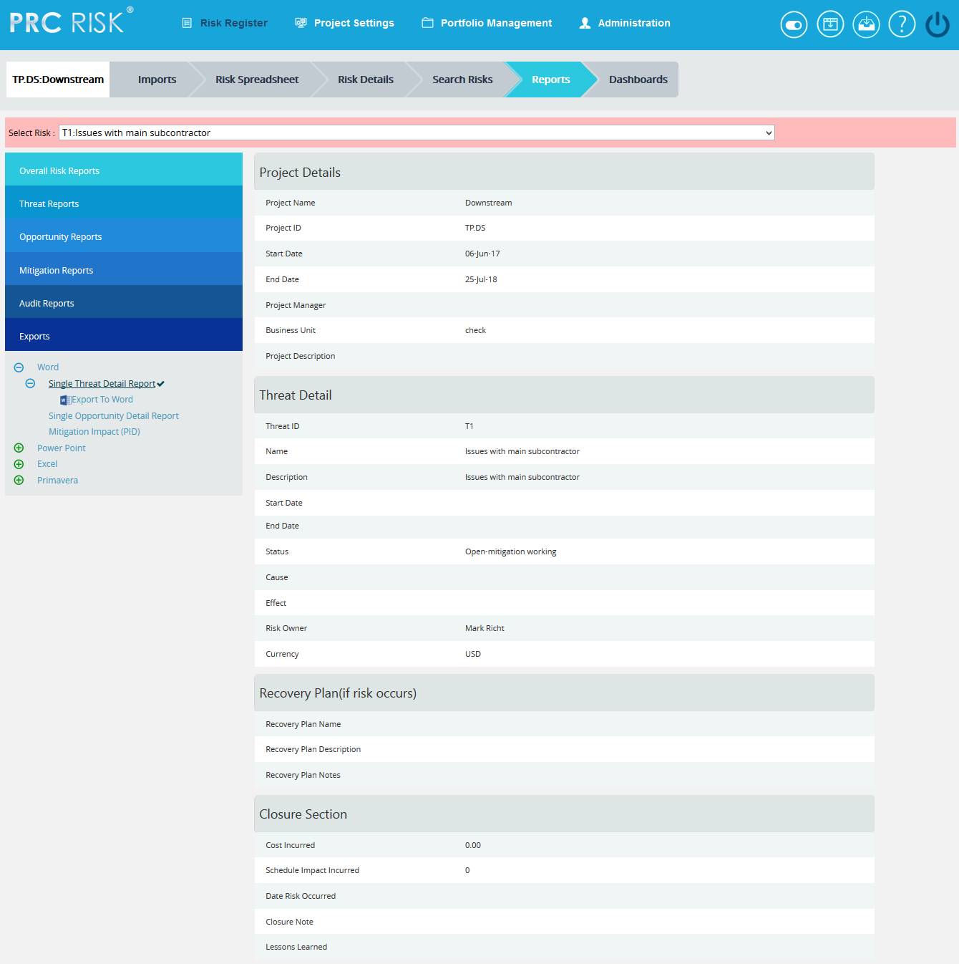

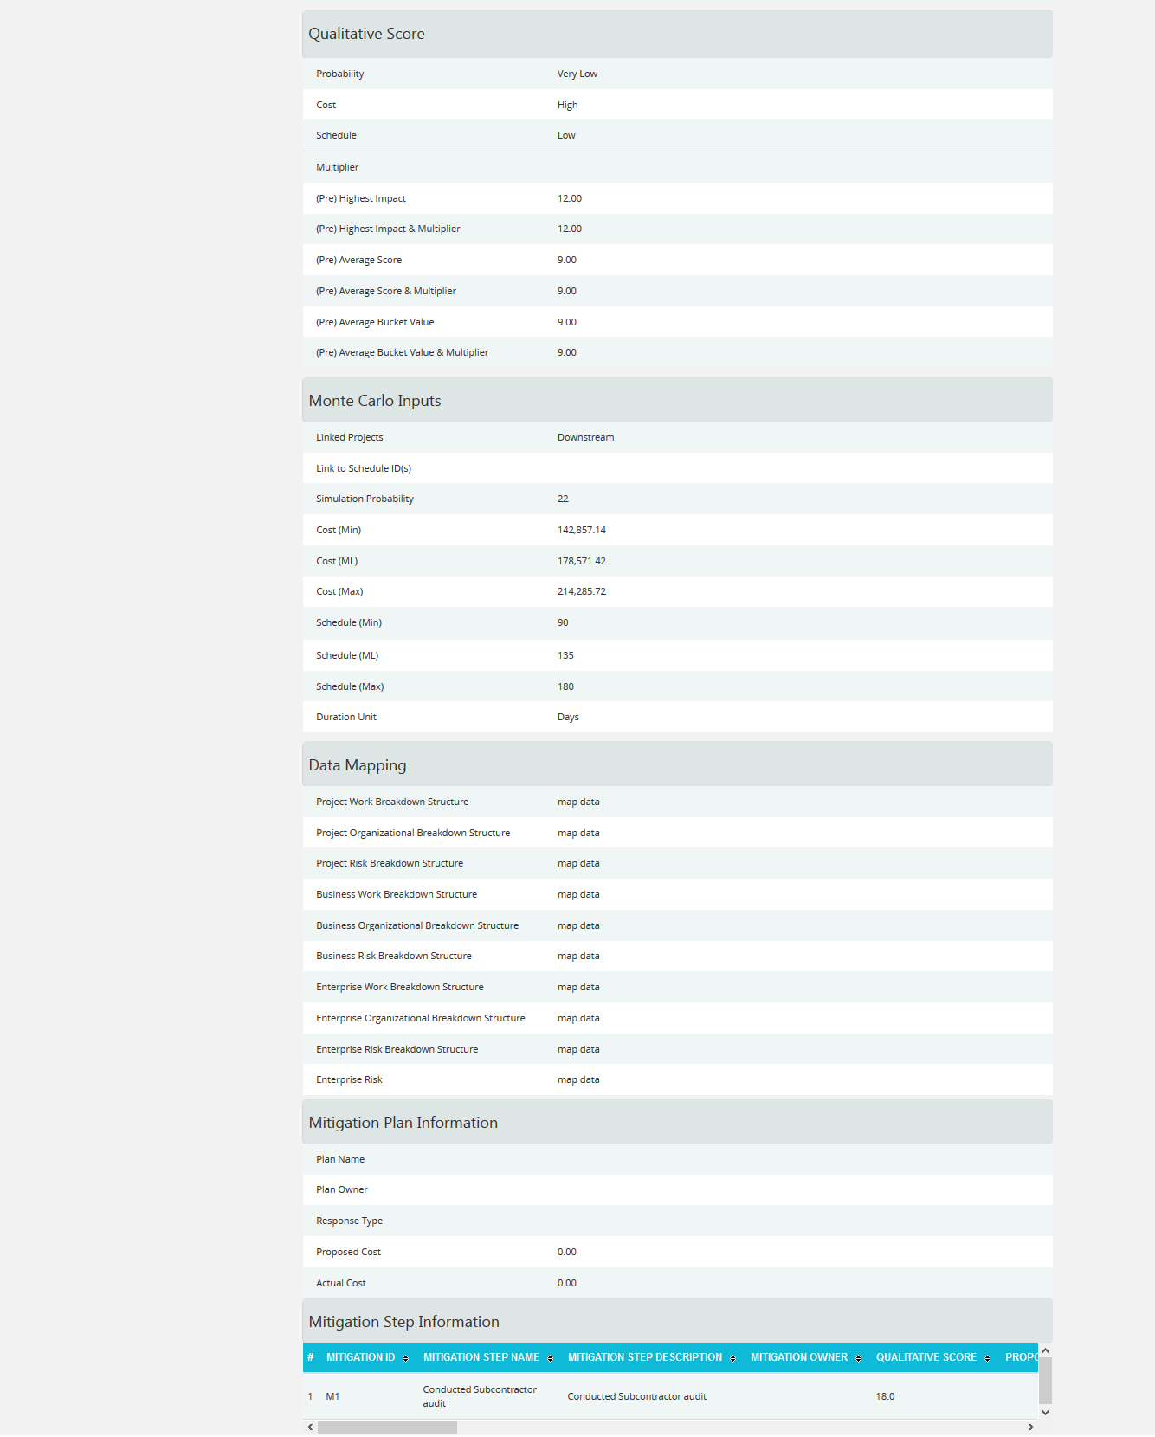
Figure 88

Single Opportunity Detail Report
The Single Opportunity Detail report shows the details of the selected opportunity (Figure 89). Select Opportunity Id from the Select Risk dropdown to view the summary report of the opportunity.
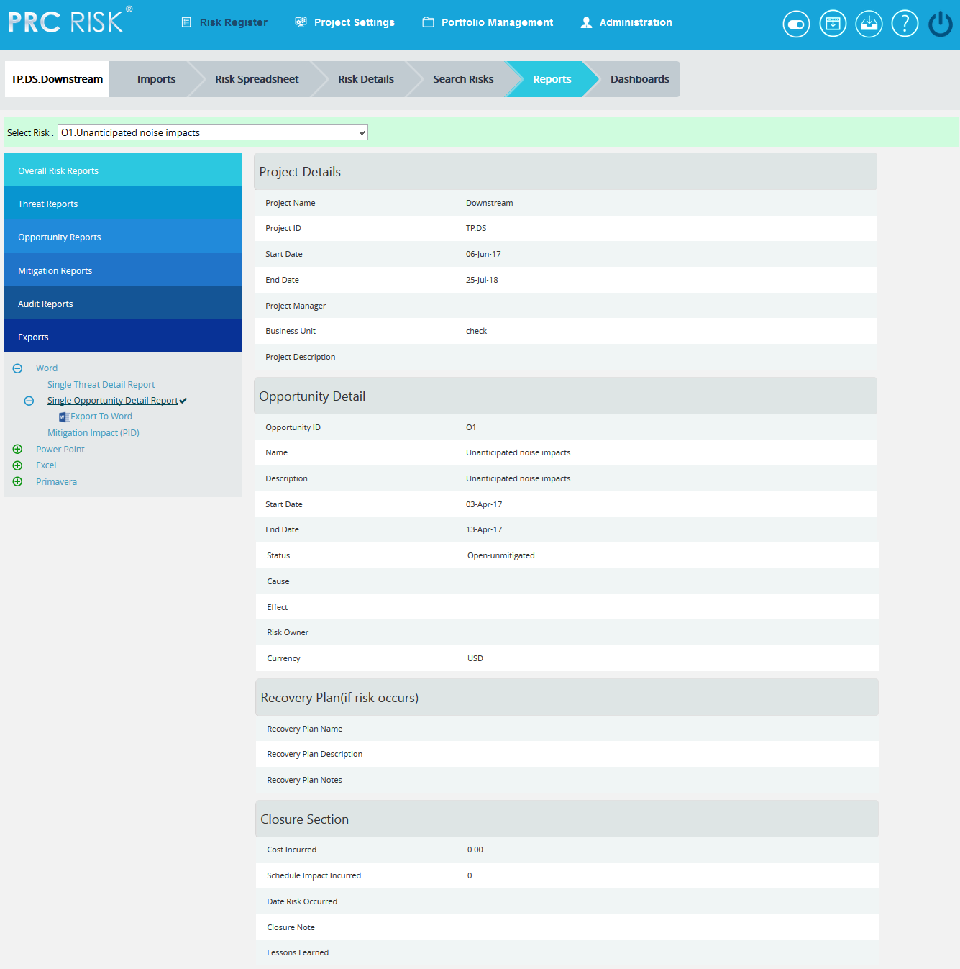
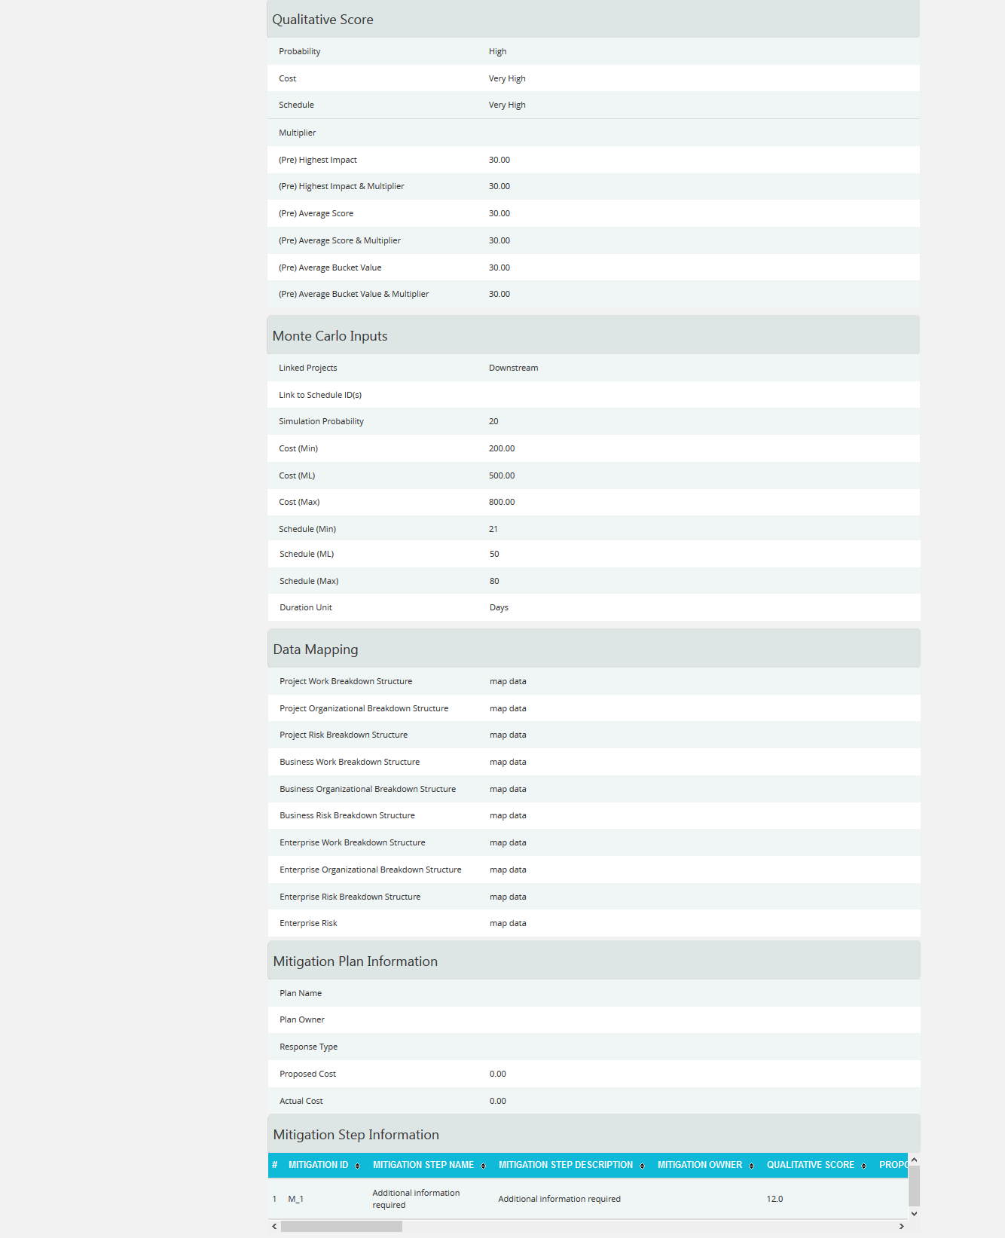
Figure 89

Mitigation Impact (PID) Report
The Mitigation Impact (PID) report shows the details of the mitigations for the selected threat/ opportunity (Figure 90).
Steps:
- Select Threat/Opportunity from the Select Threat/Opportunity dropdown.
- Select Threat Id or Opportunity Id from the Select Risk dropdown to view the mitigation summary of the Threat/Opportunity.
- To export mitigation summary report to Word, click the Export to Word link.
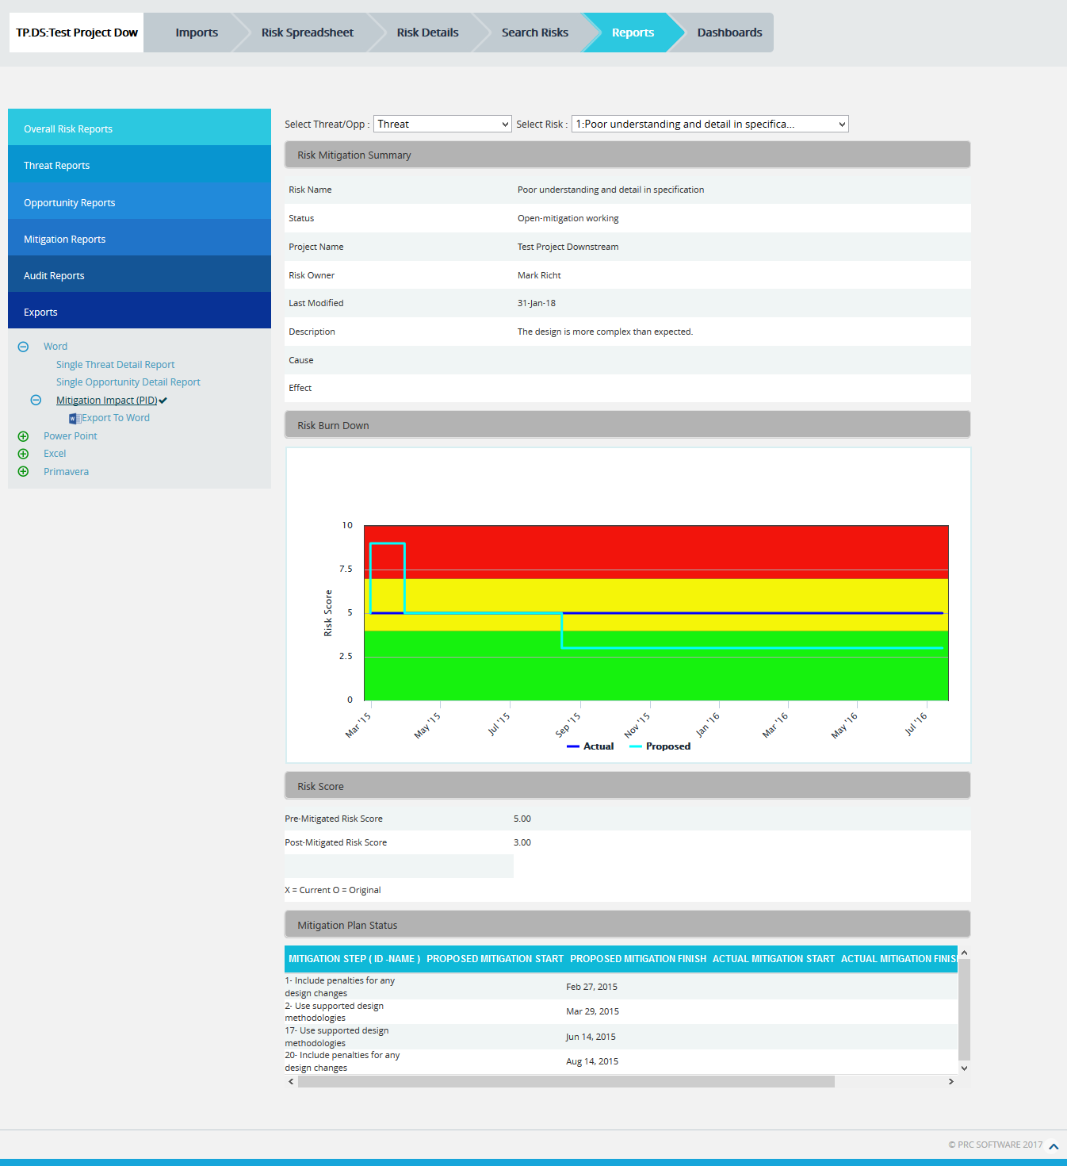
Figure 90

Project Threats (PID)
The Project Threats (PID) page provides a summary of all the risks (both open and closed) in the project. (Figure 91) The details of those risks whose Risk Score is 0.000 will not be displayed in this page. The Risk Overview page also provides a mitigation summary report of each risk. While it is exported to Power point, the highest 10 numbers of burn down chart will be created.

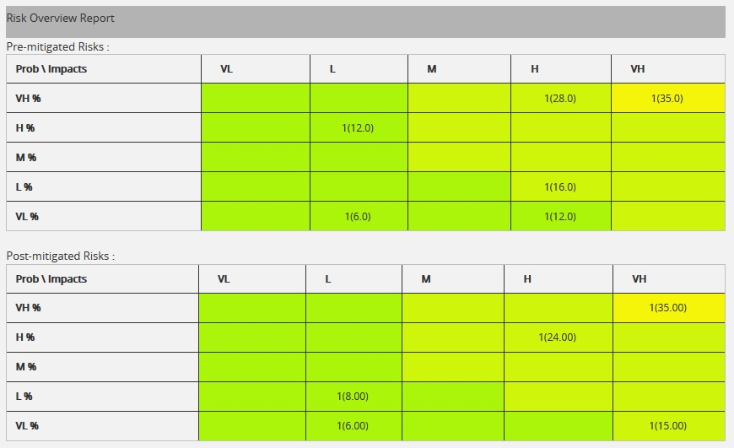
Figure 91
Pre-Mitigated Risks:
The Pre-Mitigated Risks section shows the Pre-mitigated risk score of all the risks in the project. 1(24.000) indicates that only one threat has a pre-mitigated score of 24.000.
Post-Mitigated Risks:
The Post-Mitigated Risks section shows the Post-mitigated risk score of all the risks in the project.
1(24.000) indicates that only one threat has a post-mitigated score of 24.000.

Project Opportunities (PID)

The Project Opportunities (PID) page provides the overall information of all the risks (both open and closed) in the project. (Figure 92) The details of those risks whose Risk Score is 0.000 will not be displayed in this page. The Opportunity Overview page also provides a mitigation summary report of each risk. While it is exported to Power point, the highest 10 numbers of burn down chart will be created.
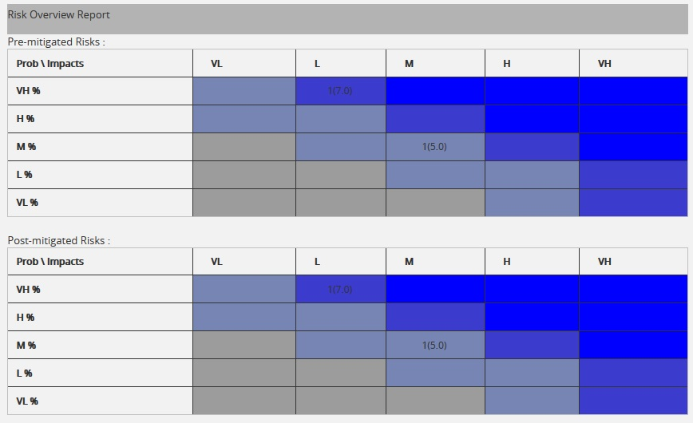
Figure 92
Pre-Mitigated Risks:
The Pre-Mitigated Risks section shows the Pre-mitigated risk score of all the risks in the project. 1(10.000) indicates that only one threat has a pre-mitigated score of 10.000.
Post-Mitigated Risks:
The Post-Mitigated Risks section shows the Post-mitigated risk score of all the risks in the project.
1(10.000) indicates that only one threat has a post-mitigated score of 10.000.

Export threat details:
This functionality is used to export the threat list of the selected project to MS Excel. A sample Excel sheet after export (only few fields are shown) is illustrated in Figure 93.
Steps:
- Risk Register ---> Reports ---> Exports
- Click the Threat List link to export. (Figure 87)
Figure 93

Export Opportunity details:
This functionality is used to export the opportunity list of the selected project to MS Excel. A sample Excel spreadsheet after export (only few fields are shown) is illustrated in Figure 94.
Steps:
- Risk Register ---> Reports ---> Exports
- Click the Opportunity list link to export. (Figure 87)
Figure 94
Export Mitigation details:
This functionality is used to export the mitigation list of the selected project to MS Excel. A sample Excel spreadsheet after export (only few fields are shown) including the mitigation details for both Threat and Opportunity is illustrated in Figure 95.

Steps:
- Risk Register ---> Reports ---> Exports
- Click the Mitigation List link to export. (Figure 87)
Figure 95
Export Mitigation Past Due details:
This functionality is used to export the mitigation past due list of the selected project to MS Excel. A sample sheet is shown (only few fields are displayed) in Figure 96. The Number of Days column in the mitigation past due list is calculated as follows:
Number of Days = Current Date -Proposed Mitigation Finish
For example, consider the first row in Figure 96. The Proposed Mitigation Finish is 03/23/2012 and if the current date is 04/12/2012, the Number of days = 20.
Steps:
- Risk Register ---> Reports ---> Exports
- Click the Mitigation Past Due link to export. (Figure 87)
Figure 96

Threats and Mitigations (Merge Cells):

The Threat and Mitigation (Merge Cells) report allows grouping of Threat Identification and Threat Analysis with its corresponding Mitigation Steps. The user has the option to set the fields, colors and titles for the three sections. To export this report to Excel, click Export to Excel link.

Steps:

- Risk Register ---> Reports
- Click the Threats and Mitigations (Merge Cells) link under Exports. (Figure 97)
- Select the fields to be exported from the Available Fields column.
- Click the Copy button to copy the selected field to the Selected Fields column or click the Copy all button to copy all the fields to the Selected Fields.
- Similarly select the fields to be removed from the Selected Fields column and click the Remove button or click the Remove All button to remove all the fields from the Selected Fields column.
- Click RESET button to reset all the selected fields. (Figure 97)
- Click the Export to Excel link to export the selected fields. (Figure 97)

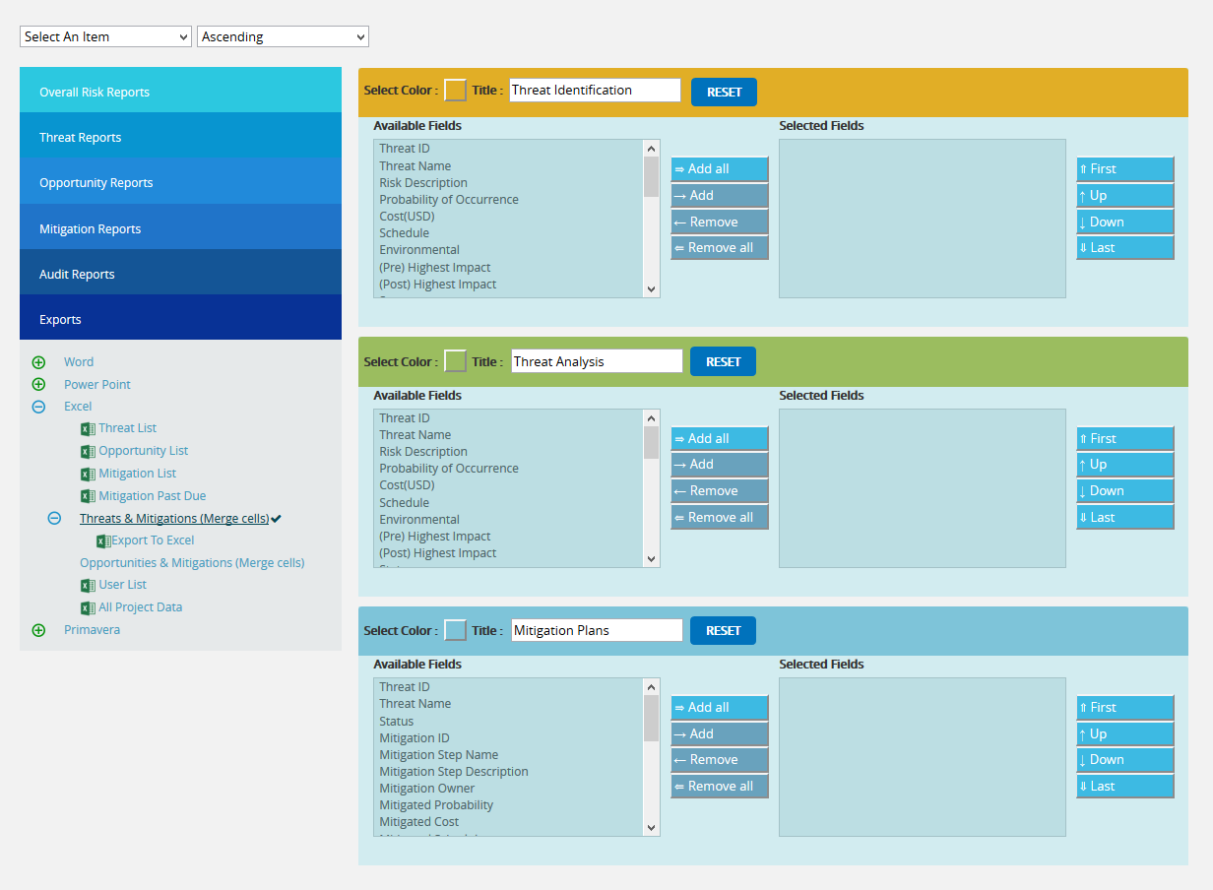

Figure 97

Opportunities and Mitigations (Merge Cells):
The Opportunities and Mitigations (Merge Cells) report allows grouping of Opportunity Identification and Opportunity Analysis with its corresponding Mitigation Steps. The user has the option to set the fields, colors and titles for the three sections. To export this report to Excel, click Export to Excel link.

Steps:
- Risk Register ---> Reports
- Click the Opportunity and Mitigation (Merge Cells) link under Exports. (Figure 98)
- Select the fields to be exported from the Available Fields.
- Click the Copy button to copy the selected field to the Selected Fields column or click the Copy all button to copy all the fields to the Selected Fields.
- Similarly select the fields to be removed from the Selected Fields column and click the Remove button or click the Remove All button to remove all the fields from the Selected Fields column.
- Click RESET button to reset all the selected fields. (Figure 98)
- Click the Export to Excel link to export the selected fields. (Figure 98)

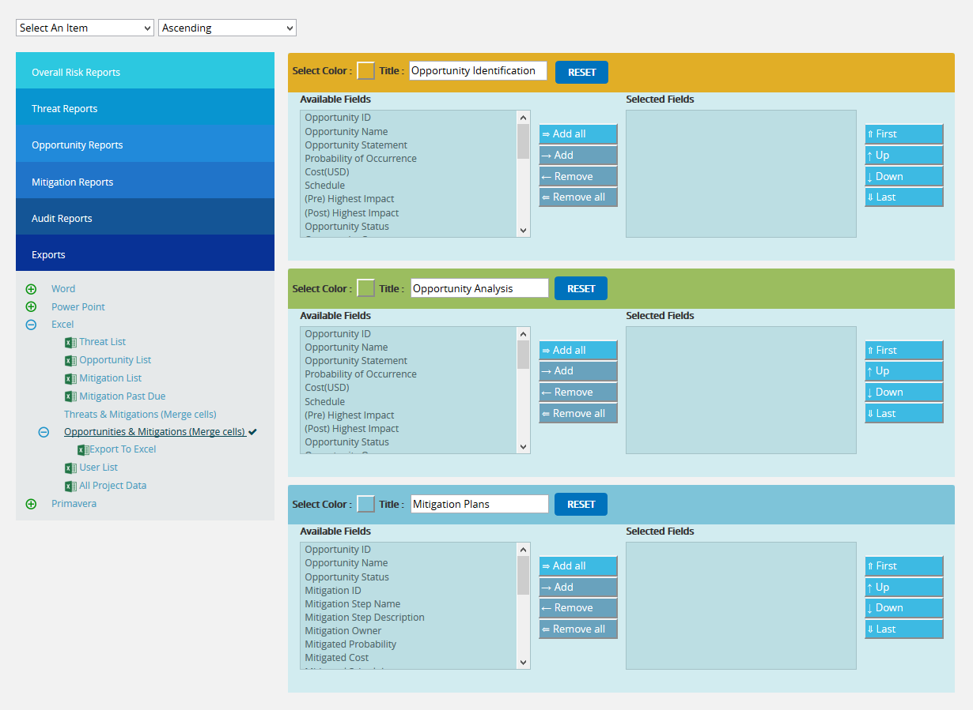

Figure 98

Export User Details:
This functionality is used to export the entire list of users assigned to the project to MS Excel. The sample spreadsheet shown in Figure 99 has all the user details in it.
Steps:
- Risk Register ---> Reports ---> Exports
- Click the User List link to export. (Figure 87)
The sample Excel sheet generated is shown in Figure 99
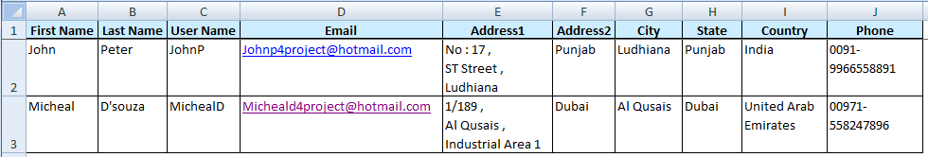
Figure 99
Export Risk Register to Primavera Risk:
This functionality is used to export the Threats, Opportunities and their Mitigation details of the selected Project along with the linked Project Ids and its corresponding Task Ids that can be viewed / imported using the Primavera Risk (Pert master) tool. The PRA (Without Project ID-rrx) exports all the details without the Project Ids.
Steps:
- Risk Register ---> Reports ---> Standard Reports
- Click the Export to Pert master links to export. (Figure 87)
The sample XML sheet generated is shown in Figure 100.
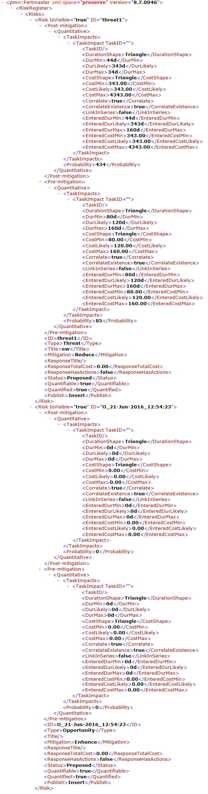

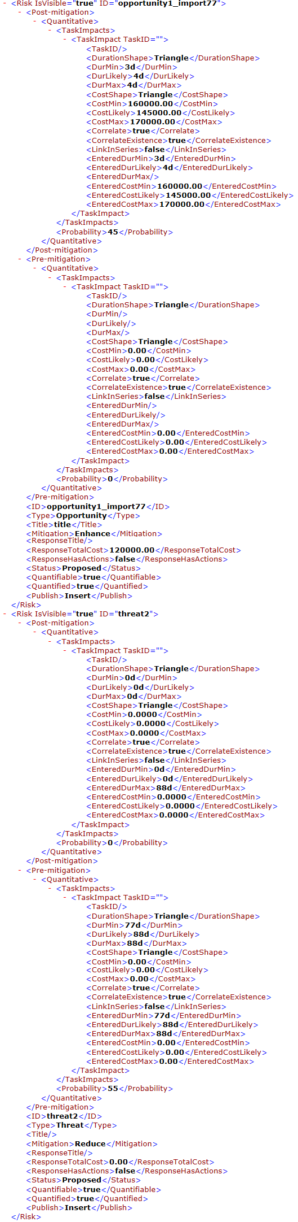

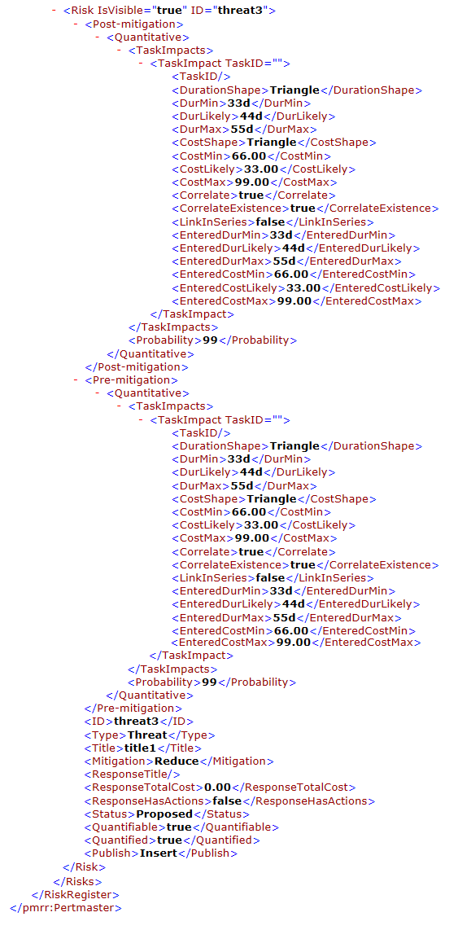

Figure 100

Audit Report - Threats
The Audit Report page is used to track the value of Threat fields. This page helps to make a comparison of previous and present values of each field of Threat.
The entire page can be exported as a CSV file (Figure 101), which can be done by following the path below:
Risk Register ---> Reports --->Audit Reports – Threats (CSV)
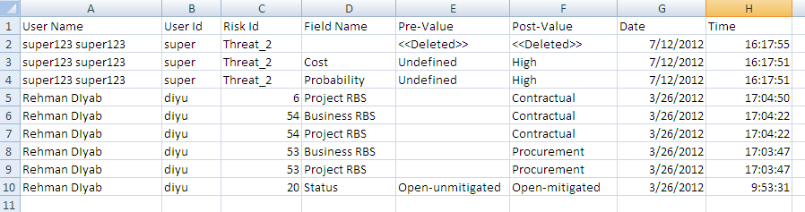
Figure 101
User Name and User ID correspond to the user who has modified the Threat/Opportunity value and the ID of that Threat/Opportunity under the Risk ID column. Pre-Value and Post-Value corresponds to the previous and present value of each field. The date and time of modification is mentioned in columns Date and Time respectively.
The entire page can be exported as a PDF file (Figure 102), which can be done by following the path below:
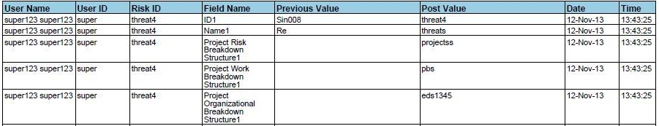
Risk Register ---> Reports --->Audit Reports – Threats (PDF)
Figure 102

Audit Report – Opportunities
The Audit Report page is used to track the value of Opportunity fields. This page helps to make a comparison of previous and present values of each field of Opportunity.
The entire page can be exported as a CSV file (Figure 103), which can be done by following the path below:
Risk Register ---> Reports --->Audit Reports – Opportunities (csv)
Figure 103
User Name and User ID correspond to the user who has modified the Threat/Opportunity value and the ID of that Threat/Opportunity under the Risk ID column. Pre-Value and Post-Value corresponds to the previous and present value of each field. The date and time of modification is mentioned in columns Date and Time respectively.
The entire page can be exported as a PDF file (Figure 104), which can be done by following the path below:
Risk Register ---> Reports --->Audit Reports – Opportunities (pdf)
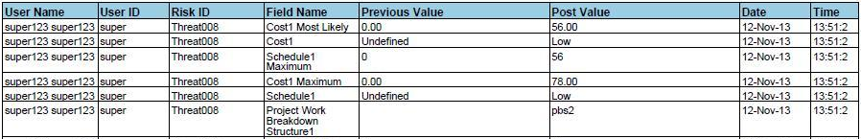
Figure 104

Audit Report – Mitigation
The Audit Report page is used to track the value of Mitigation fields. This page helps to make a comparison of previous and present values of each field of Mitigation.
The entire page can be exported as a CSV file (Figure 105), which can be done by following the path below:
Risk Register ---> Reports --->Audit Reports – Mitigation
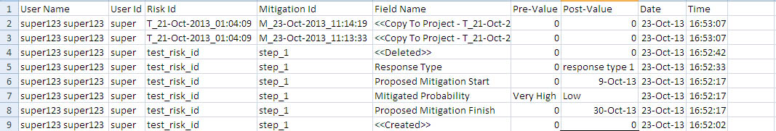
Figure 105
User Name and User ID correspond to the user who has modified the Threat/Opportunity value and the ID of that Threat/Opportunity under the Risk ID column. Pre-Value and Post-Value corresponds to the previous and present value of each field. The date and time of modification is mentioned in columns Date and Time respectively.
The entire page can be exported as a PDF file (Figure 106), which can be done by following the path below:
Risk Register ---> Reports --->Audit Report – Mitigation
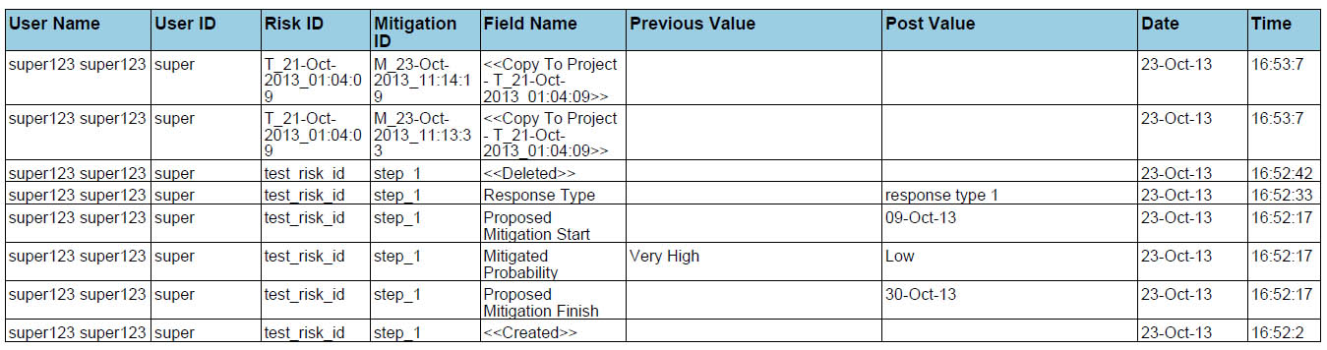
Figure 106

Risk Details (Threats)
Risk Details (Threats) contains basic identification information for a risk. Identifying the risk is useful in order to isolate the root cause of that particular risk. To track the time phasing or cost exposures, users can track the risk window Start and Finish date. For accountability and reporting, the risk owner can be tracked (person, subcontractor, department, etc). When the status of a risk is set as Closed, it will no longer be considered in the cost exposure and tornado charts (report section, dashboards). This page is visible only to those users who have either Read/Write access or View access for Risk Details (Threats). Users with Read/Write access can create new threats, edit threats, delete threats, and send email. Users designated with View access can view the threat details and send email.
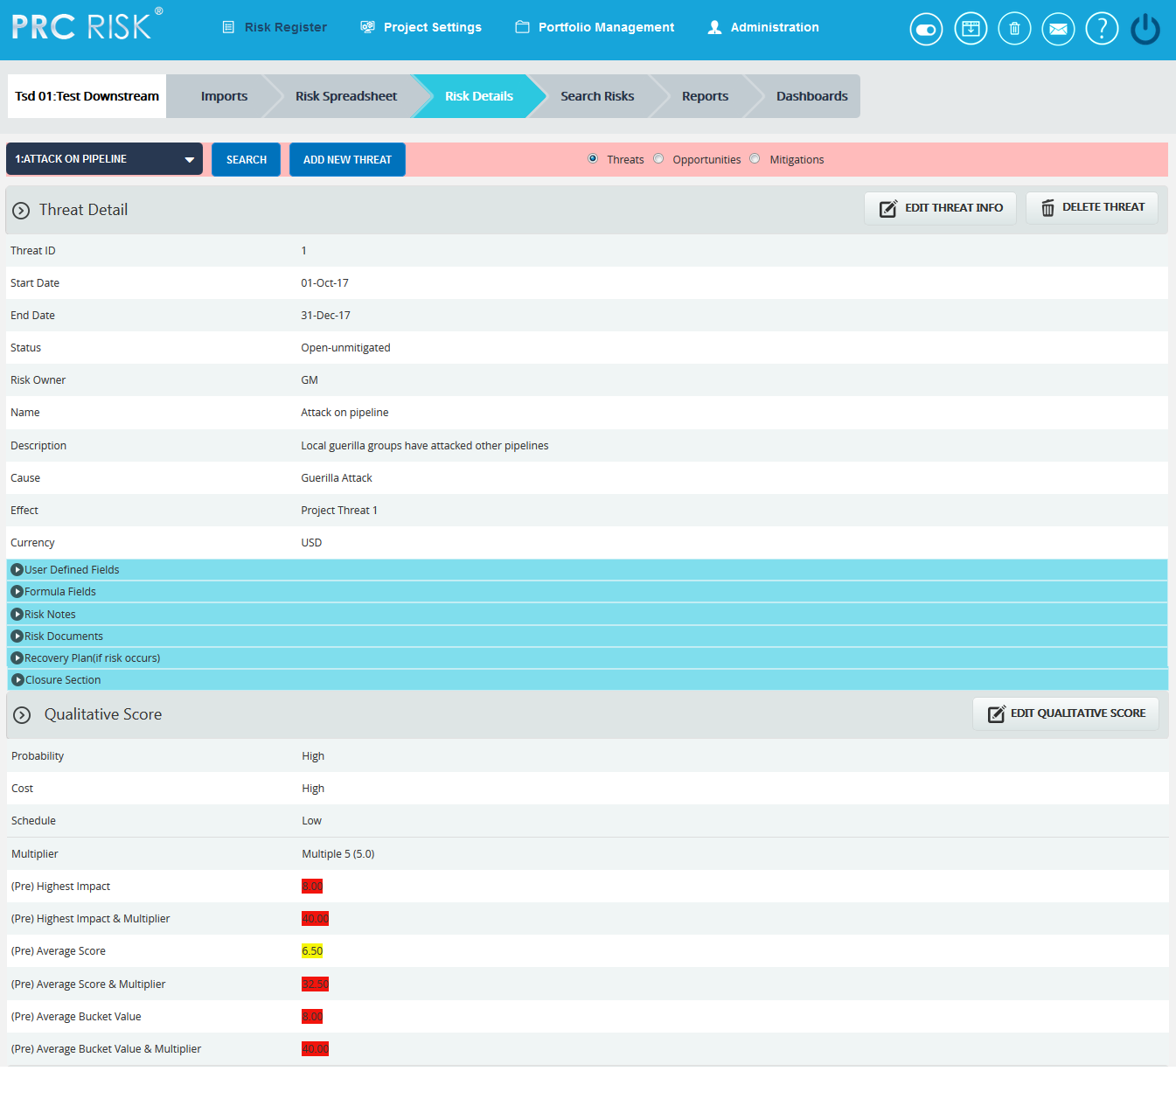

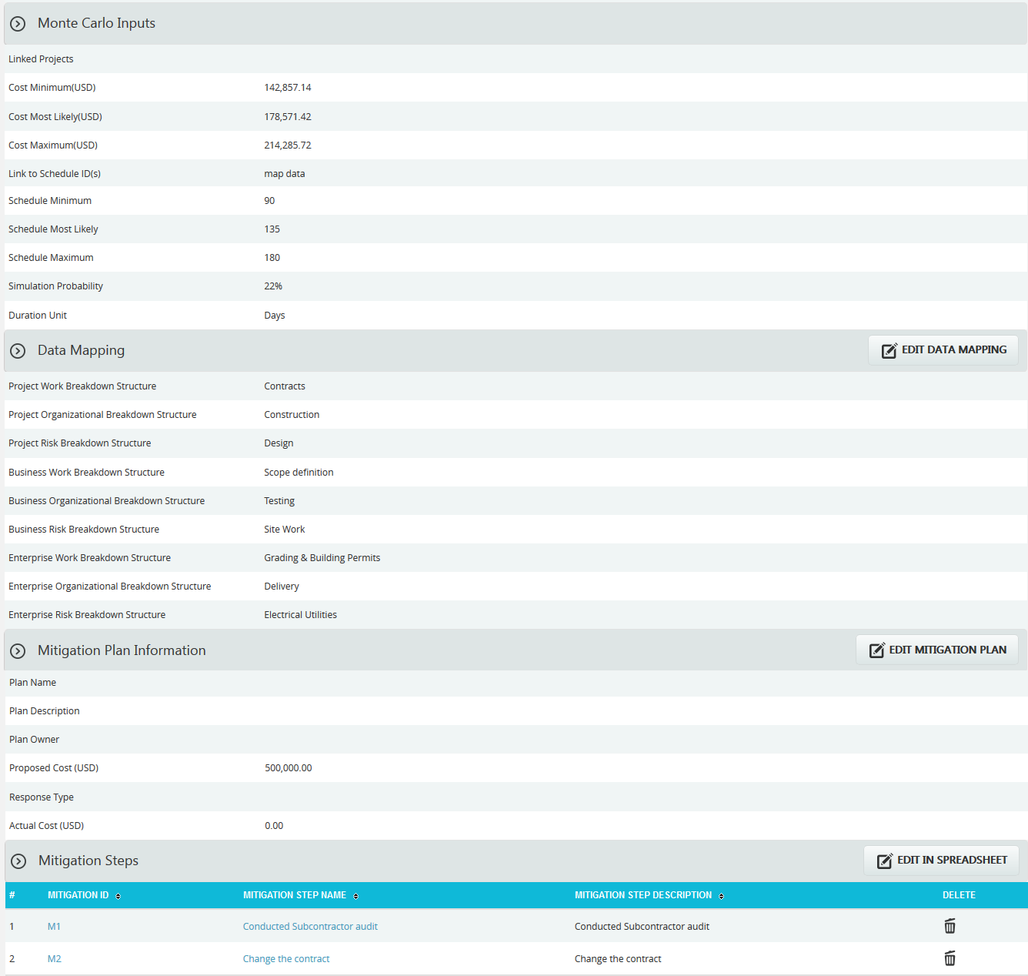
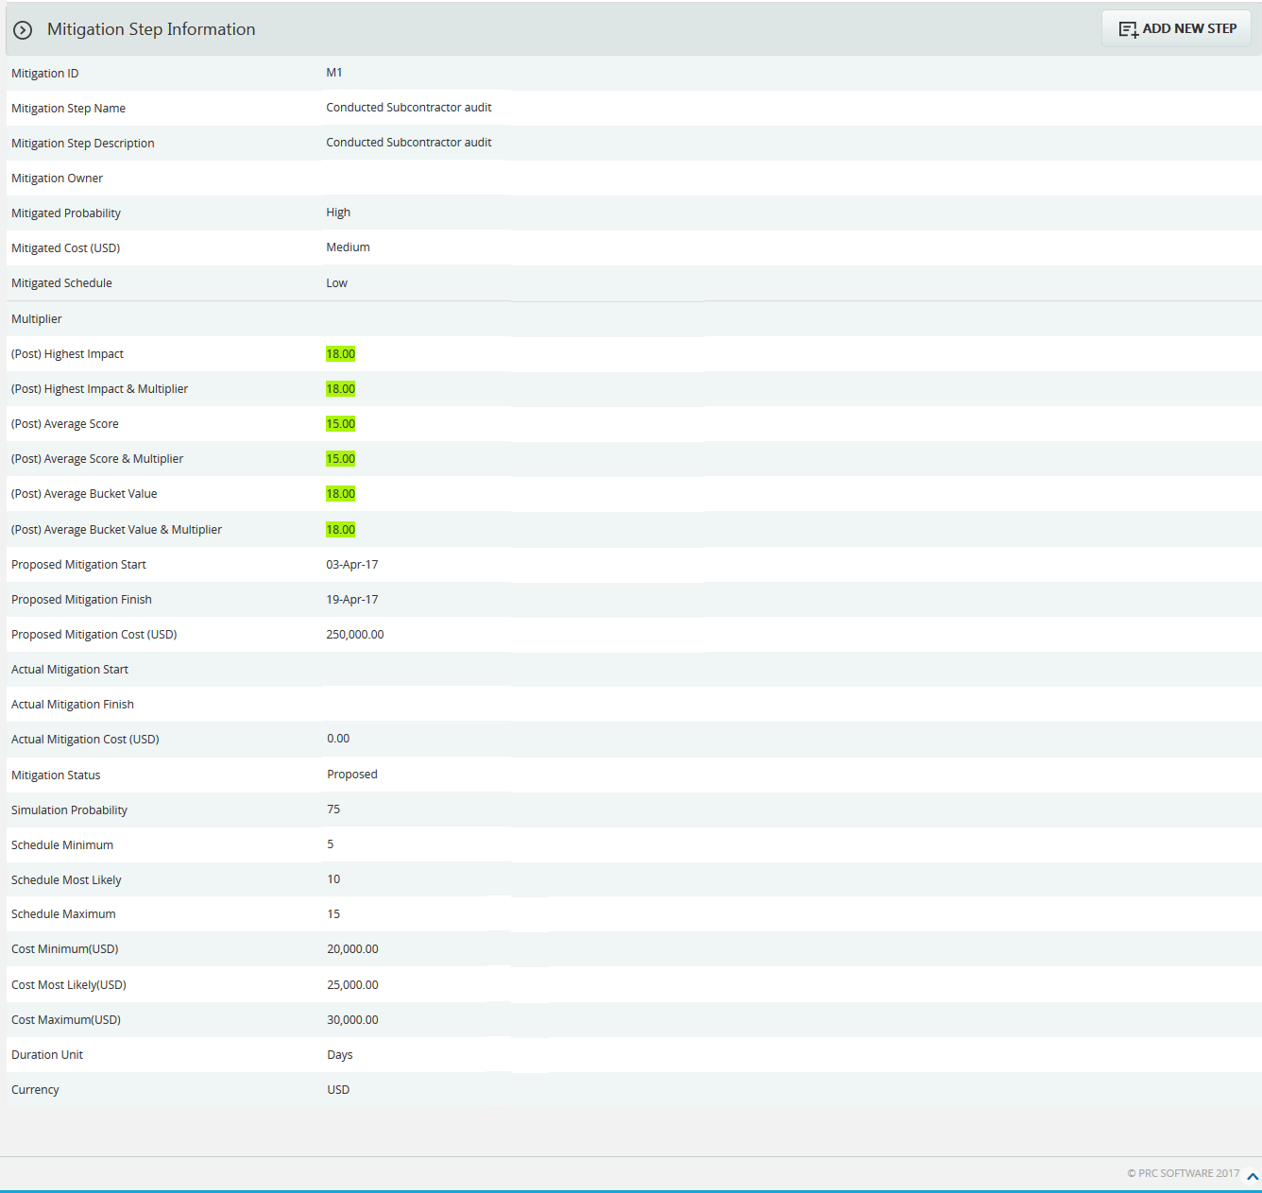
Figure 1

Navigate Page:
To go to the Risk Details (Opportunity) page or Risk Details (Mitigations), the user must navigate from the Risk Details (Threats) page.
The option for navigation from one page to another is placed on top of the page and is shown in Figure 1.
Steps:
- Risk Register —> Risk Details (Threats)
- Click the Opportunities radio button (Figure 1) to navigate to the Risk Details (Opportunity) page, or click the Mitigations radio button (Figure 1) to navigate to the Risk Details (Mitigations) page.

Searching For Threats:
Searching for threats in Risk Details (Threats) can be done in two ways. The Search function allows the user to search for a threat based on a keyword. This method is faster when you are working with large amounts of data. The Select function is commonly used for databases with less data and when the search objective is known.
Using the search function:
Steps:
- Risk Register —> Risk Details (Threats)
- Click the SEARCH button. (Figure 1)
- Enter the search keyword (which can be the ID or name) and click the SEARCH button and select the required threat. (Figure 2)

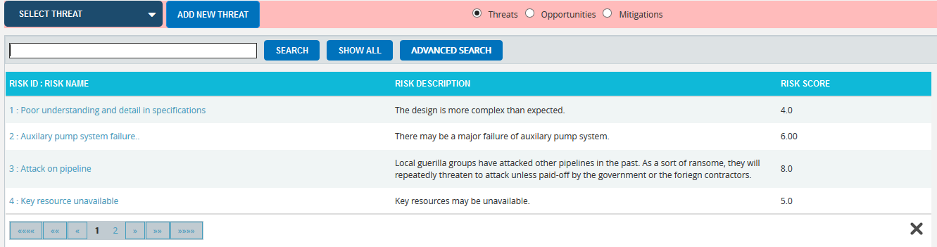
Figure 2
The Show All button in the search area lists all the threats available (by default). (Figure 2) In order to Filter or Sort threat details displayed in the search area, click the Advanced Search button. The search area changes to that shown in Figure 3.
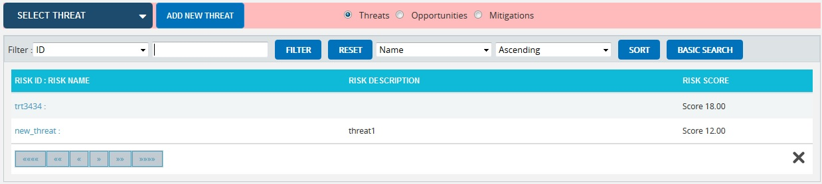
Figure 3
To Filter the search area contents:
Steps:
- Select the required column. (Figure 3)
- Enter the value based on which filtering is to be done. (Figure 3)
- Click the Filter button. (Figure 3)
To Sort the data:
- Select the required column. (Figure 3)
- Select the order (Ascending/Descending) in which sorting is to be done. (Figure 3)
- Click the Sort button (Figure 3) to sort the data in the search area.
- To go to the previous search page shown in Figure 2, click the Basic Search button shown in Figure 3.
Using the select function (dropdown list):
Steps:
- Risk Register —> Risk Details (Threats)
- Click the Select Threat dropdown. (Figure 1)
- Select the required threat from the list shown.

Creating a new threat:
Creating a new threat in the risk register is quick and easy. The risk ID is a required field to save the threat.
Steps:
- Risk Register —> Risk Details (Threats)
- Click the ADD NEW THREAT button. (Figure 1)
- After entering threat details, click the SAVE button. (Figure 1)
Risk Owner has an editable select box where we can either enter or select the Risk Owner’s name. (Figure 4)

Figure 4

Editing threat information:
When editing threat details in the Risk Details (threats), all fields under the Threat Detail section, User Defined Fields section, Recovery Plan section, Qualitative Score section, Monte Carlo Inputs section and Data Mapping section will be unlocked and the user will be able to modify those fields.
Steps:
- Risk Register —> Risk Details (Threats)
- Select the required threat.
- Click the EDIT THREAT INFO button. (Figure 1)
- After the data is modified, click the Save button. (Figure 1)

User Defined Fields Section:
Any user defined or custom field will be shown in this section. There is no limit to the number of user defined fields. User Defined Fields are added as follows:
Project settings —> Custom Fields

Formula Fields Section:
Any formula field will be shown in this section (Figure 5). There is no limit to the number of formula field. Formula Fields are added as follows:
Project settings —> Custom Fields

Figure 5

Risk notes Section:
Users can add a short Risk Note. The note will be saved with the user name and a time stamp for future tracking purposes. Risk Notes once added cannot be edited. Risk Notes added can only be deleted by a Super User. The Super User can delete Risk Notes by clicking the Close button. (Figure 6)

Figure 6
To Add New Note check the following steps below:
Steps:
- Risk Register —> Risk Details (Threats)
- Select the threat if the threat is already created.
- Click the ADD NEW NOTE link to add Risk Notes. (Figure 6) A pop up shown in Figure 7 appears.
- Enter the note and click the ADD NOTE button. (Figure 7)

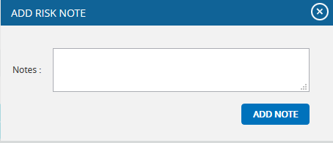
Figure 7

Risk Documents Section:
This functionality is used to upload any additional documents required. It can be of type xls, csv, xer, mpp, jpeg, jpg, png, tif, gif, txt, doc, docx and pdf.
Steps:
- Risk Register —> Risk Details (Threats)
- Click on the Risk Documents section. (Figure 1)
- Click the BROWSE button. Select the required file. (Figure 8)
- Click the UPLOAD FILE button to finish. (Figure 8)
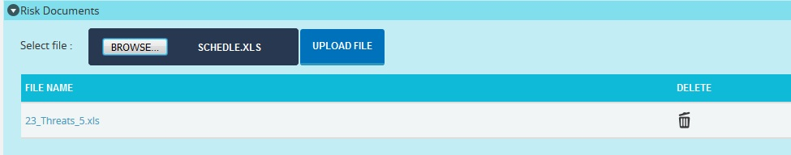
Figure 8

Recovery Plan Section:
The Recovery Plan section is to document what will be done if mitigation is not successful and the risk event does occur. It also documents the steps the team should be prepared to take if the risk becomes a reality.

Closure Section:
The Closure Section is used for documenting the actual impact of the risk event on the project. Fully documenting this section will allow similar projects in the future to learn and benefit from the lessons learned.

Qualitative Score Section:
Qualitative Score fields include Probability, Cost and Schedule and Additional Impacts, if any. (Figure 1) These fields are used to set the pre-mitigated score. If Probability and impacts have a value of either Undefined or No Risk, the risk score will be zero.

Map Schedule ID:
Schedule ID called as Activity ID is used for simulation purposes.
To map activity ID:
Steps:
- Click the MAP DATA button shown in Figure 9. A pop up shown in Figure 10 appears.
- Click the checkbox to select the corresponding activity ID you want to map for your threat. Click the SAVE button to finish. (Figure 10)

Figure 9
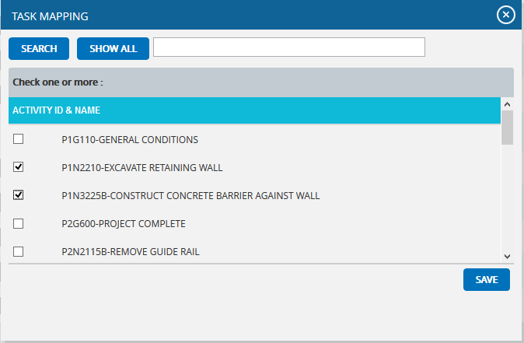
Figure 10

Data Mapping Section:
The Data Mapping section shows to which Breakdown Structure the selected threat is mapped and at what level (Project, Business Unit, or Enterprise) it is mapped. It is not required to map data, but it will be useful when the time comes to report at the portfolio level.
Project Organizational Breakdown Structure, Project Work Breakdown Structure and Project Risk Breakdown structure details are added from the page:
Project Settings —> Project Breakdown Structure
Business Organizational Breakdown Structure, Business Work Breakdown Structure, Business Risk Breakdown Structure, Enterprise Organizational Breakdown Structure, Enterprise Risk Breakdown Structure, Enterprise Work Breakdown Structure are added from the page:
Portfolio Management —> Project Breakdown Structure

Enterprise Risk details are added from the page:
Portfolio Management —> Reports —> Enterprise Risk List
To Map data:
Steps:
- Click the map data link to map data for the corresponding field. (Figure 1)
- Select the checkbox corresponding to the data to be mapped. (Figure 11)
- Click the SELECT WBS button (if Work Breakdown Structure), the SELECT OBS button (if Organizational Breakdown Structure), the SELECT RBS button (if Risk Breakdown Structure) to finish. (Figure 11)
The steps described above apply to all Organizational Breakdown Structure, Work Breakdown Structure and Risk Breakdown Structure fields.
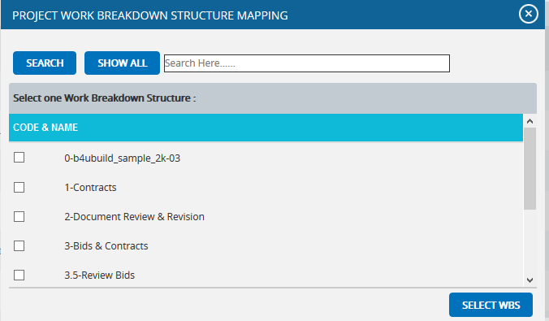
Figure 11

Mitigation Plan Information:
Users can track their Mitigation Plan or individual mitigation steps. The mitigation plan is a compilation of the individual steps below it. The mitigation plan cost is rolled up from the cost of each mitigation step. Tracking mitigation steps creates accountability when the step owner and planned dates are tracked. Reports can be generated to identify all mitigation steps that are currently behind schedule.
The qualitative and simulation scoring fields (Probability, Cost, Schedule, etc.) in the mitigation steps represent the residual risk that remains after a mitigation step is completed. The goal is to mitigate a risk until it is gone, however often this is not possible. It is important to document any residual risk that cannot be removed for the benefit of the project team and the accuracy of Monte Carlo simulations. Any graph that highlights a post-mitigated score will focus on the residual risk after all mitigation steps have been completed. The status of a mitigation step and the actual dates should be updated as the steps are started and finished. Proposed Cost is the sum of all Proposed Cost of mitigation steps and Actual Cost is the sum of all Actual Cost of mitigation steps.

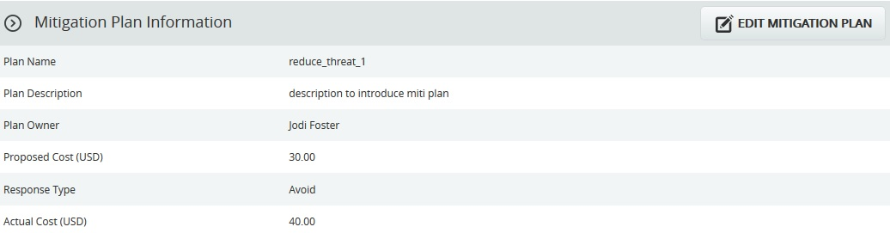Figure 12

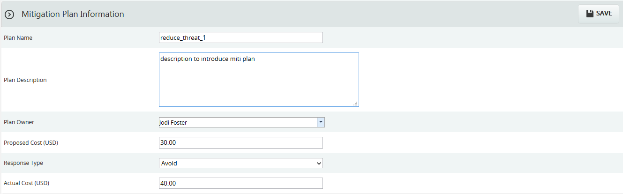
Figure 13

Edit Mitigation Plan Information:
This functionality is to edit the mitigation plan information such as Plan Name, Plan Description, Plan Owner, Proposed Cost, Response Type and Actual Cost.
Steps:
- Risk Register ---> Risk Details (Threats)
- Select the required threat.
- Click the EDIT MITIGATION PLAN button. (Figure 12)
- After the data is modified, click the SAVE button. (Figure 13)

Mitigation Steps Information:
Mitigation step information can be added from Spreadsheet page or can be added from the Risk Details page itself.

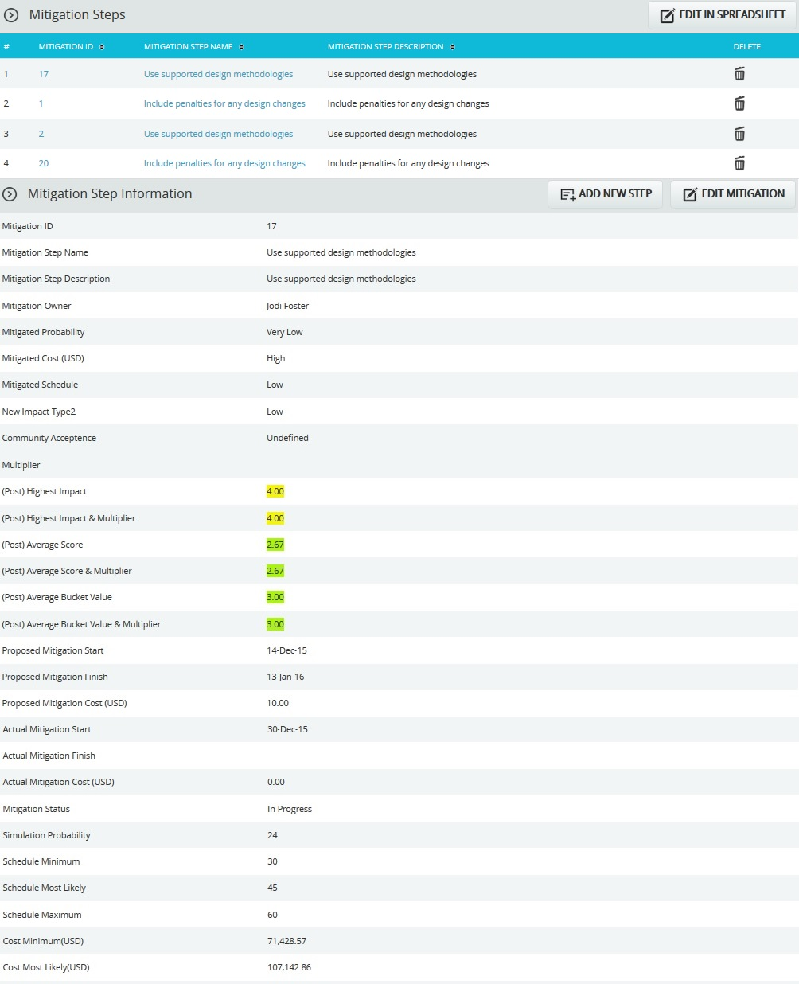
Figure 14

Edit In Spreadsheet:
This functionality is to add, edit, delete and export mitigation steps for the selected threats in spreadsheet. Click the EDIT IN SPREADSHEET button which navigates to a spreadsheet page.
Steps:
- Risk Register ---> Risk Details (Threats)
- Select the required threat.
- Click the EDIT IN SPREADSHEET button. (Figure 14)
- Add, edit, delete and export mitigation steps for the selected threat as in Spreadsheet View page. (Figure 15)
- Click GO TO RISK DETAILS button to go back to the Advanced View page. (Figure 15)

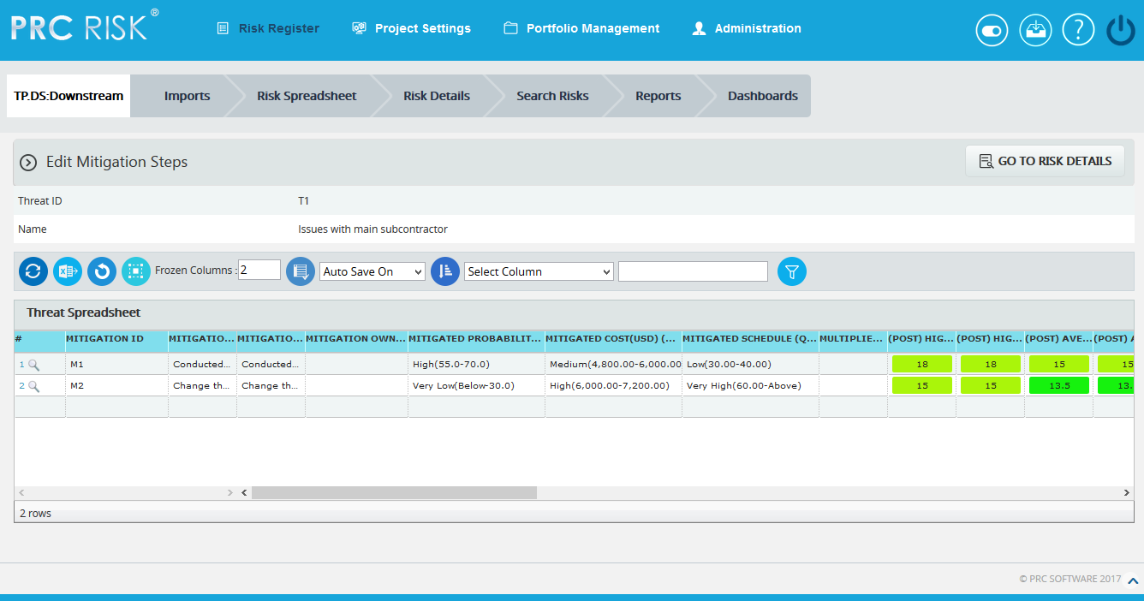

Figure 15

Add new Step:

This functionality is to add a new mitigation step for the selected threat.

Steps:
- Risk Register ---> Risk Details (Threats)
- Select the required threat.
- Click the ADD NEW STEP button. (Figure 14)
- After entering threat details, click the SAVE STEP button. This button is visible only after the ADD NEW STEP button or the EDIT MITIGATION button is clicked. (Figure 14)

Edit Mitigation Step:

This functionality is to edit the selected mitigation step of the selected threat.

Steps:
- Risk Register ---> Risk Details (Threats)
- Select the required threat.
- Select the Mitigation Step link that is to be edited, from Mitigation Steps section. (Figure 14)
- Click the EDIT MITIGATION button. (Figure 14)
- After entering mitigation details, click the SAVE STEP button. (Figure 16) This button is visible only after the ADD NEW STEP button or the EDIT MITIGATION button is clicked. (Figure 14)
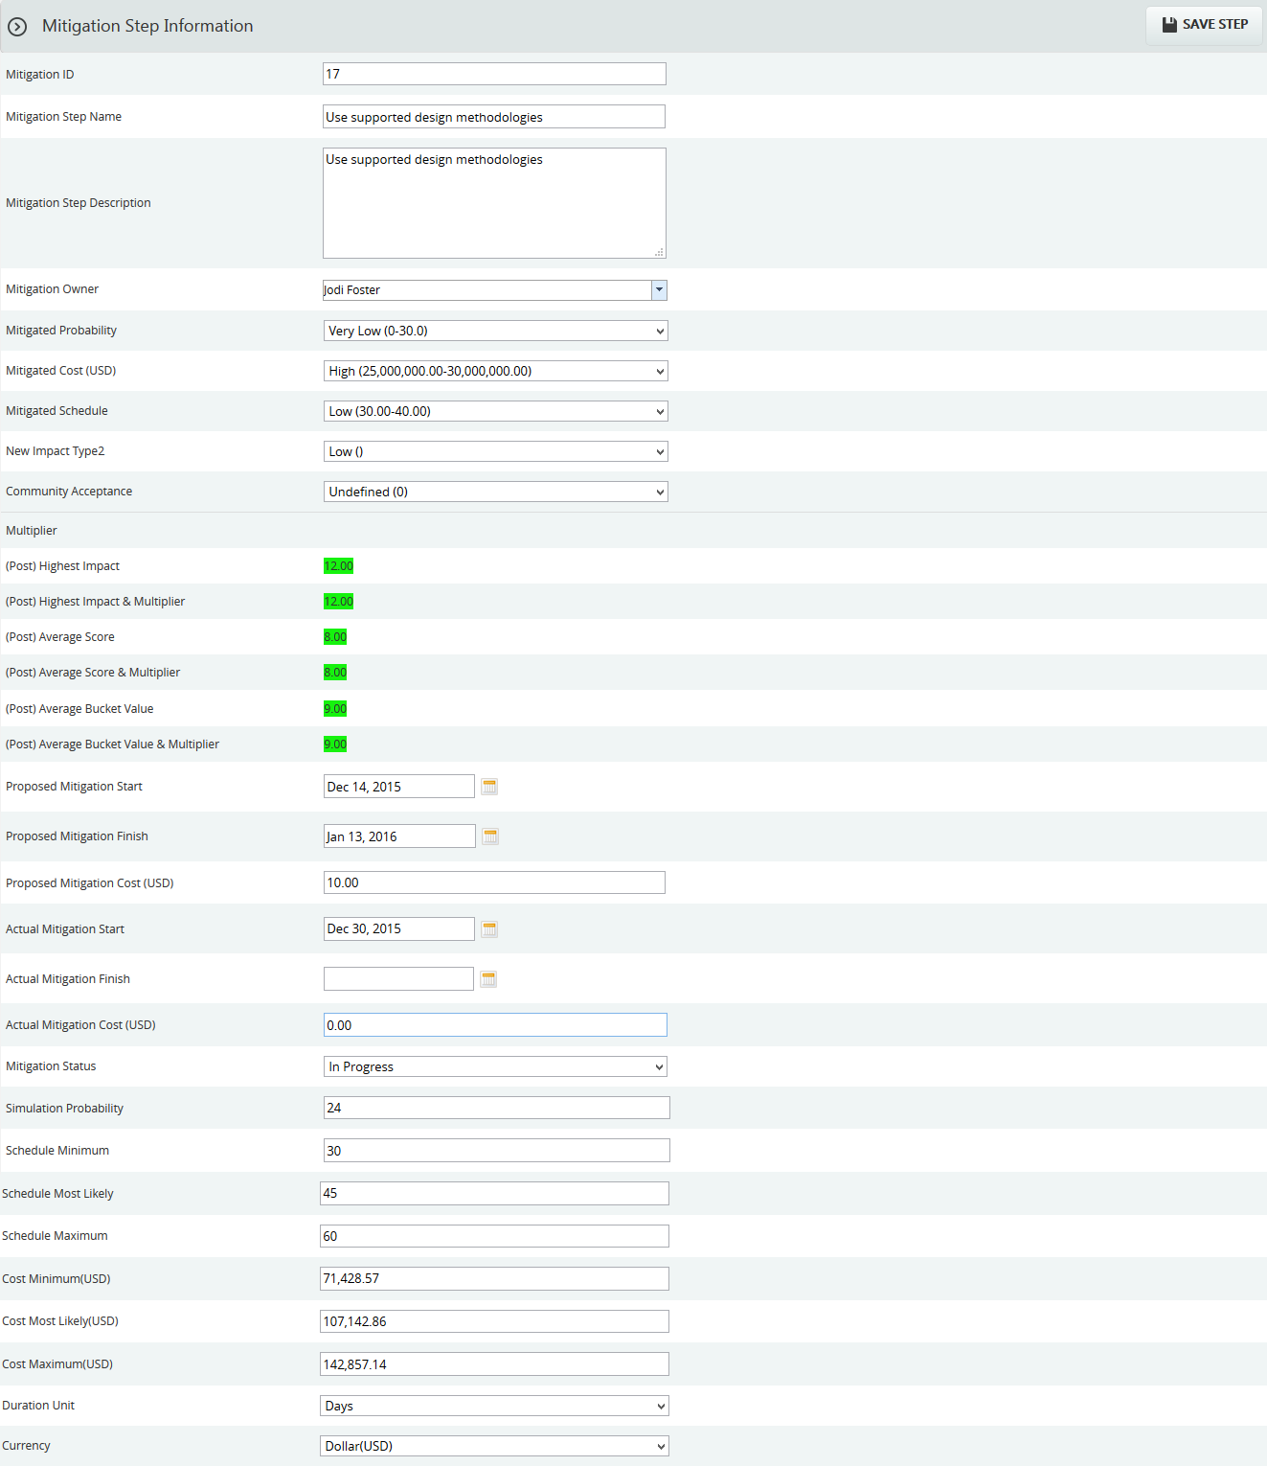

Figure 16

Recycle Bin:
To go to the Recycle Bin from Risk Details (Threats), click the Recycle Bin icon shown on top of the page in Figure 1.
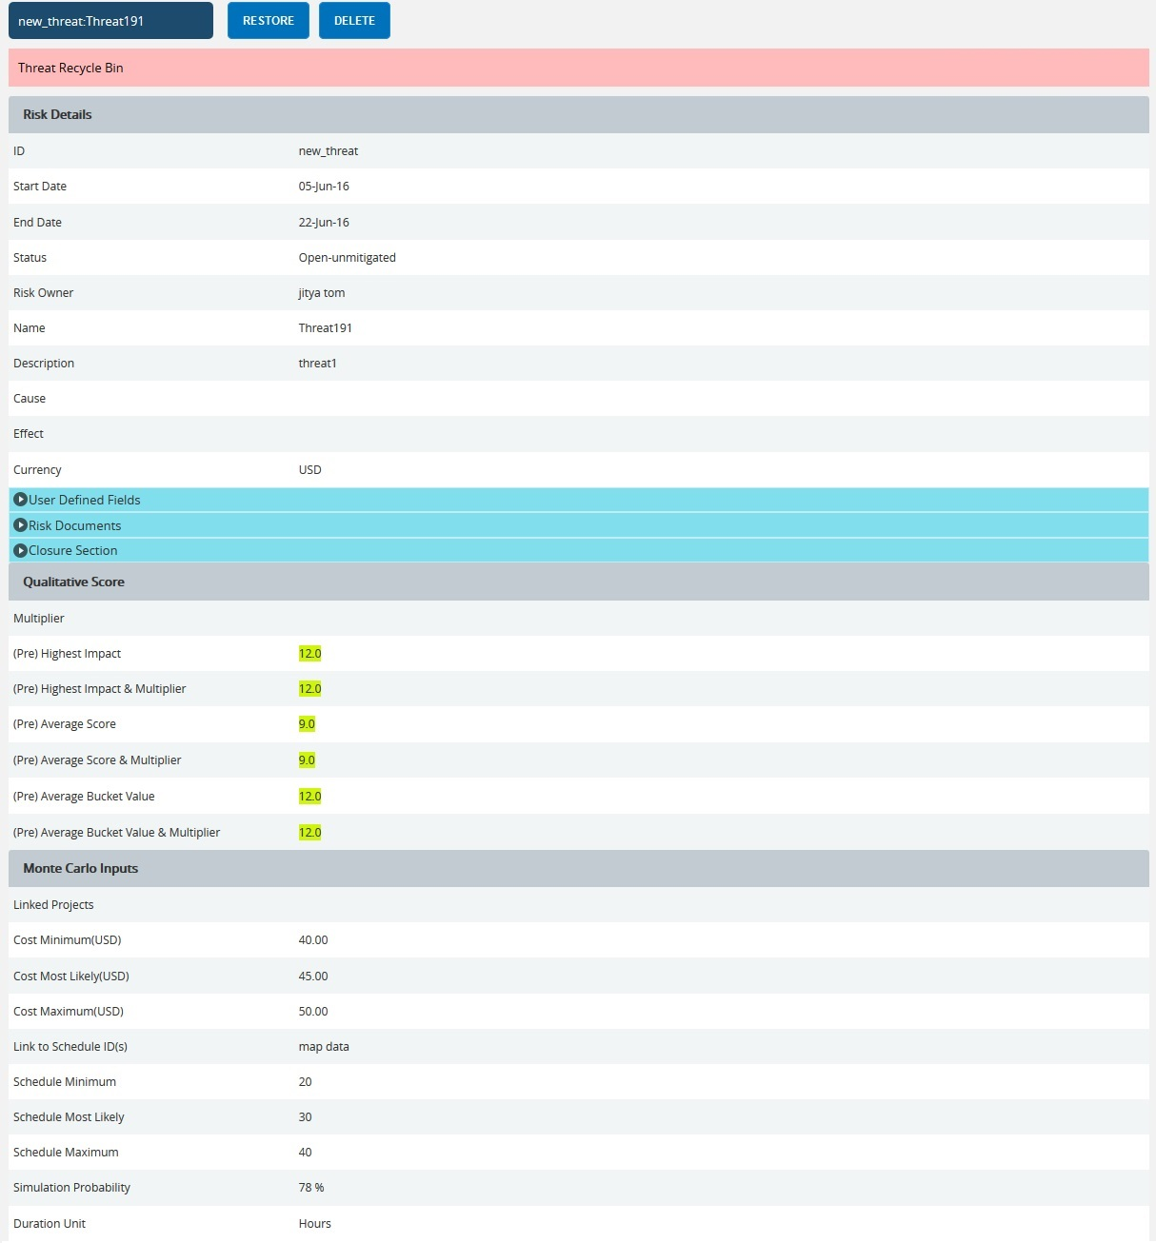
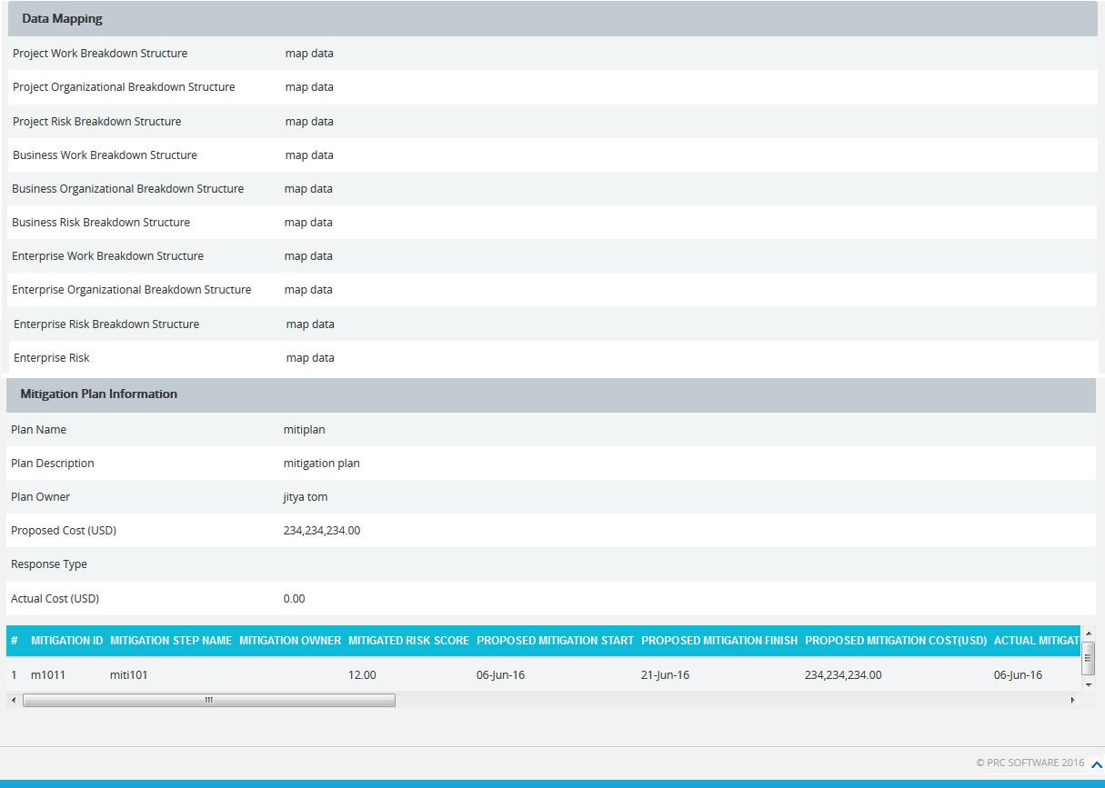
Figure 17

Restore Threats:
The following steps restore threats and remove them from the Recycle Bin and back to the pages where threat details are being shown, such as Risk Details (threats).
Steps:
- Risk Register --->Risk Details (Threats)
- Click the Recycle Bin icon to go to Recycle Bin page.
- Select the threat to restore.
- Click the RESTORE button (Figure 17) to restore selected threat.

Delete Threat From Recycle Bin:
The threat deleted from Recycle Bin will be removed completely from the system.
Steps:
- Risk Register --->Risk Details (Threats)
- Click the Recycle Bin icon to go to the Recycle Bin page.
- Select the threat to delete.
- Click the DELETE button. (Figure 17)
After you receive the confirmation message (Figure 18), click the OK button. The threat will be deleted permanently. To cancel, click the Cancel button. (Figure 18)

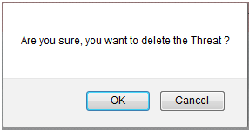
Figure 18

Email Settings:
This functionality is used to export the entire page to Word and send it by email to the person selected.
Steps:
- Risk Register ---> Risk Details (Threats)
- Click the Threats radio button to navigate to the Risk Details (Threats) page. (Figure 1)
- Select the required threat.
- Click the Email icon to send email.
- Select the user from the dropdown list to whom mail should be sent.
- Enter the message in the Message text area.
- Select the required fields for the email edit, that can be edited and saved by the recipient (refer Figure 20).
- Click the UPDATE FIELDS button to view the threats and its mitigation field values that are selected, where the email edit can be done. (Figure 19)
- Click the SEND MAIL button to finish. (Figure 19)

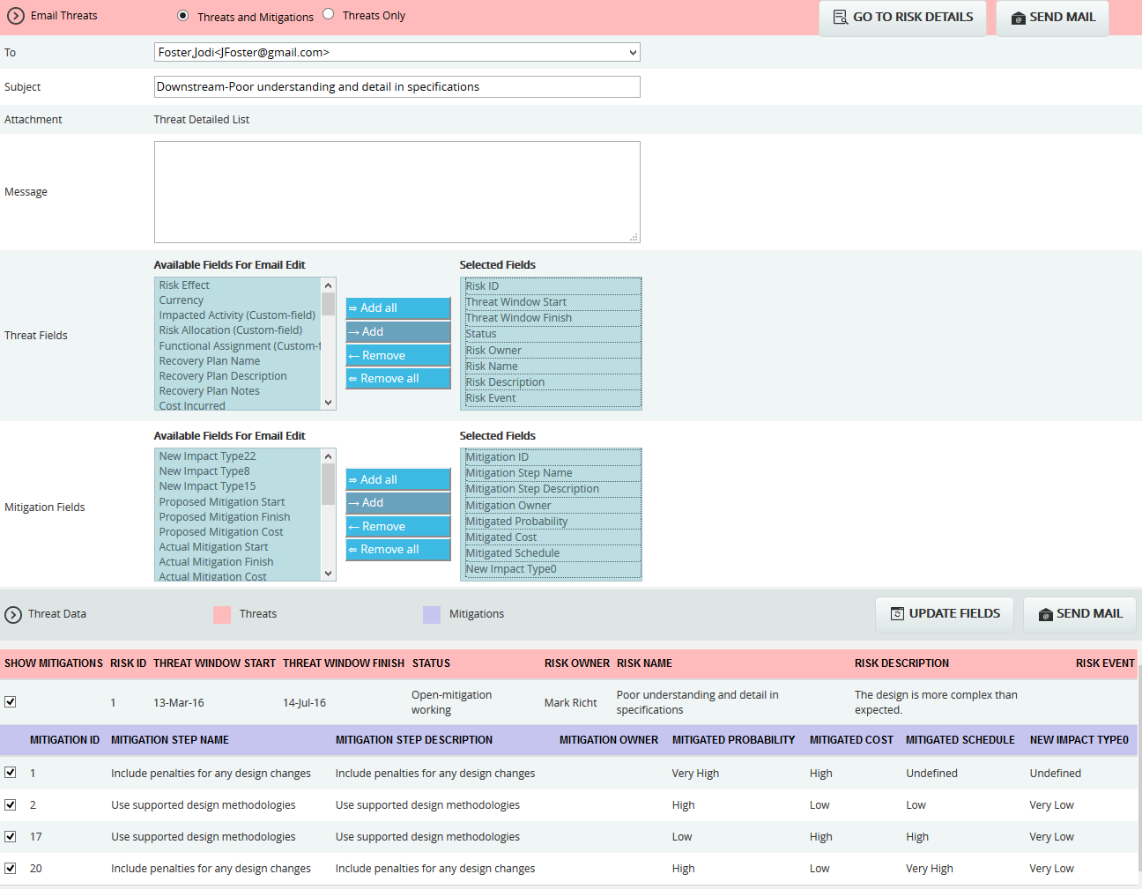

Figure 19

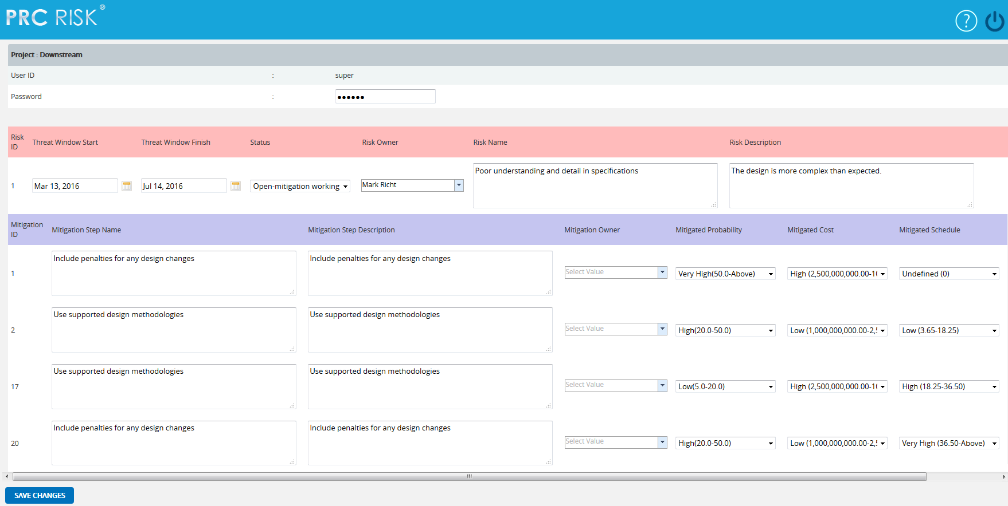
Figure 20
The recipients can see the page (Figure 20) and submit the changes by clicking the SAVE CHANGES button. The changes will be updated or error messages will be shown on another web page. The save changes can be done only once for an email sent.
Deleting Threat:
The deleted threats will be moved to the Recycle Bin.
Steps:
- Risk Register ---> Risk Details (Threats)
- Select the required threat.
- Click the Delete Threat button. (Figure 1)
After you receive the confirmation message (Figure 21), click the OK button. The threat will be moved to the recycle bin. To cancel, click the Cancel button. (Figure 21)
Figure 21

Risk Details (Opportunities)
The Risk Details (Opportunities) page allows you to Search, Edit, Map, Add, and Delete Opportunities in the selected project. To view project data, a project must be first selected from the Select Project section of the menu. The user will have access only to those projects that have been assigned by the System Administrator. Users with Read/Write access can create new opportunities, edit opportunities, delete opportunities, and send email. Users designated with View access can view the opportunity details, and send email.
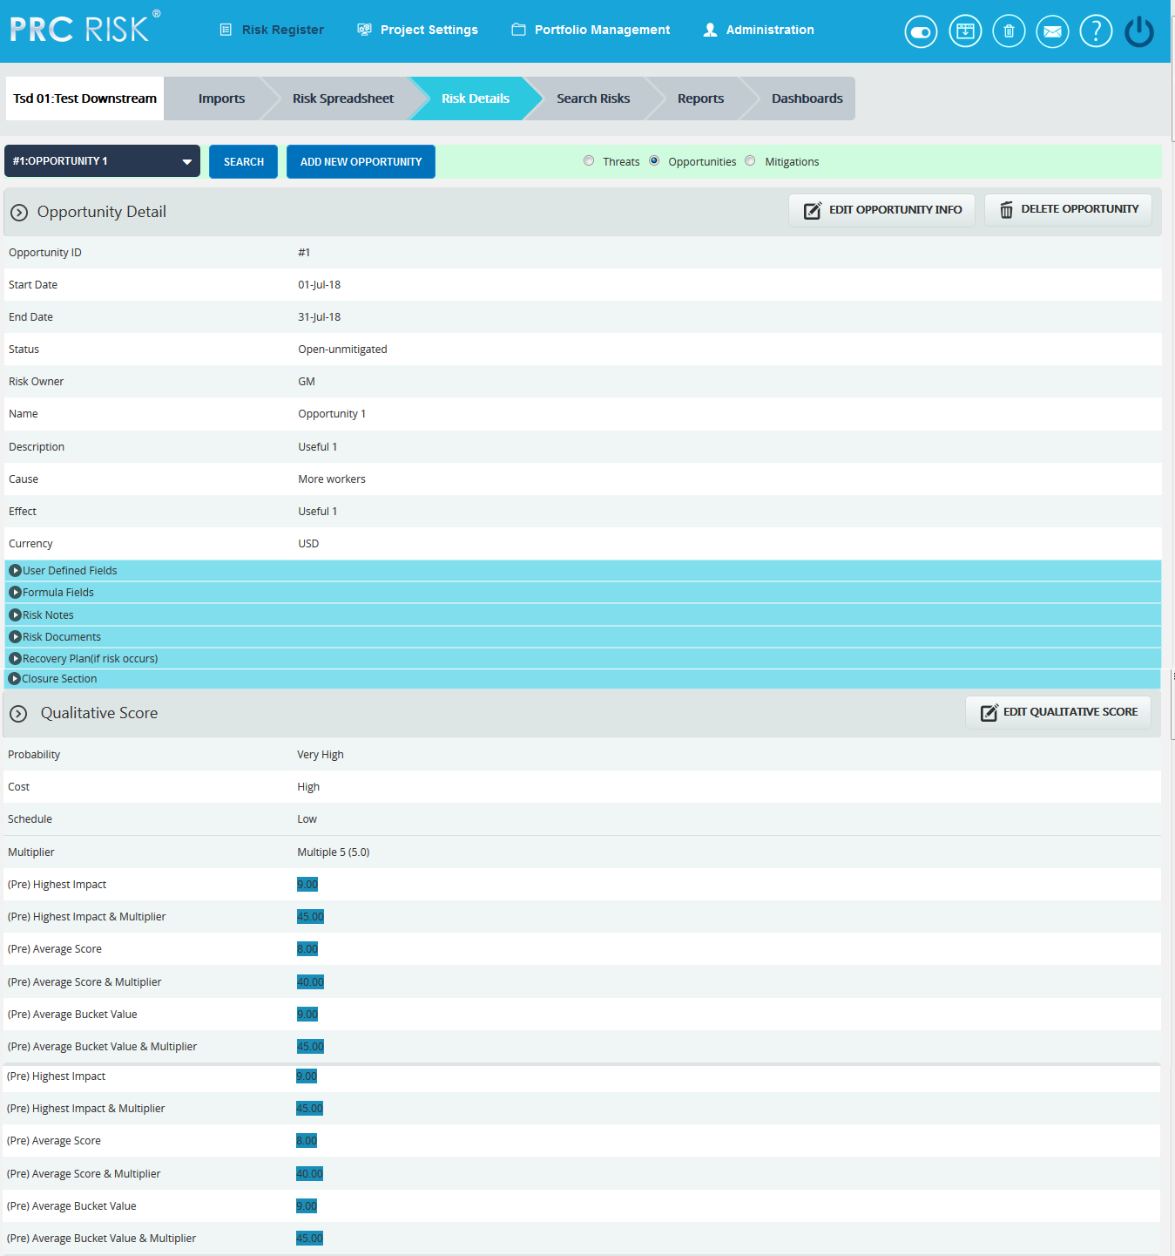

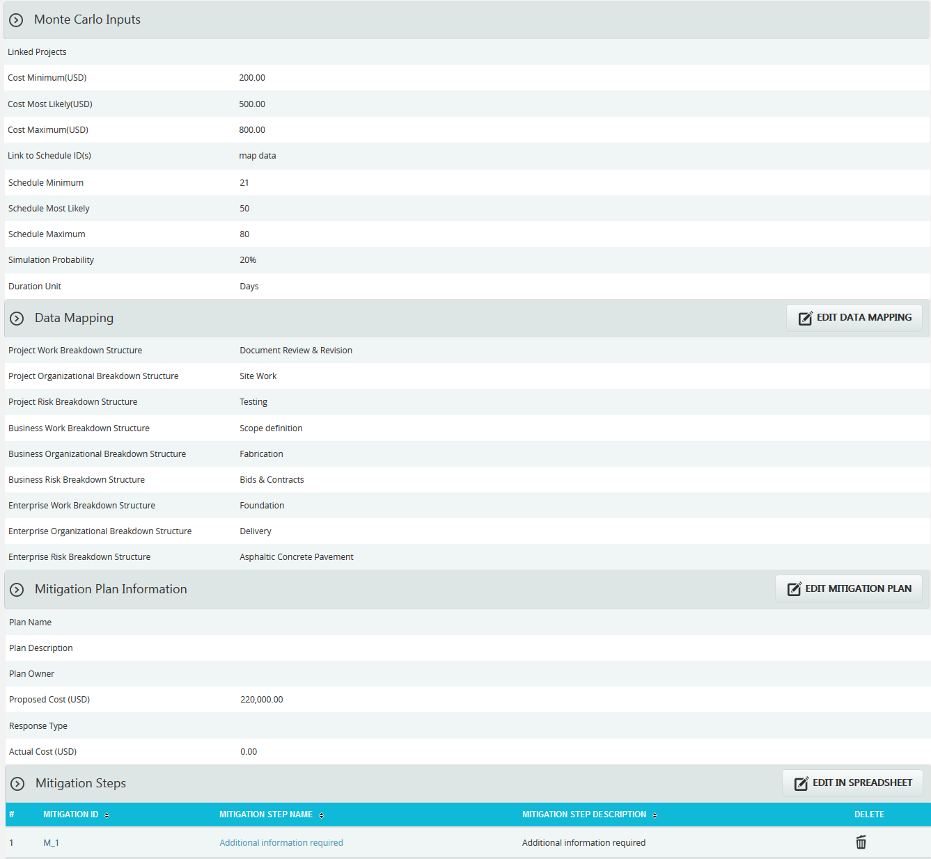
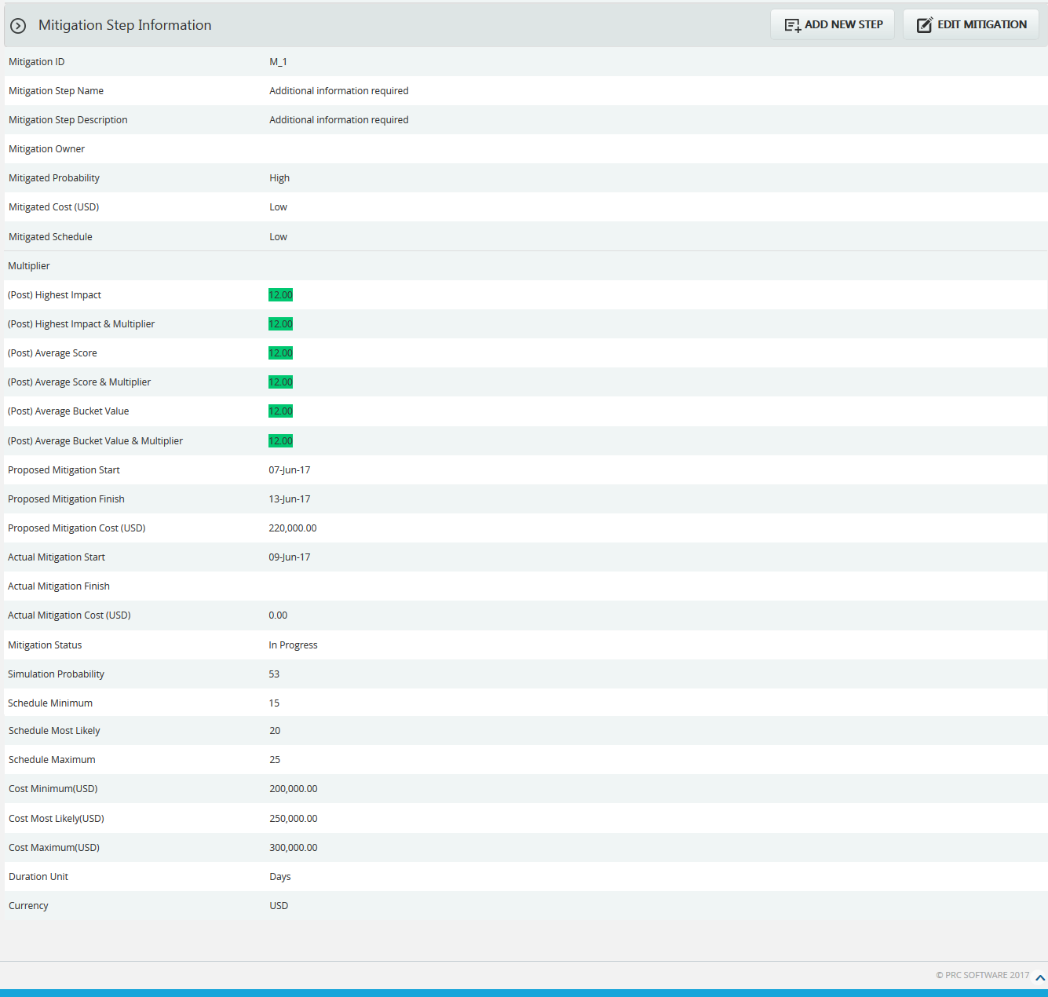
Figure 1

Navigate Page:
To go to the Risk Details (Opportunities) page, navigate from the Risk Details (Threat) page.
Steps:
- Risk Register --->Risk Details
- Click the Opportunities radio button to navigate to the Risk Details (Opportunity) page. (Figure 1)
To go to the Risk Details (Threat) page or Risk Details (Mitigations) from the Risk Details (Opportunities) page:
Click the Threats radio button to navigate to the Risk Details (Threat) page. (Figure 1)
Or
Click the Mitigations radio button to navigate to Risk Details (Mitigations) page. (Figure 1)

Searching For Opportunities:
Searching for Opportunities in Risk Details (Opportunities) can be done in two ways. The Search function allows the user to search for an opportunity based on a keyword. This method is faster when you are working with large amounts of data. The Select function is commonly used for databases with less data and when the search objective is known.
Using the search function:
Steps:
- Risk Register --->Risk Details
- Click the Opportunities radio button to navigate to the Risk Details (Opportunities) page. (Figure 1)
- Click the Search button. (Figure 1)
- Enter the search keyword (ID or name) and click the Search button and select the required opportunity. (Figure 2)
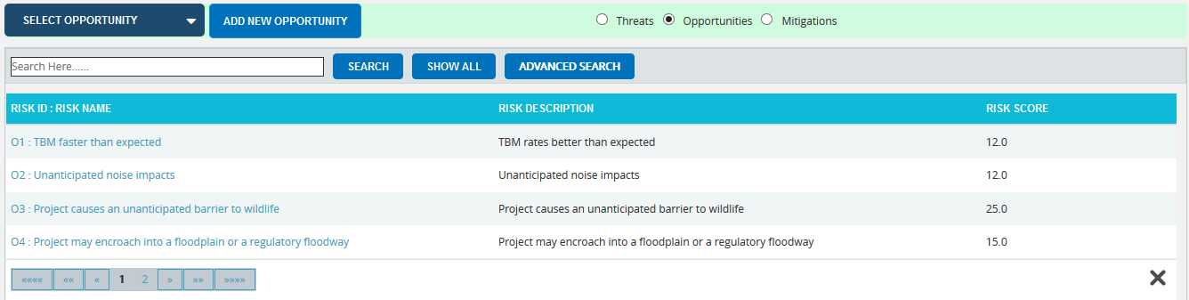
Figure 2
The Show All button in the search area lists all opportunities available (by default). (Figure 2) In order to Filter or Sort opportunity details displayed in the search area, click the Advanced Search button. The search area changes to that shown in Figure 3.

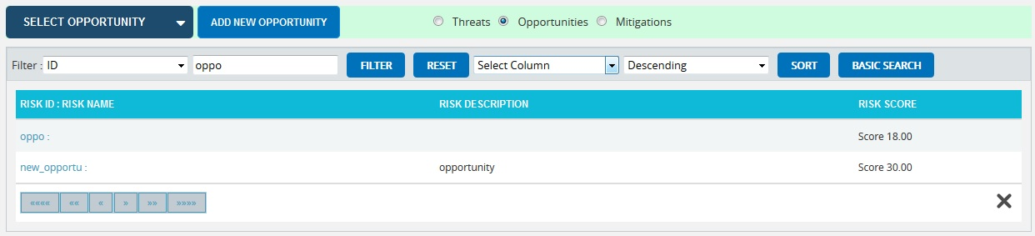
Figure 3
To Filter the search area contents:
Steps:
- Risk Register --->Risk Details
- Select the required column. (Figure 3)
- Enter the value based on which filtering is to be done. (Figure 3)
- Click the Filter button. (Figure 3)
To Sort the data:
Steps:
- Risk Register --->Risk Details
- Select the required column. (Figure 3)
- Select the order (Ascending/Descending) in which the sorting is to be done. (Figure 3)
- Click the Sort button (Figure 3) to sort the data in the search area.
- To go to the previous search page shown in Figure 2, click the Basic Search button. (Figure 3)
Using the select function (dropdown list):
Steps:
- Risk Register --->Risk Details
- Click the Opportunities radio button to navigate to the Risk Details (Opportunities) page. (Figure 1)
- Click the Select Opportunity dropdown. (Figure 1)
- Select the required Opportunity from the list shown.

Creating a new Opportunity:
Creating a new opportunity in the Risk Register is quick and easy. The Risk ID is a required field to save the opportunity.
Steps:
- Risk Register --->Risk Details
- Click the Opportunities radio button to navigate to the Risk Details (Opportunities) page. (Figure 1)
- Click the ADD NEW OPPORTUNITY button. (Figure 1)
- After entering opportunity details, click the SAVE button. (Figure 1)
The risk owner has an editable select box where the user can either enter or select the Risk Owner name. (Figure 4)

Figure 4

Editing Opportunity information:
When editing opportunity details in Risk Details (Opportunities), all fields under the Opportunity Detail section, User Defined Fields section, Recovery Plan section, Qualitative Score section, Monte Carlo Inputs section and Data Mapping section will be unlocked and the user will be able to modify those fields.
Steps:
- Risk Register --->Risk Details
- Click the Opportunities radio button to navigate to the Risk Details (Opportunities) page. (Figure 1)
- Select the required opportunity.
- Click the EDIT OPPORTUNITY INFO button. (Figure 1)
- After the data is modified, click the SAVE button. (Figure 1)

User Defined Fields Section:
Any user defined or custom field will be shown in this section. There is no limit to the number of user defined fields. User Defined Fields are added as follows:
Project settings---> Custom Fields

Formula Fields Section:
Any formula field will be shown in this section (Figure 5). There is no limit to the number of formula field. Formula Fields are added as follows:
Project settings —> Custom Fields

Figure 5

Risk notes Section:
Users can add a short Risk Note. The note will be saved with the user name and a time stamp for future tracking purposes. Risk Notes once added cannot be edited and can only be deleted by a Super User. The Super User can delete Risk Notes by clicking the Close button. (Figure 6)

Figure 6
To Add New Note, check the following steps below:
Steps:
  - Risk Register --->Risk Details
  - Click the Opportunities radio button to navigate to the Risk Details (Opportunities) page. (Figure 1)
  - Select the opportunity, if the opportunity is already created.
  - Click the ADD NEW NOTE link to add risk notes. (Figure 6) A pop up shown in Figure 7 appears.
  - Enter the note and click the ADD NOTE button. (Figure 7)
Figure 7

Risk Documents Section:
This functionality is used to upload any additional documents required. It can be of type xls, csv, xer, mpp, jpeg, jpg, png, tif, gif, txt, doc, docx and pdf.
Steps:
- Risk Register --->Risk Details
- Click the Opportunities radio button to navigate to the Risk Details (Opportunities) page. (Figure 1)
- Click on the Risk Documents section. (Figure 1)
- Click the BROWSE button (Figure 8) to select the required file.
- Click the UPLOAD FILE button to finish. (Figure 8)
Figure 8

Recovery Plan Section:
The Recovery Plan section is to document what will be done if the mitigation is not successful and the risk event does occur. It also documents the steps the team should be prepared to take if the risk becomes a reality.

Closure Section:
The Closure Section is used for documenting the actual impact of the risk event on the project. Fully documenting this section will allow similar projects in the future to learn and benefit from the lessons learned.

Qualitative Score Section:
Qualitative Score fields include Probability, Cost, Schedule and Additional Impacts, if any. (Figure 1) These fields are used to set the pre-mitigated score. If Probability and Impacts have a value of either Undefined or No Risk, the risk score will be zero.

Map schedule ID:
The Schedule ID called Activity ID is used for simulation purposes.
To map Activity ID:
Steps:
- Click the MAP DATA link shown in Figure 9. A pop up shown in Figure 10 appears.
- Click the checkbox to select the corresponding activity ID you want to map for your opportunity, then click the Save button to finish. (Figure 10)
Figure 9
Figure 10

Data Mapping Section:
The Data Mapping section shows which Breakdown Structure the selected opportunity is mapped to, and at what level (Project, Business Unit, or Enterprise). It is not required to map data, but it will be useful when the time comes to report at the portfolio level.
Project Organizational Breakdown Structure, Project Work Breakdown Structure and Project Risk Breakdown structure details are added from the page:
Project Settings --->Project Breakdown Structure
Business Organizational Breakdown Structure, Business Work Breakdown Structure, Business Risk Breakdown Structure, Enterprise Organizational Breakdown Structure, Enterprise Risk Breakdown Structure, Enterprise Work Breakdown Structure are added from the page:
Portfolio Management --->Project Breakdown Structure

Enterprise Risk details are added from page:
Portfolio Management ---> Reports ---> Other Risk Reports ---> Enterprise Risk List
To Map data:
Steps:
- Click the MAP DATA link to map data for the corresponding field. (Figure 1)
- Select the checkbox corresponding to the data to be mapped. (Figure 11)
- Click the SELECT WBS button (if Work Breakdown Structure), SELECT OBS button (if Organizational Breakdown Structure), SELECT RBS button (if Risk Breakdown Structure) to finish. (Figure 11)
The steps described above apply to all Organizational Breakdown Structure, Work Breakdown Structure and Risk Breakdown Structure fields.

Figure 11

Mitigation Details:
Users can track their Mitigation Plan or individual mitigation steps. The Mitigation Plan is a compilation of the individual steps below it. The Mitigation Plan cost is rolled up from the cost of each mitigation step. Tracking mitigation steps creates accountability when the step owner and planned dates are tracked. Reports can be generated to identify all mitigation steps that are currently behind schedule.
The qualitative and simulation scoring fields (Probability, Cost, Schedule, etc.) in the mitigation steps represent the residual risk that remains after a mitigation step is completed. The goal is to mitigate a risk until it is gone, however often this is not possible. It is important to document any residual risk that cannot be removed for the benefit of the project team and the accuracy of Monte Carlo simulations. Any graph that highlights a post-mitigated score will focus on the residual risk after all mitigation steps have been completed. The status of a mitigation step and the actual dates should be updated as the steps are started and finished. Proposed Cost is the sum of all Proposed Cost of the mitigation steps and Actual Cost is the sum of all Actual Cost of the mitigation steps.
Figure 12

Figure 13

Edit Mitigation Plan Information:
This functionality is to edit the mitigation plan information such as Plan Name, Plan Description, Plan Owner, Proposed Cost, Response Type and Actual Cost.
Steps:
- Risk Register --->Risk Details
- Click the Opportunities radio button to navigate to the Risk Details (Opportunities) page. (Figure 1)
- Select the required opportunity.
- Click the EDIT MITIGATION PLAN button. (Figure 12)
- After the data is modified, click the SAVE button. (Figure 13)

Mitigation Steps Information:
Mitigation step information can be added from the Spreadsheet page or can be added from the Risk Details page itself.

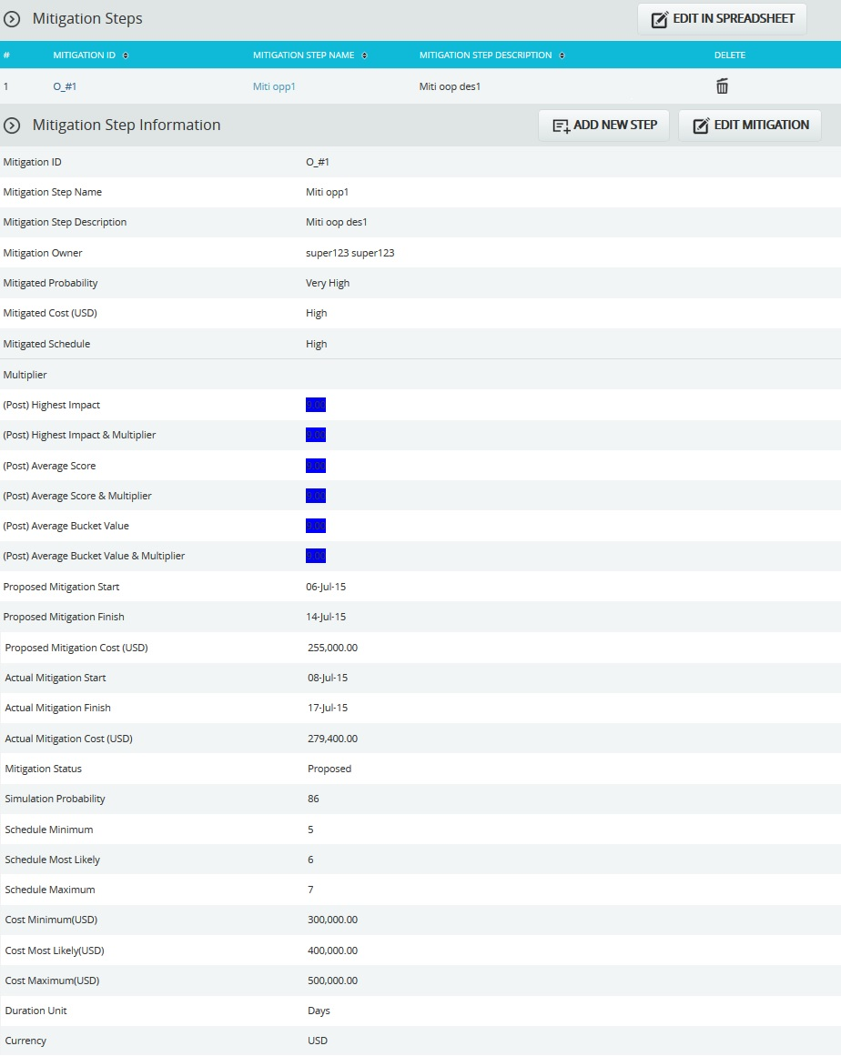
Figure 14

Edit In Spreadsheet:
This functionality is to edit, add, delete and export mitigation steps for the selected opportunity in spreadsheet. Click the EDIT IN SPREADSHEET button which navigates to a spreadsheet page.
Steps:
- Risk Register ---> Risk Details (Threats)
- Select the required opportunity.
- Click the EDIT IN SPREADSHEET button. (Figure 14)
- Edit, add, delete and export mitigation steps for the selected opportunity as in Spreadsheet View page. (Figure 15)
- Click GO TO RISK DETAILS button to go back to the Advanced View page. (Figure 15)

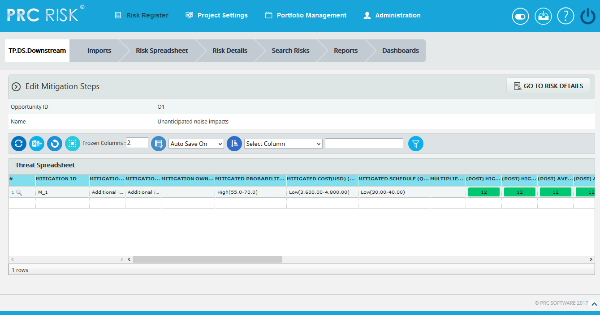
Figure 15

Add New Step:

This functionality is to add a new mitigation step for the selected opportunity.

Steps:
- Risk Register --->Risk Details
- Click the Opportunities radio button to navigate to the Risk Details (Opportunities) page. (Figure 1)
- Select the required opportunity.
- Click the ADD NEW STEP button. (Figure 14)
- After entering opportunity details, click the SAVE STEP button. This button is visible only after ADD NEW STEP button or EDIT MITIGATION button is clicked. (Figure 14)

Edit Mitigation Step:

This functionality is to edit the selected mitigation step of the opportunity selected.

Steps:
- Risk Register --->Risk Details
- Click the Opportunities radio button to navigate to the Risk Details (Opportunities) page. (Figure 1)
- Select the required opportunity.
- Select the mitigation step that is to be edited.
- Click the EDIT MITIGATION STEP button. (Figure 14)
- After entering the opportunity details, click the SAVE STEP button. This button is visible only after the ADD NEW STEP button or EDIT MITIGATION STEP button is clicked. (Figure 14)
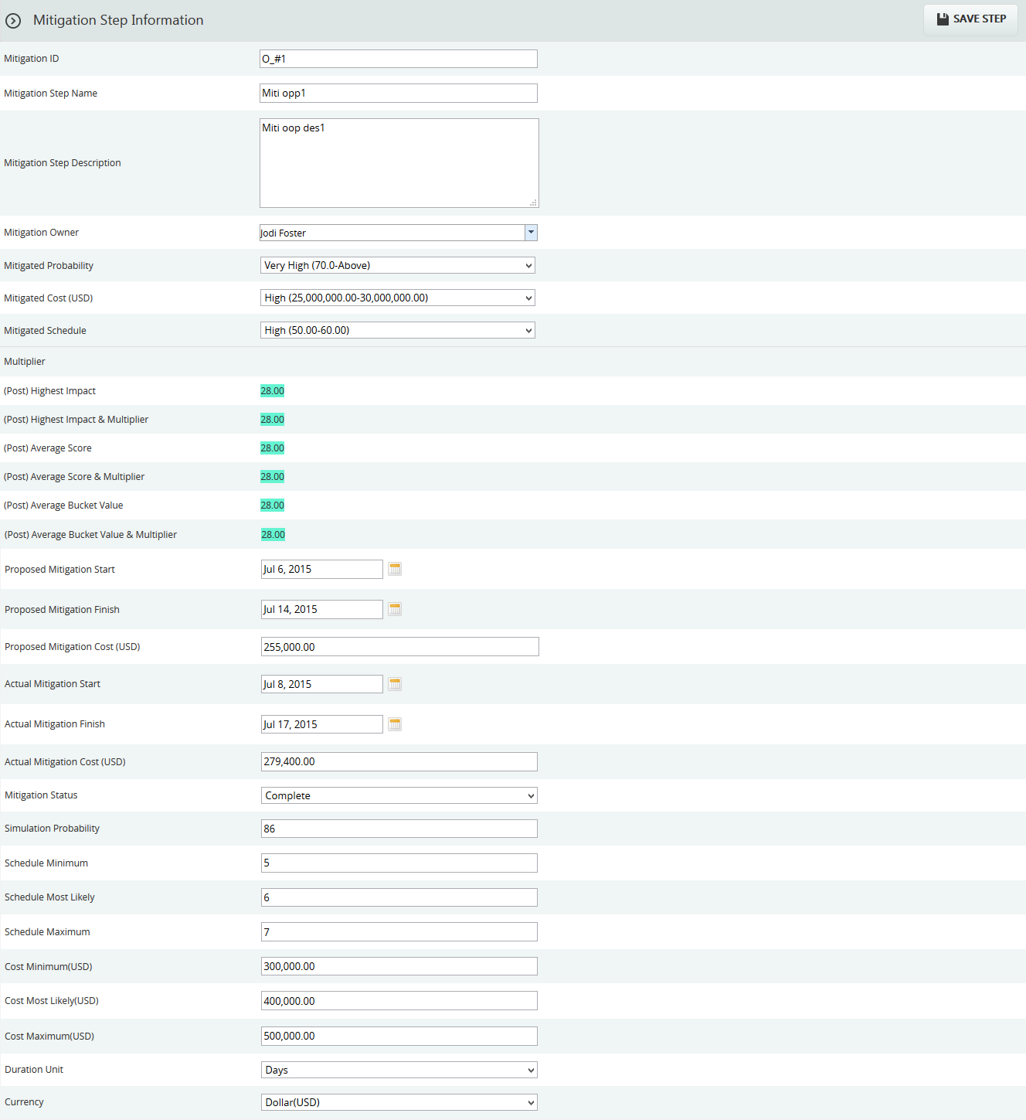

Figure 16

Recycle Bin:
To go to the Recycle Bin from Risk Details (Opportunity), click the Recycle Bin icon on top of the page in Figure 1.

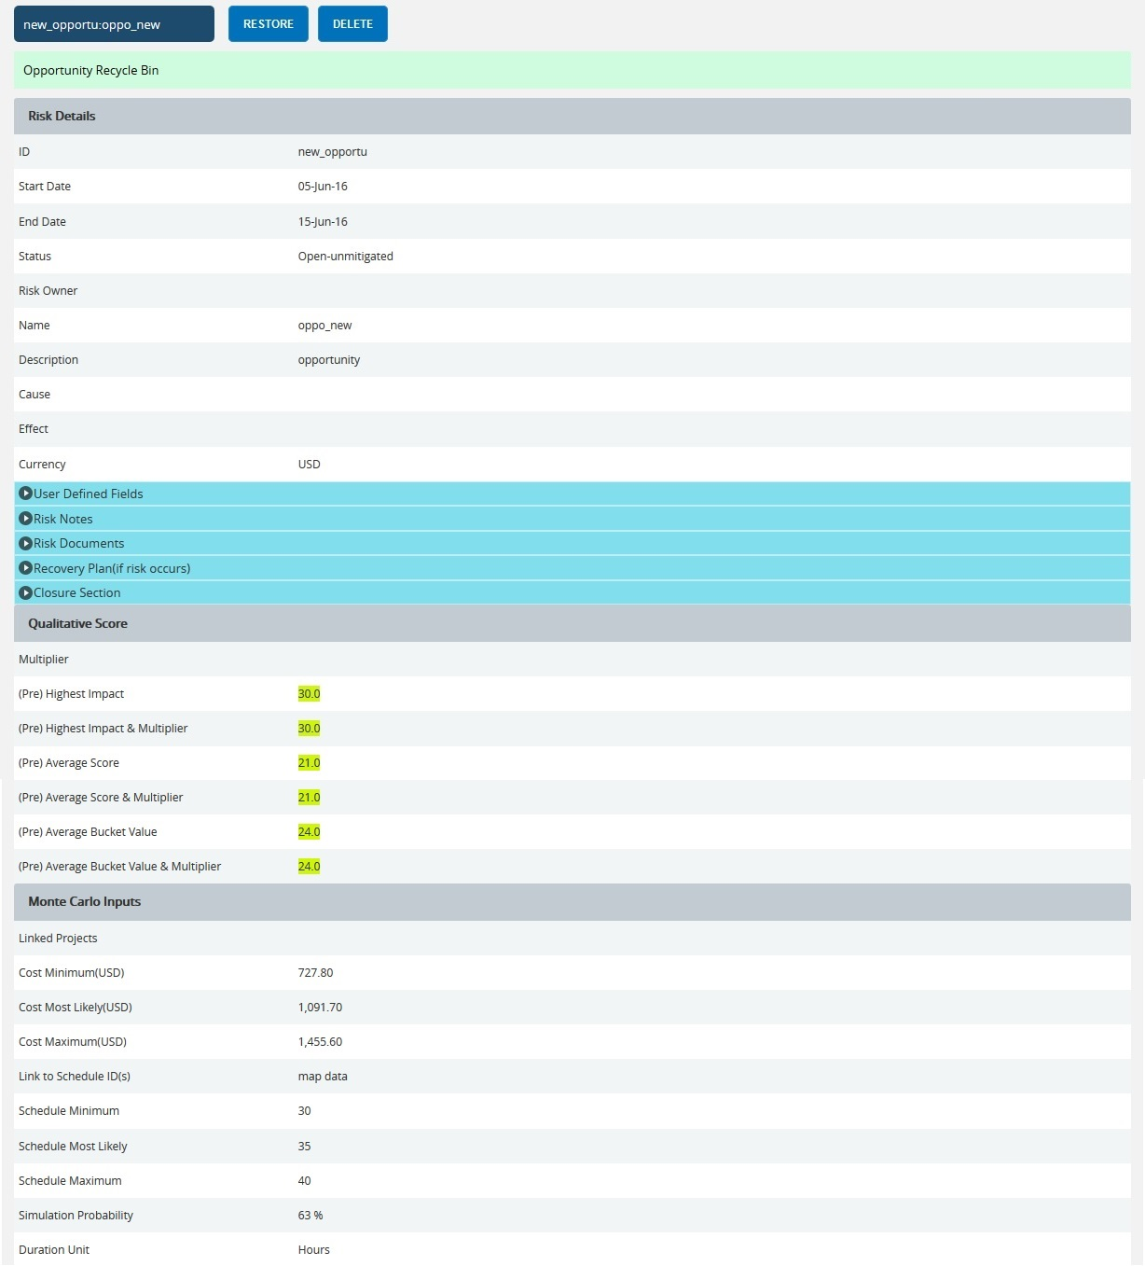
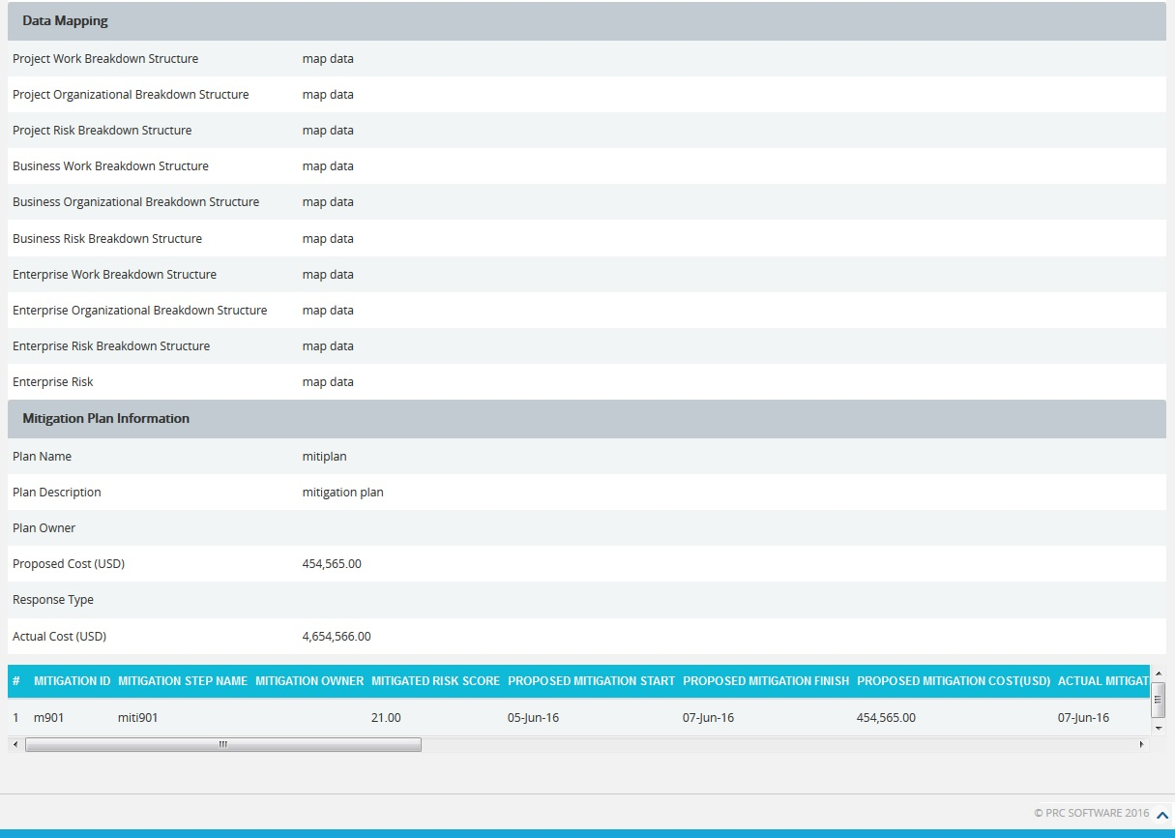
Figure 17

Restore Opportunities:
The following steps restore opportunities and remove them from the Recycle Bin and move them back to the pages where the Opportunity details are being shown, such as Risk Details (Opportunities).
Steps:
- Risk Register --->Risk Details
- Click the Opportunities radio button to navigate to the Risk Details (Opportunities) page. (Figure 1)
- Click the Recycle Bin icon to go to Recycle Bin page.
- Select the opportunity to restore.
- Click the RESTORE button to restore the selected opportunity. (Figure 17)

Delete Opportunity from Recycle Bin
The Opportunity deleted from the Recycle Bin will be removed completely from the system.
Steps:
- Risk Register --->Risk Details
- Click the Opportunities radio button to navigate to the Risk Details (Opportunities) page. (Figure 1)
- Click the Recycle Bin icon to go to the Recycle Bin page.
- Select the opportunity to delete.
- Click the DELETE button. (Figure 17)
After you receive the confirmation message (Figure 18), click the OK button. The opportunity will be deleted permanently. To cancel, click the Cancel button. (Figure 18)

Figure 18

Email Settings:
This functionality is used to export the entire page to Word and send it by email to the person selected.
Steps:
  - Risk Register --->Risk Details
  - Click the Opportunities radio button to navigate to the Risk Details (Opportunities) page. (Figure 1)
  - Select the required Opportunity.
  - Click the Email icon to send the email.
  - Select the user from the drop down list to whom mail should be sent.
  - Enter the message in the Message text area.
  - Select the required fields for the email edit, that can be edited and saved by the recipient. (Figure 20).
  - Click the UPDATE FIELDS button to view the Threats and its Mitigation field values that are selected, where the email can be edited. (Figure 19)
  - Click the SEND MAIL button to finish. (Figure 19)

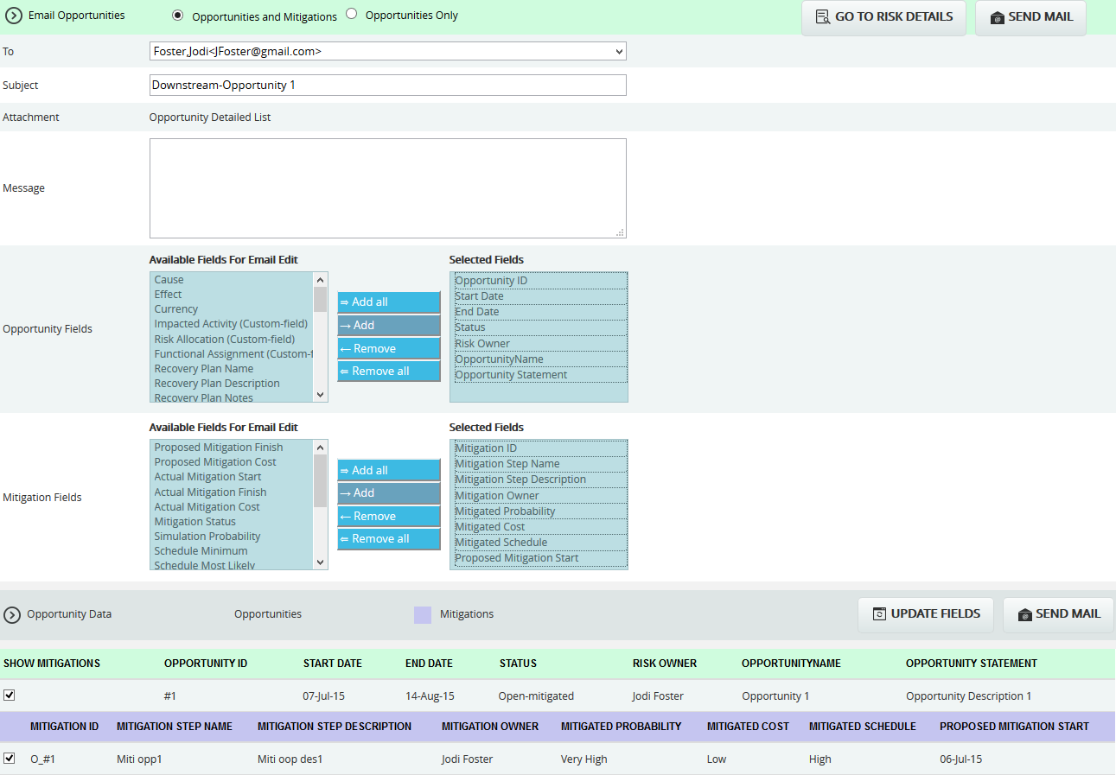
Figure 19

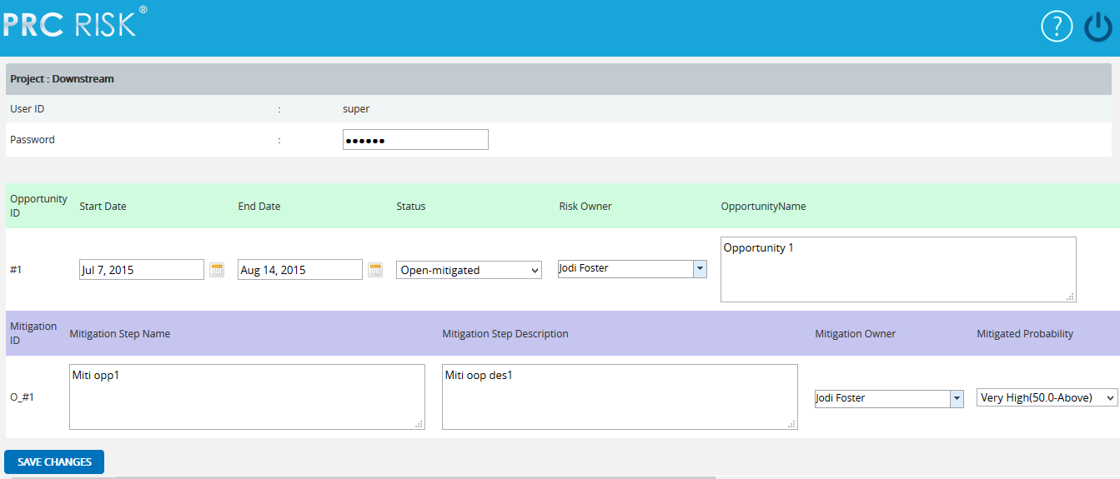
Figure 20

The recipients can see the page (Figure 20) and submit the changes by clicking the SAVE CHANGES button. The changes will be updated or error messages will be shown on another web page. The changes can be saved only once for an email sent.

Deleting Opportunity:
The deleted opportunities will be moved to the Recycle Bin.
Steps:
- Risk Register --->Risk Details
- Click the Opportunities radio button to navigate to the Risk Details (Opportunities) page. (Figure 1)
- Select the required opportunity.
- Click the DELETE OPPORTUNITY button. (Figure 1)
- After you receive the confirmation message (Figure 21) click the OK button. The Opportunity will be moved to the recycle bin. To cancel, click the Cancel button. (Figure 21)
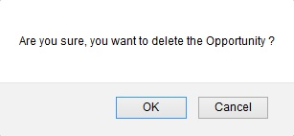
Figure 21

Risk Details (Mitigations)
Risk Details (Mitigations) page is used to add mitigation details to either threat or opportunity. Users can track their Mitigation Plan or individual Mitigation Steps. The Mitigation Plan is a compilation of the individual steps below it. The mitigation plan cost is rolled up from the cost of each mitigation step. Tracking mitigation steps creates accountability when the step owner and planned dates are tracked. The qualitative and simulation scoring fields (Probability, Cost, Schedule, etc.) in the mitigation steps represent the residual risk that remains after a mitigation step is completed. Any graph that highlights a post-mitigated score will focus on the residual risk after all mitigation steps have been completed. The status of a mitigation step and the actual dates should be updated as the steps are started and finished. This page is visible only to those users who have Read/Write access or View access for Risk Details (Mitigations).
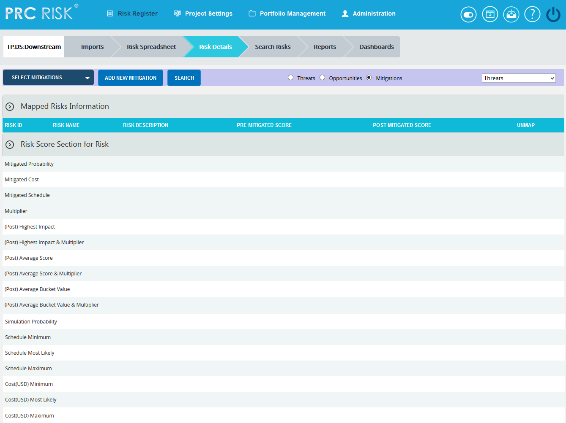
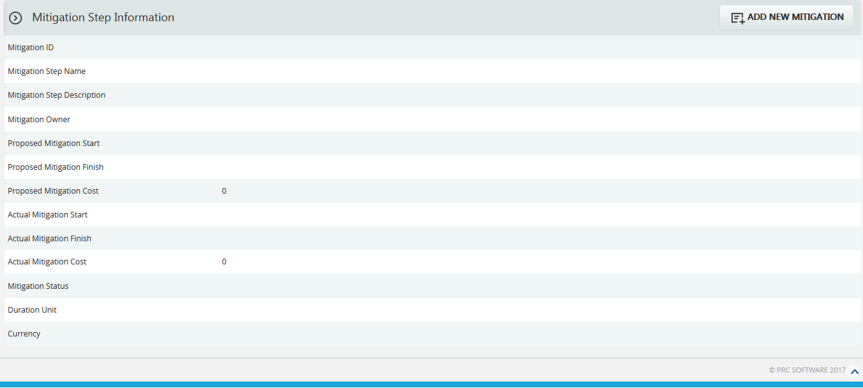
Figure 1

Select Mitigations:
This functionality is used to select the mitigations to which the risks are mapped.
Steps:
- Risk Register —> Risk Details
- Click the Mitigations Radio button to navigate to Risk Details (Mitigations) page. (Figure 1)
- Select the mitigation from the Select mitigation dropdown. (Figure 1)
- It shows the list of risks mapped to the selected mitigation step. (Figure 2)
- Click the Unmap Risk link to unmap the risks from the mitigation step. (Figure 2)

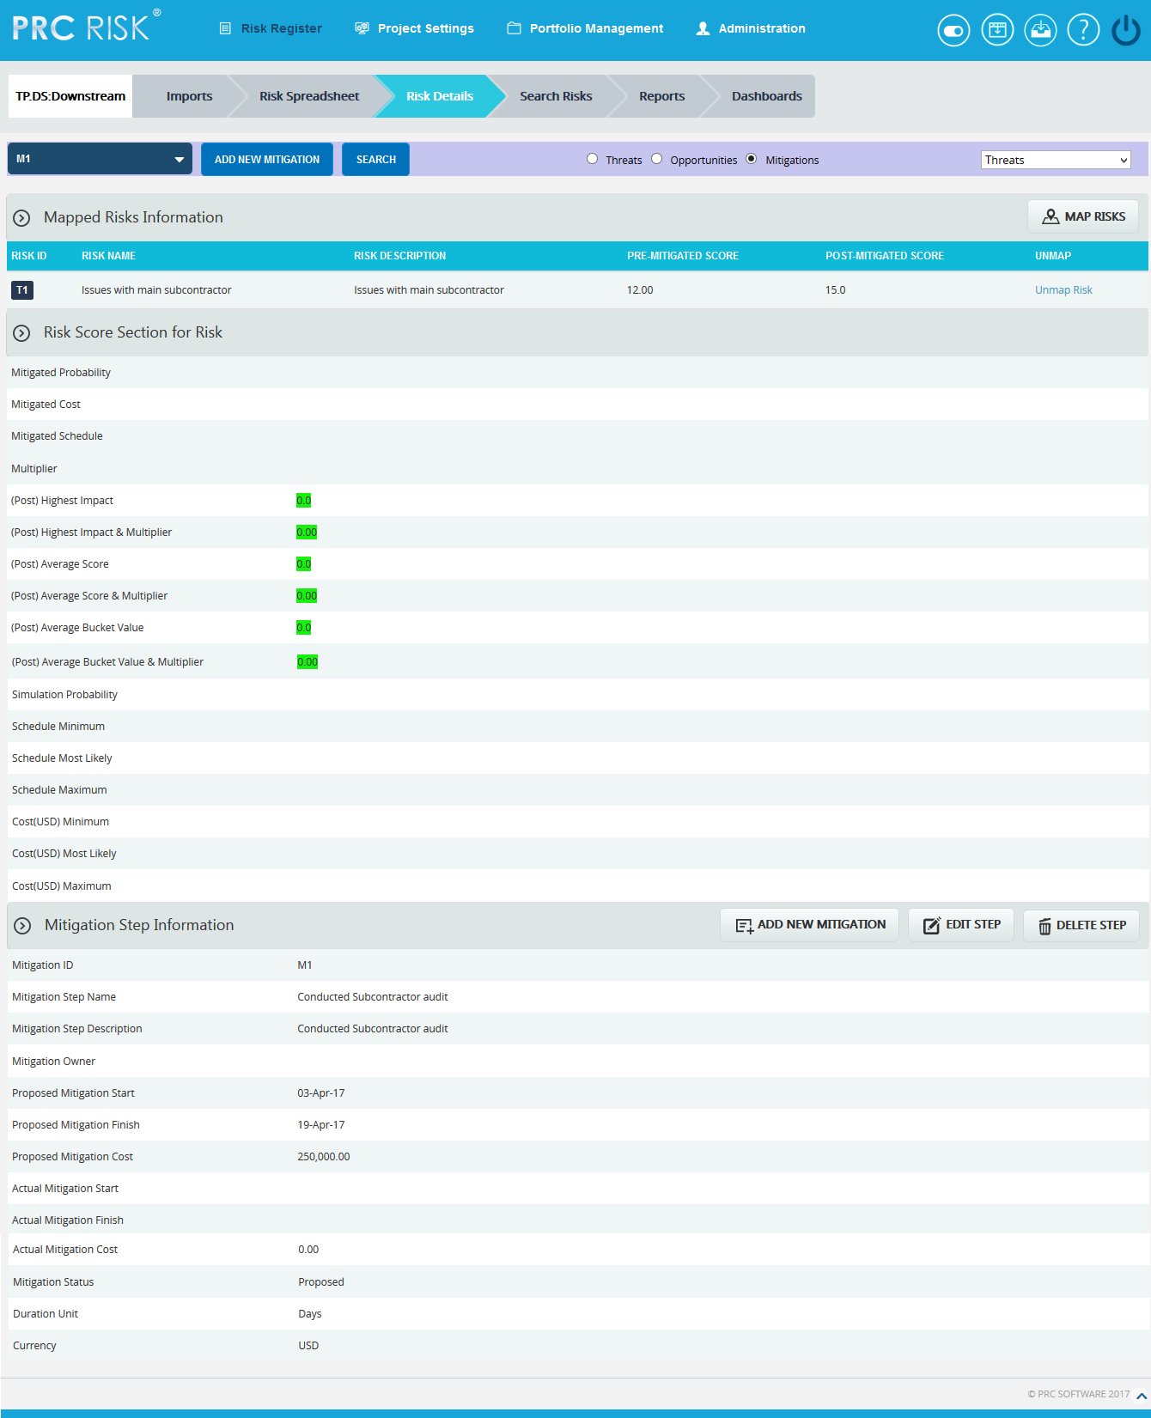

Figure 2

Map Risks:

This functionality is to select the risks to be mapped to the selected mitigation. This button is shown only after the mitigation is selected.

Steps:
- Risk Register —> Risk Details
- Click the Mitigations Radio button to navigate to Risk Details (Mitigations) page. (Figure 1)
- Select the mitigation from the Select mitigation dropdown. (Figure 1)
- Click the Map Risks button to map the risks to the selected mitigation. (Figure 2)
- A pop up appears in which select the risks and click the MAP SELECTED RISK button. (Figure 3)
- Click SEARCH RISKS button to search the risks to be mapped with.
- Click CANCEL button to close the pop up window.

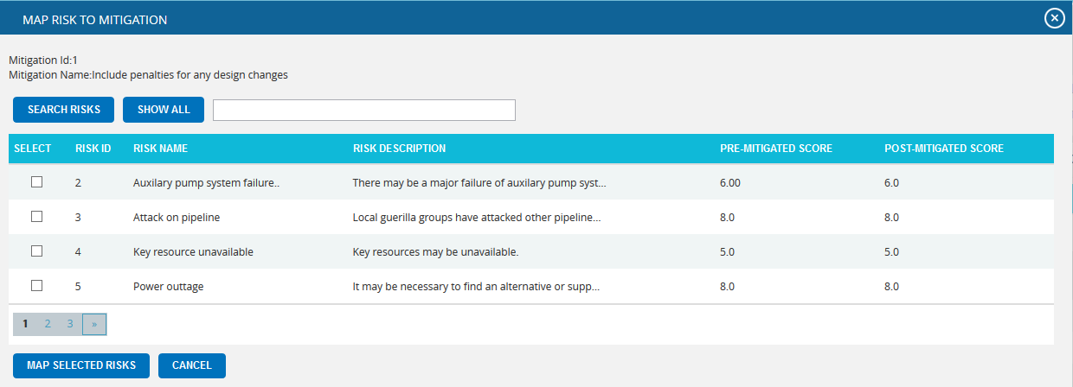

Figure 3

Add New Mitigation:

This functionality is to add a new mitigation which has to be associated with at least one risk.

Steps:
- Risk Register ---> Risk Details
- Click the Mitigations Radio button to navigate to Risk Details (Mitigations) page. (Figure 1)
- Click the ADD NEW MITIGATION button to add a new mitigation. (Figure 1) A pop up appears.

Select Type:
This functionality is used to select the risk type to which the mitigation details correspond, which is Threat by default.
Steps:
- Risk Register ---> Risk Details
- Click the Mitigations Radio button to navigate to Risk Details (Mitigations) page. (Figure 1)
- Select the type from the Select Type dropdown. (Figure 1)

Edit Risk Score Section:

The Risk Score Section for Risk shows the post-mitigated scoring information relative to each individual risk mapped to the selected mitigation.

Steps:
- Risk Register ---> Risk Details
- Click the Mitigations Radio button to navigate to Risk Details (Mitigations) page. (Figure 1)
- Select the required mitigation step name.
- Click the corresponding mapped risk’s id link from the Mapped Risks Information.
- Click the EDIT MITIGATION button. (Figure 4)
- After the data is modified, click the SAVE button. (Figure 5)
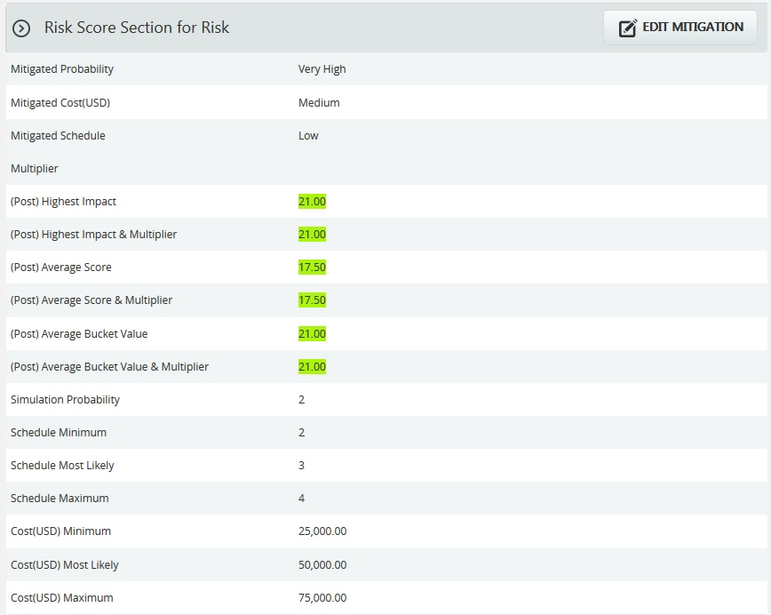

Figure 4
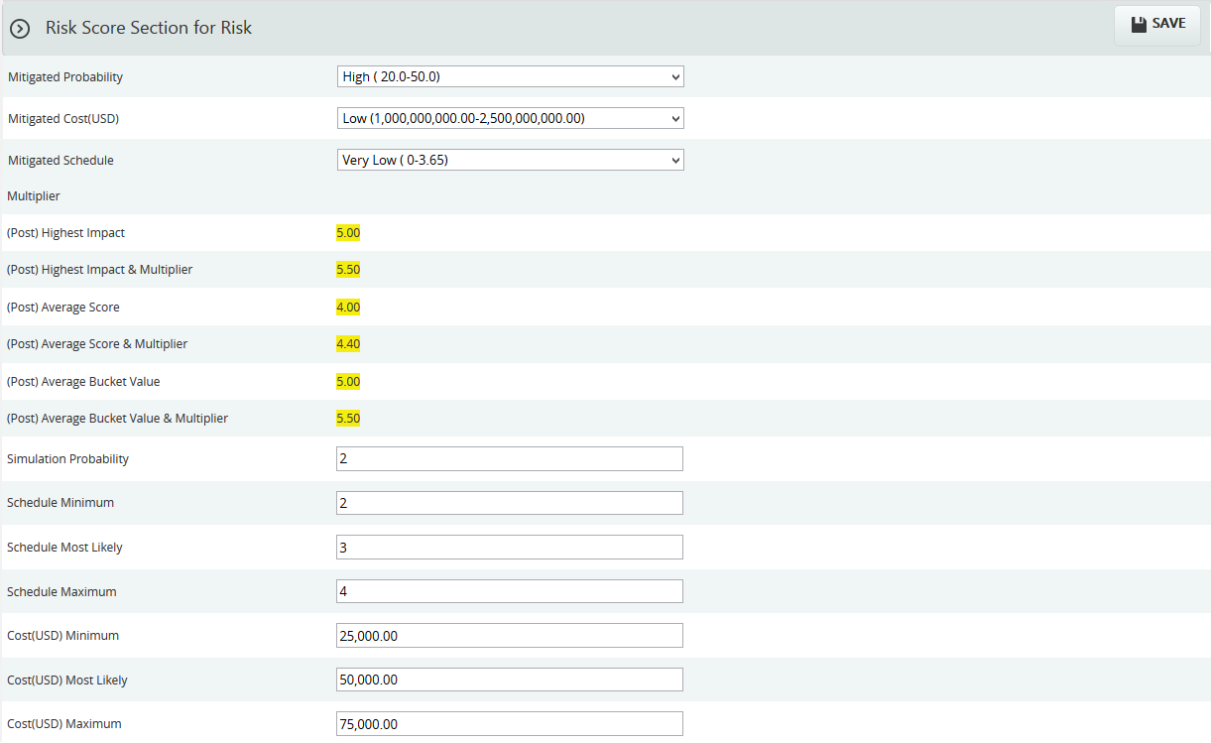

Figure 5

Edit Mitigation Step Information:
Steps:
- Risk Register ---> Risk Details
- Click the Mitigations Radio button to navigate to Risk Details (Mitigations) page. (Figure 1)
- Select the mitigation step that is to be edited.
- Click the Edit Mitigation Step button. (Figure 1)
- After entering the mitigation step details, click the Save Step button. This button is visible only after the Add New Mitigation button or the Edit Mitigation Step button is clicked. (Figure 1)

Delete Mitigation Step:

This functionality is used to delete the selected mitigation step information.

Steps:
- Risk Register ---> Risk Details
- Click the Mitigations Radio button to navigate to Risk Details (Mitigations) page. (Figure 1)
- Click the Delete Step button. (Figure 1)
- A pop up appears. (Figure 6) Click OK button to delete the selected mitigation or else click Cancel.
- A pop up appears which shows the mitigation step is successfully deleted. (Figure 7)

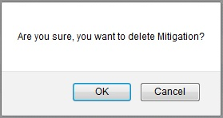
Figure 6

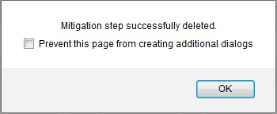
Figure 7

Spreadsheet View (Threats)
The Spreadsheet View (Threats) page allows the user to add, edit, delete and export threats in a selected project. This page is visible only to those users who have Read/Write access or View access for the page Spreadsheet View (Threat). Users with Read/Write access can create new threats, edit threats, delete threats and export to Excel. Users designated with View access can view the threat details and export to Excel. The Spreadsheet view does not contain mitigation data. Mitigation information can be viewed using the Advanced View (Threats), Advanced View (Mitigation), Spreadsheet View (Mitigation). Spreadsheet initially loads with the risks which are in open status.
This is a special component that has an Auto Save feature. When editing or adding new values to a cell the value is automatically saved by clicking in another cell. It is important to always click in another cell to trigger this auto save feature. The values in the spreadsheet can be sorted by clicking on the column header. Click again on the column header to reverse the order of sorting. The columns can be resized by clicking and dragging between the column headers. Each column has its own minimum width set. A column cannot be dragged narrower than its minimum width.
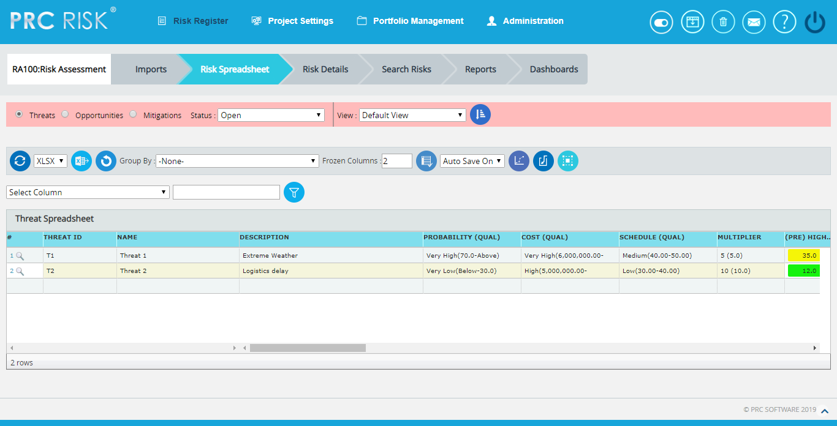
Figure 1

Drill Down:
The drill down option is available to the user at the first column of threat spreadsheet page. (Figure 1) The user can drill to the risk details page when the Drill Icon corresponding to each threat is clicked there the detailed information of the corresponding threat can be viewed.
Save All:
The Save All button is to save all the changes done in the Threat Spreadsheet page when the Auto Save is OFF. (Figure 2)
Steps:
- Risk Register ---> Risk Spreadsheet ---> Threats
- Select the Auto Save Off option from the dropdown. (Figure 2)
- Give the necessary changes in the Threat Spreadsheet page and click Save All button to save all the changes done. (Figure 2)
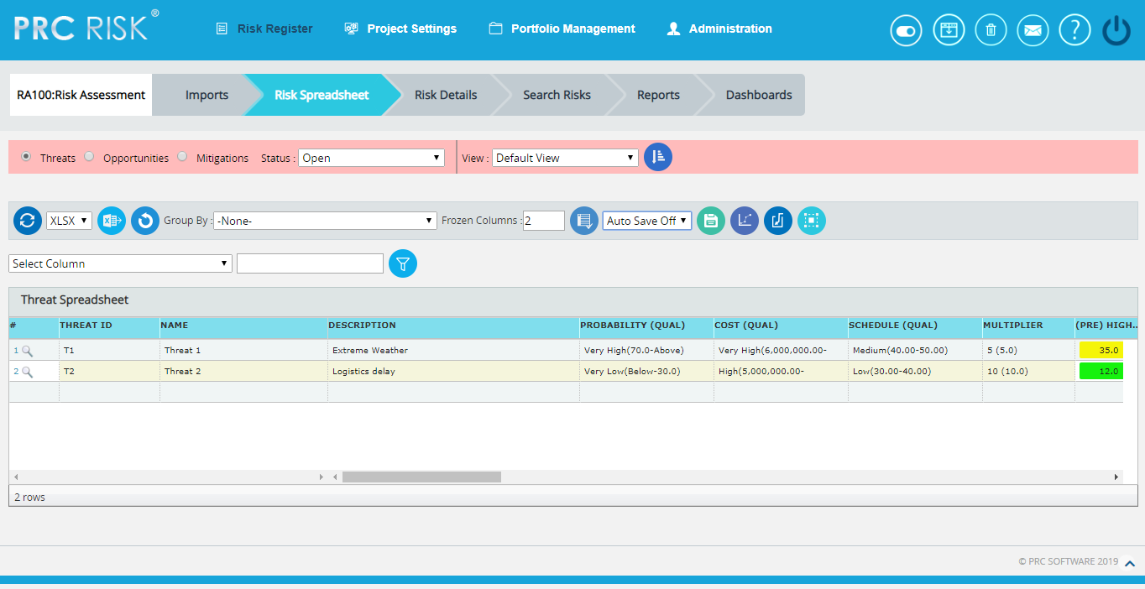
Figure 2

Navigate Page:
To go to the Spreadsheet View (Opportunity) page or Spreadsheet View (Mitigations), we have to navigate from the Spreadsheet View (Threats) page.
The option for navigation from one page to another is placed on top of the page and is shown in Figure 1.
Steps:
- Risk Register ---> Risk Spreadsheet
- Click the Opportunities radio button to navigate to the Spreadsheet View (Opportunity) page. (Figure 1)
Or
Click the Mitigations radio button to navigate to the Spreadsheet View (Mitigations) page. (Figure 1)

Export to Excel:
This functionality is used to export the entire page to Excel as .xlsx or .xls file type.
Steps:
- Risk Register ---> Risk Spreadsheet ---> Threats
- Click the Export button to export the entire page to Excel. (Figure 1)

Group by:

This functionality is to view the scoring in different ways based on each fields in the Threats Spreadsheet, i.e. ID, Name, Status etc. The default view will be No grouping.

Steps:
- Risk Register ---> Risk Spreadsheet---> Threats
- Click the Group By dropdown and select the required one from the list. (Figure 3)

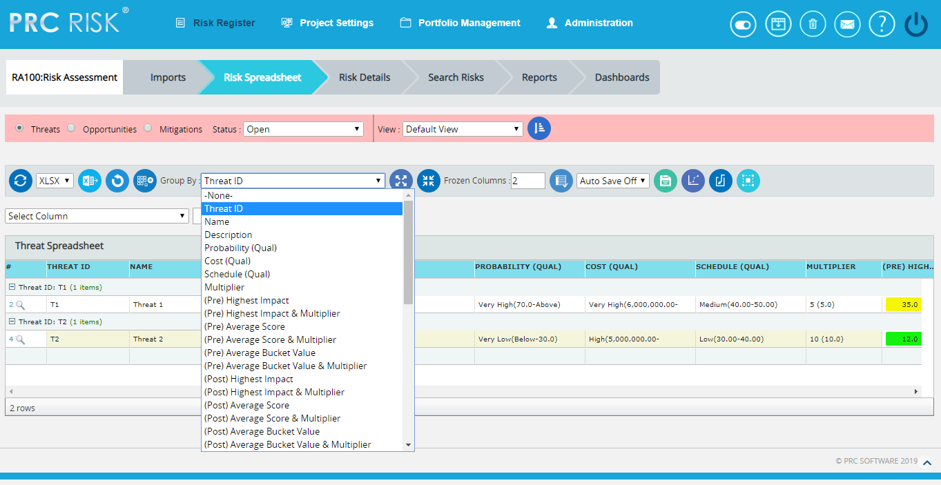

Figure 3

Ungroup to add new:

This functionality is to ungroup the grouped list and allows adding new threats.

Steps:
- Risk Register ---> Risk Spreadsheet---> Threats
- Click the Group By dropdown and select the required one from the list. (Figure 3)
- Click the Ungroup To Add New button to ungroup the list and add the new threat. (Figure 3)

Collapse All:

This functionality is to collapse the threat risk score information based on the group selected from the Group By dropdown.

Steps:
- Risk Register ---> Risk Spreadsheet---> Threats
- Click the Group By dropdown and select the required one from the list. (Figure 3)
- Click the Collapse All button to collapse the threat information. (Figure 4)

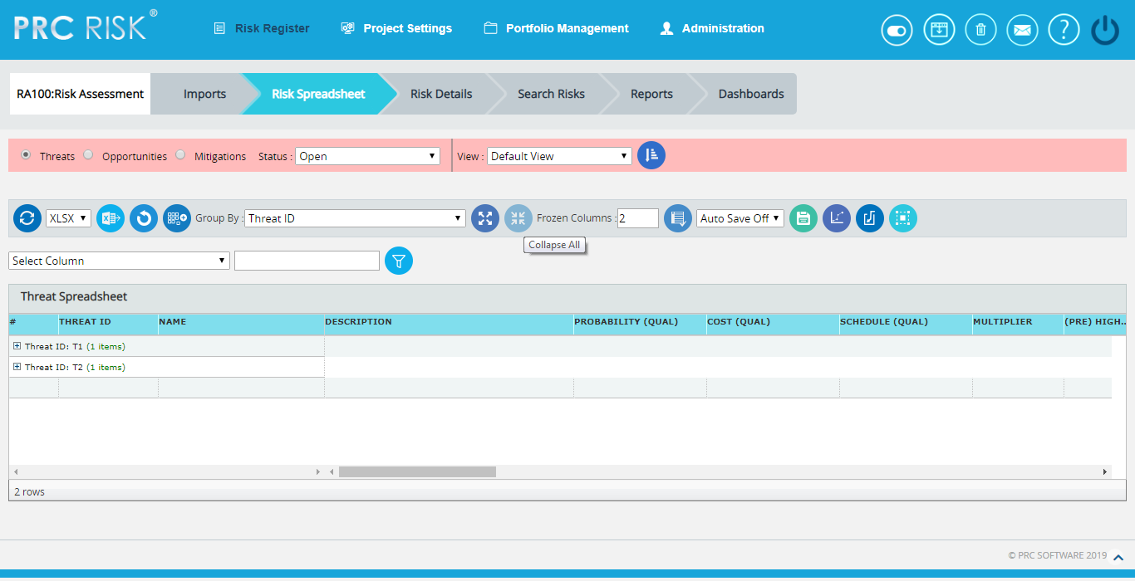

Figure 4
Expand All:
This functionality is to show the collapsed threat risk score information.
Steps:
- Risk Register ---> Risk Spreadsheet---> Threats
- Click the Group By dropdown and select the required one from the list. (Figure 3)
- Click the Expand All button to show the collapsed threat score information. (Figure 4)

Undo:
This functionality is used to reset the last saved value.
Steps:
- Risk Register ---> Risk Spreadsheet---> Threats
- Click the Undo button to return to the last saved value. (Figure 1)

Status:
This functionality is used to display the project details whose status is open, closed or both.
- Risk Register ---> Risk Spreadsheet ---> Threats
- Click the Status dropdown button and select open, close or both to display the project details with particular status. (Figure 1)

Delete Threats:
Threats can be deleted by clicking the Delete button corresponding to each row or multiple threats can be deleted simultaneously.
Delete Multiple Threats:
This functionality helps to delete multiple threats simultaneously. To delete multiple threats we must first select them. Deleted threats will be moved to the Recycle Bin from where they can be deleted permanently.
Steps:
- Risk Register ---> Risk Spreadsheet ---> Threats
- Click the Select Threats button to select the threats to delete. (Figure 1)
- Select the threats by checking the checkboxes. (Figure 5)
- Click the Delete Multiple button to delete the selected threats. (Figure 5)
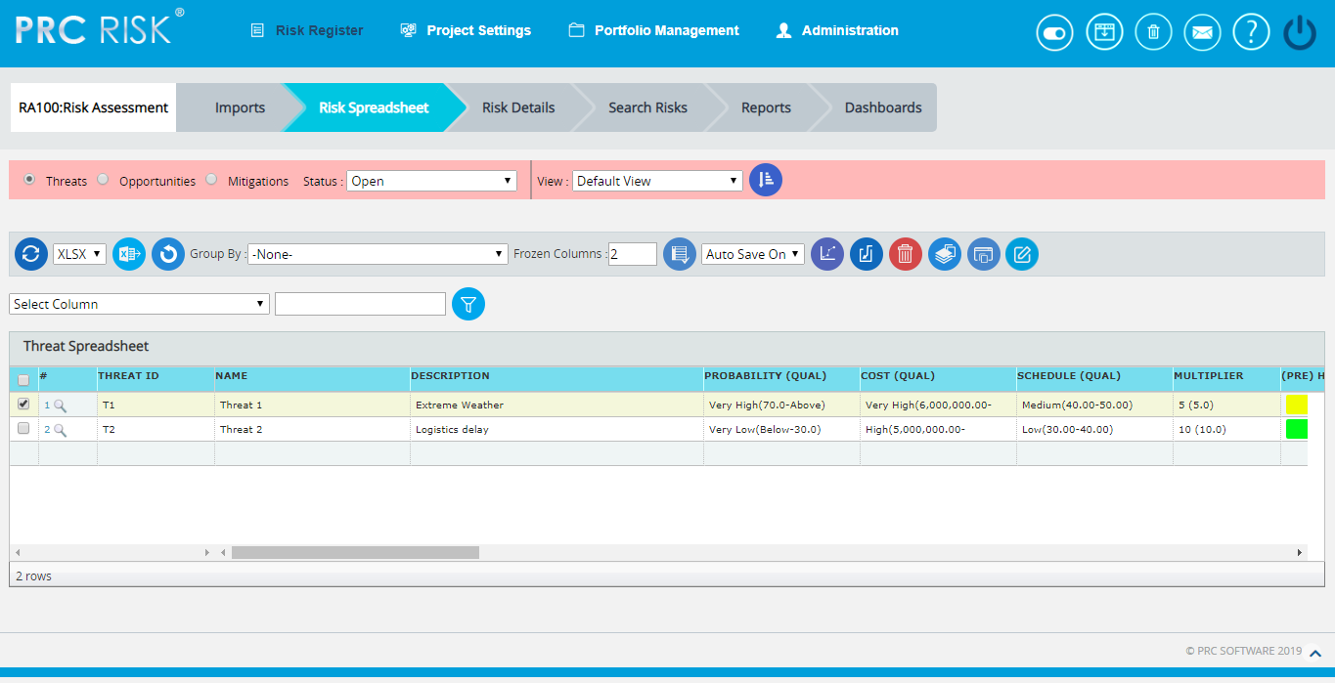
Figure 5
Delete Threats Individually:
The deleted threats will be moved to the Recycle Bin.
Steps:
- Risk Register ---> Risk Spreadsheet ---> Threats
- Click the Delete icon corresponding to each threat. (Figure 5)
Copy to Monte Carlo:
This functionality helps to copy the Qualitative details of selected threats to their corresponding Monte Carlo Inputs.
Steps:
- Risk Register ---> Risk Spreadsheet ---> Threats
- Click the Select Threats button to select the threats. (Figure 1)
- Select the threats by checking the checkboxes. (Figure 3)
- Click the Copy to Monte Carlo button to copy the selected threats' Qualitative details to their Monte Carlo Inputs. (Figure 3)
Copy to Qualitative:
This functionality helps to copy the Monte Carlo details of selected threats to their corresponding Qualitative Score.
Steps:
- Risk Register ---> Risk Spreadsheet ---> Threats
- Click the Select Threats button to select the threats. (Figure 1)
- Select the threats by checking the checkboxes. (Figure 3)
- Click the Copy to Qualitative button to copy the selected threats' Monte Carlo details to their Qualitative Score. (Figure 3)

Reorder Columns:
This functionality is used to arrange the required fields in particular order in which the risks are viewed in spreadsheet. The user can create, save & apply, delete and reset the column orders in threat spreadsheet. To set a selected order as default, check the Set as Default checkbox. The column order selected by default when no user defined column order exists is the Default Column Order which cannot be deleted. It can be edited by the user when necessary.
Steps:
- Risk Register ---> Risk Spreadsheet ---> Threats
- Click the Edit View icon to reorder the spreadsheet columns. (Figure 6)
- Select the required fields to be reordered from the Available Fields using Add & Remove buttons. (Figure 7)
- Click First, Up, Down or Last button to move the selected fields to the required position.
- Click Save and Apply icon to save and apply the changes made. (Figure 7)
- Click Reset icon to reset the fields to the previous order. (Figure 7)
- Click Delete icon to delete the selected column order from the list. (Figure 7)
- The view selection can be shuffled using the dropdown to the left of Edit View icon. (Figure 6)
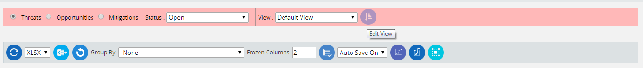
Figure 6
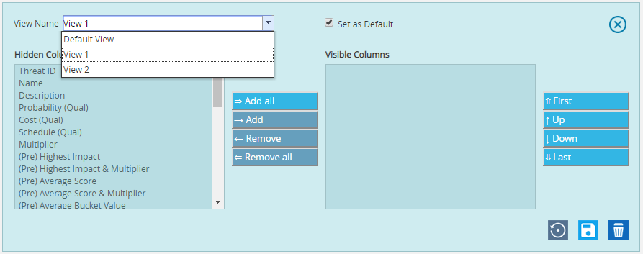
Figure 7
Quick Monte Carlo:
Cost Exposure
This functionality generates a Quick Monte Carlo Analysis that shows the Cumulative S Curve report and Top Risk reports for Threats/Opportunities or Threat and Opportunities. Top Risk reports are the following Tornado charts: Cost Values Isolated to P, Cost Percentages Isolated to P, Correlation Isolated to P & Contingency Requirement Isolated to P. The Cumulative Frequency Iterations and the Cumulative Percentage Values are highlighted based on the Iteration number and the Highlight, as shown in the chart and the table. The Top Risk reports consider simulated cost exposure values of each risk up to the Pn iteration value, where 'n' is the Percentile Value of total number of iterations given.

Steps:
- Risk Register ---> Risk Spreadsheet ---> Threats
- Click the Quick Monte Carlo button (Figure 1).
- A pop up appears (Figure 8) where the Cumulative S Curve report and Top Risk reports are shown.
- Select the Threats/Opportunities or Threats and Opportunities from Options dropdown and give the Iteration number and also the Mitigated Options. (Figure 8)
- Click Apply button to apply the given highlights based on which the Pn Percentile Value for the Top Risk reports can be taken.
- Click Run Analysis button to generate the charts. (Figure 8)
- Click Export to Word button to open the charts in Microsoft Word. (Figure 8)
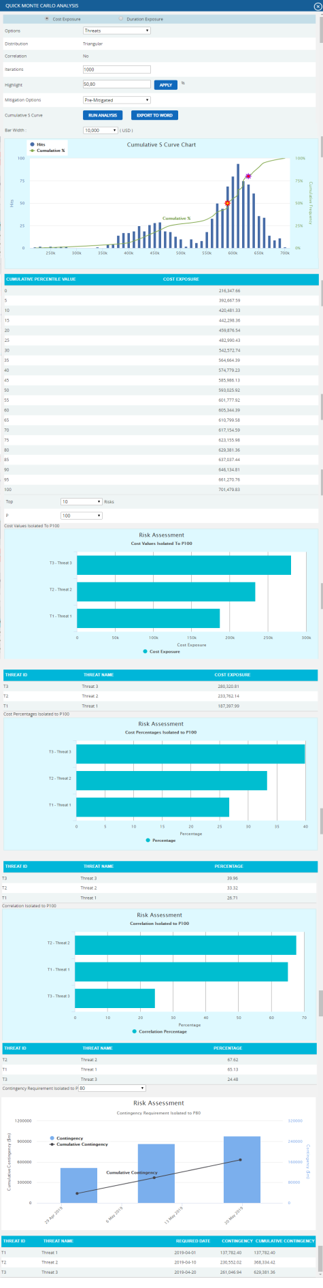
Figure 8
Duration Exposure
This functionality generates a Quick Monte Carlo Analysis that shows the Cumulative S Curve report and Top Risk reports for Threats/Opportunities or Threat and Opportunities. Top Risk reports are the following Tornado charts: Duration Values Isolated to P, Duration Percentages Isolated to P & Correlation Isolated to P. The Cumulative Frequency Iterations and the Cumulative Percentage Values are highlighted based on the Iteration number and the Highlight, as shown in the chart and the table. The Top Risk reports consider simulated duration exposure values of each risk up to the Pn iteration value, where 'n' is the Percentile Value of total number of iterations given.
Steps:
- Risk Register ---> Risk Spreadsheet ---> Threats
- Click the Quick Monte Carlo button (Figure 1).
- A pop up appears (Figure 9) where the Cumulative S Curve report and Top Risk reports are shown.
- Select the Threats/Opportunities or Threats and Opportunities from Options dropdown and give the Iteration number and also the Mitigated Options. (Figure 9)
- Click Apply button to apply the given highlights based on which the Pn Percentile Value for the Top Risk reports can be taken.
- Click Run Analysis button to generate the charts. (Figure 9)
- Click Export to Word button to open the charts in Microsoft Word. (Figure 9)
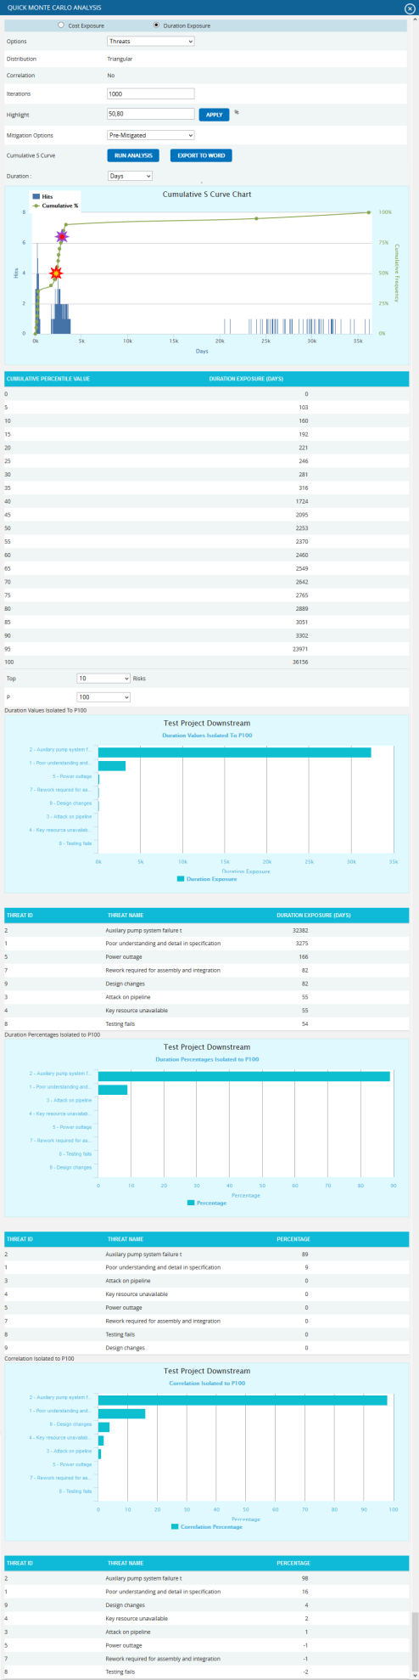
Figure 9
Recycle Bin:
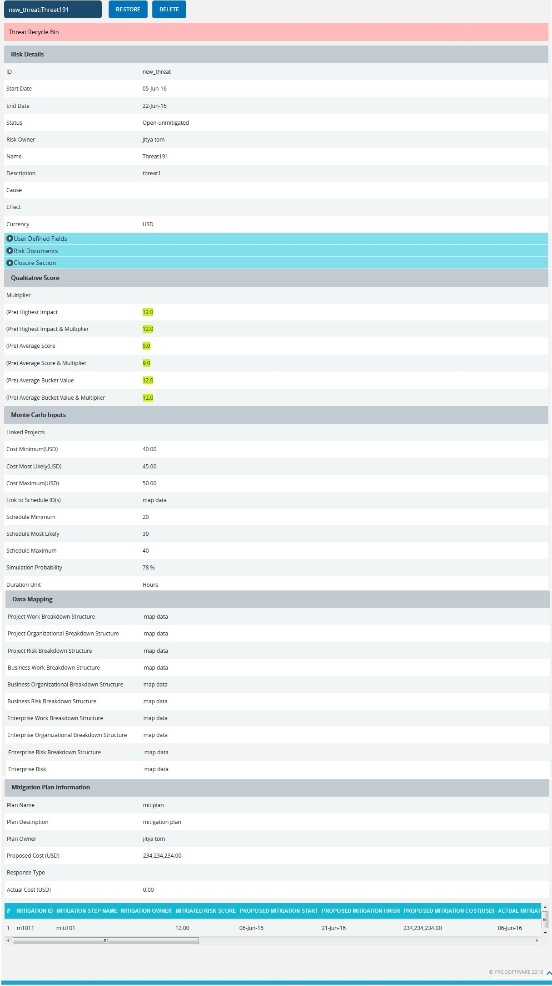
To go to the Recycle Bin from Spreadsheet view (Threats), click the Recycle Bin icon shown on top of the page in Figure 1.
Figure 10

Restore Threats:
The restored threat is removed from the Recycle Bin and is moved back to the pages where the threat details are shown (for example Spreadsheet View (threats)).
Steps:
- Risk Register ---> Risk Spreadsheet ---> Threats
- Click the Recycle Bin icon to go to Recycle Bin page.
- Select the threat to restore.
- Click the RESTORE button to restore the selected threat. (Figure 10)

Delete Threat From Recycle Bin:
A threat deleted from the Recycle Bin will be removed completely from the system.
Steps:
- Risk Register ---> Risk Spreadsheet ---> Threats
- Click the Recycle Bin icon to go to Recycle Bin page.
- Select the threat to delete.
- Click the DELETE button. (Figure 10)
After you receive the confirmation message (Figure 11), click the OK button. The threat will be deleted permanently. To cancel, click the Cancel button. (Figure 11)
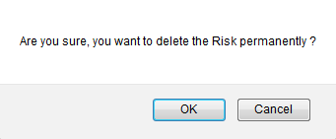
Figure 11

Frozen Column:
This functionality is used to set the number of columns as fixed when the scroll is enabled. For example, in Figure 5 Frozen Columns is set to 2 (default value) which implies that the column ID and Name will be fixed and scrolling will be applicable from the third column onwards.

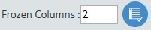
Figure 12
Steps:
- Risk Register ---> Risk Spreadsheet ---> Threats
- Enter the number of columns that must be frozen.
- Click the Set icon shown in Figure 12.

Filter Data:
To Filter the data according to a particular value
Steps:
- Risk Register ---> Risk Spreadsheet ---> Threats
- Select the required column from the Select Column dropdown. (Figure 1 )
- Enter the value in the textbox provided based on which filtering is to be done. (Figure 1)
- Click the Filter button (Figure 1). The filtered data will be displayed.

Reset Data:
This functionality is used to set the filtered values to its previous values.
Steps:
- Risk Register ---> Risk Spreadsheet ---> Threats
- Click the Reset button to reset the values. (Figure 1)

Pre-Mitigated Score:
The Pre-Mitigated Score is the risk score. The fields (Probability, Cost and Schedule and Additional Impacts) are used to set the pre-mitigated score. (Figure 1) If Probability and Impacts have a value of either Undefined or No Risk, the Pre-Mitigated Score will be zero.
Post-Mitigated Score:
The Post-Mitigated Score is the mitigation score. The fields (Probability, Cost and Schedule and Additional Impacts) are used to set the post-mitigated score. (Figure 1) If probability and Impacts have value either Undefined or No Risk the Post-Mitigated Score will be zero.

Creating a new threat:
Creating a new threat in Spreadsheet View is quick and easy. The ID field is required to save a threat.
Steps:
  - Risk Register ---> Risk Spreadsheet ---> Threats
  - Enter the details on a new line. For fields such as Name, Description, etc., a textbox pops up upon clicking the cell. (Figure 13) After entering the details click the Save button for the text fields.(Figure 13). To cancel, click the Cancel button. (Figure 13)
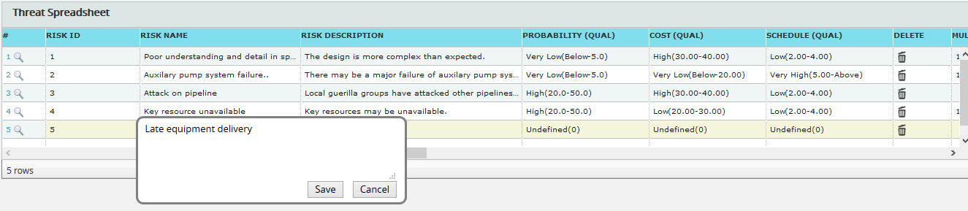
Figure 13

A calendar component pops up for the date fields upon clicking the calendar control. (Figure 14)

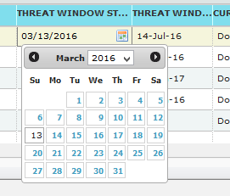
Figure 14

If the data is to be selected from a list, a dropdown appears. (Figure 15)
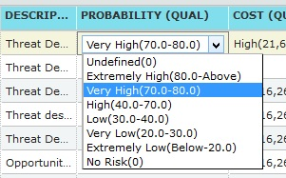
Figure 15
The other columns may be edited within the cell.
3. Click any other cell to trigger the Auto Save.

Edit Threats:
Threats can be edited individually by clicking the cells which need to be edited corresponding to each row or multiple threats can be edited simultaneously with repeating cell values.
Edit Multiple Threats:
This functionality helps to edit multiple threats simultaneously with cells of same entries. To edit multiple threats we must first select them.
Steps:
- Risk Register ---> Risk Spreadsheet ---> Threats
- Click the Select Threats button to select the threats to edit. (Figure 1)
- Select the threats by checking the checkboxes. (Figure 16)
- Click the Edit Multiple Threats button to edit the selected threats. (Figure 16)
- Select the column, enter the values to be edited and click the SAVE button in the EDIT RISK VALUE pop up that appears. (Figure 17)
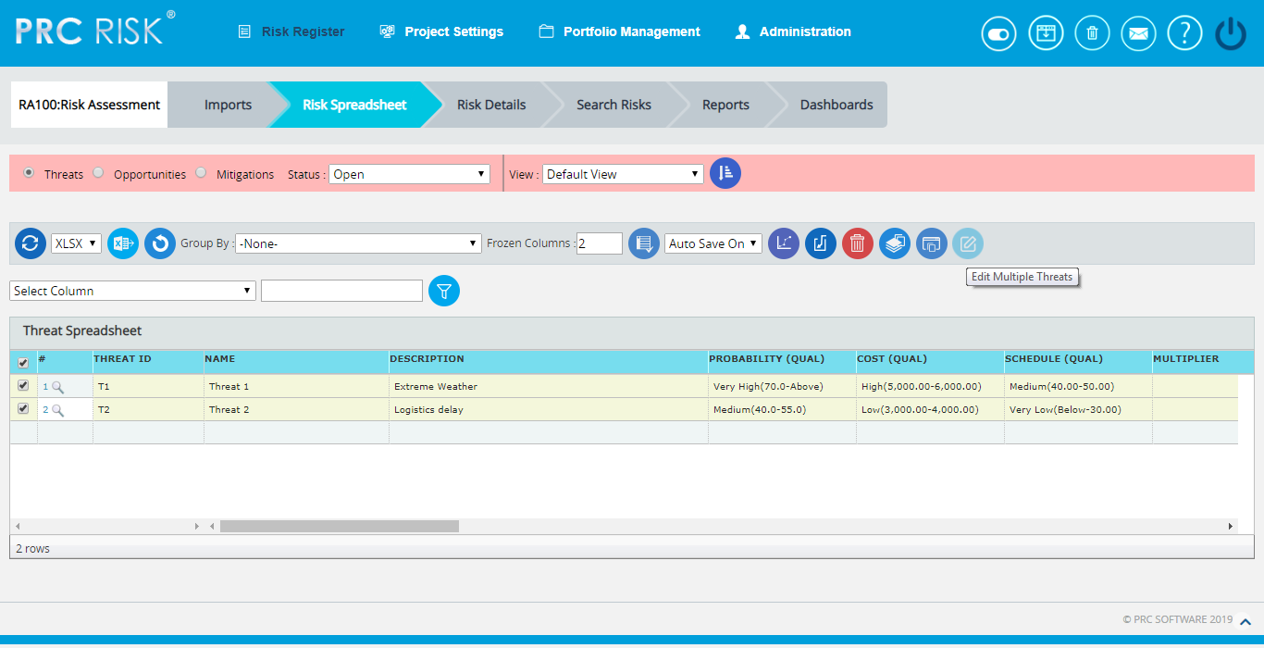

Figure 16

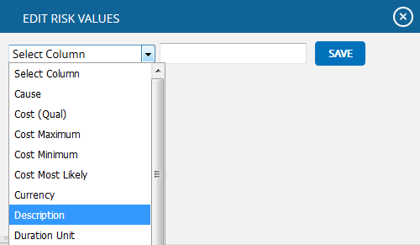

Figure 17
Edit Threats Individually:
This functionality is to edit the cells of an individual threat.
Steps:
- Risk Register ---> Risk Spreadsheet ---> Threats
- Refer to the procedures in the previous section (Creating a new threat).
- Edit the cell as required and click in any other cell to trigger the Auto Save.

User Defined Fields:
The User Defined Field or Custom Field is shown along with the threat details as the last column if Formula Field is not added. There is no limit to the number of User Defined Fields.
User Defined Fields can be added in two ways.
- The User Defined Fields can be added using the template imported from the Portfolio Management page for the project:
Project Settings ---> Import from Templates
Or
2. It can also be added from the page:
Project Settings ---> Custom Fields

Formula Fields:
The Formula Field is shown along with the threat details as the last column.(Figure 18)
There is no limit to the number of Formula Fields.

Formula Fields can be added in two ways.
- The Formula Fields can be added using the template imported from the Portfolio Management page for the project:
Project Settings ---> Import from Templates
Or
2. It can also be added from the page:
Project Settings ---> Custom Fields

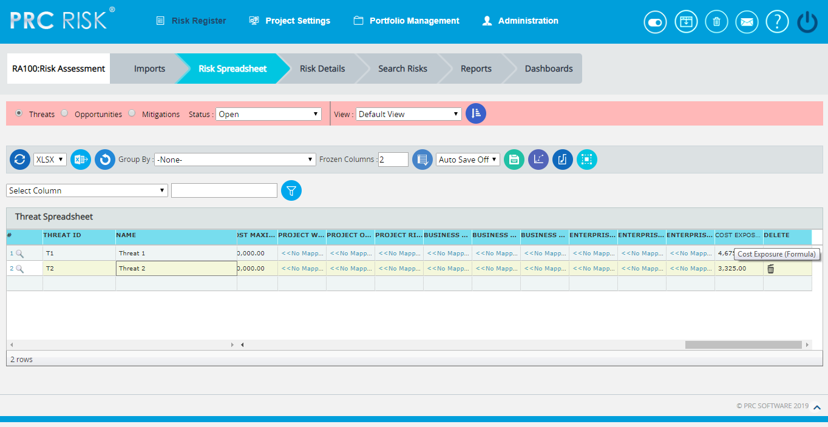
Figure 18

Data Mapping:
The Data Mapping columns shows to which Breakdown Structure the selected threat is mapped and at what level (Project, Business Unit, or Enterprise) it is mapped. It is not required to map data, but it will be useful when the time comes to report at the portfolio level.
Project Organizational Breakdown Structure, Project Work Breakdown Structure and Project Risk Breakdown structure details are added from the page:
Project Settings —> Project Breakdown Structure
Business Organizational Breakdown Structure, Business Work Breakdown Structure, Business Risk Breakdown Structure, Enterprise Organizational Breakdown Structure, Enterprise Risk Breakdown Structure, Enterprise Work Breakdown Structure are added from the page:
Portfolio Management —> Project Breakdown Structure
Enterprise Risk details are added from the page:
Portfolio Management —> Reports —> Enterprise Risk List
To Map data:
Steps:
- Click the <<No Mapping>> link to map data for the corresponding field. (Figure 19)
- Select the checkbox corresponding to the data to be mapped. (Figure 20)
- Click the SELECT BREAKDOWN button to finish. (Figure 20)
The steps described above apply to all (Business/Enterprise/Project) Organizational Breakdown Structure, Work Breakdown Structure and Risk Breakdown Structure fields.
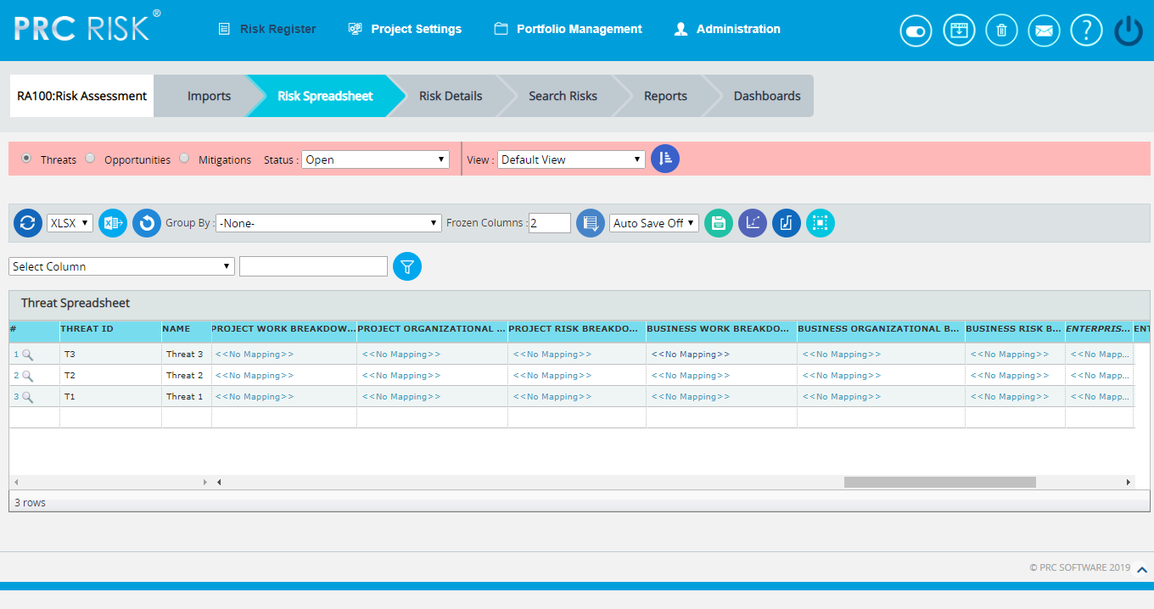
Figure 19
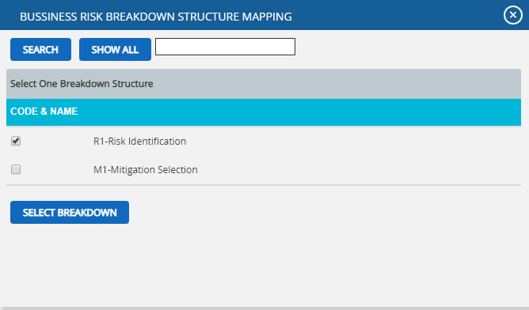
Figure 20

Bulk Email:
This functionality is to send multiple Risks and Mitigations data by email to the selected users. This functionality is applicable only to those users with the User Type: Application and Email and Email Only in the Manage Users page.
Two lists can be utilized: Available Users and Selected Users. Available Users (Figure 21) contains all the users who have access to the selected project and portfolio level users. Selected Users (Figure 21) displays the users who have been selected. A user can be added to the Selected User list using the Add button. All nodes under the Available Users list can be moved to Selected Users list using the Add All button. (Figure 21) A single node from the Selected Users list can be moved back to the Available Users list using the Remove button. The Remove All button moves all nodes from the Selected Users list to the Available Users list. The Subject by default has the value Project Name: ID/Name of the risk selected, which can be changed if needed.
Steps:
- Risk Register ---> Risk Spreadsheet ---> Threats
- Click the Threats radio button to navigate to the Risk Spreadsheet (Threats) page. (Figure 1)
- Click the Select Threats button to select the required threats to be sent. (Figure 1)
- Select the threats by checking the checkboxes. (Figure 16)
- Click the Bulk Email icon to send the email. (Figure 1) It navigates to another page. (Figure 21)
- Select at least one user to whom the mail should be sent.
- Enter the message in the Message text area.
- Select the required fields for the email edit that can be edited and saved by the recipient (refer Figure 21).
- Click the Send Mail button. (Figure 21)
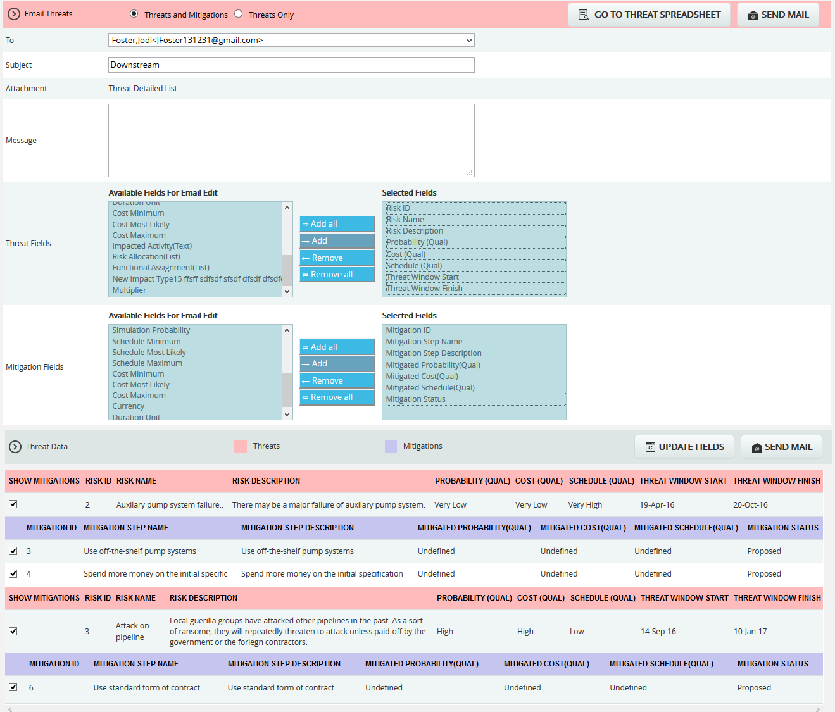
Figure 21

Update fields:
This functionality allows the recipient users to view the threats and its mitigations field values that are selected, where the email edit can be done.
Go to Threat Spreadsheet:
This functionality helps the user to navigate to the Threat Spreadsheet page.
Send Mail:
This functionality is to send the mail to the selected users after selecting the threat and its mitigation details for email edit.
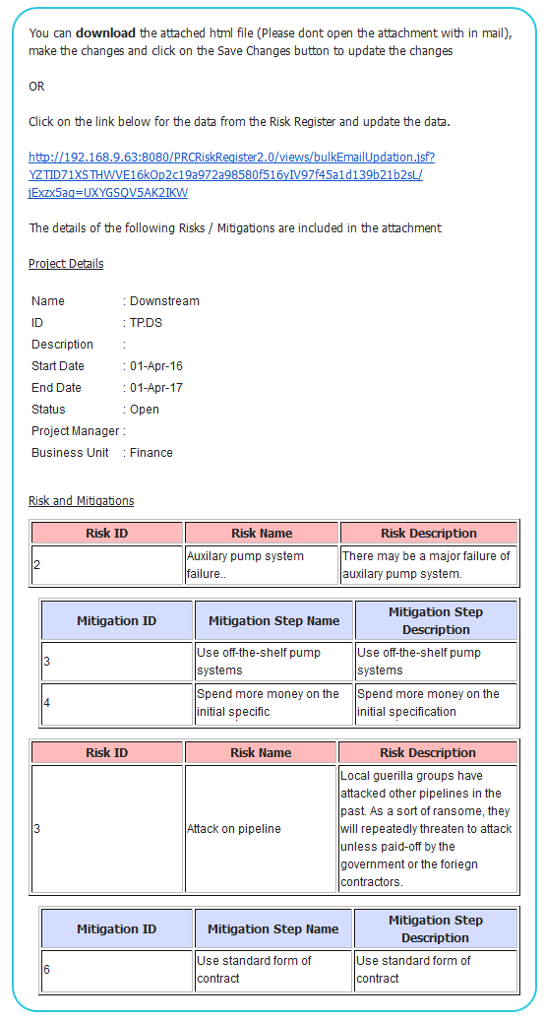
Figure 22
The recipients will receive a mail that contains the project details, the threat and mitigation data and also a link in which the user can do the email edit for the Risk Data. (Figure 22) By clicking the link it navigates to another page where the changes are made. (Figure 23) Submit the changes by clicking the Save Changes button that will update the changes made to the database, and a mail is sent to the user showing the updated fields. (Figure 24) The changes can be saved only once for an email sent.
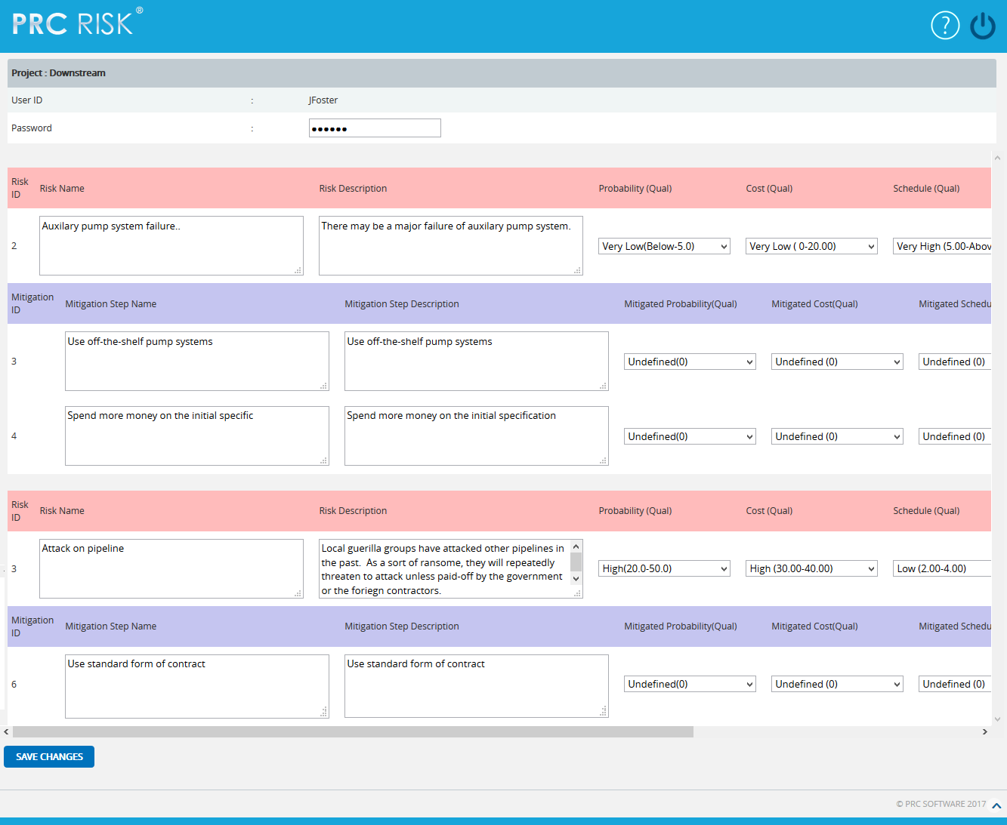
Figure 23
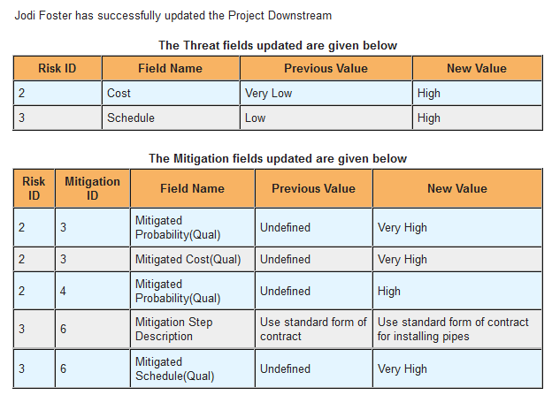
Figure 24

Spreadsheet View (Opportunities)
The Spreadsheet View (Opportunities) page allows the user to add, edit, delete, and export opportunities in a selected project. This page is visible only to those users who have Read/Write access or View access for the page Spreadsheet View (Opportunities). Users with Read/Write access can create new opportunities, edit opportunities, delete opportunities and export to Excel. Users designated with View access may view the opportunity details and export to Excel. The Spreadsheet View (Opportunity) does not contain mitigation data. Mitigation information can be viewed using the Risk Details (Opportunities), Risk Details (Mitigation), Spreadsheet View (Mitigation). Spreadsheet initially loads with the risk which are in open status.
This is a special component that has an Auto Save feature. When editing or adding new values to a cell the value is automatically saved by clicking in another cell. It is important to always click in another cell to trigger this auto save feature. The values in the spreadsheet can be sorted by clicking on the column header. Click again on the column header to reverse the order of sorting. The columns can be resized by clicking and dragging between the column headers. Each column has its own minimum width set. A column cannot be dragged narrower than its minimum width.
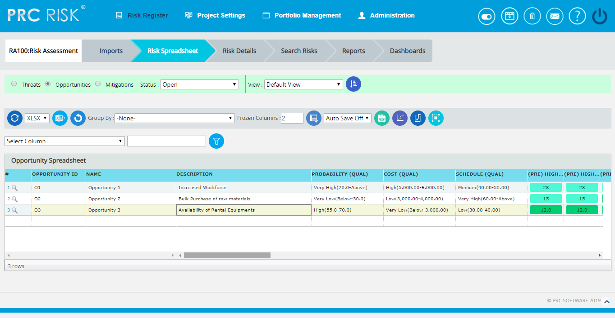
Figure 1

Drill Down:
The drill down option is available to the user at the first column of opportunity spreadsheet. (Figure 1) The user can drill to the risk details opportunity page when the Drill Icon corresponding to each opportunity is clicked there the detailed information of the corresponding opportunity can be viewed.
Save All:
The Save All button is to save all the changes done in the Opportunity Spreadsheet page when the Auto Save is OFF. (Figure 2)
Steps:
- Risk Register ---> Risk Spreadsheet ---> Opportunities
- Select the Auto Update Off option from the dropdown. (Figure 2)
- Give the necessary changes in the Threat Spreadsheet page and click Save All button to save all the changes made. (Figure 2)
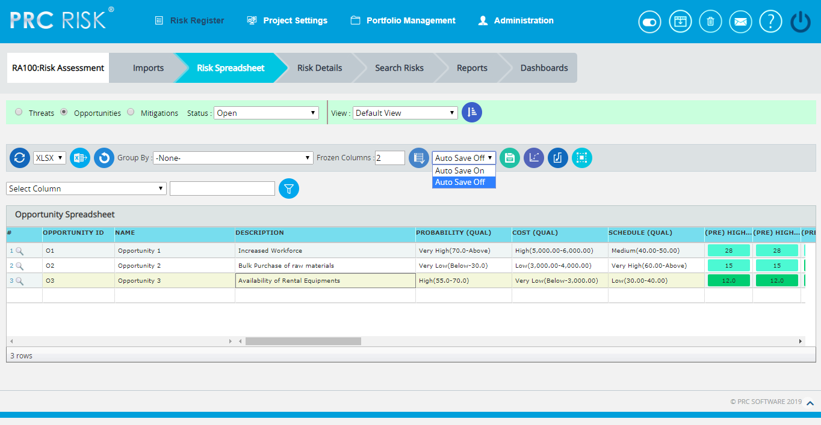
Figure 2

Navigate Page:
To go to the Spreadsheet View (Opportunity) page, click the Opportunities radio button shown on top of the page. (Figure 1) The option for navigation from one page to another is placed on top of the page and is shown in Figure 1.

Steps:
- Risk Register ---> Spreadsheet
- Click the Threats radio button (Figure 1) to navigate to the Spreadsheet view (Threats) page.
Or
Click the Mitigations radio button (Figure 1) to navigate to the Spreadsheet view (Mitigations) page.

Export to Excel:
This functionality is used to export the entire page to Excel as .xlsx or .xls file type.
Steps:
- Risk Register --->Risk Spreadsheet ---> Opportunities
- Click the Export button to export the entire page to Excel. (Figure 1)

Undo:
This functionality is used to reset the last saved value.
Steps:
- Risk Register --->Risk Spreadsheet ---> Opportunities
- Click the Undo button to return to the last saved value. (Figure 1)
Status:
This functionality is used to display the project details whose status is open, closed or both.
- Risk Register ---> Risk Spreadsheet ---> Opportunities
- Click the Status dropdown button and select open, close or both to display the project details with particular status. (Figure 1)

Delete Opportunities:
Opportunities can be deleted by clicking the Delete button corresponding to each row or multiple opportunities can be deleted simultaneously.
Delete multiple opportunities:
This functionality helps to delete multiple opportunities simultaneously. To delete multiple opportunities we must first select them. Deleted opportunities will be moved to the Recycle Bin from where they can be deleted permanently.
Steps:
- Risk Register --->Risk Spreadsheet ---> Opportunities
- Click the Select Opportunities button to select the opportunities to delete. (Figure 1)
- Select the opportunities by checking the checkboxes. (Figure 3)
- Click the Delete Multiple button to delete the selected opportunities. (Figure 3)
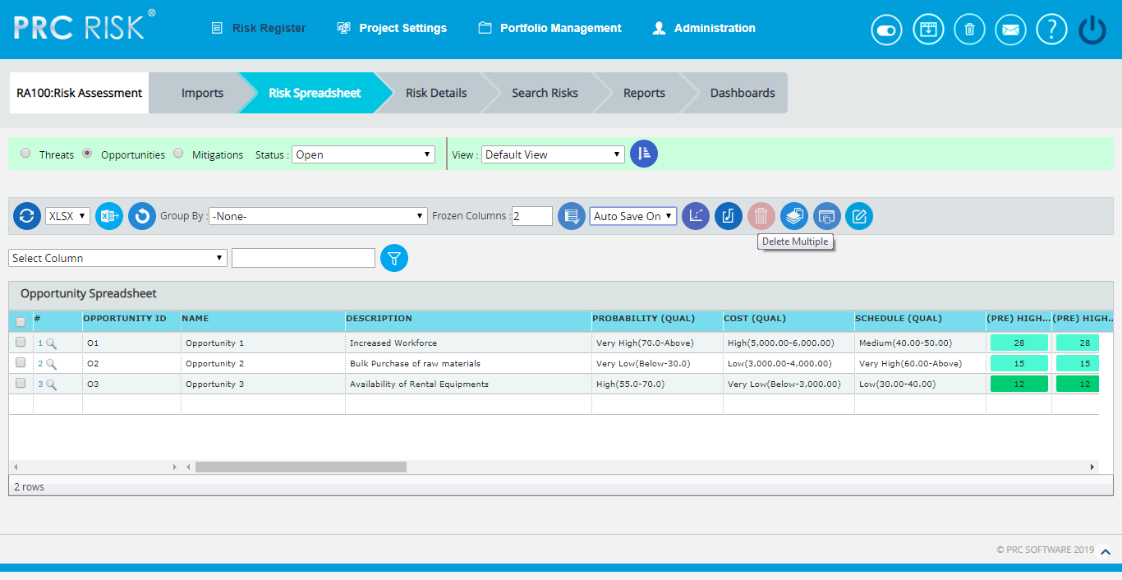
Figure 3

Delete Opportunities Individually:
The deleted opportunities will be moved to the Recycle Bin.
Steps:
- Risk Register --->Risk Spreadsheet ---> Opportunities
- Click the Delete icon corresponding to each opportunity. (Figure 3)
Group by:
This functionality is to view the scoring in different ways based on each fields in the Opportunities Spreadsheet, i.e. ID, Name, Status etc. The default view will be No grouping.
Steps:
- Risk Register ---> Risk Spreadsheet---> Opportunities
- Click the Group By dropdown and Select the required one from the list. (Figure 4)
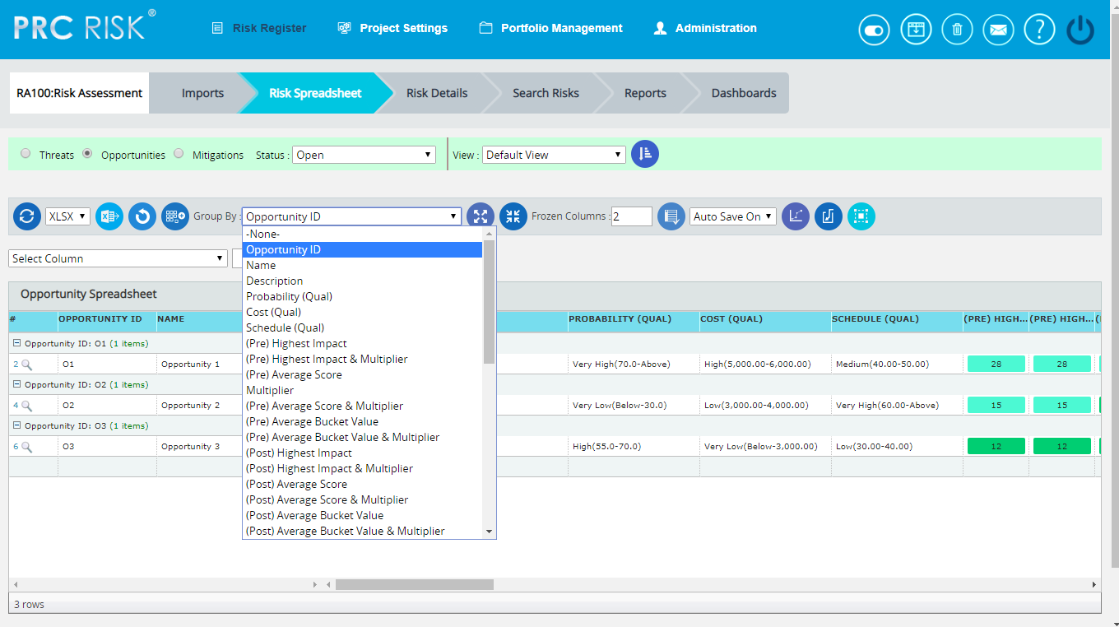
Figure 4

Ungroup to add new:
This functionality is to ungroup the grouped list and allows adding new opportunities.
Steps:
- Risk Register ---> Risk Spreadsheet---> Opportunities
- Click the Group By dropdown and select the required one from the list. (Figure 3)
- Click the Ungroup To Add New button to ungroup the list and add the new opportunity. (Figure 4)
Collapse All:
This functionality is to collapse the opportunity risk score information based on the group selected from the Group By dropdown.
Steps:
- Risk Register ---> Risk Spreadsheet---> Opportunities
- Click the Group By dropdown and select the required one from the list. (Figure 4)
- Click the Collapse All button to collapse the opportunity information. (Figure 5)

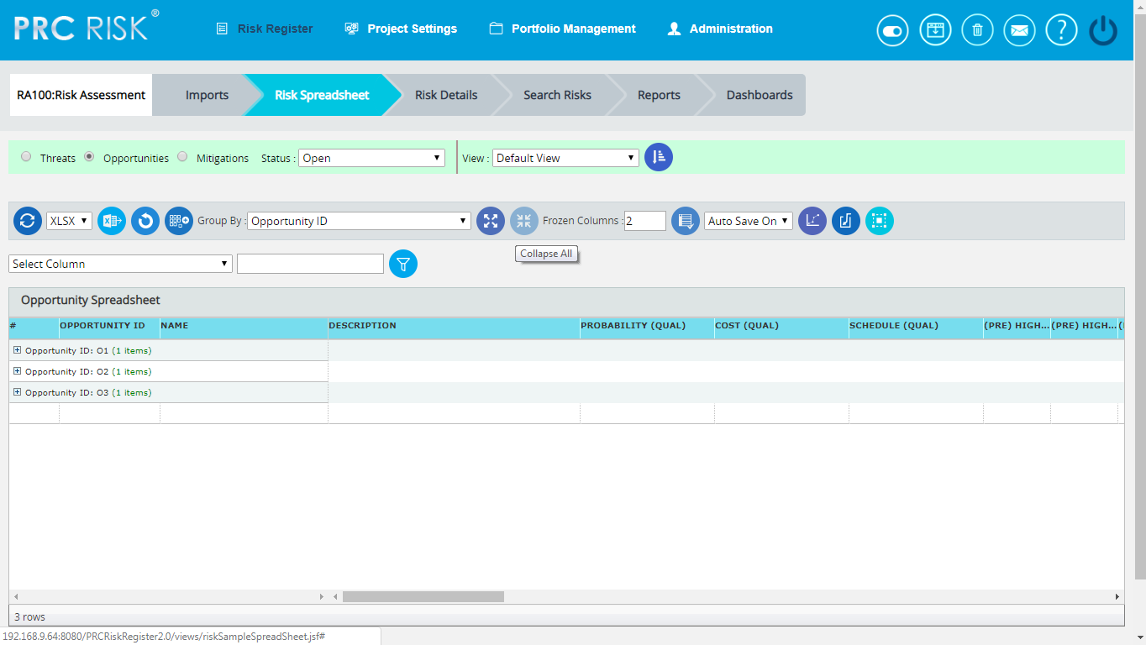
Figure 5
Expand All:
This functionality is to show the collapsed threat risk score information.
Steps:
- Risk Register ---> Risk Spreadsheet---> Opportunities
- Click the Group By dropdown and select the required one from the list. (Figure 3)
- Click the Expand All button to show the collapsed opportunity score information. (Figure 5)
Copy to Monte Carlo:
This functionality helps to copy the Qualitative details of selected opportunities to their corresponding Monte Carlo Inputs.
Steps:
- Risk Register ---> Risk Spreadsheet
- Click the Select Opportunities button to select the opportunities. (Figure 1)
- Select the opportunities by checking the checkboxes. (Figure 3)
- Click the Copy to Monte Carlo button to copy the selected opportunities' Qualitative details to their Monte Carlo Inputs. (Figure 3)
Copy to Qualitative:
This functionality helps to copy the Monte Carlo details of selected opportunities to their corresponding Qualitative Score.
Steps:
- Risk Register ---> Risk Spreadsheet
- Click the Select Opportunities button to select the threats. (Figure 1)
- Select the opportunities by checking the checkboxes. (Figure 3)
- Click the Copy to Qualitative button to copy the selected opportunities' Monte Carlo details to their Qualitative Score. (Figure 3)

Reorder Columns:
This functionality is used to arrange the required fields in a particular order in which risks are viewed in spreadsheet. The user can create, save & apply, delete and reset the column orders in opportunities spreadsheet. To set a selected order as default, check the Set as Default checkbox. The column order selected by default when no user defined column order exists is the Default Column Order which cannot be deleted. It can be edited by the user when necessary.

Steps:
- Risk Register ---> Risk Spreadsheet ---> Opportunities
- Click the Edit View icon to reorder the spreadsheet columns. (Figure 6)
- Select the required fields to be reordered from the Available Fields using Add & Remove buttons. (Figure 7)
- Click First, Up, Down or Last button to move the selected fields to the required position.
- Click Save and Apply icon to save and apply the changes made. (Figure 7)
- Click Reset icon to reset the fields to the previous order. (Figure 7)
- Click Delete icon to delete the selected column order from the list. (Figure 7)
- The view selection can be shuffled using the dropdown to the left of Edit View icon. (Figure 6)
Figure 6
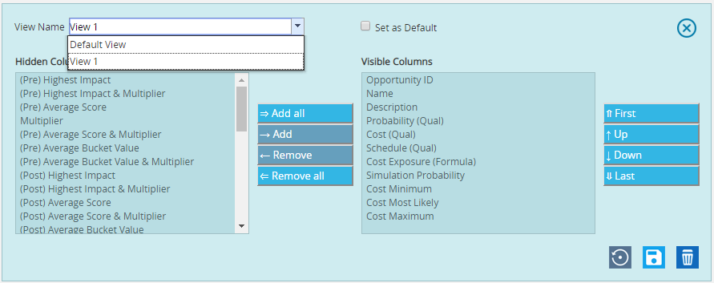
Figure 7
Quick Monte Carlo:
Cost Exposure
This functionality generates a Quick Monte Carlo Analysis that shows the Cumulative S Curve report and Top Risk reports for Threats/Opportunities or Threat and Opportunities. Top Risk reports are the following Tornado charts: Cost Values Isolated to P , Cost Percentages Isolated to P, Correlation Isolated to P & Contingency Requirement Isolated to P The Cumulative Frequency Iterations and the Cumulative Percentage Values are highlighted based on the Iteration number and the Highlight, as shown in the chart and the table. The Top Risk reports consider simulated cost exposure values of each risk up to the Pn iteration value, where 'n' is the percentile value of total number of iterations given.
Steps:
- Risk Register ---> Risk Spreadsheet ---> Opportunities
- Click the Quick Monte Carlo button. (Figure 1)
- A pop up appears (Figure 8) where the Cumulative S Curve report and Top Risk reports are shown.
- Select the Threats/Opportunities or Threats and Opportunities from Options dropdown and give the Iteration number and also the Mitigated Options. (Figure 8)
- Click Apply button to apply the given highlights based on which the Pn Percentile Value for the Top Risk reports can be taken.
- Click Run Analysis button to generate the charts. (Figure 8)
- Click Export to Word button to open the charts in Microsoft Word. (Figure 8)
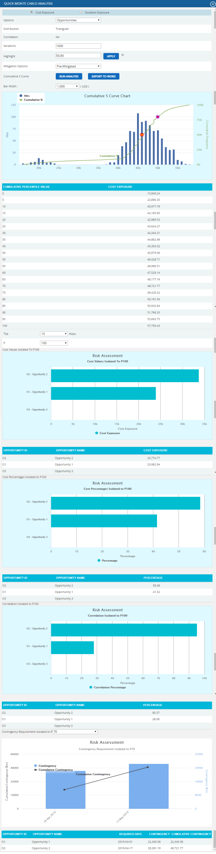
Figure 8
Duration Exposure
This functionality generates a Quick Monte Carlo Analysis that shows the Cumulative S Curve report and Top Risk reports for Threats/Opportunities or Threat and Opportunities. Top Risk reports are classified into Tornado charts, Duration Values Isolated to P , Duration Percentages Isolated to P & Correlation Isolated to P. The Cumulative Frequency Iterations and the Cumulative Percentage Values are highlighted based on the Iteration number and the Highlight, as shown in the chart and the table. The Top Risk reports consider simulated duration exposure values of each risk up to the Pn iteration value, where 'n' is the percentile value of total number of iterations given.
Steps:
- Risk Register ---> Risk Spreadsheet ---> Opportunities
- Click the Quick Monte Carlo button. (Figure 1)
- A pop up appears (Figure 9) where the Cumulative S Curve report and Top Risk reports are shown.
- Select the Threats/Opportunities or Threats and Opportunities from Options dropdown and give the Iteration number and also the Mitigated Options. (Figure 9)
- Click Apply button to apply the given highlights based on which the Pn Percentile Value for the Top Risk reports can be taken.
- Click Run Analysis button to generate the charts. (Figure 9)
- Click Export to Word button to open the charts in Microsoft Word. (Figure 9)
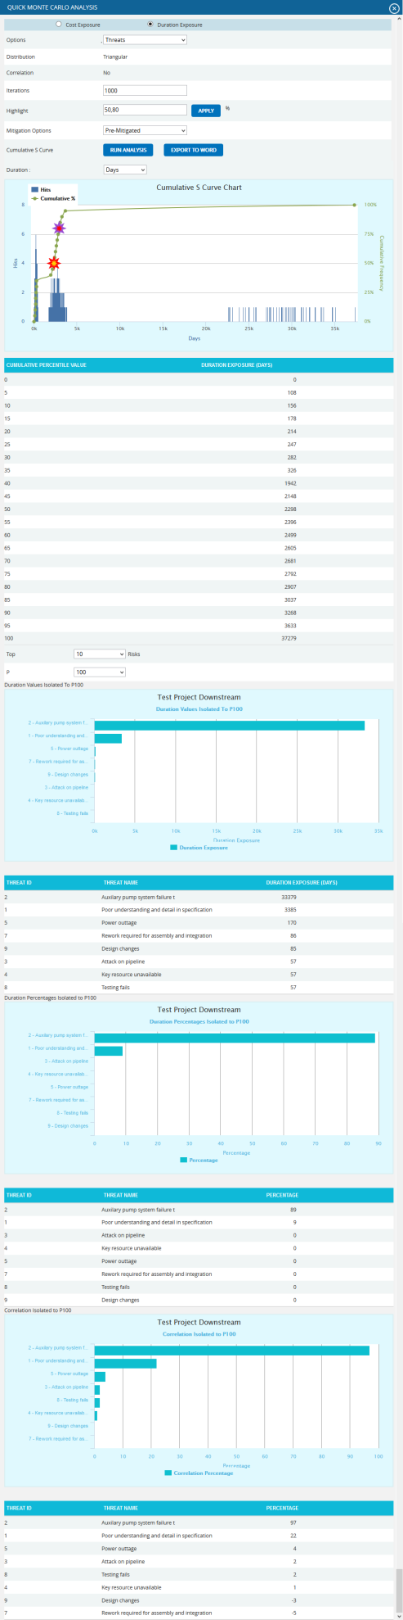
Figure 9

Recycle Bin:
To go to Recycle Bin from Spreadsheet view (Opportunities), click the Recycle Bin icon shown on top of the page in Figure 1.
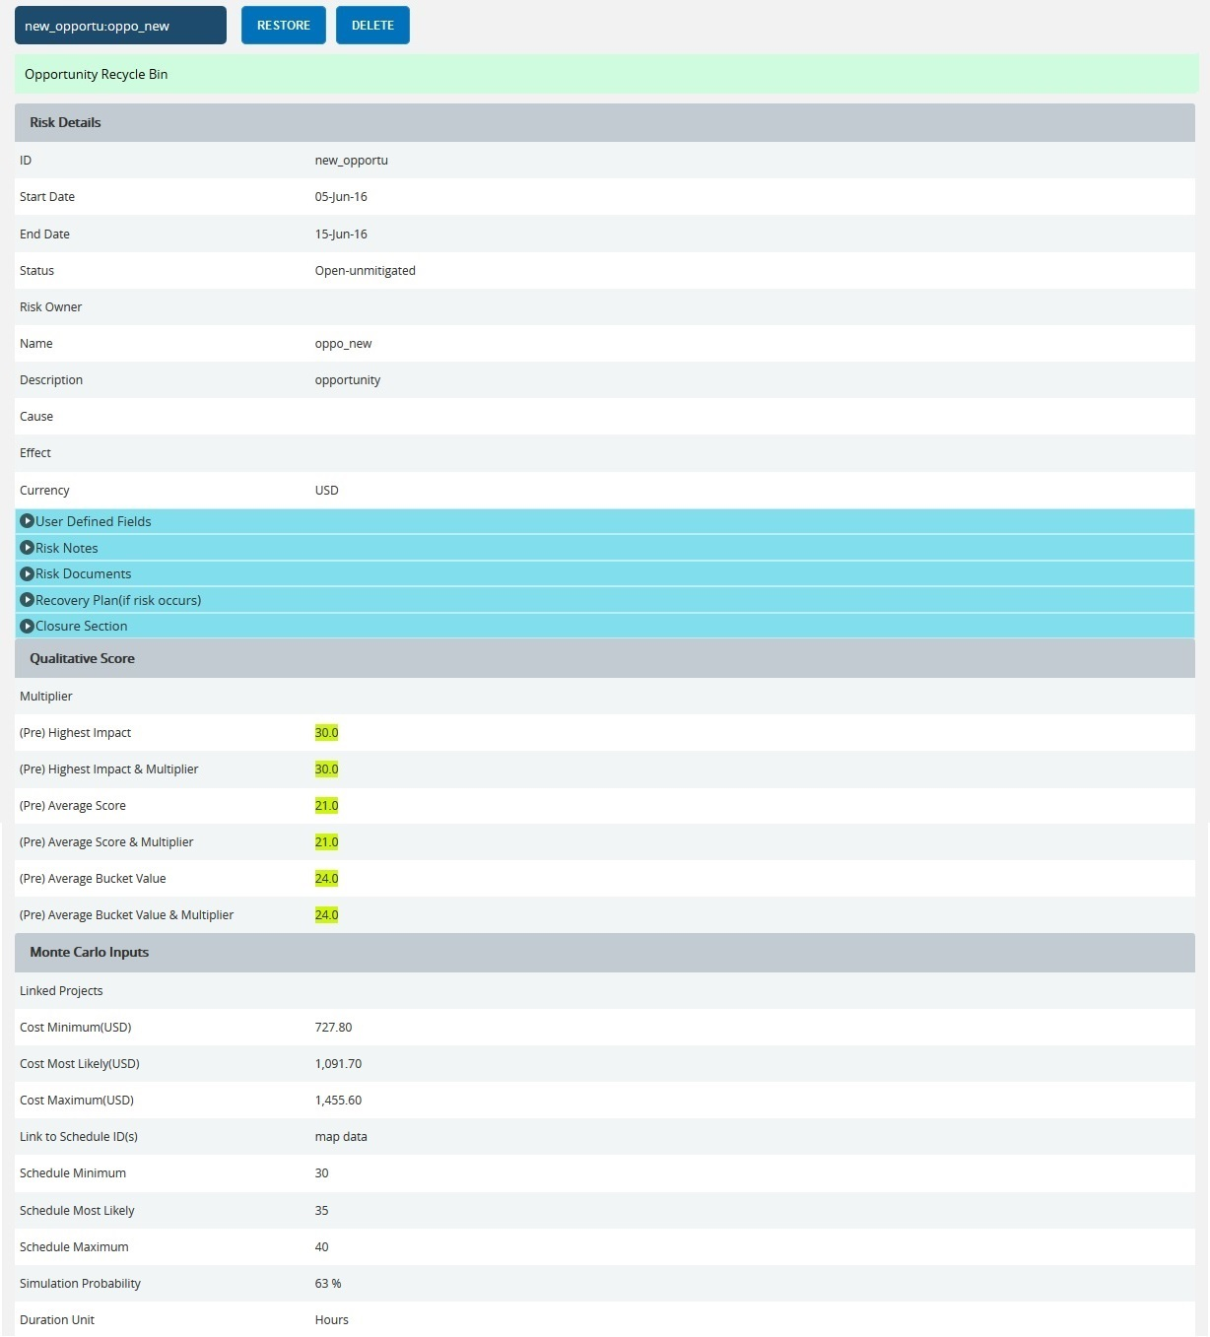

Figure 10

Restore Opportunities:
The restored opportunity is removed from the Recycle Bin and is moved back to the pages where opportunity details are shown (for example Spreadsheet View (opportunities)).
Steps:
- Risk Register --->Risk Spreadsheet ---> Opportunities
- Click the Recycle Bin icon to go to the Recycle Bin page.
- Select opportunity to restore.
- Click the RESTORE button to restore selected opportunity. (Figure 10)

Delete opportunity From Recycle Bin:
An opportunity deleted from the Recycle Bin will be removed completely from the system.
Steps:
- Risk Register ---> Risk Spreadsheet ---> Opportunities
- Click the Recycle Bin icon to go to the Recycle Bin page.
- Select the opportunity to delete.
- Click the Delete button. (Figure 10)
After you receive the confirmation message (Figure 11), click the OK button. The opportunity will be deleted permanently. To cancel, click the Cancel button. (Figure 11)
Figure 11

Frozen column:
This functionality is used to set the number of columns as fixed when the scroll is enabled. For example, in Figure 5 Frozen Columns is set to 2 (default value), which implies that the column ID and Name will be fixed and scrolling will be applicable from the third column onwards.
Figure 12
Steps:
- Risk Register --->Risk Spreadsheet ---> Opportunities
- Enter the number of columns that must be frozen.
- Click the Set button shown in Figure 12.

Filter Data:
To Filter the data according to a particular value:
Steps:
- Risk Register --->Risk Spreadsheet ---> Opportunities
- Select the required column from the Select Column dropdown. (Figure 1 )
- Enter the value in the textbox based on which filtering is to be done. (Figure 1)
- Click the Filter button (Figure 1). The filtered data will be displayed.

Reset Data:
This functionality is used to set the filtered values to its previous values.
Steps:
- Risk Register ---> Risk Spreadsheet ---> Opportunities
- Click the Reset button to reset the values. (Figure 1)

Pre-Mitigated Score:
The Pre-Mitigated Score is the risk score. The fields (Probability, Cost and Schedule and Additional Impacts) are used to set the pre-mitigated score. (Figure 1) If Probability and Impacts have a value of either Undefined or No Risk, the Pre-Mitigated Score will be zero.

Post-Mitigated Score:
The Post-Mitigated Score is the mitigation score. The fields (Probability, Cost and Schedule and Additional Impacts) are used to set the post-mitigated score. (Figure 1) If probability and Impacts have value either Undefined or No Risk the Post-Mitigated Score will be zero.

Creating a new opportunity:
Creating a new opportunity in spread sheet view is quick and easy. The ID field is required to save an opportunity.
Steps:
- Risk Register ---> Risk Spreadsheet ---> Opportunities
- Enter the details on a new line. For fields such as Name, Description etc., a textbox pops up upon clicking the cell. (Figure 13) After entering the details, click the Save button for text fields (Figure 13). The details will be saved automatically. To cancel, click the Cancel button. (Figure 13)
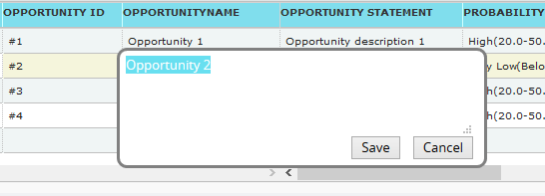
Figure 13
A calendar component pops up for date fields upon clicking the calendar control. (Figure 14)
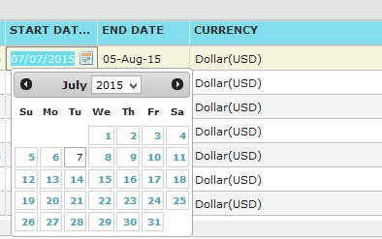
Figure 14

If the data is to be selected from a list, a dropdown appears. (Figure 15)
Figure 15
The other columns may be edited within the cell.
- Click any other cell to trigger the Auto Save.

Edit Opportunities:
Opportunities can be edited individually by clicking the cells which need to be edited corresponding to each row or multiple opportunities can be edited simultaneously with repeating cell values.
Edit Multiple Opportunities:
This functionality helps to edit multiple opportunities simultaneously with cells of same entries. To edit multiple opportunities we must first select them.
Steps:
  - Risk Register ---> Risk Spreadsheet ---> Opportunities
  - Click the Select Opportunities button to select the opportunities to edit. (Figure 1)
  - Select the threats by checking the checkboxes. (Figure 16)
  - Click the Edit Multiple Opportunities option to edit the selected opportunities.
(Figure 16)
  - Select the column, enter the values to be edited and click the SAVE button in the
EDIT RISK VALUE pop up that appears. (Figure 17)

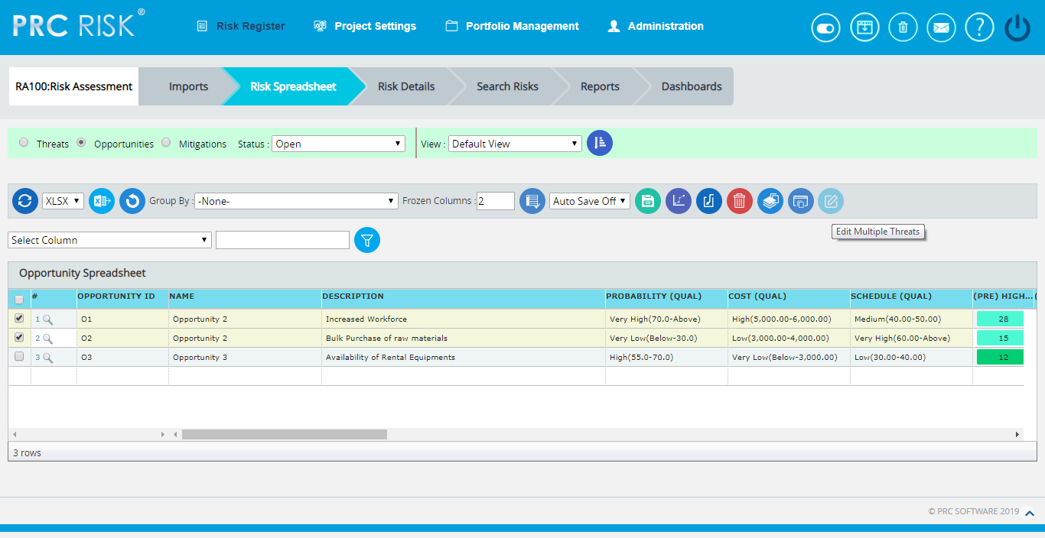

Figure 16

Figure 17

Edit Opportunities Individually:
This functionality is to edit the cells of an individual Opportunity.
Steps:
    - Risk Register ---> Risk Spreadsheet ---> Opportunities
    - Refer to the procedures in the previous section (Creating a new Opportunity).
    - Edit the cell as required and click in any other cell to trigger the Auto Save.
User Defined Fields:
User Defined Fields or Custom Fields are shown along with the opportunity details as the last column if formula field is not there. There is no limit to the number of User Defined Fields.
User Defined Fields can be added in two ways.
1. The User Defined Fields can be added using the template imported for the project from the Portfolio Management page for the project:
Project settings ---> Import from Templates
Or
2. It can be also be added from the page:
Project settings --->Custom Fields

Formula Fields:
The Formula Field is shown along with the opportunity details as the last column.(Figure 18)
There is no limit to the number of Formula Fields.

Formula Fields can be added in two ways.
- The Formula Fields can be added using the template imported from the Portfolio Management page for the project :
Project Settings ---> Import from Templates
Or
2. It can also be added from the page:
Project Settings ---> Custom Fields
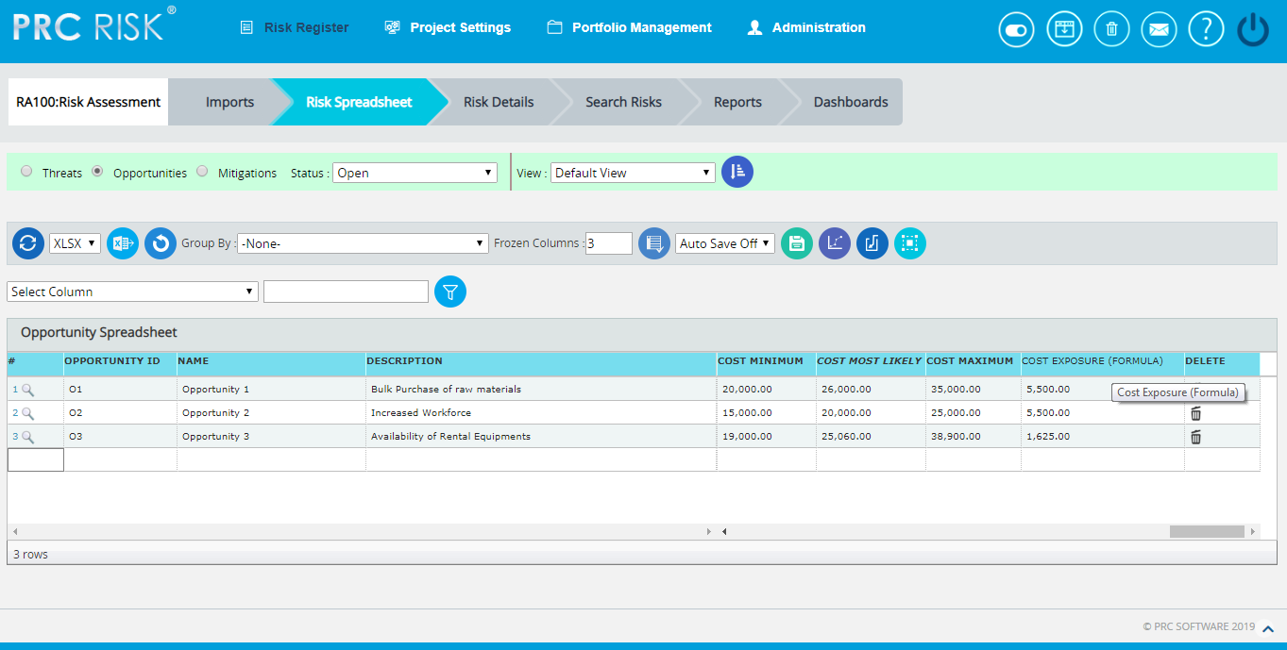
Figure 18

Data Mapping:
The Data Mapping columns shows to which Breakdown Structure the selected opportunity is mapped and at what level (Project, Business Unit, or Enterprise) it is mapped. It is not required to map data, but it will be useful when the time comes to report at the portfolio level.
Project Organizational Breakdown Structure, Project Work Breakdown Structure and Project Risk Breakdown structure details are added from the page:
Project Settings —> Project Breakdown Structure
Business Organizational Breakdown Structure, Business Work Breakdown Structure, Business Risk Breakdown Structure, Enterprise Organizational Breakdown Structure, Enterprise Risk Breakdown Structure, Enterprise Work Breakdown Structure are added from the page:
Portfolio Management —> Project Breakdown Structure
Enterprise Risk details are added from the page:
Portfolio Management —> Reports —> Enterprise Risk List

To Map data:

Steps:
- Click the <<No Mapping>> link to map data for the corresponding field. (Figure 19)
- Select the checkbox corresponding to the data to be mapped. (Figure 20)
- Click the SELECT BREAKDOWN button to finish. (Figure 20)
The steps described above apply to all (Business/Enterprise/Project) Organizational Breakdown Structure, Work Breakdown Structure and Risk Breakdown Structure fields.
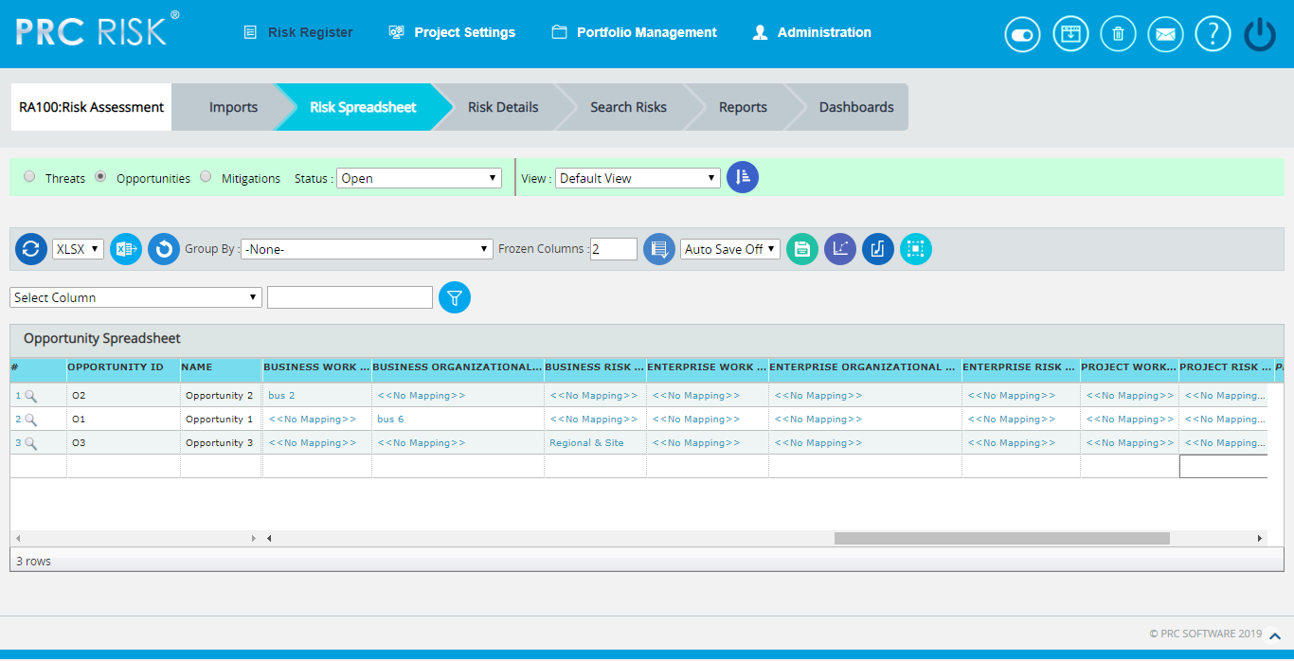
Figure 19
Figure 20
Bulk Email:
This functionality is to send multiple Risks and Mitigations data by email to the selected users. This functionality is applicable only to those users with the User Type Application and Email and Email Only in the Manage Users page.
Two lists can be utilized: Available Users and Selected Users. Available Users (Figure 21) contains all users who have access to the selected project and portfolio level users. Selected Users (Figure 21) displays the users who have been selected. A user can be added to the Selected User list using the Add button. All nodes under the Available Users list can be moved to the Selected Users list using the Add All button (Figure 21). A single node from the Selected Users list can be moved back to the Available Users list using the Remove button. The Remove All button moves all nodes from the Selected Users list to the Available Users list. The Subject by default has the value Project Name: ID/Name of the risk selected, which can be changed if needed.
Steps:
- Risk Register ---> Risk Spreadsheet
- Click the Opportunities radio button to navigate to the Risk Spreadsheet (Opportunities) page. (Figure 1)
- Click the Select Opportunities button to select the required opportunities to be sent. (Figure 1)
- Select the opportunities by checking the checkboxes. (Figure 16)
- Click the Bulk Email icon to send email. (Figure 1) It navigates to another page. (Figure 21)
- Select at least one user to whom the mail should be sent.
- Enter the message in the Message text area.
- Select the required fields for the email edit that can be edited and saved by the recipient (refer Figure 21).
- Click the Send Mail button. (Figure 21)
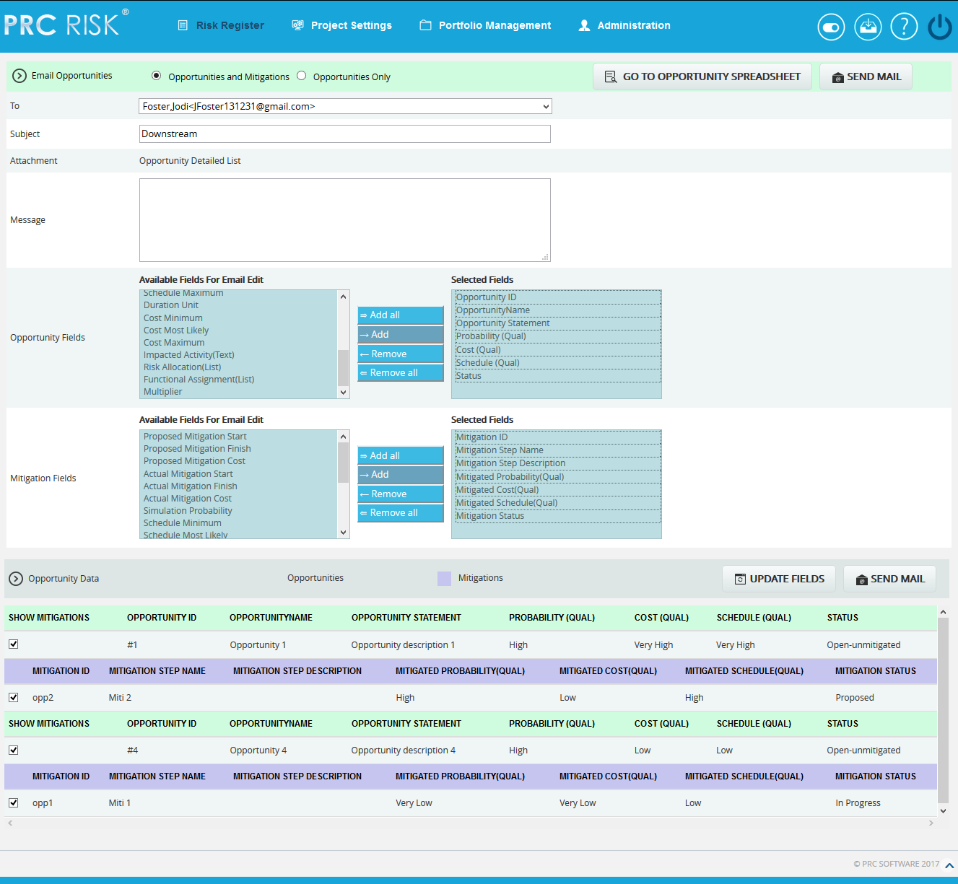
Figure 21

Update fields:
This functionality allows the recipient users to view the opportunities and its mitigations field values that are selected, where the email can be edited.
Go to Opportunity Spreadsheet:
This functionality helps the user to navigate to the Opportunity Spreadsheet page.
Send Mail:
This functionality is to send the mail to the selected users after selecting the opportunity and its mitigation details for email edit.

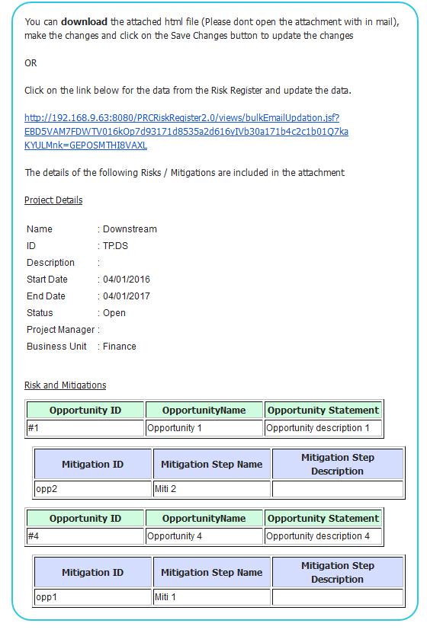
Figure 22
The recipients will receive a mail that contains the project details, the opportunities and its mitigations data and also a link in which the user can do the email edit for the Risk Data. (Figure 22) By clicking the link, it navigates to another page where the changes are made. (Figure 23) Submit the changes by clicking the Save Changes button that will update the changes done to the database, and a mail is sent to the user showing these updated fields. (Figure 24) The changes can be saved only once for an email sent.
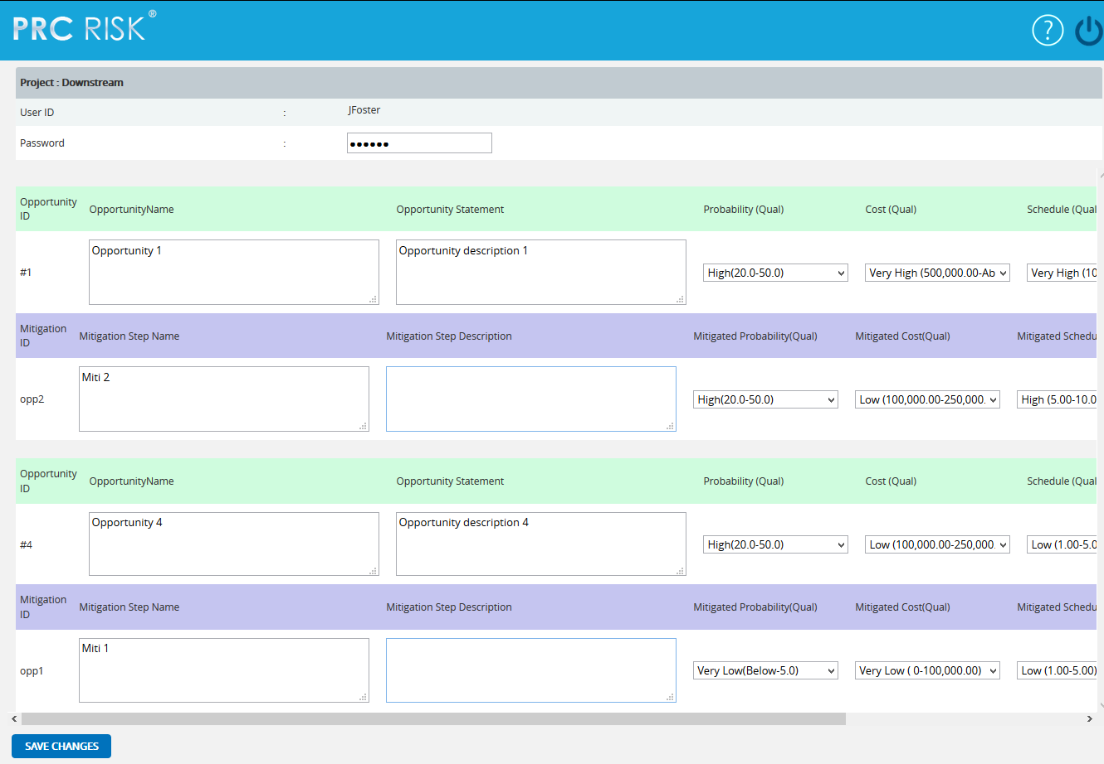
Figure 23
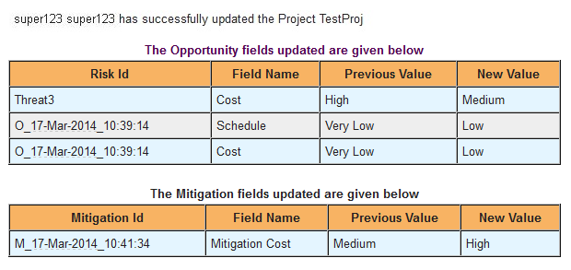
Figure 24

Spreadsheet View (Mitigations)
The Spreadsheet View (Mitigations) page allows the user to add, edit, delete, and export mitigations in a selected project. This page is visible only to those users who have Read/Write access or View access for the page Spreadsheet View (Mitigations). Users with Read/Write access can create new mitigations, edit mitigations, delete mitigations and export to Excel. Users designated with View access can view the mitigation details and export to Excel. The mitigation details in the Spreadsheet View (Mitigations) page are displayed in ascending order of the Mitigation Risk Score.
This is a special component that has an Auto Save feature. When editing or adding new values to a cell, the value is automatically saved by clicking, another cell. It is important to always click in another cell to trigger this auto save feature. The values in the spreadsheet can be sorted by clicking on the column header. Click again on the column header to reverse the order of sorting. The columns can be resized by clicking and dragging between the column headers. Each column has its own minimum width set. A column cannot be dragged narrower than its minimum width.
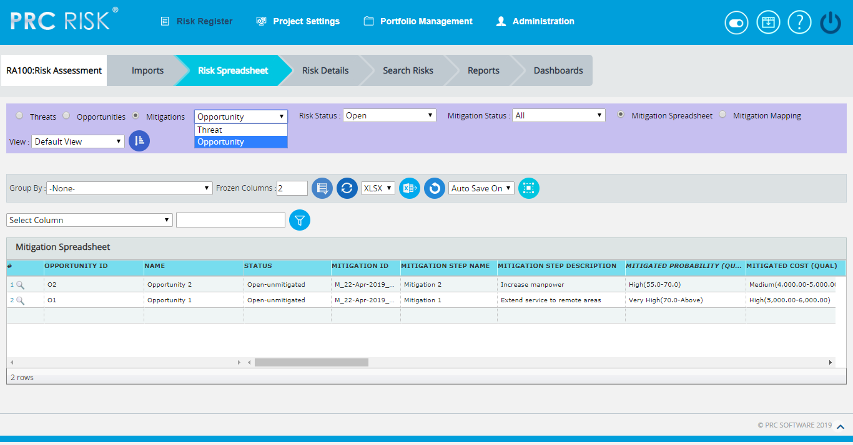
Figure 1
Drill Down:
The drill down option is available to the user at the first column of mitigation spreadsheet. (Figure 1) The user can drill to the risk details mitigation page when the Drill Icon corresponding to each mitigation is clicked there the detailed information of the corresponding mitigation can be viewed.

Navigate Page:
To go to the Spreadsheet View (Mitigations) page, click the Mitigations radio button on the top of the page. (Figure 1)
The option for navigation from one page to another is placed on top of the page and is shown in Figure 1.
Steps:
- Risk Register ---> Spreadsheet View
- Click the Threats radio button (Figure 1) to navigate to the Spreadsheet view (Threats) page.
Or
Click the Opportunities radio button (Figure 1) to navigate to the Spreadsheet view (Opportunities) page.
There is also an option to view the mitigation for Threat/Opportunity.
To view the Spreadsheet View (Mitigations) for threat, select Threat from the dropdown. (Figure 1)
To view the Spreadsheet View (Mitigations) for opportunity, select Opportunity from the dropdown. (Figure 1)
The Spreadsheet View (Mitigations) page is divided into two parts, Mitigation Spreadsheet (Figure 1) and Mitigation Mapping (Figure 2).
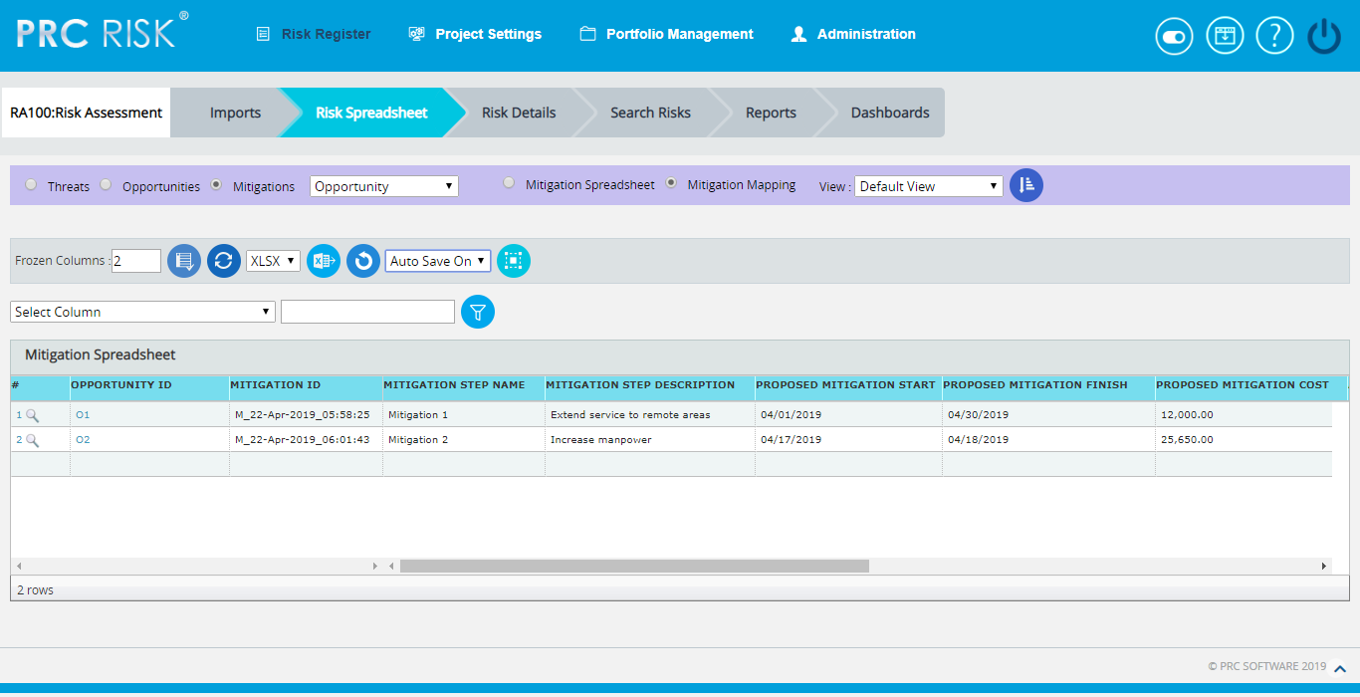
Figure 2
In the Mitigation Map Information part, the Risk IDs mapped to a corresponding mitigation step is shown in one field separated by commas. The user can click this Risk ID field and get a pop up similar to that in the risk to activity mapping from the detailed view, where we can map the risks to the mitigation step or un map the risks from the mitigation. (Figure 3)
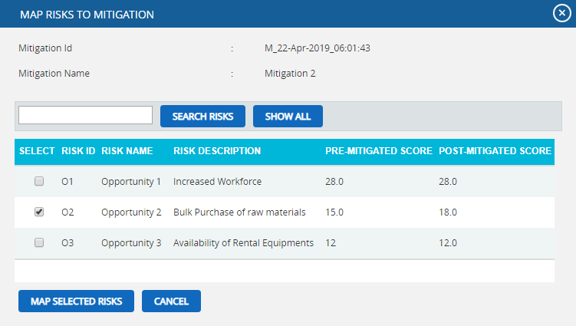
Figure 3
Steps:
- Risk Register ---> Risk Spreadsheet---> Mitigations ---> Mitigation Map Information
- Click the link in the Risk ID column for each mitigation step (Figure 2).
- A pop up appears in which the user can select the risks to be mapped by checking the checkboxes or uncheck the selected risks to remove mapping and click the OK button. (Figure 3)
- Click the Cancel button to close the pop up. (Figure 3)

Save All:
The Save All button is to save all the changes done in the Mitigation Spreadsheet and Mitigation Mapping pages when the Auto Save is OFF.
Steps:
- Risk Register ---> Risk Spreadsheet ---> Mitigation Spreadsheet/ Mitigation Mapping
- Select the Auto SAVE Off option from the dropdown. (Figure 4)
- Give the necessary changes in the Mitigation Spreadsheet / Mitigation Mapping pages and click Save All Edits button to save all the changes done. (Figure 2 and Figure 4)
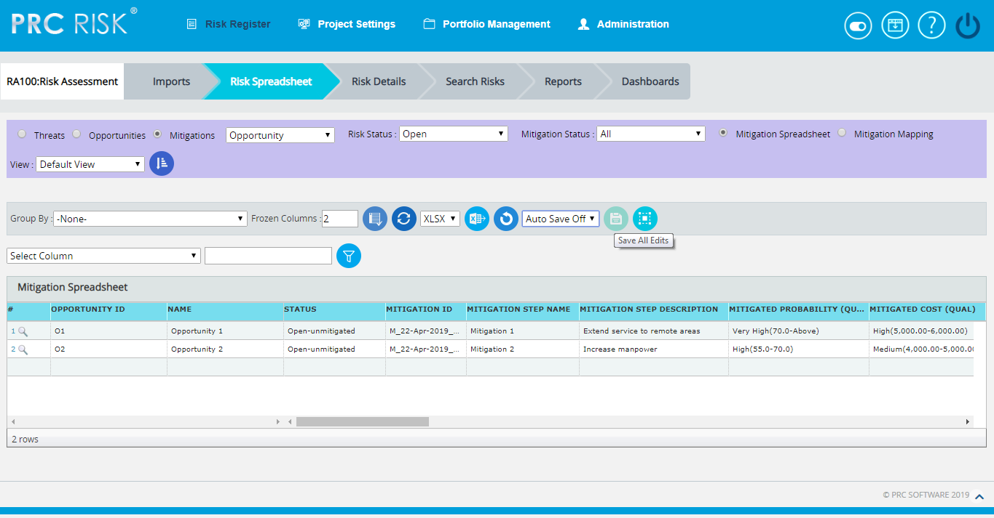
Figure 4
In the Mitigation Spreadsheet part, each Risk ID is on a separate row so that the Mitigation IDs may be repeated. Here the scoring can be viewed in different ways by Group By functionality. (Figure 5)
Group by:
This functionality is to view the scoring in different ways based on each fields in the Mitigation Spreadsheet, i.e. Risk ID, Risk Name, Risk Status, Mitigation ID etc. The default view will be No grouping.
Steps:
- Risk Register ---> Risk Spreadsheet---> Mitigations ---> Mitigation Spreadsheet
- Click the Group By dropdown and select the required one from the list. (Figure 5)
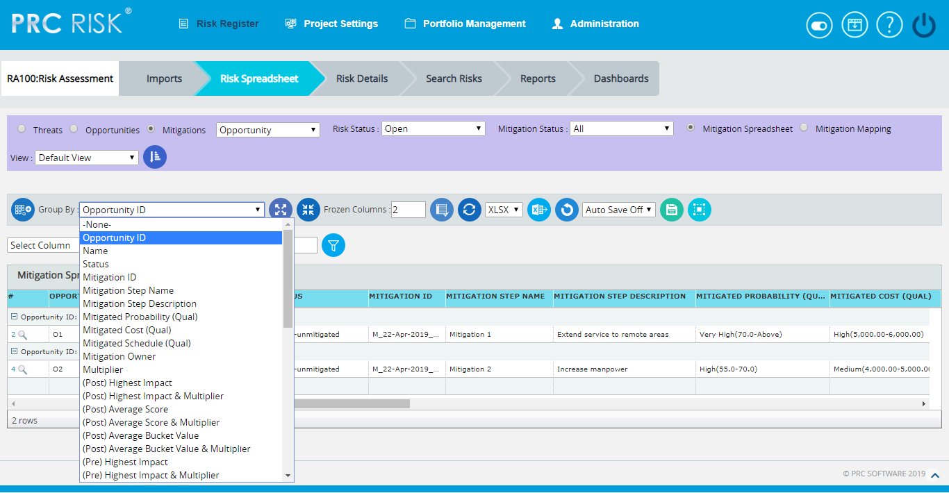
Figure 5
Ungroup to add new:
This functionality is to ungroup the grouped list and allows adding new mitigations.
Steps:
- Risk Register ---> Risk Spreadsheet---> Mitigations ---> Mitigation Spreadsheet
- Click the Group By dropdown and select the required one from the list. (Figure 5)
- Click the Ungroup To Add New button to ungroup the list and add the new mitigation. (Figure 5)

Collapse All:
This functionality is to collapse the mitigation score information based on the group selected from the Group By dropdown.
Steps:
- Risk Register ---> Risk Spreadsheet---> Mitigations ---> Mitigation Spreadsheet
- Click the Group By dropdown and select the required one from the list. (Figure 5)
- Click the Collapse All button to collapse the mitigation information. (Figure 6)
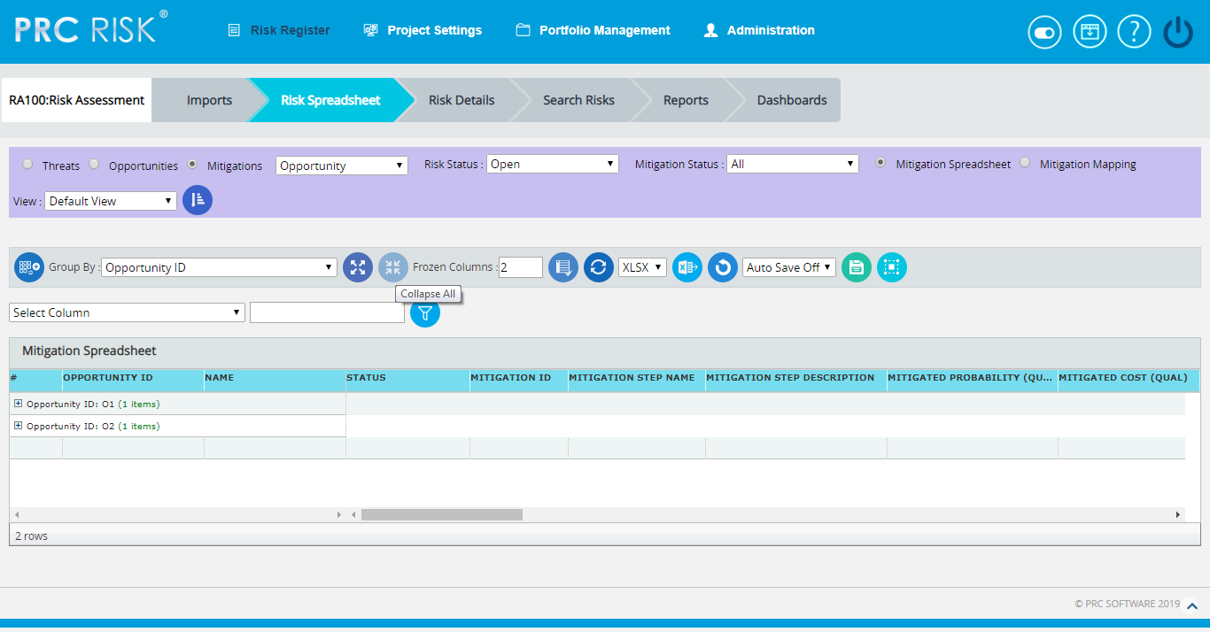
Figure 6

Expand All:
This functionality is to show the collapsed mitigation score information.
Steps:
- Risk Register ---> Risk Spreadsheet---> Mitigations ---> Mitigation Spreadsheet
- Click the Group By dropdown and select the required one from the list. (Figure 5)
- Click the Collapse All button to collapse the mitigation information. (Figure 6)
- Click the Expand All button to show the collapsed mitigation score information.

Export to Excel:
This functionality is used to export the entire page to Excel as .xlsx or .xls file type.
Steps:
- Risk Register ---> Risk Spreadsheet---> Mitigations
- Click the Export button to export the entire page to Excel. (Figure 1)

Undo:
This functionality is used to reset the last saved value.
Steps:
- Risk Register ---> Risk Spreadsheet---> Mitigations
- Click the Undo button to return to the last saved value. (Figure 1)

Risk Status:
This functionality is used to display the risk and its mitigation details based on the risk status whose value is open, closed or both.
Steps:
- Risk Register ---> Risk Spreadsheet
- Click the Mitigation radio button and select threat/opportunity from the dropdown.
- Click the Mitigation Spreadsheet radio button.
- Click the Risk Status dropdown button and select open, close or both to display the mitigation details with particular risk status. (Figure 2)

Mitigation Status:
This functionality is to display the risks and its mitigation details based on the mitigation status whose value is open, closed, proposed, in progress, rejected, complete, risk closed or approved. (Figure 7)

Steps:
      - Risk Register ---> Risk Spreadsheet
      - Click the Mitigation radio button and select threat/opportunity from the dropdown.
      - Click the Mitigation Spreadsheet radio button.
- Click the Mitigation Status dropdown button and select open, closed, proposed, in progress, rejected, complete, risk closed or approved to display the mitigation details with particular mitigation status. (Figure 7)
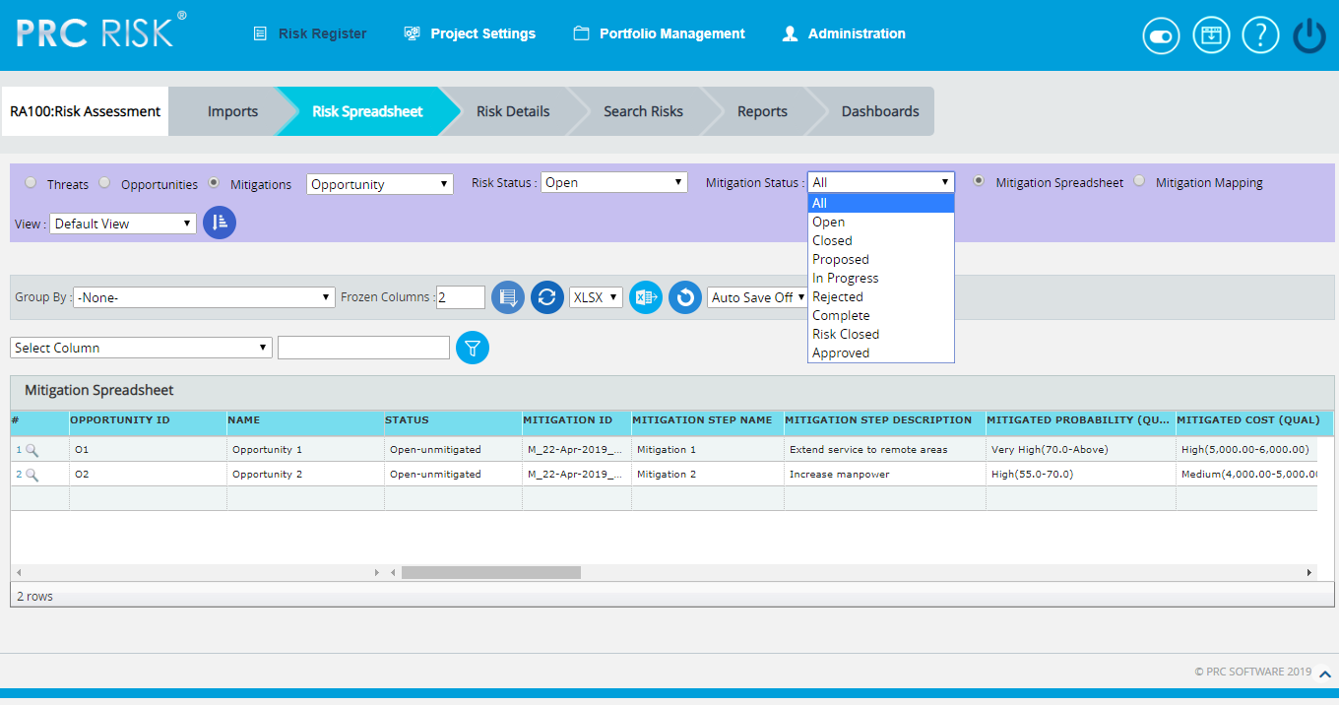
Figure 7

Delete mitigations:
Mitigations can be deleted by clicking the delete button corresponding to each row or multiple mitigations can be deleted simultaneously.
Delete multiple Mitigations:
This functionality helps to delete multiple mitigations simultaneously. To delete multiple mitigations the user must first select them.
Steps:
- Risk Register ---> Mitigations Spreadsheet
- Click the Select Mitigations button to select the mitigation to delete. (Figure 1)
- Select the mitigation by checking the checkboxes. (Figure 8)
- Click the Delete Multiple button to delete the selected mitigations. (Figure 8)
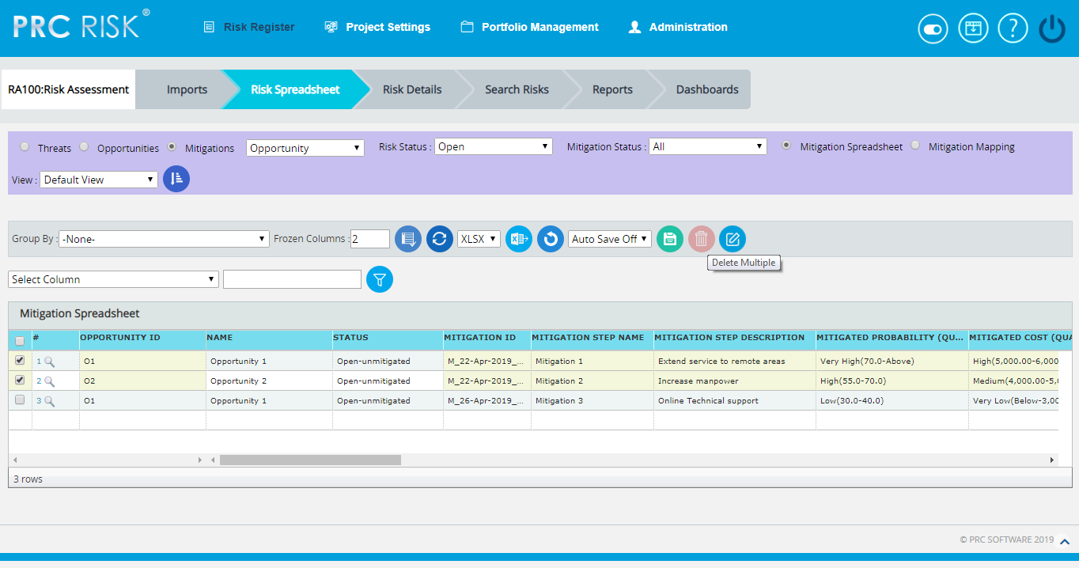
Figure 8
Delete mitigations individually:
To delete mitigations individually follow the steps described below.
Steps:
- Risk Register ---> Mitigations Spreadsheet
- Click the Close button to delete the required mitigation.
Reorder Columns:
This functionality is used to arrange the required fields in particular order in which the risks are viewed in spreadsheet. The user can create, save & apply, delete and reset the column orders in mitigation spreadsheet. To set a selected order as default, check the Set as Default checkbox. The column order selected by default when no user defined column order exists is the Default Column Order which cannot be deleted. It can be edited by the user when necessary.
Steps:
- Risk Register ---> Risk Spreadsheet ---> Mitigations
- Click the Reorder Columns button to reorder the spreadsheet columns. (Figure 1)
- Select the required fields to be reordered from the Available Fields using Add & Remove buttons. (Figure 10)
- Click First, Up, Down or Last button to move the selected fields to the required position.
- Click Save and Apply icon to save and apply the changes made. (Figure 10)
- Click Reset icon to reset the fields to the previous order. (Figure 10)
- Click Delete icon to delete the selected column order from the list. (Figure 10)
- The view selection can be shuffled using the dropdown to the left of Reorder Columns button. (Figure 9)
Figure 9
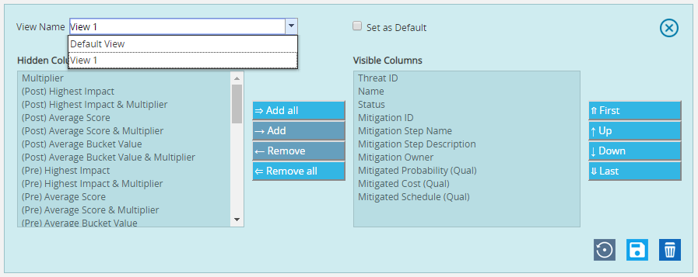
Figure 10

Frozen column:
This functionality is used to set the number of columns fixed when the scroll is enabled. For example, in Figure 6 Frozen Columns is set to 2 (default value), which implies that the column Risk ID and Risk Name will be fixed and scrolling will be applicable from the third column onwards.
Figure 11
Steps:
- Risk Register ---> Risk Spreadsheet---> Mitigations
- Enter the number of columns that must be frozen.
- Click the Set button shown in Figure 11.
Filter Data:
To Filter the data according to a particular value:
Steps:
- Risk Register ---> Risk Spreadsheet---> Mitigations
- Select the required column from the Select Column dropdown. (Figure 1 )
- Enter the value in the textbox based on which filtering is to be done. (Figure 1)
- Click the Filter button (Figure 1). The filtered data will be displayed.

Reset Data:
This functionality is used to set the filtered values to its previous values.
Steps:
- Risk Register ---> Risk Spreadsheet---> Mitigations
- Click the Reset button to reset the values. (Figure 1)

Pre-Mitigated Score:
The Pre-Mitigated Score is the risk score. The fields (Probability, Cost and Schedule and Additional Impacts) are used to set the pre-mitigated score. (Figure 1) If Probability and Impacts have a value Undefined or No Risk, the Pre-Mitigated Score will be zero.

Mitigated Risk Score:
The fields (Probability, Cost and Schedule and Additional Impacts) are used to set the Mitigated Risk Score. (Figure 1) If Probability and Impacts have a value Undefined or No Risk, the Mitigated Risk Score will be zero.

Creating New Mitigation:
Creating a new mitigation in Spreadsheet View is quick and easy.
Steps:
  - Risk Register ---> Risk Spreadsheet---> Mitigations
  - Select Risk ID from the Risk ID dropdown. The Risk Name and Pre-Mitigated Score are displayed automatically. (Figure 1)
  - Enter the details on a new line. For fields such as Name, Description etc., a textbox pops up upon clicking the cell. (Figure 12) After entering the details, click the Save button for text fields (Figure 12). To cancel, click the Cancel button. (Figure 12).

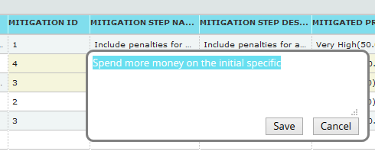
Figure 12
A calendar component pops up for date fields upon clicking the calendar control. (Figure 13)
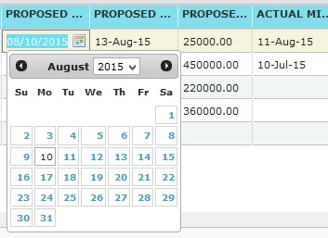
Figure 13
If the data is to be selected from a list a dropdown box appears. (Figure 14)
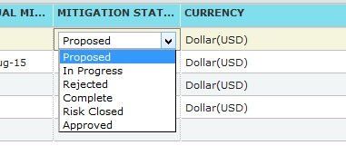
Figure 14
The other columns may be edited within the cell.
4. Click any other cell to trigger the Auto Save.

Edit Mitigations:
Mitigations can be edited individually by clicking the cells which need to be edited corresponding to each row or multiple mitigations can be edited simultaneously with repeating cell values.
Edit Multiple Mitigations:
This functionality helps to edit multiple mitigations simultaneously with cells of same entries. To edit multiple mitigations we must first select them.
Steps:
  - Risk Register ---> Risk Spreadsheet ---> Mitigations
  - Click the Select Mitigations button to select the opportunities to edit. (Figure 1)
  - Select the threats by checking the checkboxes. (Figure 15)
  - Click the Edit Multiple Mitigations button to edit the selected mitigations.
(Figure 15)
  - Select the column, enter the values to be edited and click the SAVE button in the
EDIT MULTIPLE MITIGATIONS VALUE pop up that appears. (Figure 16)

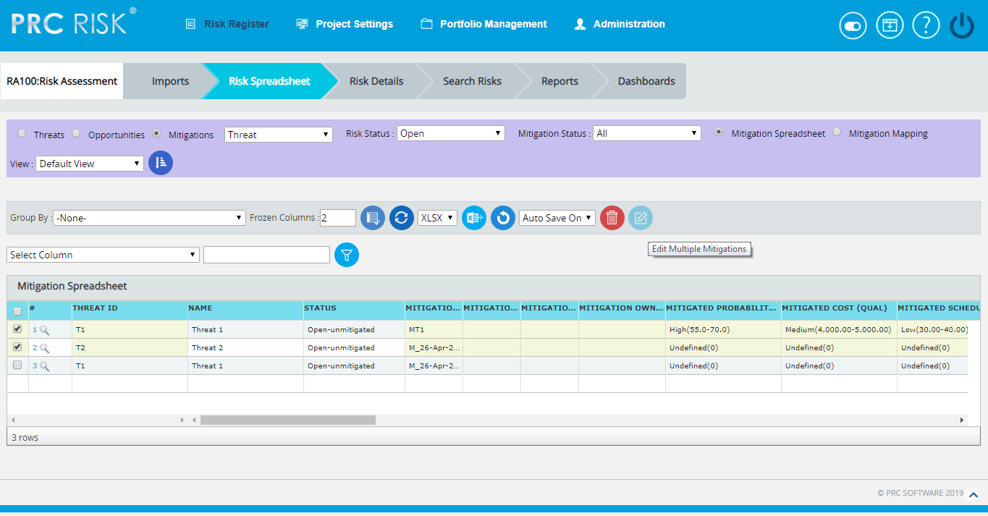

Figure 15

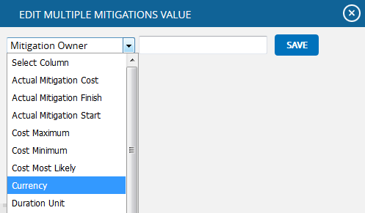

Figure 16

Edit Mitigations Individually:
This functionality is to edit the cells of an individual Mitigation.
Steps:
    - Risk Register ---> Risk Spreadsheet ---> Mitigations
    - Refer to the procedures in the previous section (Creating a new Mitigations).
    - Edit the cell as required and click in any other cell to trigger the Auto Save.
User Defined Fields:
The user defined or custom field is shown along with the mitigation details as the last column if formula field is not there. There is no limit to the number of user defined fields.
User Defined Fields can be added in two ways.
- The User Defined Fields can be added using the template imported from the Portfolio Management page for the project:
Project Settings ---> Import from Templates
Or
2. It can also be added from the page:
Project Settings ---> Custom Fields

Formula Fields:
The Formula Field is shown along with the threat details as the last column.(Figure 18)
There is no limit to the number of Formula Fields.

Formula Fields can be added in two ways.
- The Formula Fields can be added using the template imported from the Portfolio Management page for the project:
Project Settings ---> Import from Templates
Or
2. It can also be added from the page:
Project Settings ---> Custom Fields

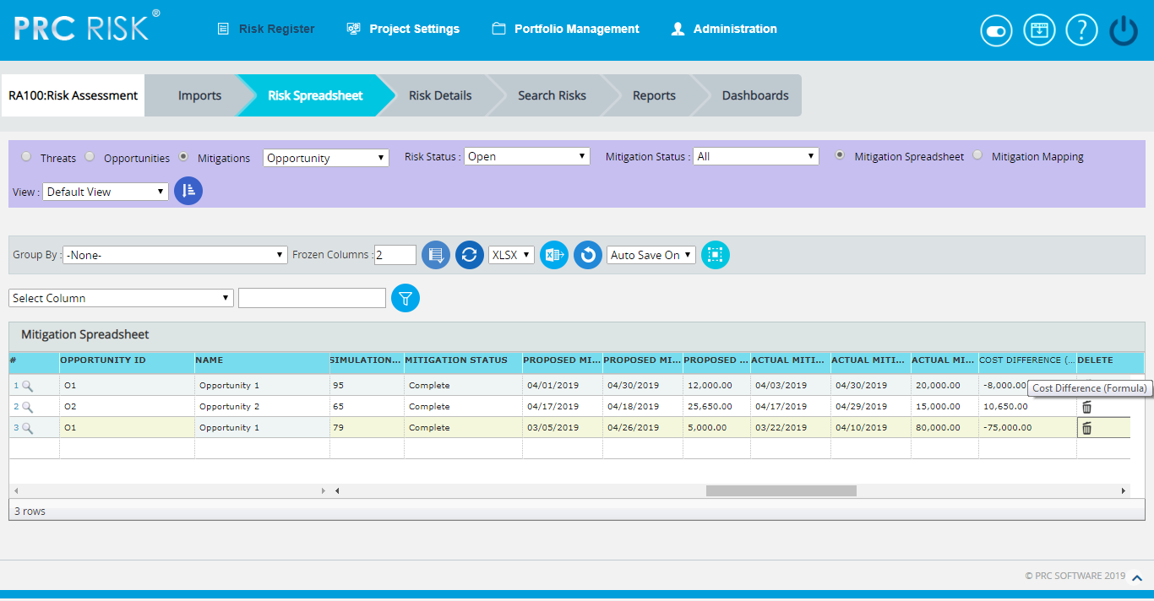
Figure 17

Search Risks (Threats)
The Search Risks (Threats) page allows you to search the company database for past and existing threats. The database consists of data from open and closed projects across multiple business units. This gives you the ability to analyze all risks and see if they apply to your current project. If you find a threat or opportunity that you want to copy, you have the option to include the mitigation plan/step(s) and edit the risk data before copying them over to the selected project. The Qualitative Score Fields and User Defined Fields will not be copied over since every project is different when it comes to these fields. If the project is not selected the access privileges will correspond to the selected threat’s project. Only threats of projects whose classified field is set to No will be displayed in the Search Risks section.
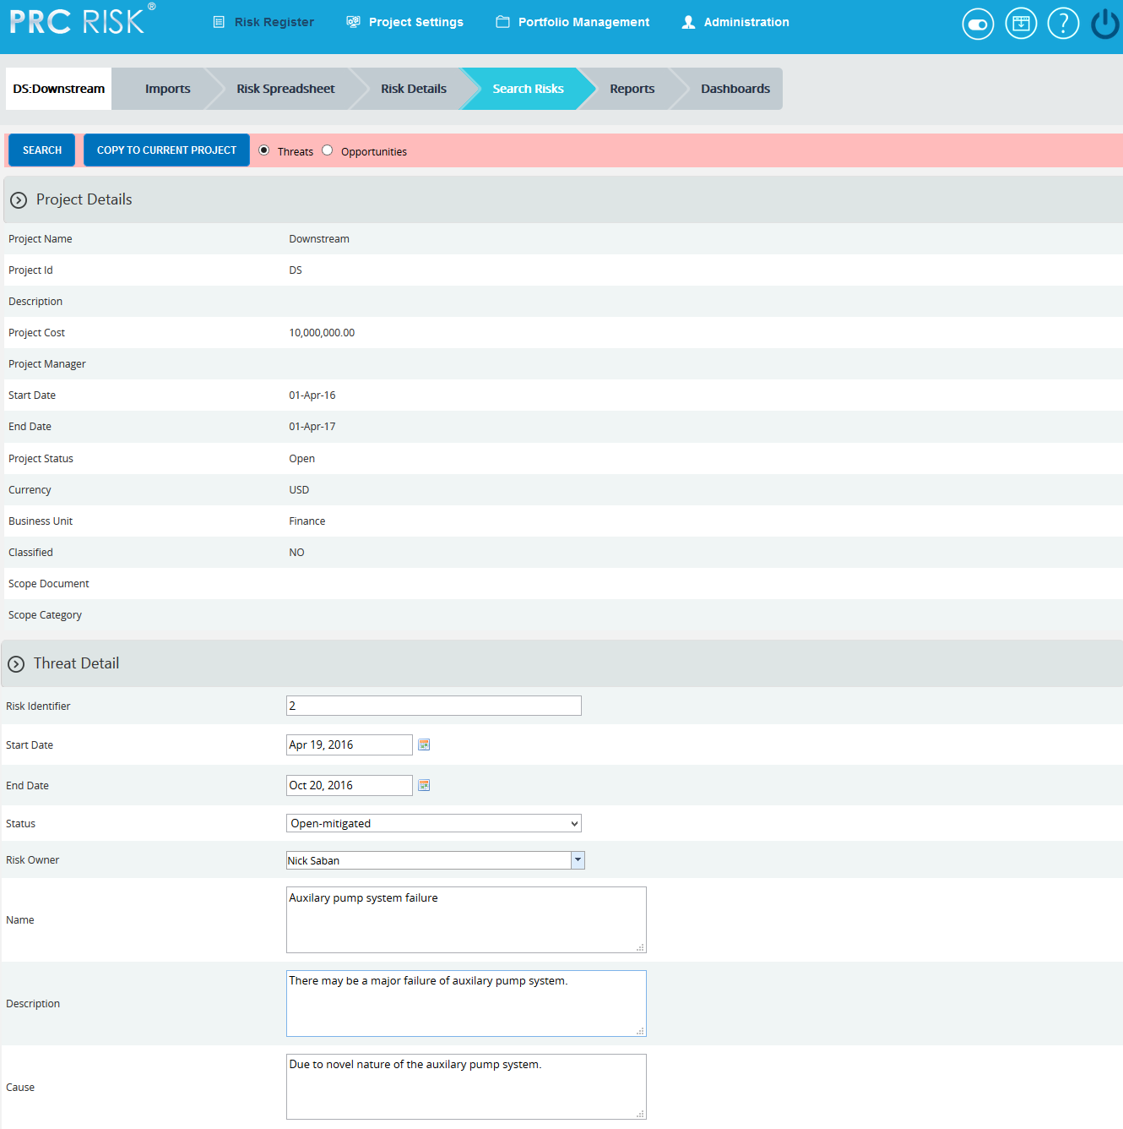
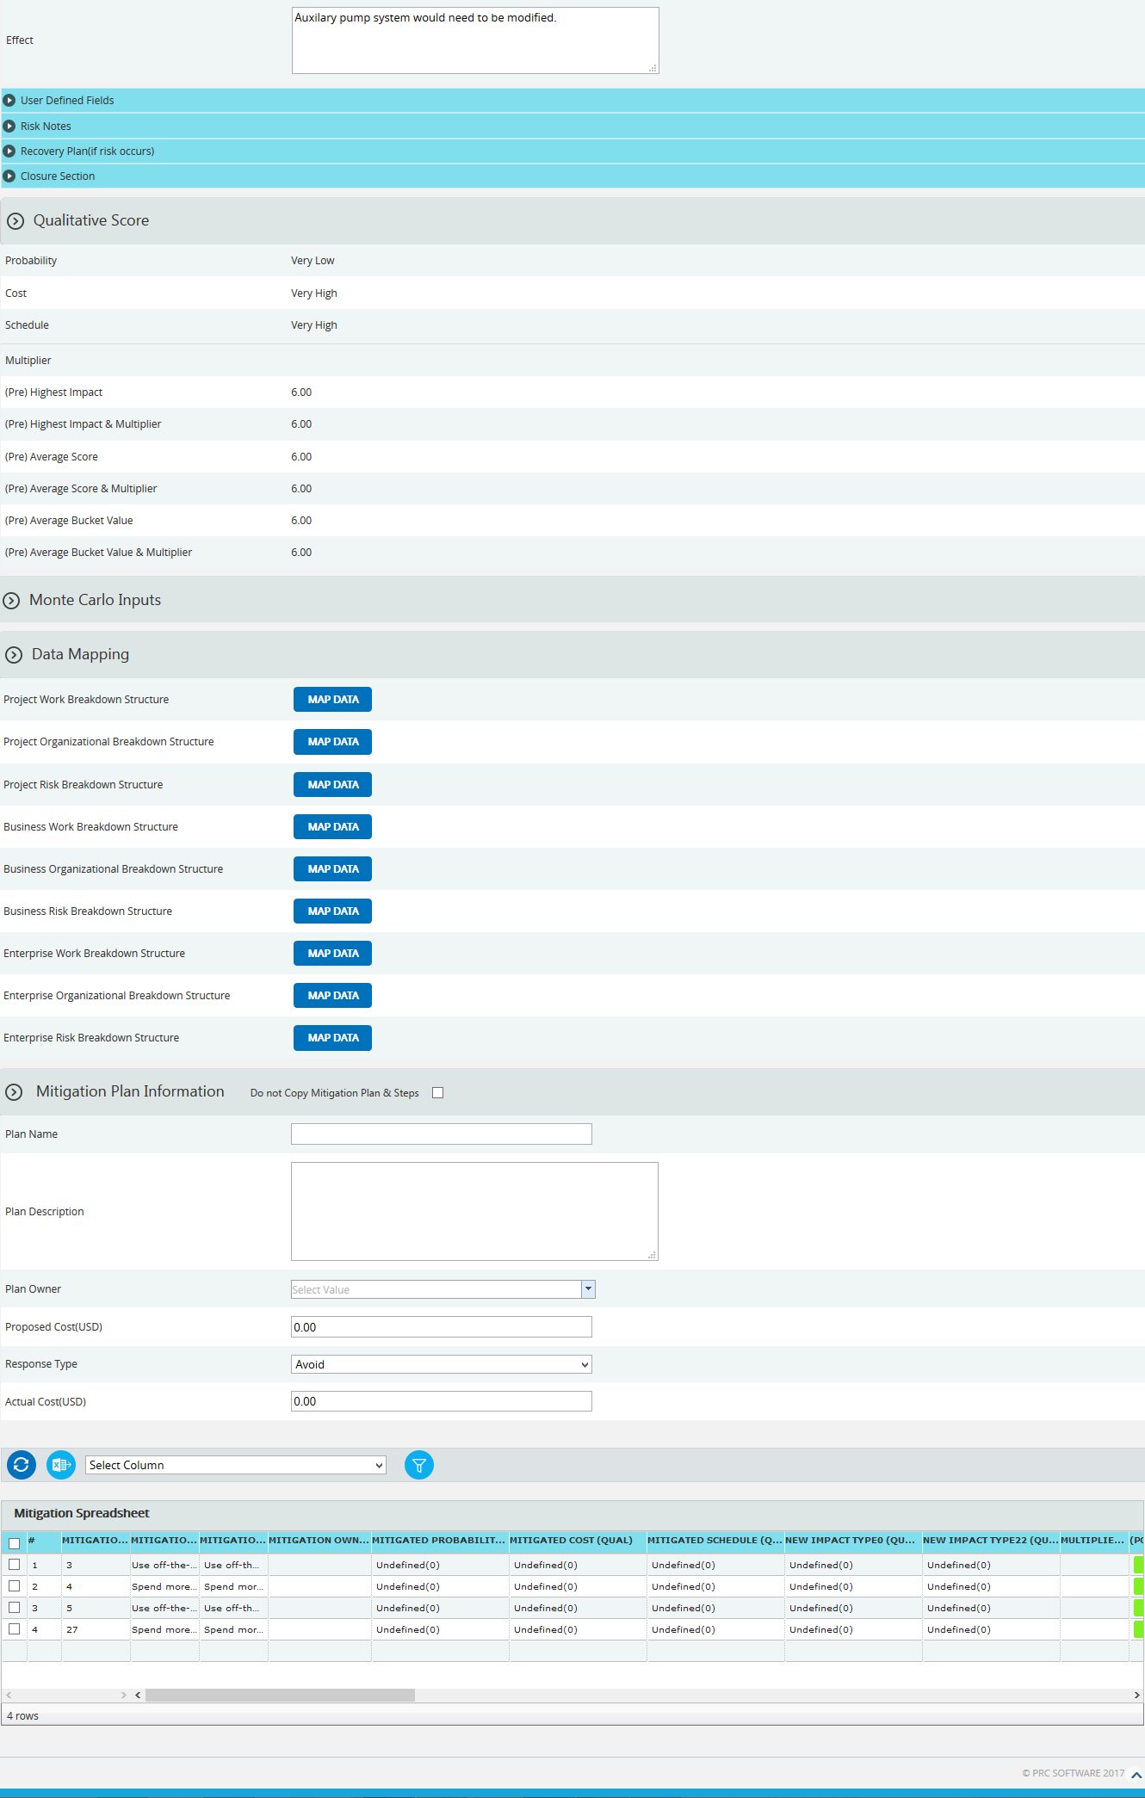
Figure 1

Navigate Page:
There is an option placed at the top of the page to navigate from one page to another. To navigate to Search Risk (Opportunities), click the Opportunities radio button shown in Figure 1.
Search:
The Search function allows the user to search for a threat based on a keyword. This method is faster when you are working with large amount of data. Threat details can be searched even if the project is not selected. If the project is not selected the fields correspond to the selected threat’s project.
Steps:
- Risk Register ---> Search Risks ---> Threats
- Click the Search button. (Figure 1)
- Enter the search keyword (which can be the ID or name) and click the Search button and select the required threat. (Figure 2)
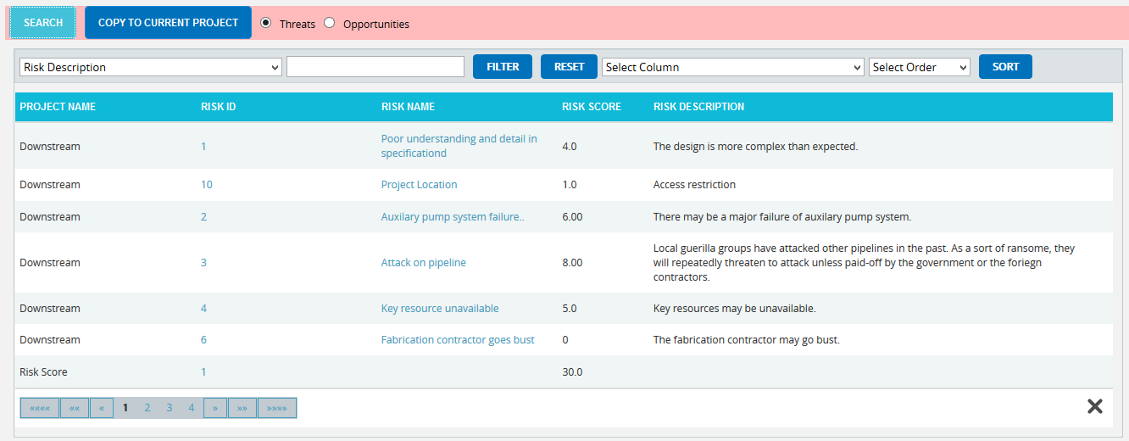
Figure 2
To Filter the search area contents
Steps:
- Select the required column. (Figure 2)
- Enter the value based on which filtering is to be done. (Figure 2)
- Click the Filter button. (Figure 2)

To Sort the data
- Select the required column. (Figure 2)
- Select the order(Ascending/Descending) in which sorting is to be done. (Figure 2)
- Click the Sort button to sort the data in the search area. (Figure 2)
To reset the details for filter and sort fields, click the Reset button. (Figure 2)

User Defined Fields Section:
Any user defined or custom field will be shown in this section. There is no limit to the number of user defined fields. In Search Risks (Threats) even though user defined fields are visible they cannot be copied to the current project.
User Defined Fields are added as follows:
Project settings ---> Custom Fields

Risk Notes Section:
The Risk notes added from Risk Details (Threats) or Spreadsheet View (Threats) are visible in this section. The user cannot add or edit risk notes from Search Risks (Threats).

Recovery Plan Section:
The Recovery Plan section is used to document what will be done if a mitigation is not successful and the risk event does occur. It also documents the steps the team should be prepared to take if the risk becomes a reality. If a Recovery plan has been added to the selected threat it will be visible in this section. Users cannot add or edit the recovery plan from Search Risks (Threats).

Closure Section:
The Closure Section is used for documenting the actual impact of the risk event on the project.

Qualitative Score Section:
Qualitative Score fields include Probability, Cost, Schedule and Additional Impacts, if any. (Figure 1) These fields are used to set the pre-mitigated score. If Probability and impacts have a value of either Undefined or No Risk, the risk score will be zero. Even though the risk score of a selected threat is visible it cannot be copied to the selected project.

Data Mapping Section:
The Data Mapping section shows which Breakdown structure the selected threat is mapped to, and at what level (Project, Business Unit, or Enterprise). It is not required to map data, but it will be useful when the time comes to report at the portfolio level.
Project Organizational Breakdown Structure, Project Work Breakdown Structure and Project Risk Breakdown structure details are added from the page:
Project Settings --->Project Breakdown Structure
Business Organizational Breakdown Structure, Business Work Breakdown Structure, Business Risk Breakdown structure, Enterprise Organizational Breakdown Structure, Enterprise Risk Breakdown structure, Enterprise Work Breakdown Structure are added from the page:
Portfolio Management ---> Manage Breakdown Structure
Enterprise Risk details are added from the page:
Portfolio Management ---> Reports ---> Enterprise Risk List

To Map data:
Steps:
- Click the map data link to map data for the corresponding field. (Figure 1)
- Select the required data from the select box. (Figure 3)
- Click the Select WBS button (if Work Breakdown Structure), Select OBS button (if Organizational Breakdown Structure), Select RBS button (if Risk Breakdown Structure) to finish. (Figure 3)
The step described above applies to all Organizational Breakdown Structure, Work Breakdown Structure and Risk Breakdown Structure fields.

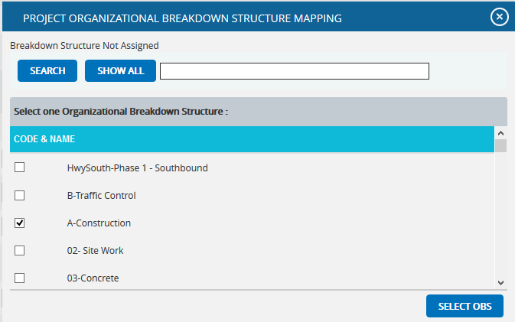
Figure 3
To search for a particular value (Figure 3), enter the value and click the Search button. To list all the values available click the Show All button.
Mitigation Details:
Users can track their Mitigation Plan or individual mitigation steps. The mitigation plan is a compilation of the individual steps below it. The mitigation plan cost is rolled up from the cost of each mitigation step. Tracking mitigation steps creates accountability when the step owner and planned dates are tracked. Reports can be generated to identify all mitigation steps that are currently behind schedule.
The qualitative and quantitative scoring fields (Probability, Cost, Schedule, etc.) in the mitigation steps represent the residual risk that remains after a mitigation step is completed. The goal is to mitigate a risk until it is gone, however often this is not possible. It is important to document any residual risk that cannot be removed for the benefit of the project team and the accuracy of Monte Carlo simulations. Any graph that highlights a post-mitigated score will focus on the residual risk after all mitigation steps have been completed. The status of a mitigation step and the actual dates should be updated as the steps are started and finished. There is an option not to copy both mitigation plan and steps or mitigation steps alone to the selected project.
If you do not want to copy both mitigation plan and steps to the selected project, click Do not Copy Mitigation Plan & Steps checkbox shown in Figure 4. If you do not want to copy just the mitigation steps, click the checkbox under the Do not Copy this Step column in Figure 5.
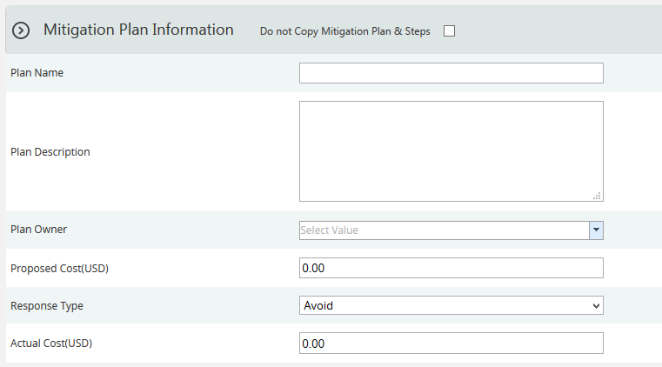
Figure 4
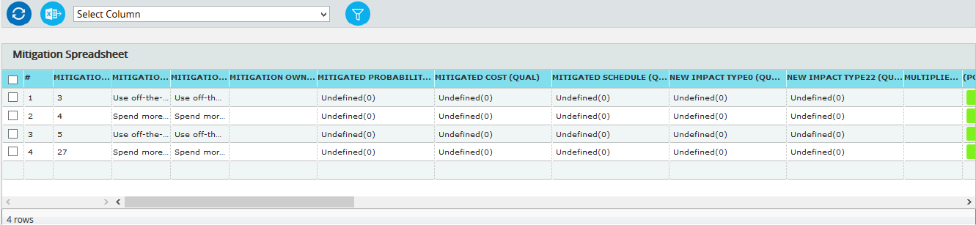
Figure 5

Copy to Current Project:
This functionality is used to copy a selected threat to the selected project.
Steps:
- Risk Register ---> Search Risks ---> Threats
- Select the required threat.
- Click the Copy To Current Project button to copy the selected threat to the current project. (Figure 1)

Search Risks (Opportunities)
The Search Risks (Opportunities) page allows you to search the company database for past and existing opportunities. The database consists of data from open and closed projects across multiple business units. This gives you the ability to analyze all risks and see if they apply to your current project. If you find a threat or opportunity that you want to copy, you have the option to include the mitigation plan/step(s) and edit the risk data before copying them over to the selected project. The Qualitative Score Fields and User Defined Fields will not be copied over since every project is different when it comes to these fields. If the project is not selected the access privileges will correspond to the selected opportunity’s project. Only opportunities of projects whose classified field is set to No will be displayed in the Search Risks section.
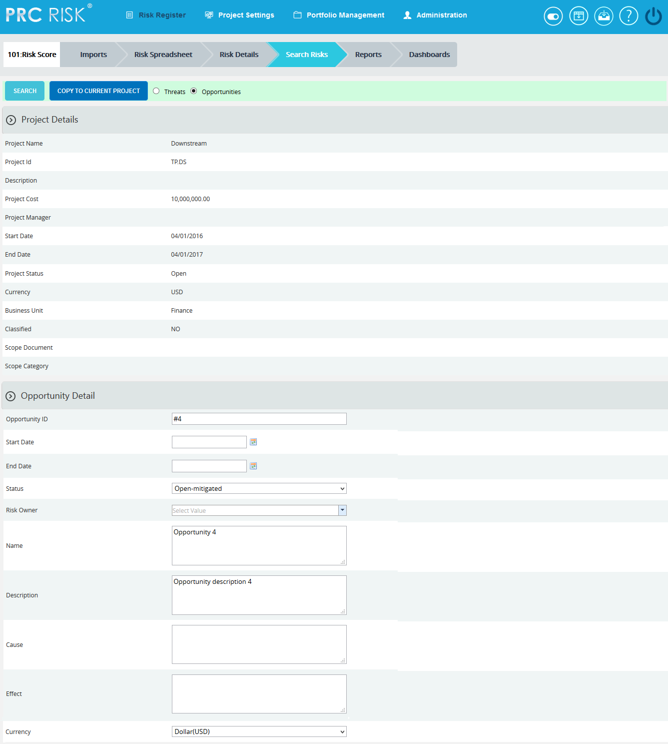
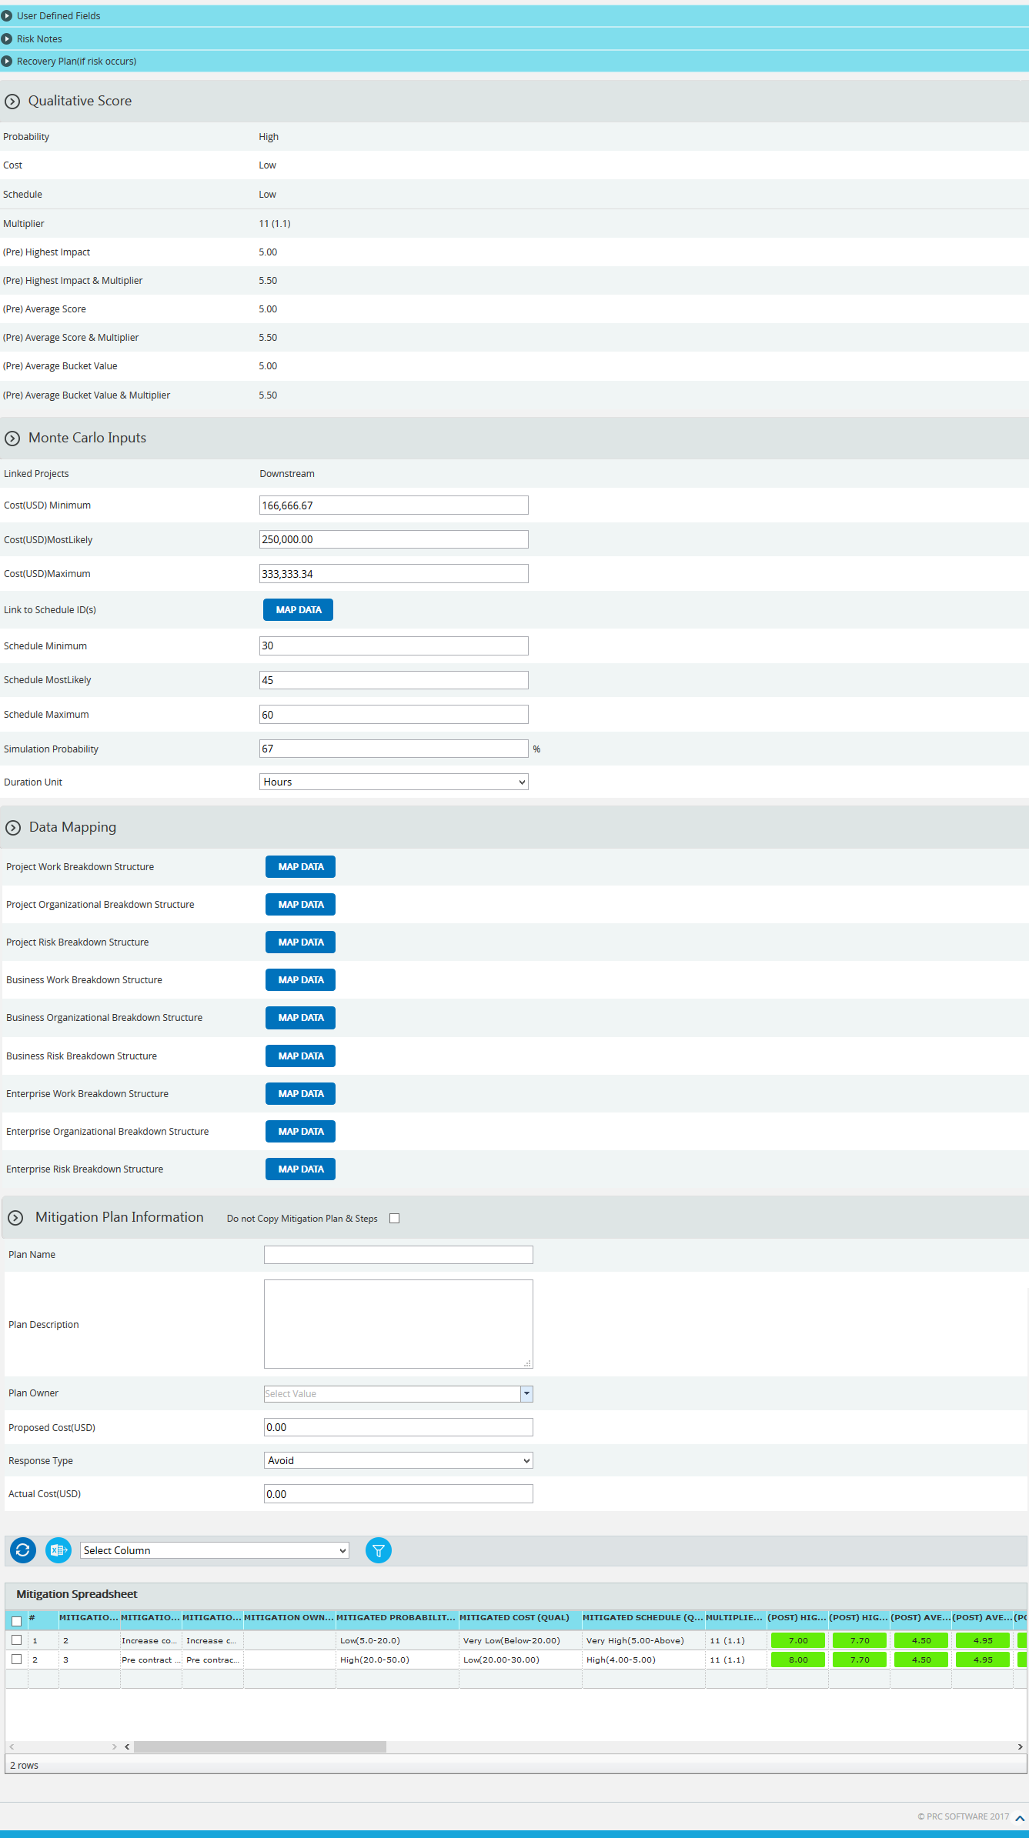
Figure 1

Navigate Page:
There is an option placed at the top of the page to navigate from one page to another. To navigate to Search Risk (Opportunities), click the Opportunities radio button shown in Figure 1.
Search:
The Search function allows the user to search for a threat based on a keyword. This method is faster when you are working with large amount of data. Opportunity details can be searched even if the project is not selected. If the project is not selected the fields correspond to the selected opportunity’s project.
Steps:
- Risk Register ---> Search Risks ---> Opportunities
- Click the Search button. (Figure 1)
- Enter the search keyword (which can be the ID or name) and click the Search button and select the required threat. (Figure 2)
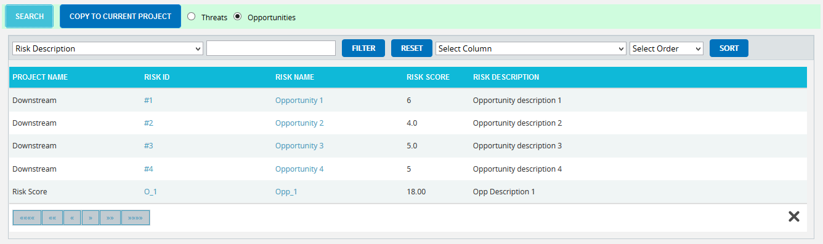
Figure 2
To Filter the search area contents
Steps:
- Select the required column. (Figure 2)
- Enter the value based on which filtering is to be done. (Figure 2)
- Click the Filter button. (Figure 2)

To Sort the data
- Select the required column. (Figure 2)
- Select the order (Ascending/Descending) in which sorting is to be done. (Figure 2)
- Click the Sort button to sort the data in the search area. (Figure 2)
To reset the details for filter and sort fields, click the Reset button. (Figure 2)

User Defined Fields Section:
Any user defined or custom field will be shown in this section. There is no limit to the number of user defined fields. In Search Risks (Opportunities) even though user defined fields are visible they cannot be copied to the current project.
User Defined Fields are added as follows:
Project settings ---> Custom Fields

Risk Notes Section:
The Risk notes added from Risk Details (Opportunities) or Spreadsheet View (Opportunities) are visible in this section. The user cannot add or edit risk notes from Search Risks (Opportunities).

Recovery Plan Section:
The Recovery Plan section is used to document what will be done if a mitigation is not successful and the risk event does occur. It also documents the steps the team should be prepared to take if the risk becomes a reality. If a Recovery plan has been added to the selected threat it will be visible in this section. Users cannot add or edit the recovery plan from Search Risks (Opportunities).

Closure Section:
The Closure Section is used for documenting the actual impact of the risk event on the project.

Qualitative Score Section:
Qualitative Score fields include Probability, Cost, Schedule and Additional Impacts, if any. (Figure 1) These fields are used to set the pre-mitigated score. If Probability and impacts have a value of either Undefined or No Risk, the risk score will be zero. Even though the risk score of a selected opportunity is visible it cannot be copied to the selected project.

Data Mapping Section:
The Data Mapping section shows which Breakdown structure the selected threat is mapped to, and at what level (Project, Business Unit, or Enterprise). It is not required to map data, but it will be useful when the time comes to report at the portfolio level.
Project Organizational Breakdown Structure, Project Work Breakdown Structure and Project Risk Breakdown structure details are added from the page:
Project Settings --->Project Breakdown Structure
Business Organizational Breakdown Structure, Business Work Breakdown Structure, Business Risk Breakdown structure, Enterprise Organizational Breakdown Structure, Enterprise Risk Breakdown structure, Enterprise Work Breakdown Structure are added from the page:
Portfolio Management ---> Manage Breakdown Structure
Enterprise Risk details are added from the page:
Portfolio Management ---> Reports ---> Enterprise Risk List

To Map data:
Steps:
- Click the map data link to map data for the corresponding field. (Figure 1)
- Select the required data from the select box. (Figure 3)
- Click the Select WBS button (if Work Breakdown Structure), Select OBS button (if Organizational Breakdown Structure), Select RBS button (if Risk Breakdown Structure) to finish. (Figure 3)
The step described above applies to all Organizational Breakdown Structure, Work Breakdown Structure and Risk Breakdown Structure fields.
Figure 3
To search for a particular value (Figure 3), enter the value and click the Search button. To list all the values available click the Show All button.
Mitigation Details:
Users can track their Mitigation Plan or individual mitigation steps. The mitigation plan is a compilation of the individual steps below it. The mitigation plan cost is rolled up from the cost of each mitigation step. Tracking mitigation steps creates accountability when the step owner and planned dates are tracked. Reports can be generated to identify all mitigation steps that are currently behind schedule.
The qualitative and quantitative scoring fields (Probability, Cost, Schedule, etc.) in the mitigation steps represent the residual risk that remains after a mitigation step is completed. The goal is to mitigate a risk until it is gone, however often this is not possible. It is important to document any residual risk that cannot be removed for the benefit of the project team and the accuracy of Monte Carlo simulations. Any graph that highlights a post-mitigated score will focus on the residual risk after all mitigation steps have been completed. The status of a mitigation step and the actual dates should be updated as the steps are started and finished. There is an option not to copy both mitigation plan and steps or mitigation steps alone to the selected project.
If you do not want to copy both mitigation plan and steps to the selected project, click Do not Copy Mitigation Plan & Steps checkbox shown in Figure 4. If you do not want to copy just the mitigation steps, click the checkbox under the Do not Copy this Step column in Figure 5.

Figure 4
Figure 5

Copy to Current Project:
This functionality is used to copy a selected threat to the selected project.
Steps:
- Risk Register ---> Search Risks ---> Threats
- Select the required threat.
- Click the Copy To Current Project button to copy the selected threat to the current project. (Figure 1)

Manager’s Dashboard (Project)
The Manager's Dashboard page shows up to 6 graphs which are chosen by the user. The graphs shown on this page must be created on the Standard Reports (Project) page. The Manager's Dashboard gives you the ability to quickly view critical project information and export them to MS Word and MS Power Point.
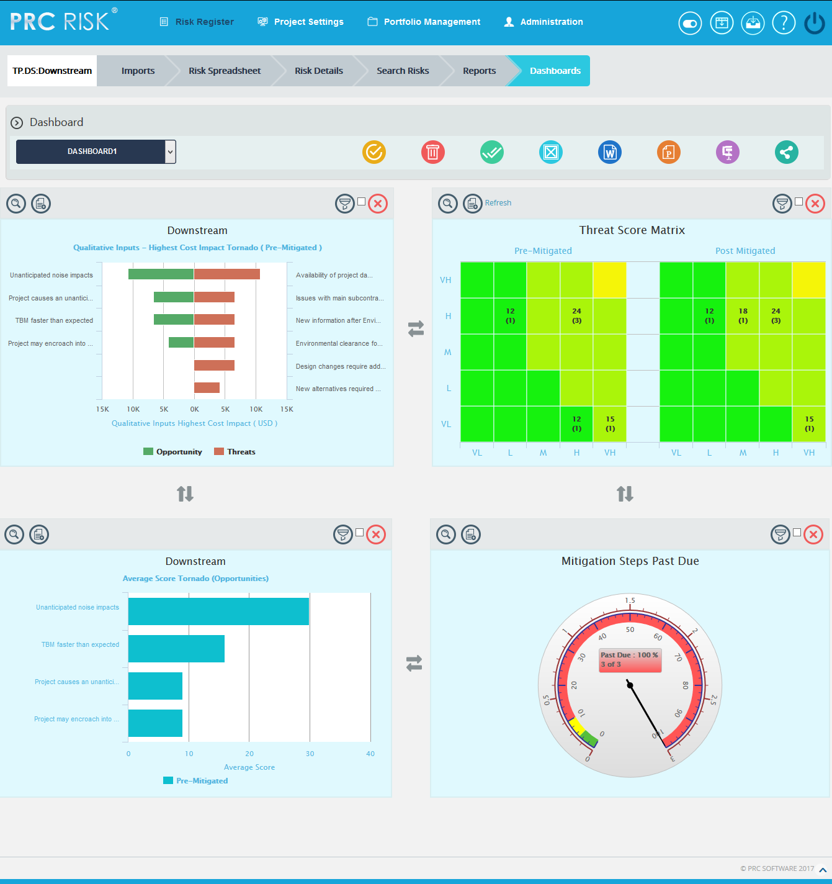
Figure 1

Show Dashboard:
This functionality is used to show the corresponding dashboard selected. In Figure 1, there is a select box which contains dashboard names. Each dashboard name generates the dashboard associated with it.
Steps:
- Risk Register --->Dashboards --->Manager’s Dashboard
- Select the name of the dashboard from the Project Dashboard dropdown. (Figure 1)
- Click the Show button to navigate to view the dashboard. (Figure 1)
To navigate to Project Dashboard:
Steps:
- Risk Register --->Dashboards --->Manager’s Dashboard
- Select the Project Dashboard from the Project Dashboard dropdown. (Figure 1)
- Click the Show button to navigate to Project Dashboard page. (Figure 1)

Delete Dashboard:
This functionality is used to delete the corresponding dashboard selected.
Steps:
- Risk Register --->Dashboards --->Manager’s Dashboard
- Select the Dashboard Name from the Project Dashboard dropdown. (Figure 1)
- Click the Delete button to delete the selected Dashboard. (Figure 1)

Export to Word:
This functionality is used to export the selected chart to MS Word.
Steps:
- Risk Register --->Dashboards --->Manager’s Dashboard
- Select the chart using the provided checkbox in the corner of each chart. (Figure 1)
- Click the Open in Word icon to export the chart to MS Word. (Figure 1)

Export to Power Point:
This functionality is used to export the selected chart to MS Power Point.
Steps:
- Risk Register --->Dashboards --->Manager’s Dashboard
- Select the chart using the provided checkbox in the corner of each chart. (Figure 1)
- Click the Power Point icon to export the chart to MS Power Point. (Figure 1)

Compress Files:
This functionality is used to compress the selected images to a Zip file.
Steps:
- Risk Register --->Dashboards --->Manager’s Dashboard
- Select the chart using the provided checkbox in the corner of each chart. (Figure 1)
- Click the Compress Files icon. (Figure 1)

Check All:
This functionality is used to select all the charts. Click the Check All icon to select all the charts. (Figure 1)

Uncheck All:
This functionality is used to uncheck the selected charts. Click the Uncheck All icon to uncheck the charts selected.

Set as default:
This functionality is used to make the selected dashboard as the default dashboard. Click the Set as Default icon to set a dashboard as default. (Figure 1)

Refresh:
This functionality is used to refresh the chart with the most recent data from the project database. To refresh the chart, click the Refresh icon. (Figure 1)

Reposition Arrows:
This functionality allows the user to move the selected chart to another position on the page. To reposition a selected chart, click the Reposition arrows nearby. (Figure 1)

Filter:
To view the filter applied to the chart, click the Show Filter icon. (Figure 1) An example of the screen that appears after filter is clicked is shown in Figure 2.
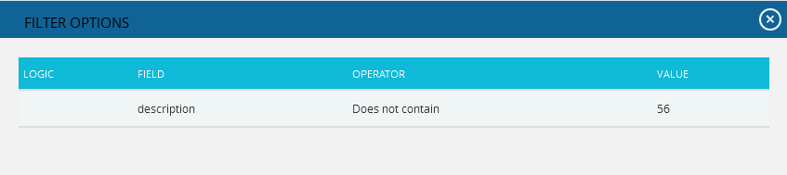
Figure 2
If the user changes the business unit on Manage Projects page for the projects in a particular chart which is already added on dashboard in which filter is applied, then on clicking the Refresh button those filters will be removed from the chart.

Delete From Dashboard:
This functionality allows you to delete a chart from the Manager's Dashboard (Portfolio). To delete a chart, click the Delete icon above each chart. (Figure 1)
Drill Down:
This functionality allows you to redirect to the particular report page in Standard reports (Portfolio) from where the chart is added. To redirect a chart, click the Drill Down icon. (Figure 1)

Copy to Dashboard:
This functionality allows you to copy a particular chart to another dashboard. Click the Copy to Dashboard icon.
Steps:
- Risk Register --->Dashboards --->Manager’s Dashboard.
- Click the Copy to Dashboard icon. (Figure 1)
- A pop up appears. (Figure 3) Select the name of the dashboard from the Name dropdown, to which the chart has to be copied.
- Click Save button. (Figure 3)
Figure 3

Share Dashboard:
This functionality allows you to share one dashboard charts to a new dashboard. Click Share Dashboard icon.
Steps:
- Risk Register --->Dashboards --->Manager’s Dashboard.
- Click the Share Dashboard icon. (Figure 1)
- A pop up appears. (Figure 4) Give the name and description of the new dashboard to which the chart has to be shared. The global access option allows the user to share the dashboard globally.
- Click Save button. (Figure 4)
Figure 4

Dashboard (Project)

The Project Dashboard page shows 6 fixed graphs, the Total Risk Count, Mitigation Steps Past Due, Threat Score Matrix, Opportunity Score Matrix, Overall Score Tornado (Pre-Mitigated) and Overall Score Tornado (Post-Mitigated). The Project Dashboard is useful because you can quickly view the 6 graphs that are most commonly used at the project level. The Project Dashboard page is visible to only those users with Read/Write or View access.
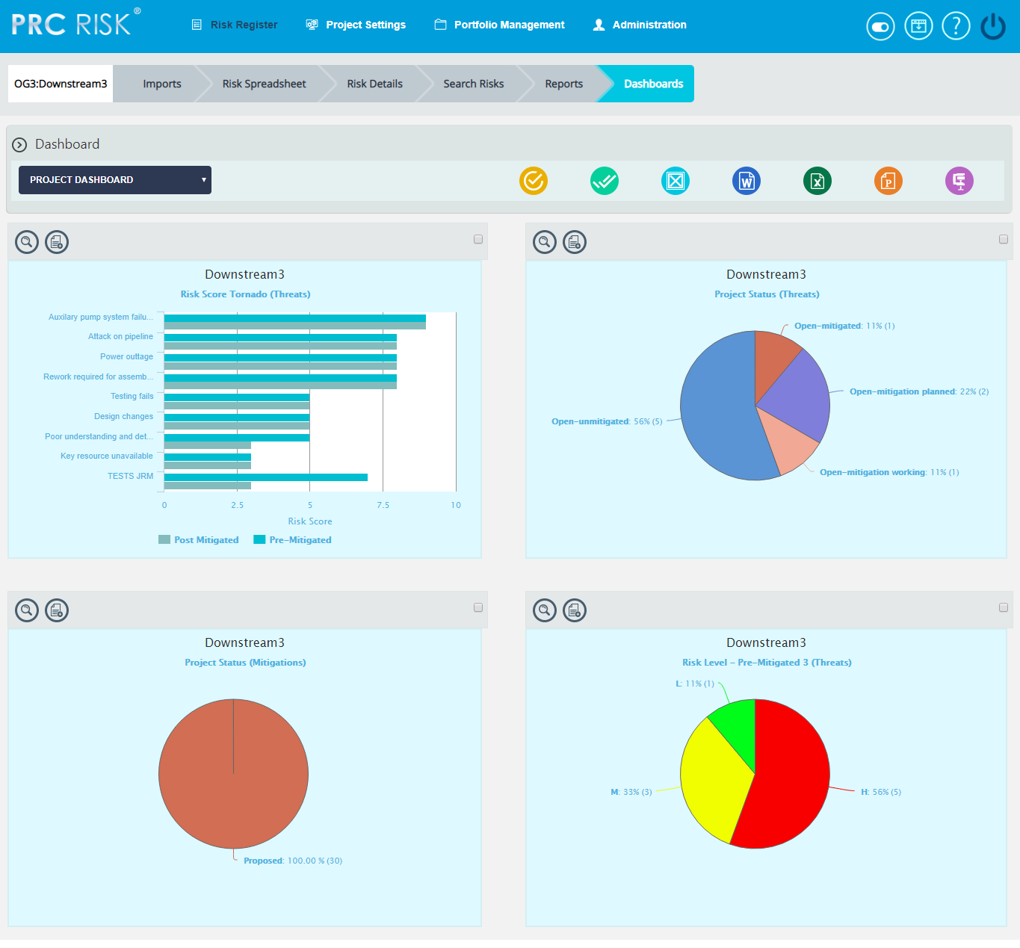
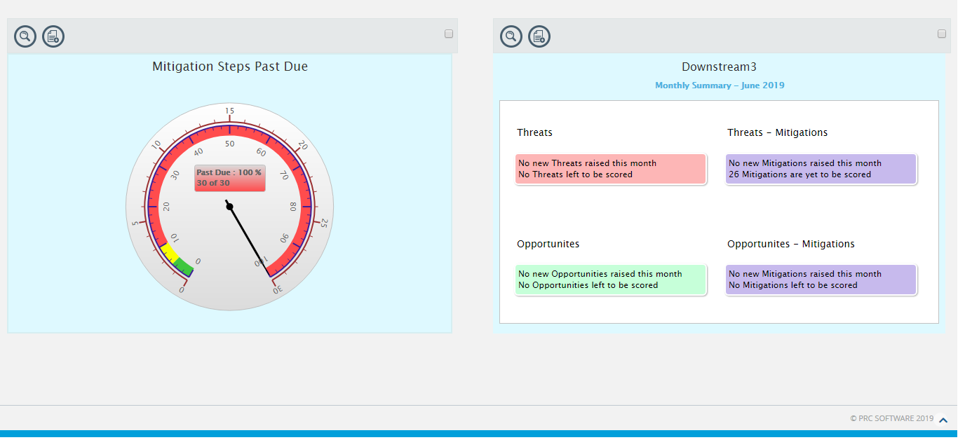
Figure 1

Show Dashboard:
This functionality is used to navigate to the Manager's Dashboard (Project) page. In Figure 1 the select box contains dashboard names. Each dashboard name generates the dashboard associated in the Manager's Dashboard (Project) page.
Steps:
- Risk Register ---> Dashboards
- Select the dashboard name from the Dashboard dropdown. (Figure 1)
- Click the Show button to navigate to the Manager's Dashboard page. (Figure 1)
Export to Word:
This functionality is used to export the selected chart to MS Word.
Steps:
- Risk Register ---> Dashboards
- Select the chart using the provided checkbox in the corner of each chart. (Figure 1)
- Click the Open in Word icon to Export the chart to MS Word. (Figure 1)

Export to Excel:
This functionality is used to export the selected chart to MS Excel.
Steps:
- Risk Register ---> Dashboard
- Select the chart using the provided checkbox in the corner of each chart. (Figure 1)
- Click the Excel icon to Export the chart to MS Excel. (Figure 1)
Export to Power Point:
This functionality is used to export the selected chart to MS Power Point.
Steps:
- Risk Register ---> Dashboards
- Select the chart using the provided checkbox in the corner of each chart. (Figure 1)
- Click the Power Point icon to Export the chart to MS Power Point. (Figure 1)
Compress Files:
This functionality is used to compress the selected images to a Zip file.
Steps:
- Risk Register ---> Dashboards
- Select the chart using the provided checkbox in the corner of each chart. (Figure 1)
- Click the Compress Files icon. (Figure 1)
Check All:
This functionality is used to select all the charts in the Project Dashboard page. Click the Check All icon to select all the charts. (Figure 1)
Uncheck All:
This functionality is used to uncheck the selected charts. Click the Uncheck All icon to uncheck the charts selected.
Set as default:
This functionality is used to make the selected dashboard as the default dashboard. Click the Set as Default icon to set a dashboard as default. (Figure 1)

Drill Down:
This functionality allows you to redirect to the particular report page in Standard reports (Portfolio) from where the chart is added. To redirect a chart, click Drill Down icon. (Figure 1)
Copy to Dashboard:
This functionality allows you to copy a particular chart to another dashboard. Click the Copy to Dashboard icon.
Steps:
- Risk Register --->Dashboards --->Manager’s Dashboard.
- Click the Copy to Dashboard icon. (Figure 1)
- A pop up appears (Figure 2). Select the name of the dashboard from the Name dropdown, to which the chart has to be copied.
- Click Save button. (Figure 2)
Figure 2

Import Mitigations
The Import Mitigations page allows the user to import mitigations. This functionality is important when you need to download a large amount of data from an existing file to the Risk Register.
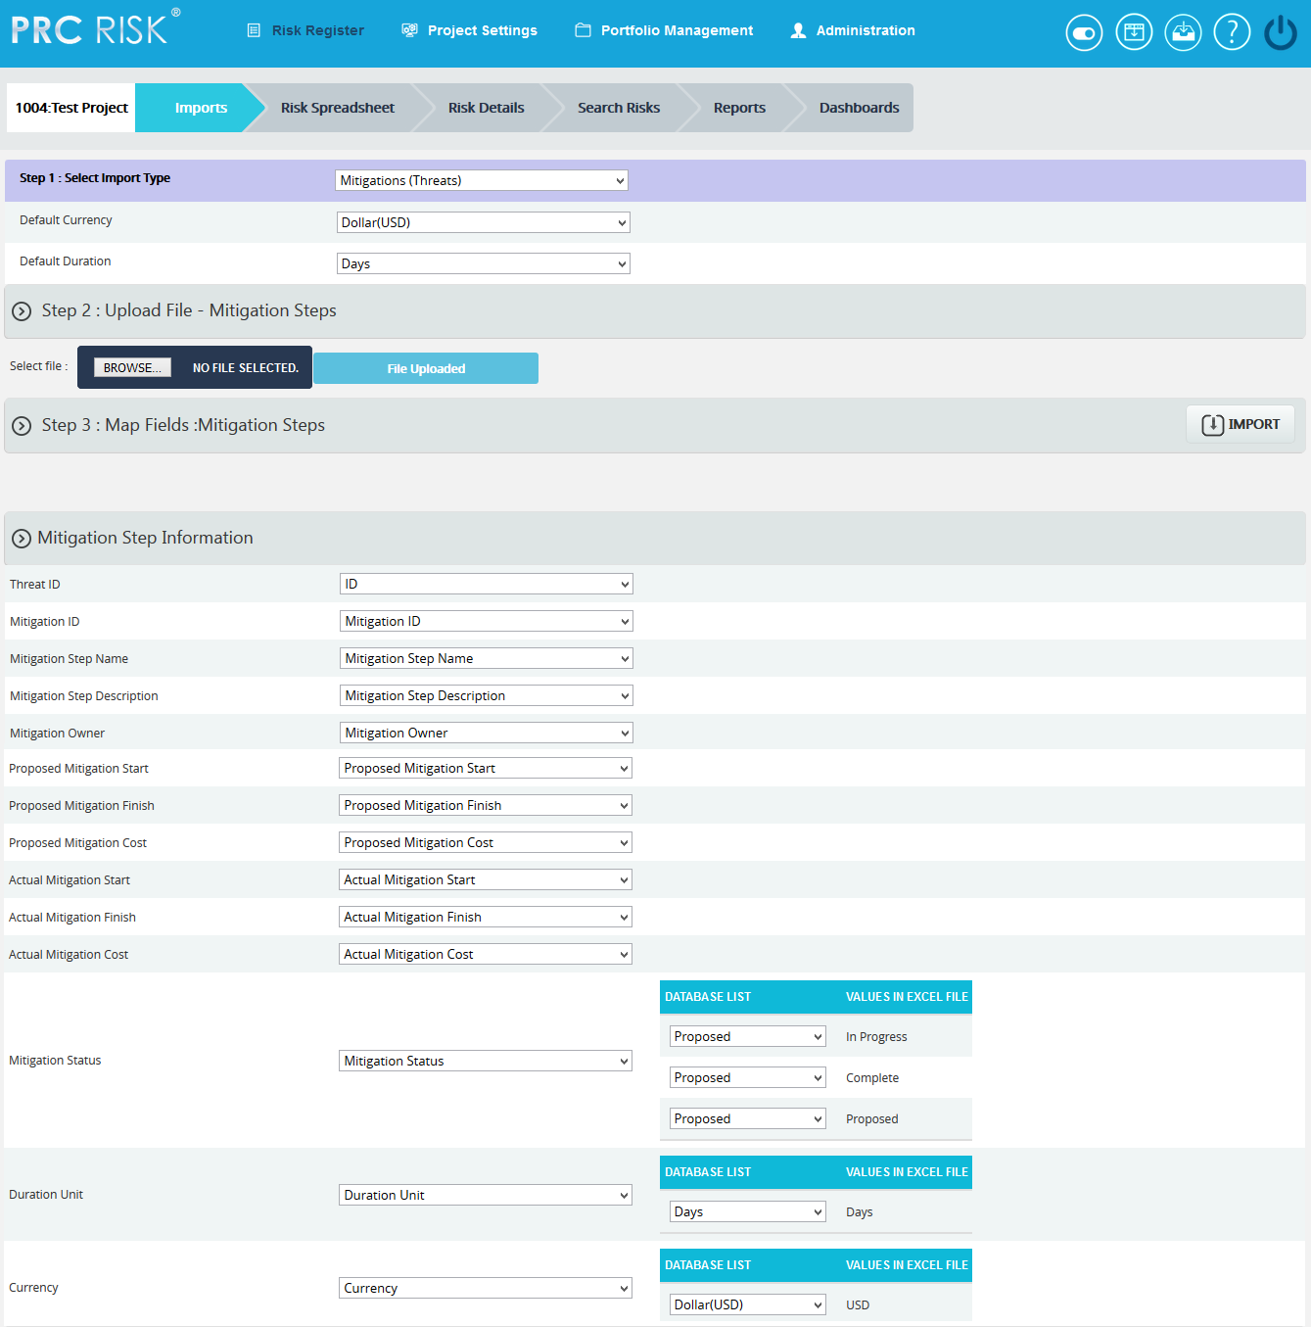
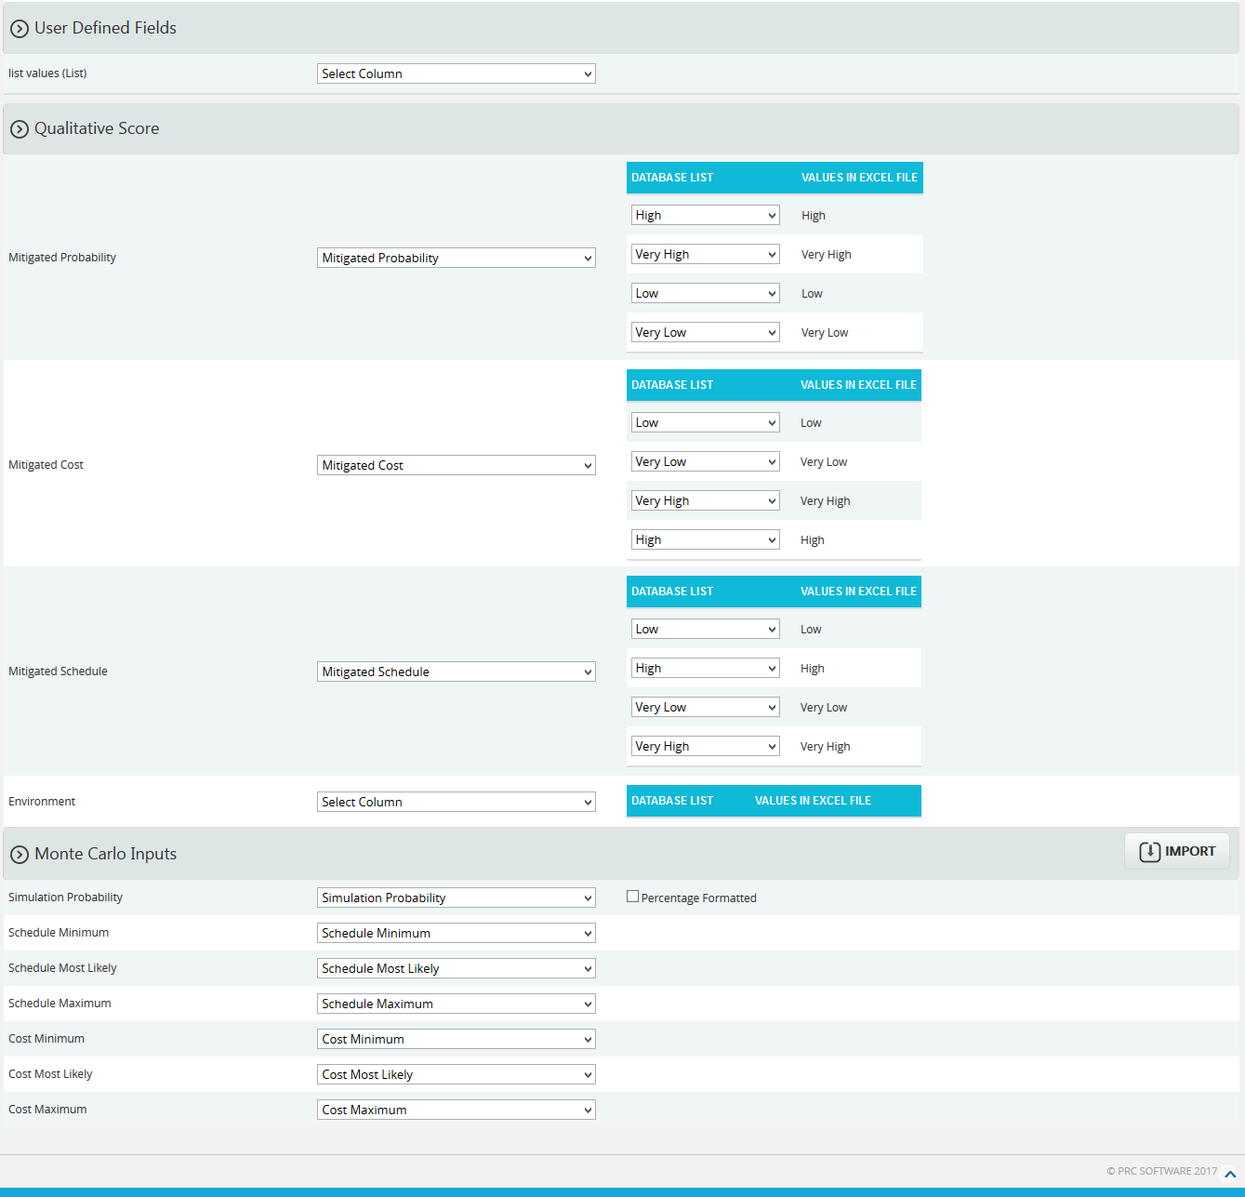
Figure 1

Navigate Page:
To go to the Import Mitigations page, navigate from the Import Risk Register page. The option for navigation from one page to another is located at the top of the page and is shown in Figure 1.
Steps:
- Risk Register ---> Imports
- Select Mitigations from Select Import Type dropdown (Figure 1) to navigate to the Import Mitigation page.
To navigate to the Import Risk Register page or the Import Opportunity Register page from the Import Mitigation page, check the steps below.
Steps:
Select Opportunities from Select Import Type dropdown (Figure 1) to navigate to the Import Opportunity Register page.
Or
Select Threats from Select Import Type dropdown (Figure 1) to navigate to the Import Risk Register page.
Upload File:
Files of type csv, xls which contain mitigation details can be uploaded. The Clear All button (Figure 3) is used to clear uploaded files. The Clear link (Figure 3) also clears the uploaded file. After the file is uploaded it must be mapped with the correct fields before saving.
Steps:
  - Risk Register ---> Imports
  - Select Mitigations (Threats)/Mitigations (Opportunities) from the dropdown. (Figure 1)
  - Click the Browse button. Select the required file. (Figure 2)
  - Click the Upload File button to finish. (Figure 3)
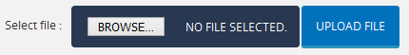
Figure 2
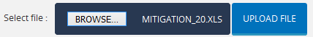
Figure 3

Select Sheet:
If the uploaded file contains more than one sheet, the user must select the sheet required.
Steps:
- Risk Register ---> Imports
- Select the sheet required and click the Change Sheet button to change the sheet. (Figure 1)
Map Data:
The Risk ID field and Mitigation Step Name must be mapped, otherwise the file will not be imported. The mapped Risk ID should correspond to the Threat/Opportunity (depends on the risk type selected). If the Threat/Opportunity does not match the Risk ID, the file cannot be imported and a validation message will be shown indicating that the Risk ID does not match.
Proposed Mitigation Start, Proposed Mitigation Finish, Actual Mitigation Start and Actual Mitigation Finish each have a date format displayed next to its field. (Figure 4) The date format is set during user creation in the Administration ---> Manage Users page under the Date Format section. Imported mitigation fields should have the same date format shown in the page. All other formats will generate an invalid date format message.

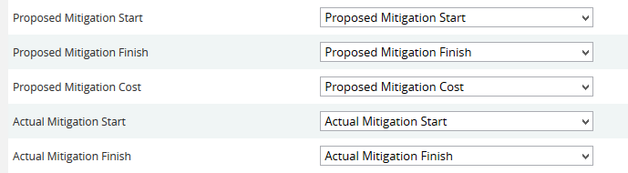
Figure 4
There are four possible values for Field Mitigation Status. The user must map the value as Proposed, In-progress, Rejected or Complete in order to import the Mitigation Status field. In Figure 5 we have mapped the mitigation status value as In Progress.

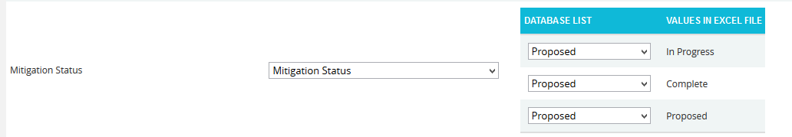
Figure 5
For the Qualitative score fields: Probability, Cost, schedule and additional impacts, (Figure 6) the user should map the corresponding fields if the score must also be imported.

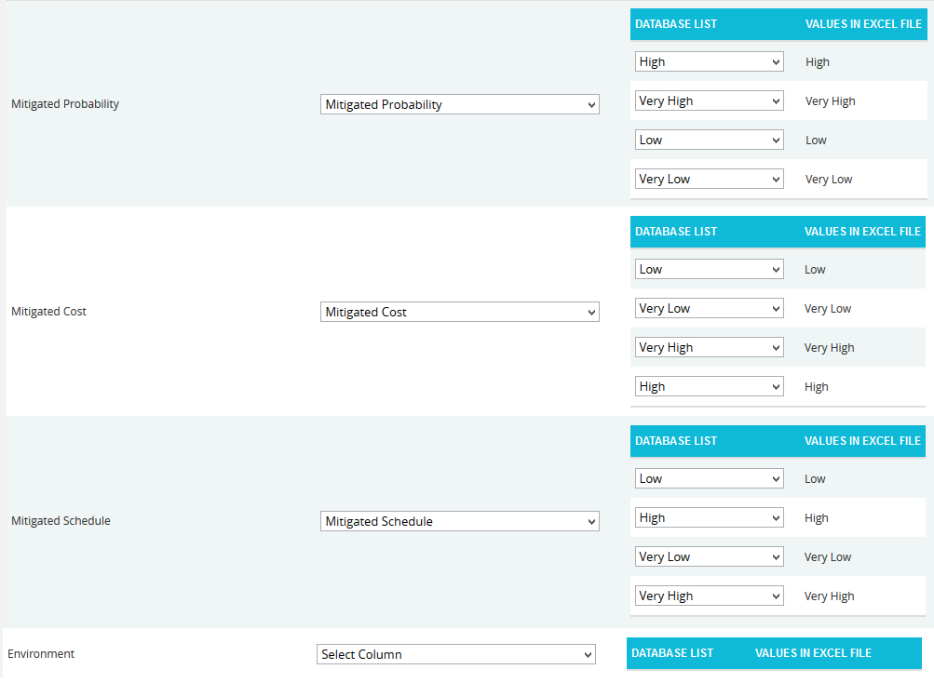
Figure 6

In the Simulation Probability field, the box for Percentage Formatted (Figure 7) should be checked if the simulation probability data is represented in percentage form.

Figure 7

Import Mitigation Details:
Once the required fields have been mapped, save the data to make it available in other pages.
Steps:
- Risk Register ---> Imports
- Select the Mitigations (Threats)/Mitigations (Opportunities) from the dropdown. (Figure 1)
- Click the Import Mitigation Data button to save the imported file. (Figure 1)
If the Imported file contains a duplicated mitigation, a validation message (Figure 8) will be generated. Click the OK button (Figure 8) to confirm, and on confirmation the mapped data is overwritten. If you do not want to overwrite the data, click the Cancel button. (Figure 8)

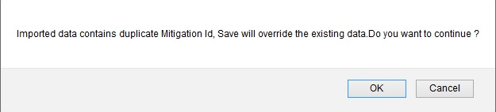
Figure 8

Import Opportunity Register
The Import Opportunity Register page allows the user to import opportunities. This functionality is helpful when downloading a large amount of data to the PRC Enterprise Risk Register from an existing file.
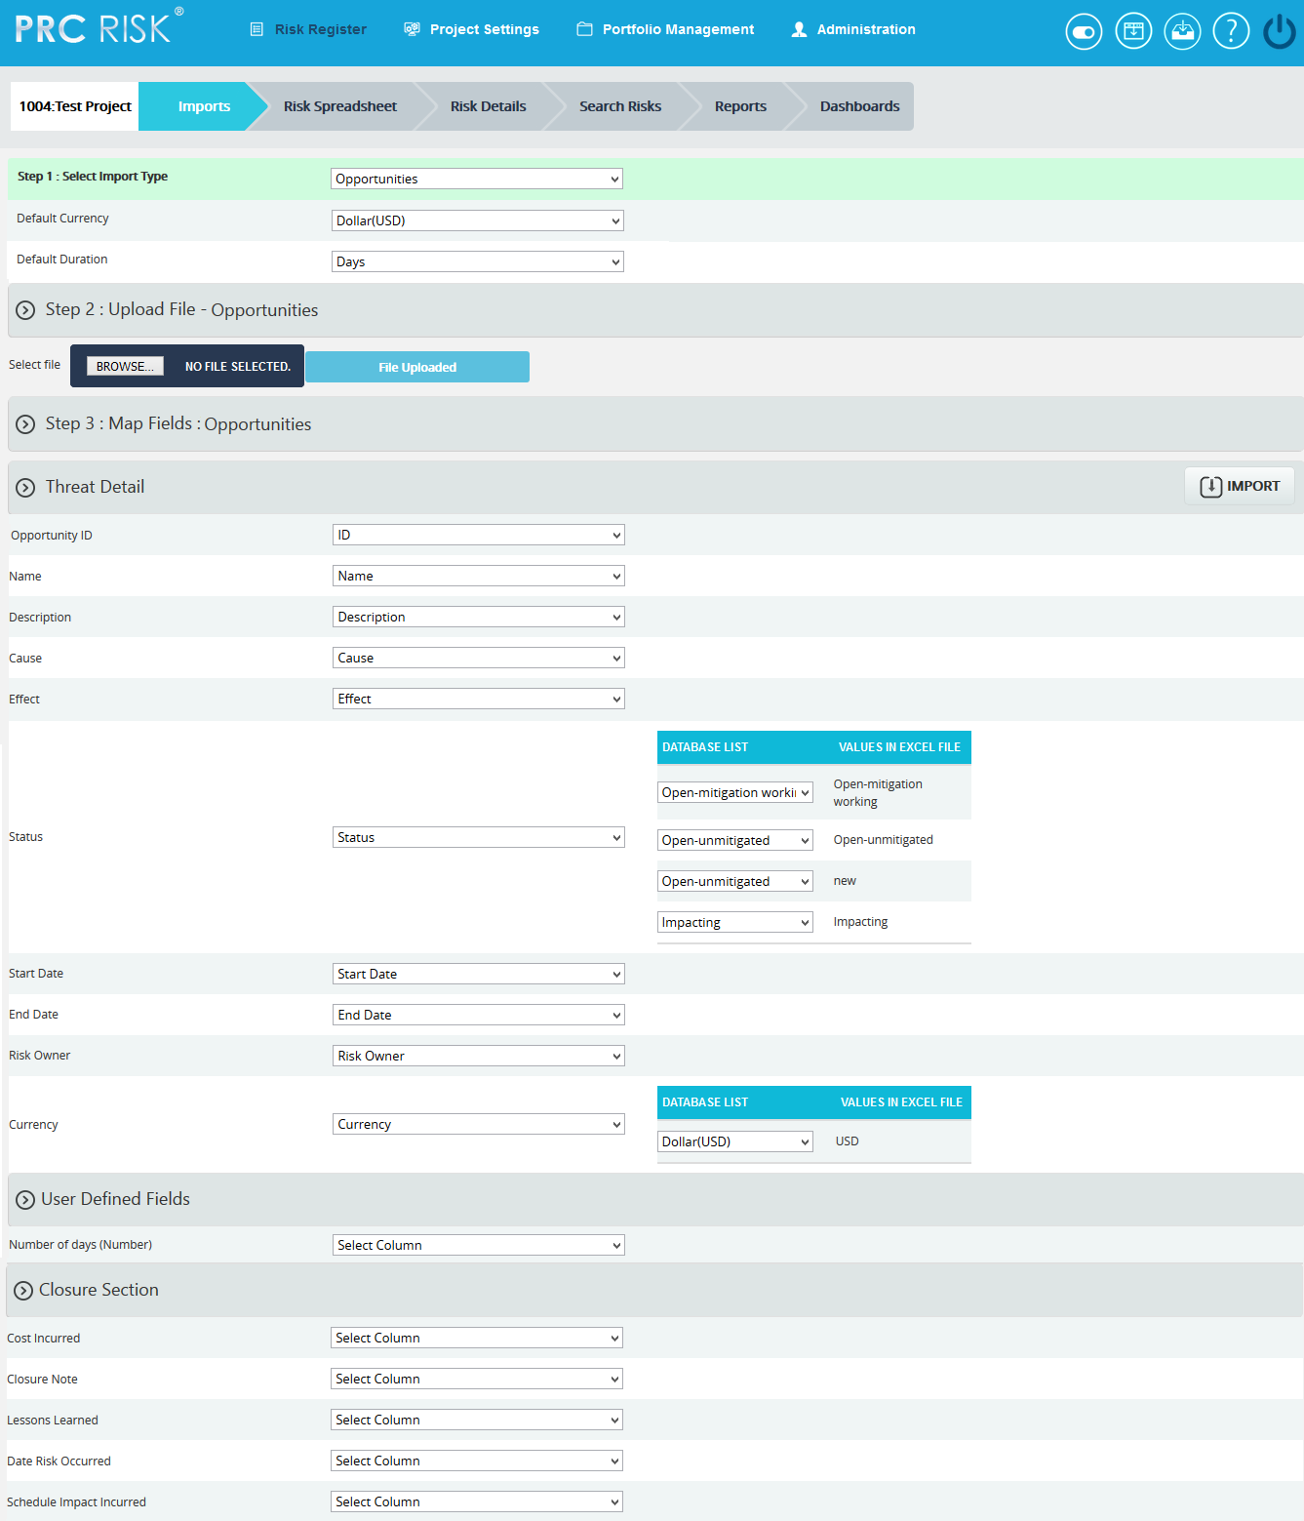
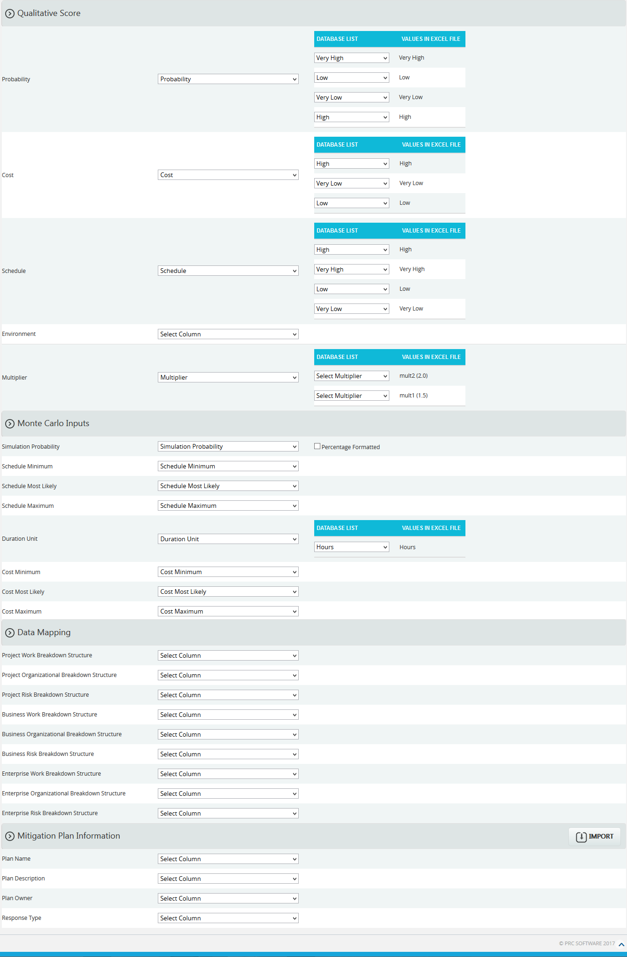
Figure 1

Navigate Page:
To go to the Import Opportunity Register page, navigate from the Import Risk Register page. The option for navigation from one page to another is placed on top of the page and is shown in Figure 1.
Steps:
- Risk Register ---> Imports
- Select Opportunities from Select Import Type dropdown (Figure 1) to navigate to the Import Opportunity Register page.
To navigate to the Import Risk Register page or the Import Mitigations page from the Import Opportunity Register page, check the following steps.
Select Mitigations from Select Import Type dropdown (Figure 1) to navigate to the Import Mitigation page.
Or
Select Threats from Select Import Type dropdown (Figure 1) to navigate to the Import Risk Register page.
Upload File:
Files of type csv, xls which contain opportunity details can be uploaded. The Clear All button (Figure 3) is used to clear uploaded files. The Clear link (Figure 3) also clears the uploaded file. After the file is uploaded it must be mapped with the correct fields before saving.
Steps:
- Risk Register ---> Imports
- Select Opportunities from dropdown. (Figure 1)
- Click the Browse button. Select the required file. (Figure 2)
- Click the Upload File button to finish. (Figure 3)
Figure 2

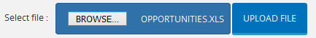
Figure 3

Select Sheet:
If the uploaded file contains more than one sheet, the user should select the required sheet.
Steps:
- Risk Register ---> Imports
- Select the sheet required; and click the Change Sheet button to change the sheet. (Figure 1)
Map Data:
The ID field must be mapped or the file will not be imported. The five values available for field status are: Open-mitigated, Open-unmitigated, Closed-no impact, Closed-rejected, and Closed-occurred. If the status field needs to be imported, the user must map the value required. In Figure 4, the value open-unmitigated has been mapped as the field status for all opportunities in the file.
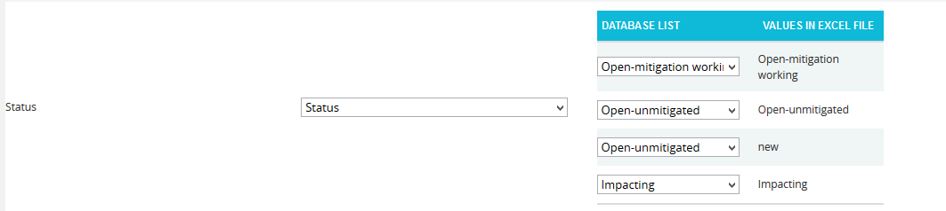
Figure 4
Start date and End date have a date format displayed next to its field. (Figure 5) This date format is set during user creation in Administration ---> Manage Users page under the Date Format section. The Imported Opportunity fields should also have the same date format shown in the page, otherwise a message will be generated indicating that the date format is invalid.

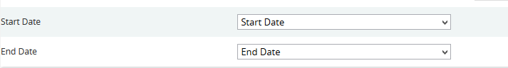
Figure 5
For the Qualitative score fields (Probability, Cost, Schedule and Additional Impacts), the corresponding fields must be mapped if the score must also be imported.
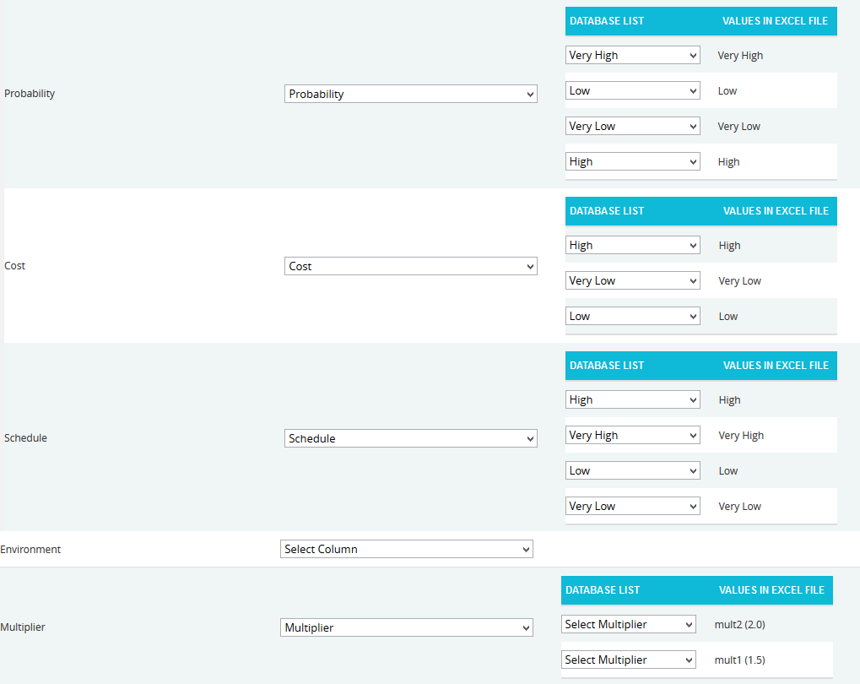
Figure 6

The checkbox Percentage Formatted is located near the Simulation Probability field. (Figure 7) It should be checked if the simulation probability data is represented in percentage form.

Figure 7

Import Opportunity Details:
Once the required fields have been mapped, save the data to make it available in other pages.
Steps:
- Risk Register ---> Imports
- Select Opportunities from dropdown. (Figure 1)
- Click the Import Opportunity Data button (Figure 1) to save the imported file.
If the Imported file contains duplicated opportunities, validation message (Figure 8) will be shown. Click the OK button (Figure 8) to confirm. Upon confirmation, the mapped data is overwritten. If the user does not want to overwrite the data, click the Cancel button. (Figure 8)
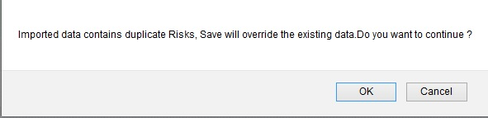
Figure 8

Import Risk Register
The Import Risk Register page allows you to import threats. This functionality is helpful when the user needs large amounts of data to be added and the user has the file which contains the threat details which can be imported. The accepted file types are .csv and .xls.
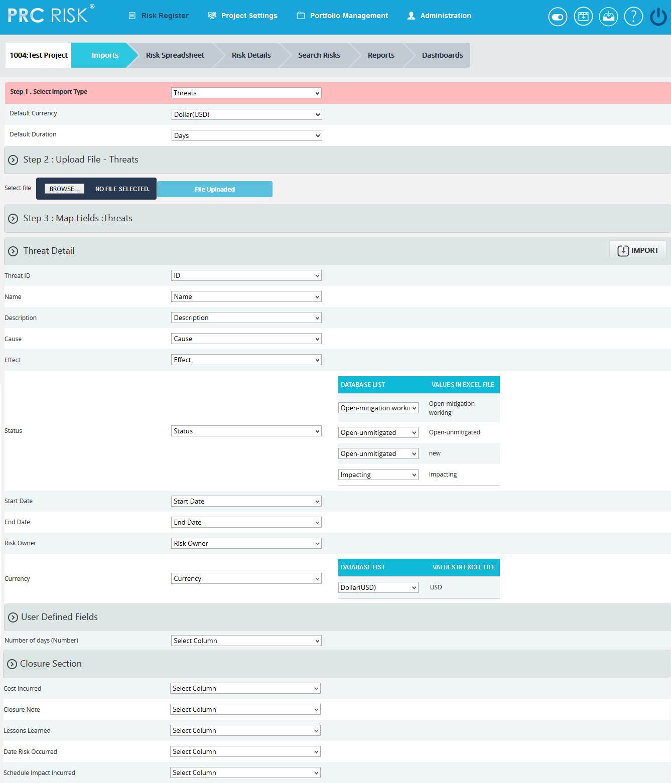
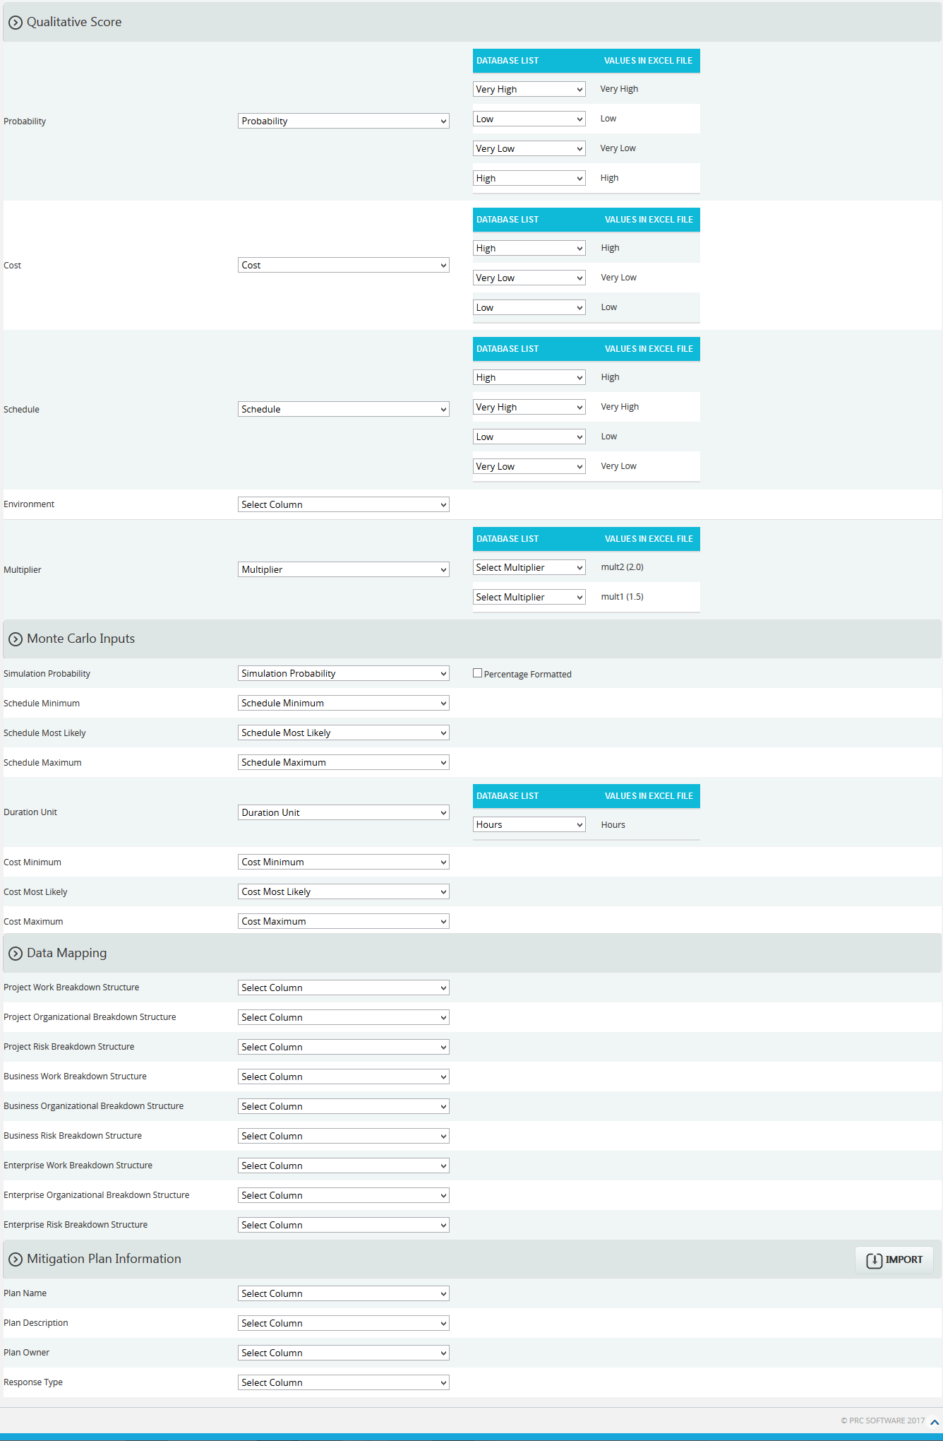
Figure 1

Navigate Page:
This functionality is used to navigate from the Import Risk Register page to the Import Page for opportunities or mitigation. To navigate to the Opportunity or Mitigation page, click on the corresponding radio button shown in Figure 1.
Steps:
- Risk Register ---> Imports
- Select Opportunities from Select Import Type dropdown (Figure 1) to navigate to the Import Opportunity Register page.
Or
Select Mitigations from Select Import Type dropdown (Figure 1) to navigate to the Import Mitigations page.
Upload File:
Files of type csv, xls which contain threat details can be uploaded. The Clear All button (Figure 3) is used to clear uploaded files. The Clear link (Figure 3) also clears the uploaded file. After the file is uploaded, it must be mapped with the correct fields before saving.
Steps:
- Risk Register ---> Imports
- Click the Browse button. Select the required file. (Figure 2)
- Click the Upload File button to finish. (Figure 3)
Figure 2
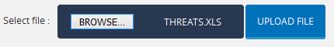
Figure 3

Select Sheet:
If the uploaded file contains more than one sheet, the user should select the sheet required.
Steps:
- Risk Register ---> Imports
- Select the sheet required and click the Change Sheet button to change the sheet. (Figure 1)
Map Data:
The Id field must be mapped for the file to be imported. There are five available values: Open-mitigated, Open-unmitigated, Closed-no impact, Closed-rejected, and Closed-occurred. The field status requires the value to be mapped if the status field needs to be imported. In Figure 4, the value Open-unmitigated is being mapped for the field status for all the threats in the file.
Figure 4
Start date and End date has a date format displayed next to its field. (Figure 5) This date format is set during user creation in Administration ---> Manage Users page under the Date Format section. The Imported Threat fields should also have the same date format shown in the page or a validation message will appear indicating the date format is invalid.

Figure 5
For the Qualitative score fields such as Probability, Cost, Schedule and Additional Impacts, the user should map the corresponding fields if the score must also be imported.

Figure 6

The Simulation Probability field (Figure 7) includes a checkbox for Percentage Formatted. When the simulation probability data is represented as a percentage, this box should be checked.
Figure 7

Import Threat Details:
Once the required fields have been mapped, Save the data to make it available in other pages.
Steps:
- Risk Register ---> Imports
- Click the Import Risk Data button to save the imported file. (Figure 1)
If the Imported file contains duplicated threats, a validation message (Figure 8) will be shown. Click the OK button (Figure 8) to confirm. Upon confirmation, the mapped data is overwritten. If you don’t want to overwrite the data you can click the Cancel button (Figure 8).
Figure 8

Manage Email Update

The Manage Email Update page shows all emails received by the logged in user and allows to update those mails if necessary. This page shows the name of the project, sender, subject and the time the email was received. If it is a bulk email, it also shows the number of risks attached with the mail. The user can only update an email, if the received data of a threat or opportunity is not deleted from the project.
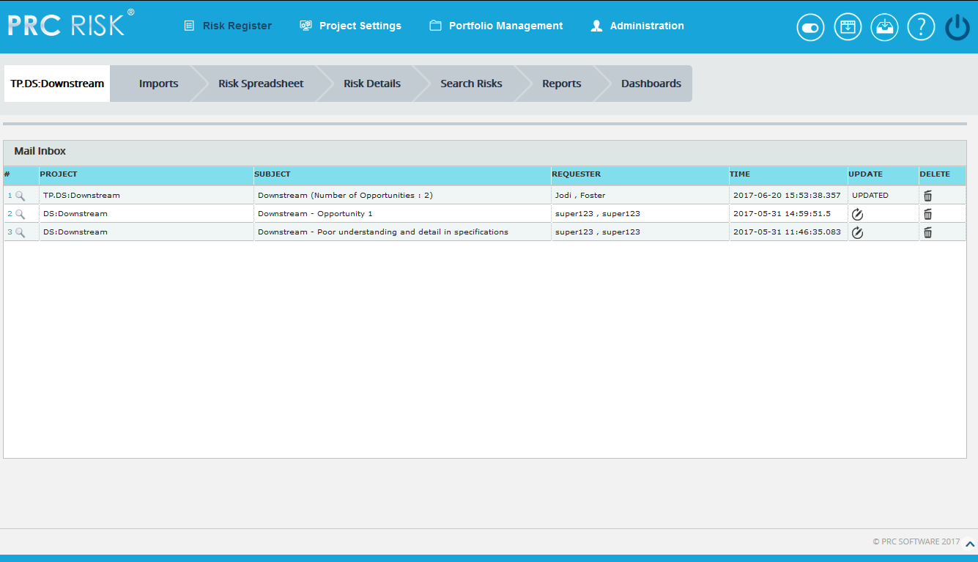
Figure 1
Drill Down:
The drill down icon is shown in the first column of each email received. If the icon is clicked, it navigates to the Email Updation page where the user can update the corresponding risk.
Update:
The emails can be updated by a click on the icon shown in the Update column of the inbox. An email can only be updated once. If it is done, the column shows UPDATED.
Delete:
The user can delete an email received by a click on the delete icon at the each row.

Email Updation
The Email Updation page allows user to update the email received in the email inbox. The user can update a risk only once through this page. Data can be entered in the corresponding boxes of each risk or mitigation and save for updating.
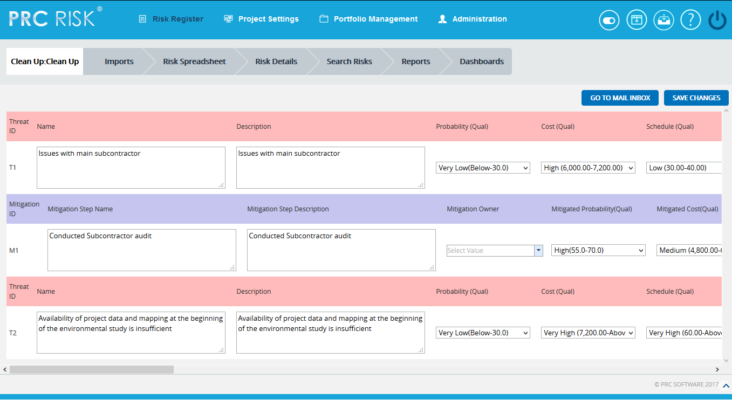
Figure 1
Go To Mail Inbox:
The user will be navigated to the Manage Email Update page when this button is clicked.
Save Changes:
The risk or mitigations are saved by a click on this button.

Automation Rules

ORIGINAL SETTING | NEW SETTING | OUTPUT
Mitigation Status = proposed | In Progress | Mark the actual start date with today's date.
Mitigation Status = proposed | Complete | Mark the actual start date with today's date and the actual finish with today's date.
Mitigation Status = In Progress | Proposed | Remove the actual start date.
Mitigation Status = In Progress | Rejected | Remove the actual start date.
Mitigation Status = In Progress | Complete | Mark the actual finish with today's date.
Mitigation Status = In Progress | Approved | Remove the actual start date.
Mitigation Status = Rejected | In Progress | Mark the actual start with today's date.
Mitigation Status = Rejected | Complete | Mark the actual start date with today's date and the actual finish with today's date.
Mitigation Status = Complete | Proposed | Remove the actual start and finish dates.
Mitigation Status = Complete | In Progress | Remove the actual finish date.
Mitigation Status = Complete | Approved | Remove the actual start and finish dates.
Mitigation Status = Complete | Rejected | Remove the actual start and finish dates.
Mitigation Status = Approved | In Progress | Mark the actual start with today's date.
Mitigation Status = Approved | Complete | Mark the actual start date with today's date and the actual finish with today's date.
Mitigation Status = Risk Closed | Proposed | Remove the actual start and finish dates.
Mitigation Status = Risk Closed | In Progress | Mark the actual start with today's date unless it is already marked and remove the actual finish if there is one.
Mitigation Status = Risk Closed | Rejected | Remove the actual start and finish dates if they exist.
Mitigation Status = Risk Closed | Approved | Remove the actual start and finish dates if they exist.
Risk Status = Open (Any) or Impacting | Closed (Any) | Set all mitigation status to "Risk Closed." Do not change the actual dates.
User sets an actual start on mitigation |  | Set mitigation status to In Progress unless it is already in In Progress or Complete status.
User sets an actual finish on a mitigation |  | Set mitigation status to Complete if not already in Complete status.
Create new risk | Set risk ID based on a timestamp | Set the risk ID based on a timestamp if the user did not type in the ID column to create the risk. ID = T + timestamp for threats. O + timestamp for opportunities. User can overwrite.
Create new mitigation step | Set mitigation ID based on a timestamp | Set the risk ID based on a timestamp if the user did not type in the ID column to create the mitigation. ID = M + timestamp. User can overwrite.

FIELD DESCRIPTION

Administration
1. User Management

Field Name | Data Type | Width
First Name | Text | 200
Last Name | Text | 200
Email | Text | 200
Address1 | Text | 250
Address2 | Text | 250
City | Text | 50
State | Text | 50
Phone | Text | 15
Country | Text | 50
User Name | Text | 200
Password | Text | 50

2. Manage Projects

Field Name | Data Type | Width
Project Name | Text | 250
Project Id | Text | 200
Description | Text | 8000
Project Cost | Float
Project Manager | Text | 50
Start Date | Date
End Date | Date
Project Status | Text | 50
Currency | Text | 50
Classified(Uncheck for 'No') | Yes / No
Scope Category | Text | 50
Scope Document | Text | 50

- Currency Settings
Field Name | Data Type | Width
Exchange Rate | Float

- Enterprise Project Structure

Field Name | Data Type | Width
Name | Text | 150
Description | Text | 8000

- Access Manager
Field Name | Data Type | Width
Role Name | Text | 500

Portfolio Management

  - Scoring System

Field Name | Data Type | Width
Template Name | Text | 200
Template Description | Text | 8000
Probability
Short Name | Text | 50
Full Name | Text | 100
Lower Threshold | Float
Upper Threshold | Float
Tolerance
Short Name | Text | 50
Full Name | Text | 100
Lower Threshold | Float
Upper Threshold | Float
Impact
Short Name | Text | 50
Full Name | Text | 50
Additional Impact
Impact Type | Text | 2000
Description | Text | 2000

  - Field Settings

Field Name | Data Type | Width
Template Name | Text | 200
Template Description | Text | 8000
ID | Text | 250
Name | Text | 250
Description | Text | 250
Cause | Text | 250
Effect | Text | 250
Status | Text | 250
Start Date | Text | 250
End Date | Text | 250
Risk Owner | Text | 250
Currency | Text | 250
Plan Name | Text | 250
Plan Description | Text | 250
Plan Owner | Text | 250
Response Type | Text | 250
Total Cost | Text | 250
Proposed Cost | Text | 250
Actual Cost | Text | 250
Mitigation Step Name | Text | 250
Mitigation Step Description | Text | 250
Mitigation Owner | Text | 250
Response Type | Text | 250
Proposed Mitigation Start | Text | 250
Proposed Mitigation Finish | Text | 250
Actual Mitigation Start | Text | 250
Actual Mitigation Finish | Text | 250
Actual Mitigation Cost | Text | 250
Mitigated Probability | Text | 250
Mitigated Schedule Score | Text | 250
Mitigated Cost Score | Text | 250
Mitigated Risk Score | Text | 250
Proposed Mitigation Cost | Text | 250
Mitigation Status | Text | 250
Cost Incurred | Text | 250
Date Risk Occurred | Text | 250
Schedule Impact Incurred | Text | 250
Closure Note | Text | 250
Lessons Learned | Text | 250
Probability | Text | 250
Cost | Text | 250
Schedule | Text | 250
Multiplier | Text | 250
(Pre)Highest Impact | Text | 250
(Pre) Highest Impact & Multiplier | Text | 250
(Pre) Average Score | Text | 250
(Pre) Average Score & Multiplier | Text | 250
(Pre)Average Bucket Value | Text | 250
(Pre)Average Bucket Value & Multiplier | Text | 250
(Post)Highest Impact | Text | 250
(Post) Highest Impact & Multiplier | Text | 250
(Post)Average Score | Text | 250
(Post)Average Score &Multiplier | Text | 250
(Post)Average Bucket Value | Text | 250
(Post)Average Bucket Value & Multiplier | Text | 250
Project Name | Text | 250
Link To Schedule Id(s) | Text | 250
Simulation Probability | Text | 250
Cost | Text | 250
Schedule | Text | 250
Duration Unit | Text | 50
Project Work Breakdown Structure | Text | 250
Project Organizational Breakdown Structure | Text | 250
Project Risk Breakdown Structure | Text | 250
Business Work Breakdown Structure | Text | 250
Business Organizational Breakdown Structure | Text | 250
Business Risk Breakdown Structure | Text | 250
Enterprise Work Breakdown Structure | Text | 250
Enterprise Organizational Breakdown Structure | Text | 250
Enterprise Risk Breakdown Structure | Text | 250
Enterprise Risk | Text | 250
Date | Text | 250
User | Text | 250
Notes | Text | 250
Recovery Plan Name | Text | 250
Recovery Plan Description | Text | 250
Recovery Plan Notes | Text | 250

  - Custom Fields

Field Name | Data Type | Width
Template Name | Text | 200
Template Description | Text | 8000
Name | Text | 250
List | Text | 200

  - Breakdown Structures

Field Name | Data Type | Width
Enterprise level Breakdown Structure
Code | Text | 250
Name | Text | 250
Business unit Breakdown Structure
Business Unit Name | Text | 250
Code | Text | 250
Name | Text | 250

  - Standard Reports

Field Name | Data Type | Width
Filter
Logic | Text | 500
Field | Text | 250
Operator | Text
Value(text) | Text
Value(date) | Date
Value(number) | Text | 250
Chart Manager
Chart Name | Text | 250
Background Color | Text | 250
Pre-Mitigated | Text | 250
Post-Mitigated | Text | 250
Open-Mitigated-Working | Text | 250
Open-Mitigated-Planned | Text | 250
Closed-No impact | Text | 250
Closed-Occurred | Text | 250
Text Color | Text | 250
Plot Background Color | Text | 250
Threat Color | Text | 250
Opportunity Color | Text | 250
Legend1 | Text | 350
Legend2 | Text | 350
Title | Text | 350
Color1 | Text | 250
Color2 | Text | 250
Color3 | Text | 250
Color4 | Text | 250
Color5 | Text | 250
Color6 | Text | 250
Color7 | Text | 250
Color8 | Text | 250
x-axis | Text | 350
y -axis | Text | 350
Rejected | Text | 250

- Dashboard
Field Name | Data Type | Width
Name(In Report) | Text | 300
Description(In Report) | Text | 8000
Chart1 | Text | Max
Chart2 | Text | Max
Chart3 | Text | Max
Chart4 | Text | Max
Chart5 | Text | Max
Chart6 | Text | Max
Chart1 details | Text | Max
Chart2 details | Text | Max
Chart3 details | Text | Max
Chart4 details | Text | Max
Chart5 details | Text | Max
Chart6 details | Text | Max

Project Settings

  - Scoring System

Field Name | Data Type | Width
Probability
Short Name | Text | 50
Full Name | Text | 100
Lower Threshold | Float
Upper threshold | Float
Tolerance
Short Name | Text | 50
Full Name | Text | 100
Lower Threshold | Float
Upper Threshold | Float
Multiplier Settings
Name | Text | 255
Value | Float
Impact
Short Name | Text | 50
Full Name | Text | 500
Additional Impact
Impact Type | Text | 100
Description | Text | 2000

  - Field Settings

Field Name | Data Type | Width
ID | Text | 50
Name | Text | 500
Description | Text | 8000
Cause | Text | 8000
Effect | Text | 200
Status | Text | 200
Start Date | Text | 200
End Date | Text | 200
Risk Owner | Text | 250
Currency | Text | 250
Plan Name | Text | 200
Plan Description | Text | 200
Plan Owner | Text | 200
Response Type | Text | 200
Total Cost | Text | 200
Proposed Cost | Text | 200
Actual Cost | Text | 200
Mitigation Step Name | Text | 200
Mitigation Step Description | Text | 200
Mitigation Owner | Text | 200
Response Type | Text | 200
Proposed Mitigation Start | Text | 200
Proposed Mitigation Finish | Text | 200
Actual Mitigation Start | Text | 200
Actual Mitigation Finish | Text | 200
Actual Mitigation Cost | Text | 200
Mitigated Probability | Text | 200
Mitigated Schedule Score | Text | 200
Mitigated Cost Score | Text | 200
Mitigated Risk Score | Text | 200
Proposed Mitigation Cost | Text | 200
Mitigation Status | Text | 200
Cost Incurred | Text | 250
Date Risk Occurred | Text | 250
Schedule Impact Incurred | Text | 250
Closure Note | Text | 250
Lessons Learned | Text | 250
Probability | Text | 250
Cost | Text | 250
Schedule | Text | 250
Multiplier | Text | 250
(Pre)Highest Impact | Text | 250
(Pre) Highest Impact & Multiplier | Text | 250
(Pre) Average Score | Text | 250
(Pre) Average Score & Multiplier | Text | 250
(Pre)Average Bucket Value | Text | 250
(Pre)Average Bucket Value & Multiplier | Text | 250
(Post)Highest Impact | Text | 250
(Post) Highest Impact & Multiplier | Text | 250
(Post)Average Score | Text | 250
(Post)Average Score &Multiplier | Text | 250
(Post)Average Bucket Value | Text | 250
(Post)Average Bucket Value & Multiplier | Text | 250
Project Name | Text | 250
Link To Schedule Id(s) | Text | 250
Simulation Probability | Text | 250
Cost | Text | 250
Schedule | Text | 250
Duration Unit | Text | 250
Project Work Breakdown Structure | Text | 250
Project Organizational Breakdown Structure | Text | 250
Project Risk Breakdown Structure | Text | 250
Business Work Breakdown Structure | Text | 250
Business Organizational Breakdown Structure | Text | 250
Business Risk Breakdown Structure | Text | 250
Enterprise Work Breakdown Structure | Text | 250
Enterprise Organizational Breakdown Structure | Text | 250
Enterprise Risk Breakdown Structure | Text | 250
Enterprise Risk | Text | 250
Date | Text | 250
User | Text | 250
Notes | Text | 250
Recovery Plan Name | Text | 250
Recovery Plan Description | Text | 250
Recovery Plan Notes | Text | 250

  - Custom Fields

Field Name | Data Type | Width
Name | Text | 250
List | Text | 200
Values | Text | 2000

  - Project Breakdown Structures

Field Name | Data Type | Width
Code | Text | 250
Name | Text | 250

Risk Register

    - Risk Details, Risk Spreadsheet, Search Risks

Field Name | Data Type | Width
ID | Text | 500
Start Date | Date
End Date | Date
Status | Text | 2000
Risk Owner | Text | 200
Name | Text | 2000
Description | Text | 8000
Cause | Text | 8000
Effect | Text | 8000
Currency | Text | 5
Date | Text | 2000
Notes | Text | 8000
Recovery Plan Name | Text | 2000
Recovery Plan Description | Text | 8000
Recovery Plan Notes | Text | 8000
Cost Incurred | Float
Date Risk Occurred | Date
Schedule Impact Incurred | Text | 200
Closure Note | Text | 8000
Lessons Learned | Text | 8000
Qualitative Score | Text | 10
(Pre) Highest Impact | Text | 10
(Pre) Average Score | Text | 10
(Pre) Average Bucket Value | Text | 10
Cost Minimum(USD) | Float
Cost Most Likely(USD) | Float
Cost Maximum(USD) | Float
Link to Schedule ID(Name) | Text | 8000
Link to Schedule ID(Code) | Text | 250
Schedule Minimum | Text | 10
Schedule Most Likely | Text | 10
Schedule Maximum | Text | 10
Plan Name | Text | 2000
Plan Description | Text | 8000
Plan Owner | Text | 200
Proposed Cost (USD) | Text | 30
Actual Cost (USD) | Text | 30
Mitigation Id | Text | 500
Mitigation Step Name | Text | 2000
Mitigation Step Description | Text | 8000
Mitigation Owner | Text | 200
Proposed Mitigation Start | Text | 500
Proposed Mitigation Finish | Text | 500
Proposed Mitigation Cost (USD) | Text | 500
Actual Mitigation Start | Text | 500
Actual Mitigation Finish | Text | 500
Actual Mitigation Cost (USD) | Text | 500
Response Type | Text | 200
Mitigation Status | Text | 200
Simulation Probability | Text | 10
Schedule Minimum | Text | 2000
Schedule Most Likely | Text | 2000
Schedule Maximum | Text | 2000
Cost Minimum(USD) | Text | 30
Cost Most Likely(USD) | Text | 30
Cost Maximum(USD) | Text | 30

    - Dashboard

Field Name | Data Type | Width
Name(In Report) | Text | 300
Description(In Report) | Text | 8000

    - Standard Reports
Field Name | Data Type | Width
Filter
Logic | Text | 500
Field | Text | 250
Operator | Text
Value(text) | Text
Value(date) | Date
Value(number) | Text | 250
Chart Manager
Chart Name | Text | 250
Background Color | Text | 250
Pre-mitigated | Text | 250
Post-mitigated | Text | 250
Open-Mitigated-Working | Text | 250
Open-Mitigated-Planned | Text | 250
Closed-No impact | Text | 250
Closed-Occurred | Text | 250
Rejected | Text | 250
Text Color | Text | 250
Plot Background Color | Text | 250
Threat Color | Text | 250
Opportunity Color | Text | 250
Legend1 | Text | 350
Legend2 | Text | 350
Title | Text | 350
Color1 | Text | 250
Color2 | Text | 250
Color3 | Text | 250
Color4 | Text | 250
Color5 | Text | 250
Color6 | Text | 250
Color7 | Text | 250
Color8 | Text | 250
x-axis | Text | 350
y -axis | Text | 350

